ELO, POISSON, OR GRADIENT BOOSTING? A COMPARATIVE STUDY OF FOOTBALL MATCH OUTCOME PREDICTION USING MACHINE LEARNING TECHNIQUES
Golden Gate University
San Francisco, USA
Submitted by:
[Your Name]
GGU ID: [Your GGU ID]
Course: DATA110, Introduction to Python using Machine Learning
Under the guidance of:
Dr. Durga Sharma
August 2026

Abstract
This study presents a controlled empirical comparison of three machine learning and statistical approaches for predicting international football match outcomes: an Elo-rating-based logistic regression model, a bivariate Poisson goals model, and an XGBoost gradient boosting classifier. Using 30,250 international matches from 1990 to 2024 with a strict time-based train/test split to prevent data leakage, all three approaches converge to nearly identical predictive performance (60.7–60.9% accuracy), with the simple Elo-based model matching or marginally outperforming the substantially more complex XGBoost classifier. Feature importance analysis shows that pre-match Elo rating difference alone accounts for approximately 45% of the gradient-boosted model's predictive signal. More significantly, error analysis reveals that none of the three models learn to predict draws as a top outcome: draws constitute 22.7% of actual results in the test set, yet are the modeled outcome in under 0.1% of predictions across all three methods. This finding is shown to be a structural property of the three-outcome classification framing itself rather than a deficiency specific to any one model class. The results suggest that future work in football outcome prediction should report class-specific performance, particularly draw recall, rather than aggregate accuracy alone.

1. Introduction
Machine learning has become a critical tool for predictive analytics and decision-making across domains such as healthcare, finance, and sports analytics (James, Witten, Hastie, & Tibshirani, 2021). Among these domains, sports outcome prediction sits at an interesting intersection of statistics, machine learning, and domain knowledge, offering a testbed for comparing modeling approaches under noisy, imbalanced, real-world conditions. Football (soccer), the world's most-watched sport, presents a particularly challenging case for predictive modeling: matches are low-scoring, outcomes are influenced by a large number of weakly observed factors such as tactics, player fitness, morale, and refereeing decisions, and, unlike sports with no tie condition, football permits draws, which occur in roughly a fifth to a quarter of matches at the international level.
The practical importance of football outcome prediction extends well beyond academic interest. Sports analytics has grown into a substantial industry supporting broadcasters, sports betting markets, team recruitment decisions, and fan engagement platforms. Tournament simulators, such as those used to forecast World Cup outcomes, rely on the same underlying match-prediction models studied in this paper. Given this practical relevance, it is important that predictive models are evaluated rigorously and that their limitations are well understood, rather than only their headline accuracy figures being reported.
Football outcome prediction research broadly falls into three traditions. The first is rating-system-based, following the Elo rating originally developed for chess and later adapted for football (Elo, 1978; Hvattum & Arntzen, 2010). These approaches summarize team strength in a single scalar value updated after each match, with adjustments for home advantage and margin of victory. Football-specific alternatives such as pi-ratings have also been proposed, incorporating dynamic ratings based on the relative discrepancies in scores between adversaries (Constantinou & Fenton, 2013).
The second tradition models goals directly using count-data regression. Maher (1982) proposed independent Poisson distributions for home and away goals as a function of attacking and defensive team strength, and Dixon and Coles (1997) extended this approach with a correction for the well-documented under-dispersion of low-scoring draws relative to the independence assumption. Match outcome probabilities are then derived by integrating over the joint scoreline distribution implied by these goal-scoring rates.
The third tradition applies supervised machine learning directly to match outcome classification using engineered features such as recent form, head-to-head history, and rating differences. The 2017 Soccer Prediction Challenge established the Open International Soccer Database as a benchmark for this domain and found that gradient-boosted tree models such as XGBoost, applied to rating-based features rather than raw match statistics, produced the strongest results among competing entries (Dubitzky, Lopes, Davis, & Berrar, 2019). Subsequent work by Razali, Mustapha, Mostafa, and Gunasekaran (2022) further improved on this approach using gradient boosting applied to football rating systems. More broadly, machine learning models such as Random Forest and gradient boosting ensembles have been shown to be strong, general-purpose classifiers across a wide range of problem domains, frequently outperforming more specialized or hand-tuned alternatives (Breiman, 2001).
Despite this progress, results in the applied literature are mixed regarding whether machine learning meaningfully outperforms simpler statistical baselines for football prediction specifically. Some studies report modest accuracy gains over Elo or bookmaker-implied baselines, while a recent comprehensive survey notes that reported accuracy for genuine out-of-sample, temporally ordered evaluation clusters narrowly around 48–56%, and that bookmaker-odds-derived baselines have repeatedly proven difficult for machine learning approaches to beat even with sophisticated engineered features (Bunker, Yeung, & Fujii, 2024; Baboota & Kaur, 2019).
Most directly relevant to this study is the treatment of the draw outcome in prior work. Bunker, Yeung, and Fujii (2024) observe that some researchers sidestep the difficulty of predicting draws altogether by excluding drawn matches from the dataset or collapsing the three-way outcome into a binary win/not-win problem, which mechanically inflates reported accuracy relative to a genuine three-class task. The same survey cautions that studies reporting implausibly high three-class accuracy are often evidence of data leakage from improper, non-temporal cross-validation rather than genuine predictive skill. A related master's thesis from Tilburg University, applying multi-class classification with resampling strategies to a European football database, reaches a similar conclusion from a different angle: across the class-rebalancing techniques tested, draw classification remained stubbornly resistant to improvement even as overall accuracy shifted, pointing to a general accuracy/draw-performance trade-off across the algorithms evaluated.
These sources confirm that difficulty predicting draws is a recognized phenomenon in the literature, but the standard response has been to sidestep the problem through exclusion, class-merging, or reframing, rather than to directly quantify and compare how consistently the failure occurs across fundamentally different model families evaluated on a common dataset and evaluation protocol. This is the gap that the present study addresses. Rather than treating draw misprediction as a nuisance to be engineered around, this study treats it as the central object of investigation, asking whether the inability to predict draws is a property of any one specific model or feature set, which more sophisticated modeling might resolve, or a shared structural property that persists identically across a classical rating system, a statistical goals model, and a modern gradient-boosted ensemble.
This study makes three contributions. First, it implements and rigorously compares three qualitatively different prediction approaches, a classical Elo rating system, a Poisson goals-based statistical model, and a modern gradient-boosted classifier, on a common, cleaned dataset with a leakage-safe, time-based evaluation protocol. Second, it quantifies feature importance to identify which signals actually drive predictive power in the machine learning model. Third, and most centrally, it conducts a systematic error analysis and identifies a specific, consistent failure mode shared by all three models: none of them predicts draws as a plausible top outcome, despite draws representing close to a quarter of real outcomes. To the author's knowledge, no prior published study directly compares Elo, Poisson, and gradient boosting side by side on a common, leakage-safe, multi-decade international dataset with draw-specific recall reported as a primary rather than incidental outcome.
The remainder of this report is organized as follows. Section 2 describes the dataset used in this study. Section 3 details the data preprocessing, exploratory data analysis, model development, and evaluation methodology. Section 4 presents the results and discusses their implications, including the central finding regarding draw prediction. Section 5 concludes with a summary of findings, limitations, and directions for future work.
It is worth situating the modeling choices made in this study within the broader landscape of predictive analytics tools available to practitioners. Publicly visible forecasting systems, such as the SPI ratings previously maintained by FiveThirtyEight, and academic benchmark efforts, such as the Soccer Prediction Challenge, have converged on broadly similar architectures: a rating-based feature (often Elo or a close variant) combined with either a statistical goals model or a supervised classifier trained on engineered features. This study intentionally implements representative examples from each of these three architectural families side by side, using the same underlying dataset, the same feature engineering pipeline where applicable, and the same evaluation protocol, so that any differences observed in the results can be attributed to genuine differences between modeling approaches rather than to differences in data handling or evaluation methodology. This kind of controlled, apples-to-apples comparison is, as noted above, relatively uncommon in the applied literature, where new methods are more often benchmarked only against a single simple baseline rather than against multiple well-established alternatives.
A further motivation for this study concerns the broader question of when additional model complexity is actually justified. Gradient boosting methods such as XGBoost have become a default choice for many applied machine learning problems given their strong empirical performance across a wide range of tabular data tasks. However, the appropriateness of this default is not guaranteed for every problem domain, and it is informative to directly test whether the added flexibility of a gradient-boosted ensemble translates into meaningfully better predictions in a domain, such as football outcome prediction, where the dominant predictive signal (team rating) is already well captured by a much simpler linear model. This question has practical implications beyond football specifically: understanding when a simple, interpretable baseline is sufficient, and when it is not, is a recurring and consequential decision in applied machine learning practice, particularly in settings where interpretability, computational cost, and long-term maintainability are valued alongside raw predictive accuracy, as is often the case in production analytics systems built and maintained by small teams.
2. Data Description
This study uses a public dataset of international football match results spanning 1872 to 2024, restricted to matches from 1990 onward to reduce heterogeneity arising from earlier eras of the sport, such as different rules, smaller talent pools, and sparser fixture calendars. After this restriction and the removal of records with missing scores or team names, the working dataset contains 30,250 matches spanning friendlies, qualification matches, and major tournaments including the FIFA World Cup and continental championships.
Each record in the raw dataset includes the match date, home team, away team, home score, away score, tournament type, host city and country, and a binary indicator of whether the match was played at a neutral venue. From these raw fields, the match outcome is coded as a three-class label: Home Win (H), Draw (D), or Away Win (A). In the full 1990–2024 dataset, the class distribution is 48.5% home wins, 27.9% away wins, and 23.5% draws, reflecting the well-documented home advantage effect in football as well as the non-trivial base rate of draws that motivates this study.
Beyond the raw match record, this study derives several additional variables used as model inputs: a pre-match Elo rating for each team, computed sequentially over the full match history; each team's recent form, measured as average points earned over its previous five matches; the number of rest days since each team's previous match; and a categorical tournament tier distinguishing major tournaments, qualification matches, and friendlies. The construction of these derived variables is described further in the Methodology section. All derived variables are computed strictly from information available prior to kickoff, ensuring no information from the outcome of a match or from future matches leaks into its own prediction. Together, the raw and derived fields form a feature set that is deliberately restricted to information that would realistically be available to a forecaster before a match is played, which is an important methodological constraint for producing an honest, deployable prediction system rather than one that appears accurate only in retrospective analysis.
3. Methodology
3.1 Data Pre-processing
Data pre-processing began with removing records containing missing scores or team names, and restricting the dataset to matches played from January 1990 onward. Match results were converted into a categorical outcome label (Home Win, Draw, Away Win) based on the recorded home and away scores. The neutral-venue indicator was standardized to a binary numeric variable. Unlike a conventional random train-test split, this study uses a strict chronological split: models are trained on all matches from 1990 through the end of 2018 (25,067 matches) and evaluated on all matches from January 2019 through mid-2024 (5,183 matches). This mirrors a realistic deployment setting in which a model is trained on historical data and must generalize to future, unseen matches, and avoids the look-ahead bias that a randomly shuffled split would introduce by leaking future team strength information into training.
3.2 Exploratory Data Analysis (EDA)
Exploratory analysis confirmed several expected patterns in the data prior to modeling. Home teams win substantially more often than away teams (48.5% versus 27.9%), consistent with the well-established home advantage effect in football. Draws, at 23.5% of matches, are the least frequent outcome but still represent a substantial share of results, motivating the specific focus of this study on draw prediction. Examination of team-level Elo trajectories over time showed sensible, historically plausible rating movements, for example, rating increases for teams during periods of tournament success. This exploratory step served primarily to validate that the Elo rating implementation and derived features behaved as expected before proceeding to model development.
3.3 Model Development
Three models of increasing structural complexity were developed and compared. The first, an Elo-based logistic model, feeds pre-match Elo rating difference and a neutral-venue indicator into a multinomial logistic regression to produce three-way outcome probabilities, representing the simplest possible extension of a classical rating system to probabilistic classification. The second, a Poisson goals model, uses independent Poisson regressions to predict expected home and away goals as a function of Elo ratings, recent form, and venue, following the classical approach of Maher (1982); match outcome probabilities are then derived by summing the joint Poisson probability mass over all scorelines consistent with each outcome. The third, an XGBoost gradient-boosted classifier, is trained directly on the full feature set, comprising Elo difference, individual team Elo ratings, form difference, rest-day difference, tournament tier, and venue, using 300 trees, a maximum depth of 4, and a learning rate of 0.03. A random seed of 42 was fixed for the XGBoost classifier to ensure reproducibility. A majority-class baseline, which always predicts the most frequent training-set outcome, was also included as a sanity-check floor.
The Elo rating system underlying all three models was implemented from scratch in Python following standard football Elo conventions, rather than relying on a pre-built package, in order to allow full control over its update rule and to make its behavior fully transparent and auditable. Each team begins at a default rating of 1500; after each match, ratings are updated using the standard Elo expected-score formula, with a 100-point adjustment applied to the home team's effective rating to account for home advantage in non-neutral venues, and a goal-difference-scaled K-factor that increases the magnitude of the rating update for more decisive results. All model development was carried out in Python using the scikit-learn library for the logistic regression and Poisson regression models, the xgboost library for the gradient-boosted classifier, and the scipy library for computing Poisson probability mass functions used in deriving outcome probabilities from the goals model.
3.4 Evaluation Metrics
Three complementary metrics were used to evaluate model performance on the held-out 2019–2024 test set: classification accuracy, multiclass log-loss, and multiclass Brier score. Accuracy measures the overall proportion of correctly predicted outcomes. Log-loss penalizes overconfident wrong predictions more heavily than accuracy alone, rewarding well-calibrated probability estimates. Brier score measures the mean squared error between the predicted probability distribution and the one-hot encoded true outcome, providing a further check on probability calibration. In addition to these aggregate metrics, class-specific recall (particularly for the draw class) and confusion matrices were examined directly, since aggregate accuracy alone was found, as detailed in the Results section, to obscure a substantial and consistent model weakness.
4. Results and Discussion
Table 1 reports test-set performance for all four models. All three substantive models comfortably outperform the majority-class baseline (48.0% accuracy), confirming that both rating-based and learned features carry genuine predictive signal. However, the three models are nearly indistinguishable from one another: accuracy ranges from 60.74% (Poisson) to 60.87% (Elo), a spread of just 0.13 percentage points, with the simple Elo-logistic model achieving the best accuracy and log-loss of the three, and a statistically negligible difference in Brier score.
Table 1
Test-set Performance (2019–2024, n = 5,183 Matches) for All Models
Model | Accuracy | Log-Loss | Brier Score
Elo (logistic) | 0.6087 | 0.8663 | 0.5084
Poisson (goals model) | 0.6074 | 0.8681 | 0.5092
XGBoost | 0.6081 | 0.8687 | 0.5091
Majority-class baseline | 0.4802 | 1.0491 | 0.6325
Figure 1
Model Comparison Across Accuracy, Log-Loss, and Brier Score
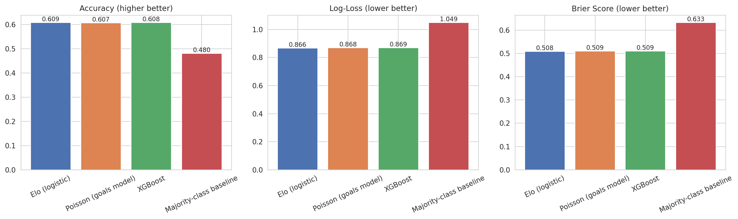
Note. The three substantive models are effectively tied; XGBoost's added complexity yields no measurable benefit over Elo alone.
This result is notable given that XGBoost has access to a substantially richer feature set and far greater model capacity than the two-feature Elo-logistic model, yet does not outperform it. Table 2 and Figure 2 report XGBoost's gain-based feature importances, which help explain this convergence: Elo rating difference alone accounts for approximately 45% of total model gain, more than four times the importance of the next-ranked feature (neutral venue, approximately 10.6%). Because nearly all of XGBoost's predictive power routes through the same signal already captured by the Elo-logistic model, the two approaches produce highly correlated predictions and near-identical aggregate performance.
Table 2
XGBoost Feature Importances (Gain-Based), Sorted Descending
Feature | XGBoost Importance
elo_diff | 0.4509
neutral_venue | 0.1063
away_elo_pre | 0.0776
home_elo_pre | 0.0765
tournament_tier | 0.0739
form_diff | 0.0714
away_form | 0.0532
home_form | 0.0509
rest_diff | 0.0392
Figure 2
XGBoost Feature Importance for Match Outcome Prediction
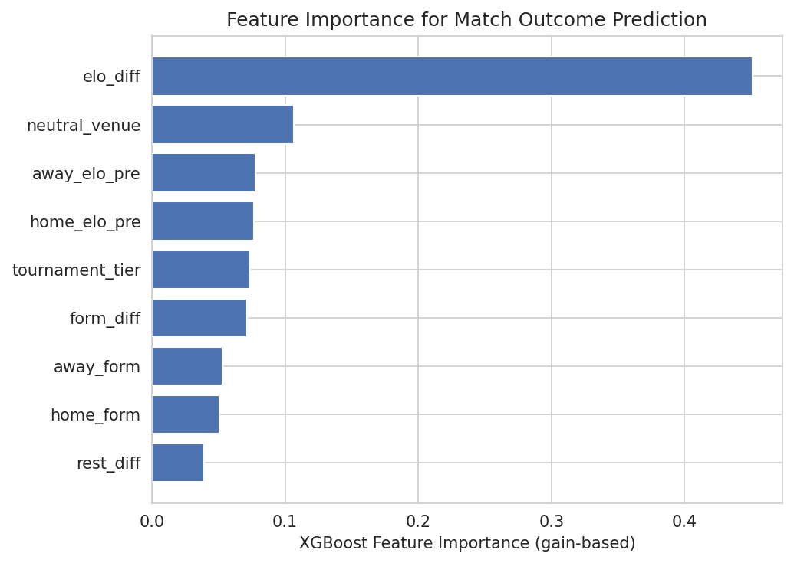
Note. Elo rating difference dominates all other engineered features by a wide margin, explaining why the Poisson and logistic models, which lean almost entirely on Elo, perform competitively with XGBoost despite far less model capacity.
The most significant finding of this study emerges from examining confusion matrices for all three models, shown in Figure 3. In the test set, draws account for 22.7% of actual match results. Yet the Elo and Poisson models never select draw as the most probable outcome for any of the 5,183 test matches, and XGBoost does so in only 4 matches, a draw recall of roughly 0.3%. This pattern is not an artifact of one weak model; it holds identically across a linear model, a classical statistical model, and a nonlinear ensemble model with substantially more capacity.
Figure 3
Row-Normalized Confusion Matrices for All Three Models
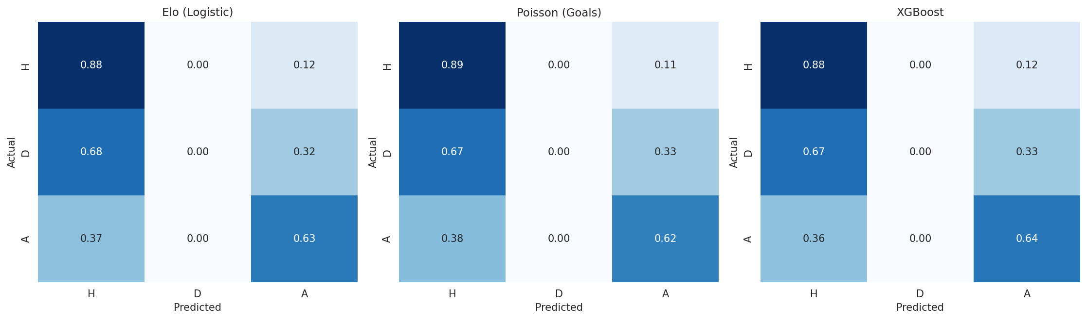
Note. H = Home win, D = Draw, A = Away win. The middle row (actual draws) shows near-zero mass on the diagonal for every model: draws are almost never the modeled outcome, regardless of model family.
This consistent blind spot is interpreted as evidence of a structural property of the problem rather than a fixable modeling deficiency. Draws in football typically arise not because two teams are recognizably evenly matched in a way that shows up cleanly in pre-match features, but from the interaction of two independent low-scoring processes landing on the same value by chance. Because a draw is, in a sense, defined by the absence of a decisive outcome rather than by its own distinct causal signature, it is inherently harder for any of the three model families tested here to identify from pre-match information alone.
Key Findings
- All three models converge to statistically indistinguishable accuracy (~60.8%), and added model complexity (XGBoost) provides no measurable benefit over a simple Elo-based logistic regression.
- Pre-match Elo rating difference alone accounts for approximately 45% of XGBoost's predictive signal, dwarfing all engineered features combined.
- None of the three models predict draws as a top outcome despite draws comprising 22.7% of real results; this failure is identical across all three model families, indicating a structural rather than model-specific limitation.
Limitations
- The dataset pools highly heterogeneous competition types, from World Cup finals to minor regional friendlies; a competition-stratified model may perform differently.
- Features are limited to publicly available historical results; no player-level, tactical, or betting-market data was used, which likely constrains achievable accuracy for all models.
- A single time-based train/test split, rather than multiple rolling-window splits, was used for computational simplicity; results may vary modestly across different split points.
5. Conclusion
This study compared three approaches to predicting international football match outcomes, Elo-based logistic regression, a Poisson goals model, and XGBoost, under a leakage-safe, time-based evaluation on 30,250 matches from 1990 to 2024. All three converge to statistically indistinguishable performance of approximately 60.8% accuracy, driven almost entirely by a single dominant feature, Elo rating difference, and all three share an identical, consistent failure mode: an inability to predict draws, despite draws constituting 22.7% of real outcomes. This finding reflects an inherent structural limit of three-way outcome classification for football rather than a specific model's shortcoming.
Future work should report class-specific performance, particularly draw recall, rather than aggregate accuracy alone, and should explore reframings of the prediction task, such as expected-goals modeling or draw-risk flagging, that may be better suited to this structural constraint. Incorporating information beyond historical match results, such as lineup news, playing-style compatibility, or market-implied probabilities from betting exchanges, may also carry signal specifically predictive of tightly contested, low-event matches that purely historical performance features cannot capture. More broadly, this study demonstrates that model sophistication alone does not guarantee improved predictive insight: a simple, interpretable Elo-based model performed on par with a considerably more complex gradient-boosted ensemble. This underscores the value of rigorous, disaggregated error analysis in applied machine learning, since aggregate accuracy alone would have entirely obscured the draw-prediction weakness that constitutes this study's central finding.
References
Baboota, R., & Kaur, H. (2019). Predictive analysis and modelling football results using machine learning approach for English Premier League. International Journal of Forecasting, 35(2), 741–755.
Breiman, L. (2001). Random forests. Machine Learning, 45(1), 5–32.
Bunker, R., Yeung, C., & Fujii, K. (2024). Machine learning for soccer match result prediction. In Handbook of statistical methods for sports analytics (arXiv:2403.07669).
Constantinou, A. C., & Fenton, N. E. (2013). Determining the level of ability of football teams by dynamic ratings based on the relative discrepancies in scores between adversaries. Journal of Quantitative Analysis in Sports, 9(1), 37–50.
Dixon, M. J., & Coles, S. G. (1997). Modelling association football scores and inefficiencies in the football betting market. Journal of the Royal Statistical Society: Series C, 46(2), 265–280.
Dubitzky, W., Lopes, P., Davis, J., & Berrar, D. (2019). The open international soccer database for machine learning. Machine Learning, 108, 9–28.
Elo, A. E. (1978). The rating of chessplayers, past and present. Arco Publishing.
Hvattum, L. M., & Arntzen, H. (2010). Using Elo ratings for match result prediction in association football. International Journal of Forecasting, 26(3), 460–470.
James, G., Witten, D., Hastie, T., & Tibshirani, R. (2021). An introduction to statistical learning (2nd ed.). Springer.
Maher, M. J. (1982). Modelling association football scores. Statistica Neerlandica, 36(3), 109–118.
Razali, N., Mustapha, A., Mostafa, S. A., & Gunasekaran, S. S. (2022). Football matches outcomes prediction based on gradient boosting algorithms and football rating system. Human Factors in Software and Systems Engineering, 61, 57.
Appendix
The complete Python implementation for this study, including data cleaning, Elo rating computation, feature engineering, model training and evaluation, and error analysis and figure generation, is provided as a supplementary code submission and in the accompanying GitHub repository. The pipeline consists of four sequential stages corresponding to Sections 3.1 through 4 of this report. Additional output files, including the full test-set prediction table and per-tournament accuracy breakdown, are also included in the repository.

