Ex.No. : 3
DML Commands – INSERT, SELECT
Aim:
To perform Data Manipulation Language (DML) Commands such as INSERT, SELECT in the tables.
Description:
Data Manipulation Language (DML) statements are used for managing data within schema objects.
DML Commands: INSERT, SELECT
➢ INSERT - insert data into a table
➢ SELECT - retrieve data from a database
INSERT:
INSERT INTO table_name
VALUES (value1, value2, value3,...);
(or)
INSERT INTO table_name (column1, column2, column3,...)
VALUES (value1, value2, value3,...);
SELECT:
SELECT column_name(s)
FROM table_name;
PROCEDURE
- Open MySQL Workbench and connect to the MySQL server.
- Select the bank database using the USE command.
- Insert the required records into the BANKRECORDS table using the INSERT INTO command.
- Insert the required records into the ACCOUNT table.
- Insert the required records into the BRANCH table.
- Insert the required records into the TRANSACTION table.
- Use the SELECT command to retrieve all records from each table.
- Verify the inserted records in the MySQL Workbench result grid.
- Record the outputs obtained for the INSERT and SELECT operations.

QUESTIONS:
1. Populate all the four tables with your own data.
The tables are:
- BANKRECORDS
- ACCOUNT
- BRANCH
- TRANSACTION
2. View all the records from the four tables.
DATA TO INSERT
1. BANKRECORDS
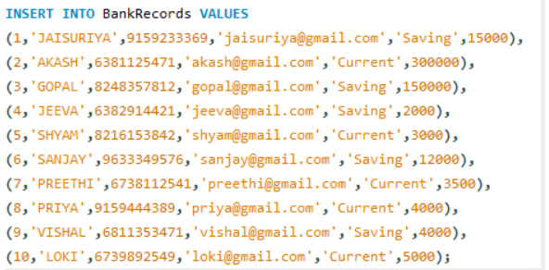
2. ACCOUNT
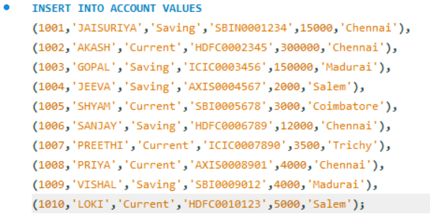

3. BRANCH
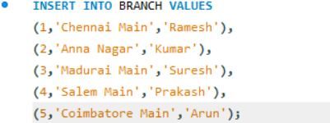
4. TRANSACTION
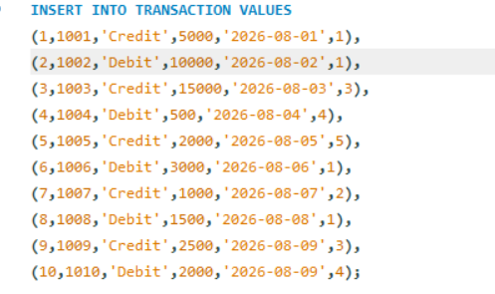
QUESTION 2 — VIEW ALL RECORDS
1. BANKRECORDS
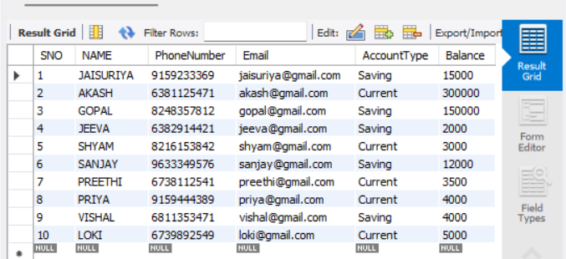

2. ACCOUNT
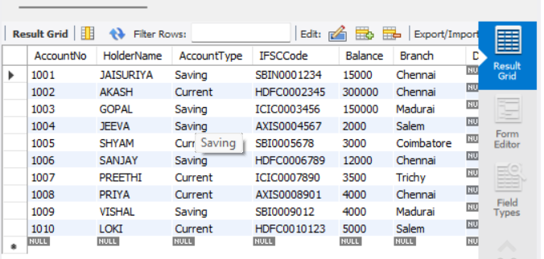
3. BRANCH
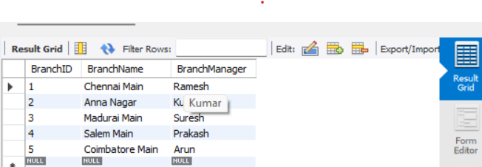
4. TRANSACTION
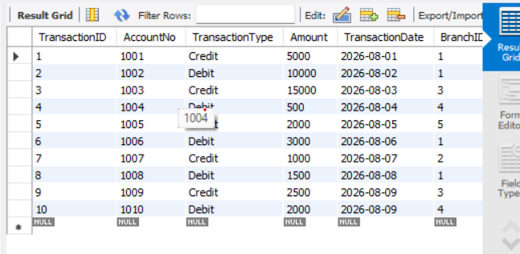
RESULT:
Data Manipulation Language (DML) Commands such as INSERT, SELECT are performed in the five tables.

