Ex.No: 18
Date: __________
HIGH LEVEL LANGUAGE EXTENSION WITH CURSORS
Aim:
To implement Cursors using program in MySQL.
Description:
A Cursor is a temporary memory or temporary work area used by the database server to process query results row by row. Cursors are useful when each record needs to be processed individually.
Types of Cursors:
1. Implicit Cursor: Automatically created by MySQL for SQL statements.
2. Explicit Cursor: Created by the user to fetch data from a table in a row-by-row manner.
How to create an Explicit Cursor:
1. Declare Cursor Object
Syntax: DECLARE cursor_name CURSOR FOR SELECT * FROM table_name;
2. Open Cursor Connection
Syntax: OPEN cursor_name;
3. Fetch Data from Cursor
Syntax: FETCH cursor_name INTO variable_name;
4. Close Cursor Connection
Syntax: CLOSE cursor_name;
Problem-1:
Write a Cursor program using MySQL to retrieve the email IDs and build an email list from the BankRecords table.
SOLUTION:
The following program uses the BankRecords table and fetches the Email column one record at a time using an explicit cursor.
Program-1: Create and Populate BankRecords Table
CREATE TABLE IF NOT EXISTS BankRecords (
SNO INT PRIMARY KEY,
NAME VARCHAR(50) UNIQUE,
PhoneNumber BIGINT,
Email VARCHAR(100),
AccountType VARCHAR(20),
Balance INT
);
INSERT INTO BankRecords VALUES
(2,'AKASH',9876543210,'akash@gmail.com','Saving',25000),
(11,'ARUN',9876543211,'arun@gmail.com','Saving',30000),
(3,'GOPAL',9876543212,'gopal@gmail.com','Current',45000),
(12,'KARTHIK',9876543213,'karthik@gmail.com','Saving',55000),
(30,'KUMAR',9876543214,'kumar@gmail.com','Current',40000),
(10,'LOKI',9876543215,'loki@gmail.com','Saving',35000),
(31,'MANOJ',9876543216,'manoj@gmail.com','Current',60000),
(13,'RAHUL',9876543217,'rahul@gmail.com','Saving',28000),
(20,'VIGNESH',9876543218,'vignesh@gmail.com','Current',50000);
Program-2: Cursor Program
DELIMITER $$
CREATE PROCEDURE build_email_list(INOUT email_list VARCHAR(4000))
BEGIN
DECLARE v_finished INTEGER DEFAULT 0;
DECLARE v_email VARCHAR(100) DEFAULT '';
DECLARE email_cursor CURSOR FOR
SELECT Email FROM BankRecords;
DECLARE CONTINUE HANDLER FOR NOT FOUND
SET v_finished = 1;
OPEN email_cursor;
get_email: LOOP
FETCH email_cursor INTO v_email;
IF v_finished = 1 THEN
LEAVE get_email;
END IF;
SET email_list = CONCAT(email_list, v_email, '; ');
END LOOP get_email;
CLOSE email_cursor;
END $$
DELIMITER ;
SET @email_list = '';
CALL build_email_list(@email_list);
SELECT @email_list AS Email_List;
OUTPUT:
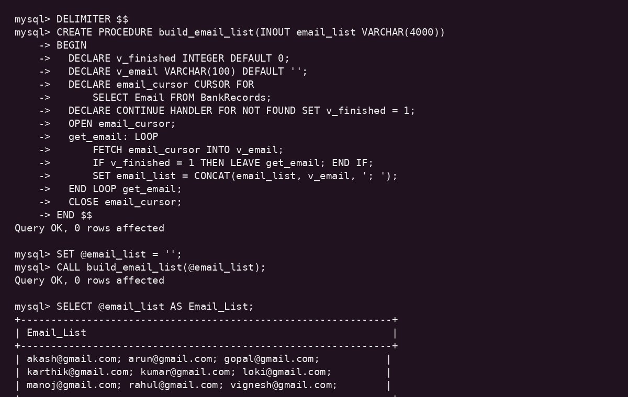
RESULT:
Thus the Cursor program using MySQL to retrieve email IDs from the BankRecords table and build an email list was executed successfully.

