Ex. No.: 11
Date:12-8-26
DATABASE WITH AUTO_INCREMENT SEQUENCES
AIM:
To create an Auto Increment sequence on the given relation.
DESCRIPTION:
SEQUENCE:
In MySQL, a sequence is a list of integers generated in ascending order such as 1, 2, 3, and so on. Many applications use sequences to generate unique numbers mainly for identification.
To create a sequence automatically in MySQL, we use the AUTO_INCREMENT attribute for a column, which is typically a PRIMARY KEY column.
PROCEDURE
- Open MySQL and select the required database.
- Check the structure of the BankRecords table.
- Modify the SNO column using AUTO_INCREMENT.
- Insert records without entering the SNO value.
- Insert a record manually by specifying the SNO.
- Remove the AUTO_INCREMENT property and verify the table structure.

SYNTAX:
CREATE TABLE table_name
(
column_name INT AUTO_INCREMENT PRIMARY KEY,
column_name2 datatype,
column_name3 datatype
);
QUESTIONS:
1. Populate SNO using AUTO_INCREMENT in BankRecords table.
First, modify the SNO column:
ALTER TABLE BankRecords
MODIFY SNO INT AUTO_INCREMENT;
Now insert records without entering the SNO value:
INSERT INTO BankRecords
(NAME, PhoneNumber, Email, AccountType, Balance)
VALUES
('ARUN', 9876543210, 'arun@gmail.com', 'Saving', 25000),
('KARTHIK', 9876543211, 'karthik@gmail.com', 'Current', 35000),
('RAHUL', 9876543212, 'rahul@gmail.com', 'Saving', 45000);
Display the records:
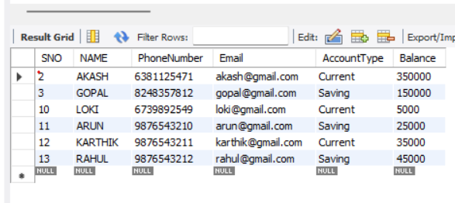
2. Manually populate SNO.
INSERT INTO BankRecords
(SNO, NAME, PhoneNumber, Email, AccountType, Balance)
VALUES
(20, 'VIGNESH', 9876543213, 'vignesh@gmail.com', 'Saving', 55000);
Display the record:
SELECT * FROM BankRecords
WHERE SNO = 20;
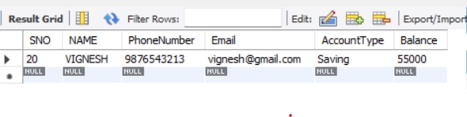
3. Drop the AUTO_INCREMENT.
ALTER TABLE BankRecords
MODIFY SNO INT;

Verify the table structure:
DESC BankRecords;
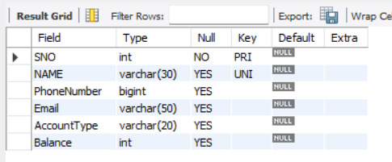
RESULT
The AUTO_INCREMENT sequence was successfully created, records were inserted automatically and manually, and the AUTO_INCREMENT property was successfully removed from the BankRecords table.

