Ex.No: 17
Date:
HIGH LEVEL PROGRAMMING EXTENSIONS – PROCEDURES
Aim: To implement stored procedures using programs in MySQL.
PROCEDURES:
A procedure is a subprogram that performs a specific action.
Creating a Procedure
We use the CREATE PROCEDURE statement to create a new stored procedure. The DELIMITER command is used to change the standard delimiter.
Calling a Stored Procedure
To call a stored procedure, use the following SQL command:
CALL procedure_name();
Problem 1:
Create a simple procedure to display all records from the BankRecords table.
Program 1:
DELIMITER //
CREATE PROCEDURE GetBankRecords()
BEGIN
SELECT * FROM BankRecords;
END //
DELIMITER ;
Execute:
CALL GetBankRecords();
Output:
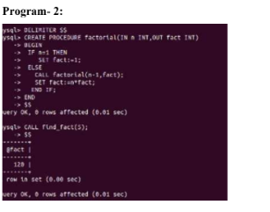
Problem 2:
Create a stored procedure GetCustomerLevel() that accepts a customer's SNO and determines the customer level based on the account balance.
• Balance greater than or equal to 100000 → PLATINUM
• Balance greater than or equal to 50000 → GOLD
• Balance less than 50000 → SILVER
Program 2:
DELIMITER //
CREATE PROCEDURE GetCustomerLevel(
IN p_SNO INT,
OUT p_CustomerLevel VARCHAR(20)
)
BEGIN
DECLARE p_Balance INT;
SELECT Balance INTO p_Balance
FROM BankRecords
WHERE SNO = p_SNO;
IF p_Balance >= 100000 THEN
SET p_CustomerLevel = 'PLATINUM';
ELSEIF p_Balance >= 50000 THEN
SET p_CustomerLevel = 'GOLD';
ELSE
SET p_CustomerLevel = 'SILVER';
END IF;
END //
DELIMITER ;
Execute:
CALL GetCustomerLevel(2, @level);
SELECT @level AS Customer_Level;
Output:
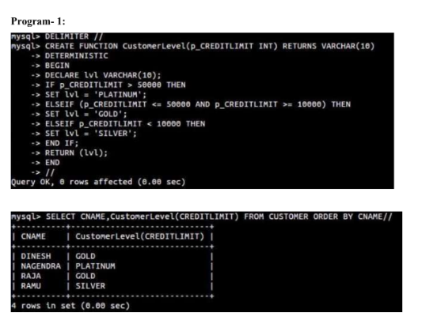
RESULT:
Thus, the high-level programming procedures were executed successfully using the BankRecords table.

