Ex. No: 12
Date:13.08.26
Simple Programming using REPEAT, WHILE
AIM:
To learn how to use various MySQL loop statements including WHILE and REPEAT to run a block of code repeatedly based on a condition.
PROCEDURE
- Open MySQL and select the bank database.
- Create a function using the WHILE loop.
- Execute the function using a SELECT statement.
- Create another function using the REPEAT loop.
- Execute the function until the specified condition becomes TRUE.
- Display and verify the output.

Program-1: WHILE Loop
Write a function using WHILE statement to count the number of records in the BankRecords table.
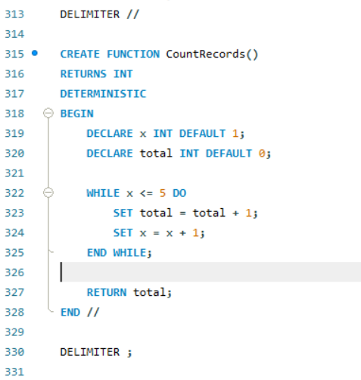
Execute:
SELECT CountRecords();


Program-2: REPEAT Loop
Write a function using REPEAT statement to calculate an amount until it reaches 4000.
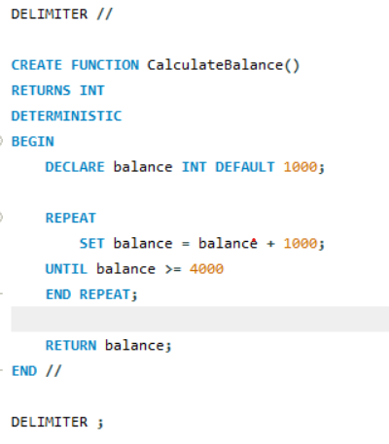
Execute:
SELECT CalculateBalance();
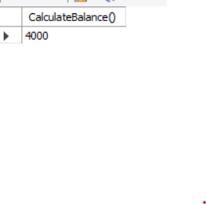
RESULT:
Thus, the simple programming exercises using WHILE and REPEAT loops were executed successfully in the bank database.

