Ex. No: 14
Date:16/08/2026
TCL COMMANDS – COMMIT, SAVEPOINT, ROLLBACK
AIM:
To learn how to use various TCL commands such as COMMIT, SAVEPOINT, and ROLLBACK SQL commands.
PROCEDURE
- Select the bank database and view the BankRecords table.
- Start a transaction using START TRANSACTION.
- Perform an UPDATE operation and create Savepoint A.
- Insert a new record and create Savepoint B.
- Insert another record and create Savepoint C.
- Use ROLLBACK to return to a savepoint and use COMMIT to permanently save the transaction.

PROGRAM
First select your database:
SQL
USE bank;
View existing records:
SQL
SELECT * FROM BankRecords;
Step 1: Start Transaction
SQL
START TRANSACTION;
Step 2: Update a record
Update the balance of ARUN:
SQL
UPDATE BankRecords
SET Balance = 30000
WHERE NAME = 'ARUN';

SAVEPOINT A;

Check the result:
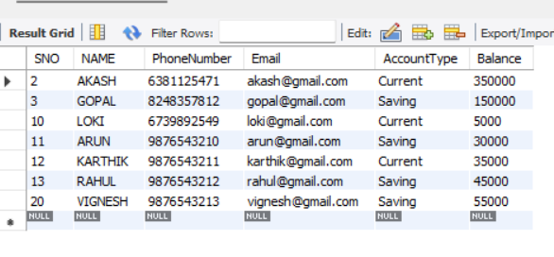
Step 3: Insert a new record
INSERT INTO BankRecords
(SNO, NAME, PhoneNumber, Email, AccountType, Balance)
VALUES
(30, 'KUMAR', 9876543220, 'kumar@gmail.com', 'Saving', 40000);

SAVEPOINT B;
Check the result:
SELECT * FROM BankRecords;
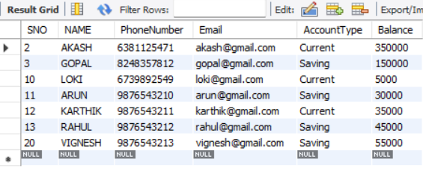

Step 3: Insert a new record
INSERT INTO BankRecords
(SNO, NAME, PhoneNumber, Email, AccountType, Balance)
VALUES
(30, 'KUMAR', 9876543220, 'kumar@gmail.com', 'Saving', 40000);

SAVEPOINT B;
Check:
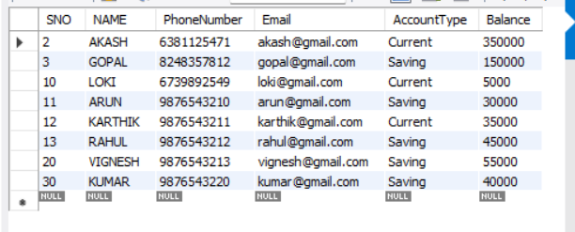
Step 4: Insert another record
INSERT INTO BankRecords
(SNO, NAME, PhoneNumber, Email, AccountType, Balance)
VALUES
(31, 'MANOJ', 9876543221, 'manoj@gmail.com', 'Current', 60000);

SAVEPOINT C;

ROLLBACK
Rollback to Savepoint B:
ROLLBACK TO B;
Now check the records:
SELECT * FROM BankRecords;
COMMIT
Finally, permanently save the remaining changes:
SQL
COMMIT;
Verify:
SQL
SELECT * FROM BankRecords;
RESULT:
The TCL commands COMMIT, SAVEPOINT, and ROLLBACK were successfully implemented and verified using the BankRecords table.

