Ex. No.: 10
Date:12-08-2026
Database with VIEW and INDEX
AIM:
To create view and index on the given relation.
PROCEDURE
- Open MySQL Workbench.
- Select your database.
SQL
USE bank;
- Create the v1 view.
- Display the records from the view.
- Insert a record into the view.
- Delete the inserted record from the view.
- Create an index on the Balance column.
- Display customers having balance above ₹50,000.
- Display and drop the index.
- Create an index on the SNO column.
- Display the customer whose SNO is 10.
- Drop the index.

QUESTIONS ON VIEW
1. Create a view named v1 using the BankRecords table which holds the customer name, account type and balance.
CREATE VIEW v1 AS
SELECT NAME, AccountType, Balance
FROM BankRecords;
Output:
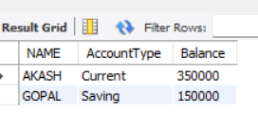
Insert a record into the view:
INSERT INTO v1 (NAME, AccountType, Balance)
VALUES ('ARUN', 'Saving', 25000);
Output
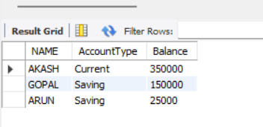

Delete the record from the view:
SQL
DELETE FROM v1
WHERE NAME = 'ARUN';
Output:
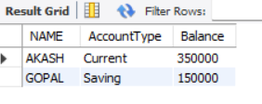
Delete the record from the view:
DELETE FROM v1
WHERE NAME = 'ARUN';
Drop the index:
DROP INDEX index1 ON BankRecords;
2. Create index1 for the SNO attribute and display the name of the customer whose SNO is 10.
Create Index:
CREATE INDEX index1
ON BankRecords(SNO);
Display
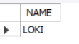
Drop the index:
DROP INDEX index1 ON BankRecords;
OUTPUTS
1) VIEW
CREATE VIEW v1 AS
SELECT NAME, AccountType, Balance
FROM BankRecords;

SELECT * FROM v1;

Output:
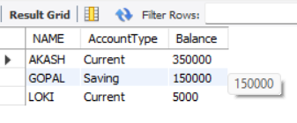
2) INSERT INTO VIEW
INSERT INTO v1 (NAME, AccountType, Balance)
VALUES ('ARUN', 'Saving', 25000);

SELECT * FROM v1;
Output:
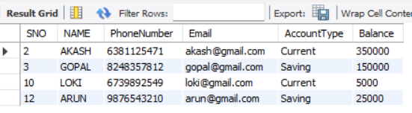
3) DELETE FROM VIEW
DELETE FROM v1
WHERE NAME = 'ARUN';

SELECT * FROM v1;
Output:

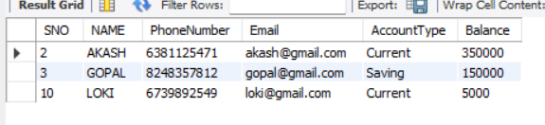
4) INDEX ON BALANCE
CREATE INDEX index1
ON BankRecords(Balance);

SELECT NAME, Balance
FROM BankRecords
WHERE Balance > 50000;
Output:
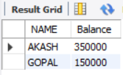
RESULT
The records from the BankRecords table are successfully displayed using VIEW and INDEX operations.

