Ex.No. : 4
Date:1-08-2026
DML Commands with Constraints – UPDATE, DELETE
AIM:
To perform Data Manipulation Language (DML) Commands such as UPDATE, DELETE in the table.
DESCRIPTION:
Data Manipulation Language (DML) statements are used for managing data within schema objects.
DML Commands: UPDATE, DELETE
➢ UPDATE - updates existing data within a table
➢ DELETE - deletes records from a table
UPDATE:
UPDATE table_name
SET column1=value1, column2=value2,...
WHERE some_column=some_value;
DELETE:
DELETE FROM table_name
WHERE some_column=some_value;
PROCEDURE
- Open MySQL Workbench and connect to the MySQL server.
- Select the database containing your BANKRECORDS and ACCOUNT tables.
- Use the UPDATE command to modify the balance of the account with AccountNo = 1001.
- Use the SELECT command to verify the updated balance.
- Use the DELETE command to remove the record from BANKRECORDS where SNO = 10.
- Use the SELECT command to verify that the record has been deleted.
- Update the balance of the customer AKASH to 350000 using the UPDATE command.
- Verify the updated record using the SELECT command.
- Delete all records from BANKRECORDS having a balance greater than 200000.
- Display the remaining records using the SELECT command and verify the changes.

QUESTIONS
- Update the balance of the account whose AccountNo is 1001.


OUTPUT:
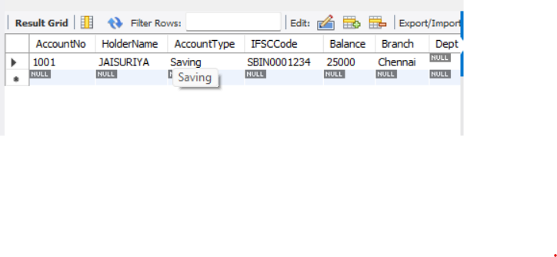
2) Delete the record in the BANKRECORDS table whose SNO is 10.
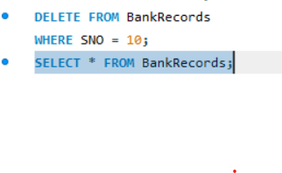
OUTPUT:
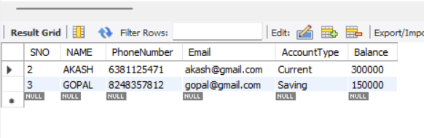
3) Modify the balance for the account holder whose name is AKASH with a value 350000.
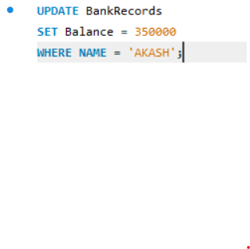
OUTPUT:
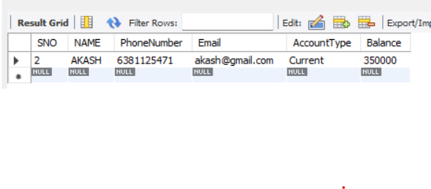
4) Remove all accounts having a balance over 200000.
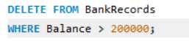
OUTPUT:
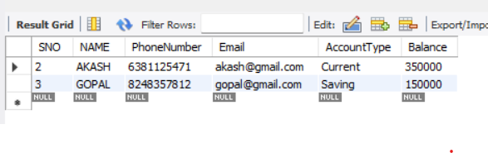
RESULT:
Data Manipulation Language (DML) commands such as UPDATE and DELETE were successfully performed and verified on the BANKRECORDS and ACCOUNT tables.

