Ex. No.: 5
Date:1-8-2026
SELECT with various clause – WHERE, Pattern Matching
AIM:
To view the records from the tables using SELECT commands with WHERE Clause and Pattern matching.
DESCRIPTION:
The SELECT statement allows you to get the data from tables. A table consists of rows and columns like a spreadsheet. Often, you want to see a subset rows, a subset of columns, or a combination of two. The result of the SELECT statement is called a result set that is a list of rows, each consisting of the same number of columns.
SELECT:
SQL
SELECT column_1, column_2, ...
FROM table_1
[INNER | LEFT | RIGHT] JOIN table_2 ON conditions
WHERE conditions
GROUP BY column_1
HAVING group_conditions
ORDER BY column_1
LIMIT offset, length;
LIKE:
➢ The LIKE operator is commonly used to select data based on patterns.
➢ The LIKE operator allows you to select data from a table based on a specified pattern.
➢ MySQL provides two wildcard characters for using with the LIKE operator, the percentage % and underscore _.
➢ The percentage % wildcard allows you to match any string of zero or more characters.
➢ The underscore _ wildcard allows you to match any single character.

QUESTIONS
Since your tables are BankRecords, ACCOUNT, BRANCH and TRANSACTION, use these banking-related questions instead of the Student/Faculty questions.
WHERE:
1. Display the SNO, NAME and Balance of all customers.
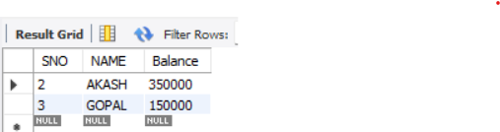
2. Display all customers having a Saving account.
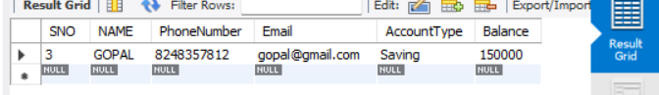
3. Display all bank records having a balance greater than 50000.
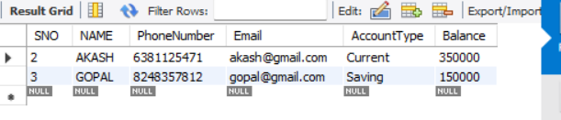
4. Display all account details having a balance less than 10000.
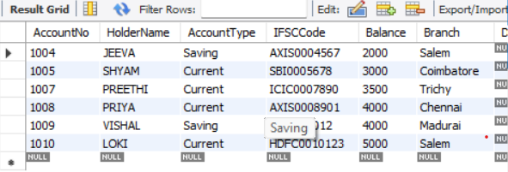
5. Display all account details whose branch is not 'Chennai'.
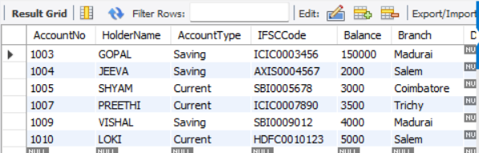

LIKE:
6. List the customers whose name ends with the substring "sh".
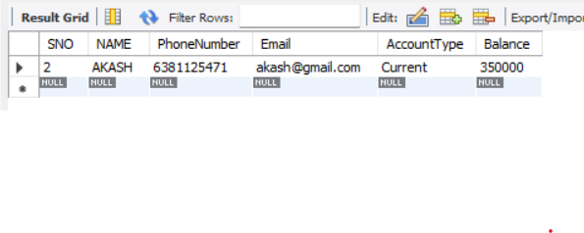
7. Display all customers whose name contains the substring "sh".
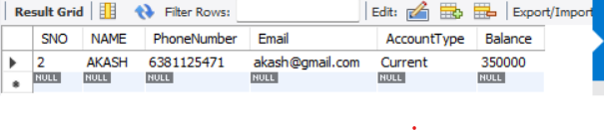
8. Find all customers whose city contains the substring "Ch".
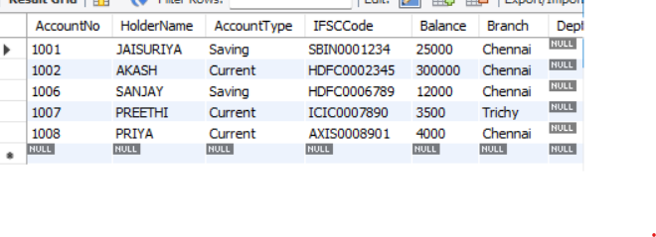
9. Display the customers whose names do not contain six letters.
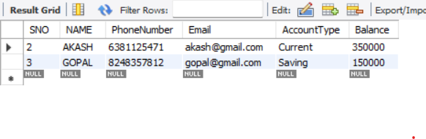
10. Find all customers whose names contain "am".
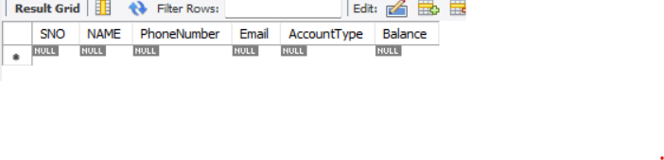
RESULT:
The records from the BANKRECORDS and ACCOUNT tables were successfully displayed using SELECT commands with WHERE Clause and Pattern Matching.

