Ex. No. : 6
Date:2-08-26
SELECT with various clause – BETWEEN, IN, Aggregate Function
AIM:
To view the records from the tables using SELECT commands with BETWEEN, IN, Aggregate functions.
DESCRIPTION:
➢ The BETWEEN operator allows you to specify a range to test.
➢ The IN operator allows you to determine if a specified value matches any one of a list.
➢ MySQL provides many aggregate functions that include AVG, COUNT, SUM, MIN, MAX, etc.
BETWEEN operator:
SQL
SELECT column1, column2, ...
FROM table_name
WHERE expr [NOT] BETWEEN begin_expr AND end_expr;
IN operator:
SQL
SELECT column1, column2, ...
FROM table_name
WHERE (expr|column_1) IN ('value1','value2',...);
PROCEDURE
- Open MySQL Workbench.
- Select your database:
SQL
USE bank;
- Execute the IN query to display records matching the specified account types.
- Execute the BETWEEN query to display accounts within the specified balance range.
- Use AVG() to calculate the average balance.
- Use MAX() and MIN() to find the highest and lowest balance.
- Use GROUP BY with aggregate functions to calculate balance statistics for each account type.
- Use SUM() to calculate the total balance.
- Use COUNT() to find the number of customers in each account type.
- Capture the result grids for the OUTPUTS section.

QUESTIONS
IN & BETWEEN
1. List the account details of customers having AccountType as "Saving" or "Current".
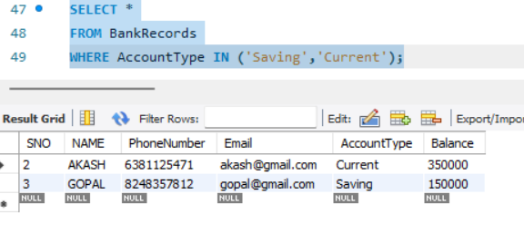

2. Display all bank records having a balance between ₹10,000 and ₹1,00,000.
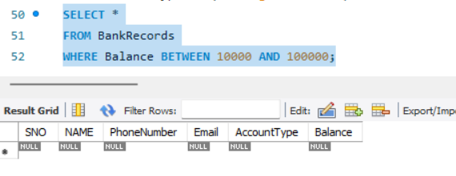
AGGREGATE
3. Find the average balance of all accounts.
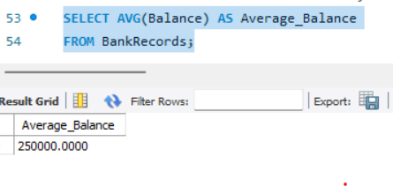
4. List the maximum and minimum balance of the accounts.
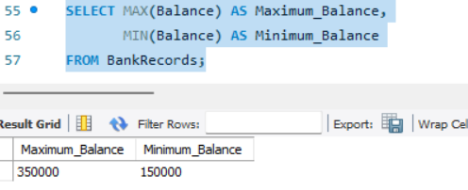
5. List the maximum, minimum and average balance for each AccountType.
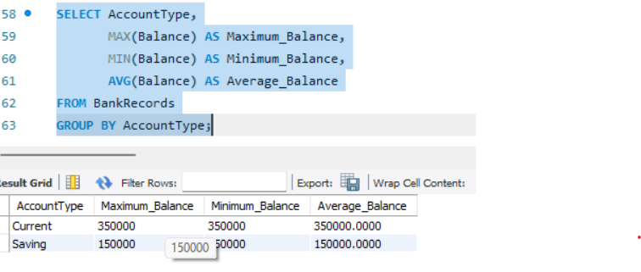
6. Calculate the sum of all account balances.
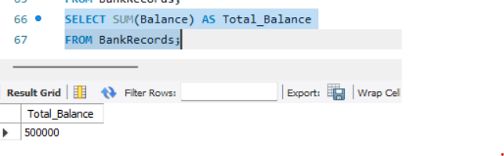
7. Count the number of customers for each AccountType.
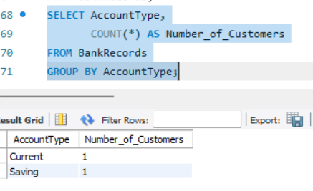
RESULT:
The records from the BANKRECORDS table were successfully displayed using SELECT commands with BETWEEN, IN and Aggregate functions.

