Ex. No.: 7
Date:2-08-26
SELECT with various clause – GROUP BY, HAVING, ORDER BY
AIM:
To view the records from the tables using SELECT commands with GROUP BY, HAVING and ORDER BY.
DESCRIPTION:
GROUP BY – HAVING:
➢ The GROUP BY clause groups a set of rows into a set of summary rows by values of columns or expressions.
➢ The GROUP BY clause is used with aggregate functions such as SUM, AVG, MAX, MIN, and COUNT.
➢ To filter the groups returned by the GROUP BY clause, you use a HAVING clause.
ORDER BY:
The ORDER BY clause is used to sort the result set.
➢ ASC stands for ascending order.
➢ DESC stands for descending order.
SYNTAX:
GROUP BY – HAVING:
SQL
SELECT c1, c2, ..., aggregate_function(ci)
FROM table
WHERE where_conditions
GROUP BY c1, c2, ...
HAVING conditions;
ORDER BY:
SQL
SELECT column1, column2, ...
FROM table
ORDER BY column1 [ASC|DESC], column2 [ASC|DESC];

PROCEDURE
- Open MySQL Workbench and connect to the MySQL server.
- Select your database:
SQL
USE bank;
- Execute the first query using GROUP BY to group customers based on AccountType.
- Execute the second query using GROUP BY and HAVING to filter account types based on total balance.
- Execute the third query using ORDER BY Balance ASC to display balances in ascending order.
- Execute the fourth query using ORDER BY Balance DESC to display account details from highest to lowest balance.
- Observe the result in the MySQL Workbench result grid.
- Capture the four result outputs and paste them into the OUTPUTS section of your record.

QUESTIONS
GROUP BY – HAVING
1. Display the number of customers for each AccountType.
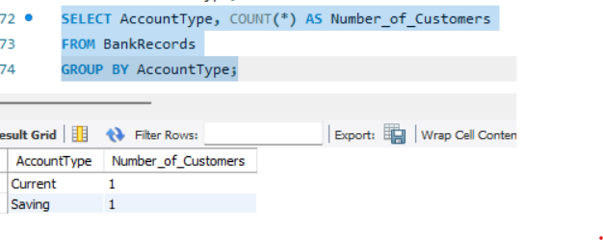
2. Display the AccountType whose total balance is greater than 10000.
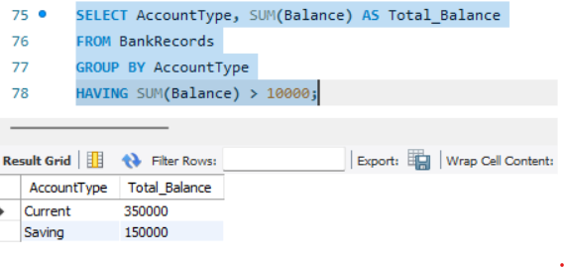
ORDER BY
3. Display the customer name, AccountType and Balance in ascending order of Balance.
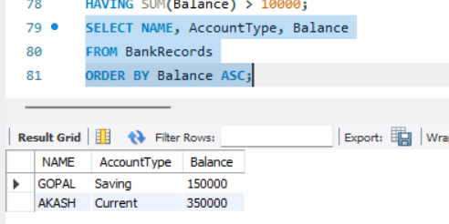

4. Display all account details in descending order of Balance.
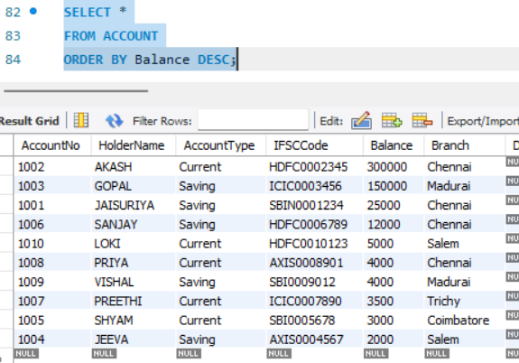
RESULT:
The records from the BANKRECORDS and ACCOUNT tables were successfully displayed using SELECT commands with GROUP BY, HAVING and ORDER BY.

