Ex. No.: 8
Date:2-08-26
Query with Sub Query & Correlated Query
AIM:
To perform subquery and correlated query on the given relations.
DESCRIPTION:
SUBQUERY
A MySQL subquery is a query nested within another query such as SELECT, INSERT, UPDATE or DELETE. A MySQL subquery can also be nested inside another subquery.
A MySQL subquery is called an inner query, while the query that contains the subquery is called the outer query.
CORRELATED QUERY
A correlated subquery is a subquery that uses the data from the outer query. In other words, a correlated subquery depends on the outer query and is evaluated for each row of the outer query.
SYNTAX:
SUBQUERY:
SQL
SELECT c1, c2, ...
FROM table
WHERE c1 IN
(
SELECT c1
FROM table
WHERE conditions
);
CORRELATED QUERY:
SQL
SELECT *
FROM table_name
WHERE EXISTS
(
SELECT *
FROM table_name
WHERE conditions
);
PROCEDURE
- Open MySQL Workbench.
- Select your database:
SQL
USE bank;
- Execute the first query to find customers whose balance is greater than the overall average balance.
- Execute the second query to find account types having more than one customer.
- Execute the third query to find the account having the highest balance.
- Execute the fourth query using a correlated subquery to compare each customer's balance with the average balance of their account type.
- Observe the results in the MySQL Workbench result grid.
- Capture the four outputs and paste them into the OUTPUTS section of your record.

QUESTIONS
For your Bank Management System, use the following questions instead of the Student/Faculty questions.
1. Which bank records have a balance greater than the average balance?
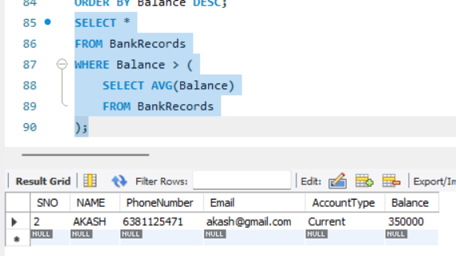
2. Which account types have more than one customer?
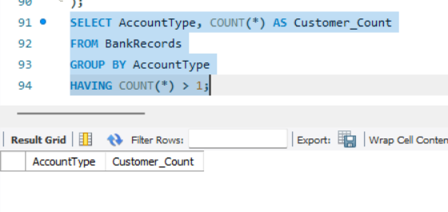
3. Which account has the highest balance and what is the balance?
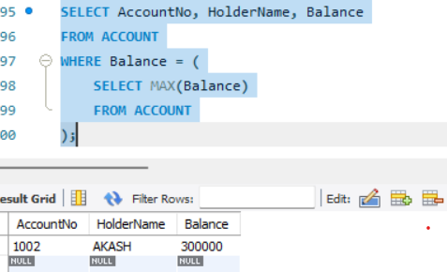

4. List the account holders whose balance is greater than the average balance of their account type.
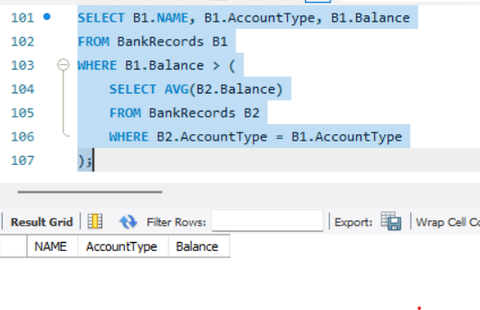
RESULT:
The records from the BANKRECORDS and ACCOUNT tables were successfully displayed using Sub-Query and Correlated Sub-Query.

