Ex. No.: 9
Date:2-08-26
Query with Joins – EquiJoin, Inner Join, Outer Join
AIM:
To perform JOIN using Equi Join, Inner Join and Outer Join on the given relations.
DESCRIPTION:
JOIN
A MySQL JOIN is used to combine data from two or more tables based on a related column between the tables.
Types of JOINs:
- Cross Join
- Inner Join
- Left Join
- Right Join
CROSS JOIN
The CROSS JOIN produces a Cartesian product of rows from two tables.
INNER JOIN
The INNER JOIN returns only the records that have matching values in both tables.
LEFT JOIN
The LEFT JOIN returns all records from the left table and matching records from the right table. If there is no match, NULL is displayed.
RIGHT JOIN
The RIGHT JOIN returns all records from the right table and matching records from the left table. If there is no match, NULL is displayed.

SYNTAX
CROSS JOIN:
SQL
SELECT t1.column1, t2.column1
FROM t1
CROSS JOIN t2;
INNER JOIN:
SQL
SELECT t1.column1, t2.column1
FROM t1
INNER JOIN t2
ON t1.column = t2.column;
LEFT JOIN:
SQL
SELECT t1.column1, t2.column1
FROM t1
LEFT JOIN t2
ON t1.column = t2.column
ORDER BY t1.column;
RIGHT JOIN:
SQL
SELECT t1.column1, t2.column1
FROM t1
RIGHT JOIN t2
ON t1.column = t2.column
ORDER BY t2.column;
PROCEDURE
- Open MySQL Workbench.
- Select your database:
SQL
USE bank;
- Check your table structures before running the JOIN queries:
SQL
DESC CUSTOMER;
DESC ACCOUNT;
DESC TRANSACTION;
- Identify the common columns between the tables.
- Execute the INNER JOIN query.
- Execute the LEFT JOIN query.
- Execute the second INNER JOIN query.
- Observe the results in the MySQL Workbench result grid.
- Take screenshots of the outputs and paste them in the OUTPUTS section.

QUESTIONS
1. Display the account holder name, account type and balance along with the transaction details.
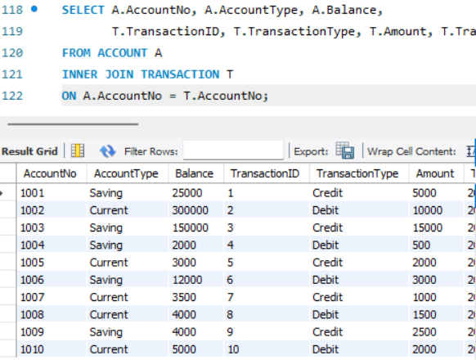
Q2. Display all accounts and their transaction details, including accounts with no transactions.
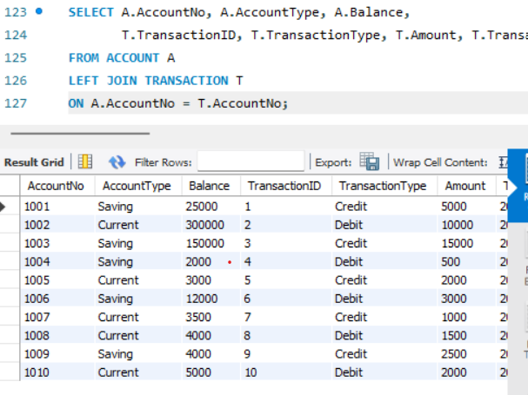

Q3. Display transaction details along with the corresponding account details.
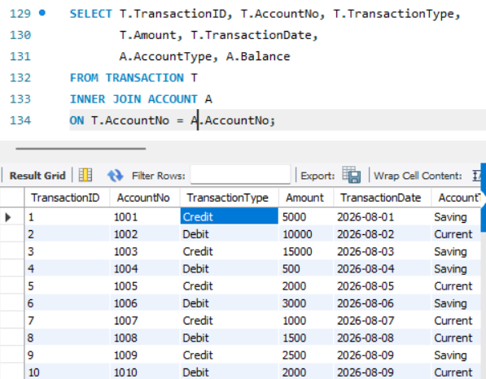
RESULT:
The records from the tables are successfully displayed using JOIN operations such as Equi Join, Inner Join and Outer Join.

