Ex. No: 13
Date:15.08.2026
Simple Programming using CASE and LOOP
AIM:
To learn how to use various MySQL statements including CASE and LOOP to execute a block of code based on a condition.
PROCEDURE
- Open MySQL and select the bank database.
- Create a function using the CASE statement.
- Execute the function with different balance values.
- Create another function using the LOOP statement.
- Use the LEAVE statement to terminate the loop when the condition is satisfied.
- Execute and verify the output.

Program 1: CASE Statement
Write a function using CASE statement to classify a customer's account balance.
- Balance ≤ 5000 → Low Balance
- Balance ≤ 50000 → Average Balance
- Otherwise → High Balance
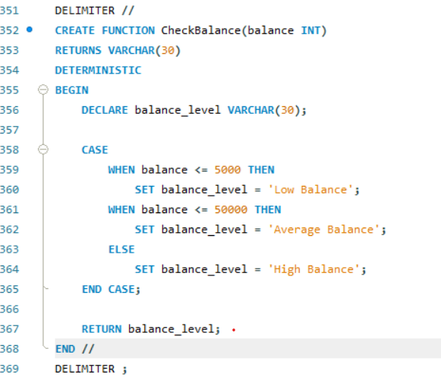
Execute:
SELECT CheckBalance(25000);
Output:

Program 2: LOOP Statement
Write a function using LOOP statement to increase the balance until it reaches 5000.
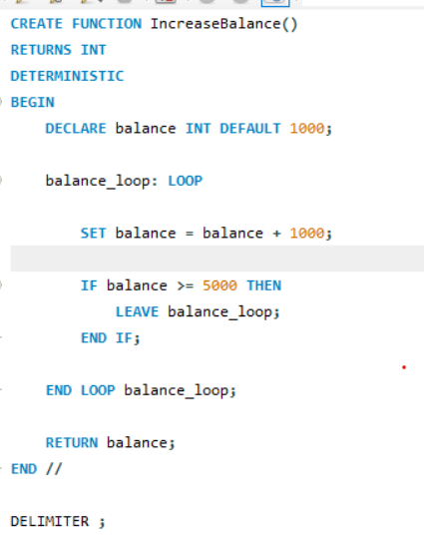
Execute:
SELECT IncreaseBalance();
Output:

RESULT:
Thus, the simple programming exercises using CASE and LOOP were executed successfully in the bank database.

