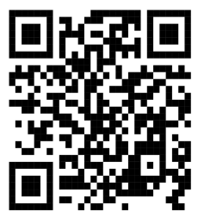
Experiment No.: 07
Date:
Experiment Title:
State Chart Diagram for Library Management System
Aim:
To design and understand the State Chart Diagram for a Library Management System that represents the different states and transitions involved in borrowing and returning books.
Problem Description:
A library management system is used by students and faculty to search, borrow, and return books. The system should validate user login, check book availability, allow borrowing, update records, and handle book returns including late fine payment. The objective is to represent these operations using a state chart diagram.
Methodology:
The system behaviour is represented using states and transitions.First, the user logs into the system. The system validates the user information. If the user is valid, they can search for books. The system checks whether the requested book is available. If available, the user can borrow the book. The library records are updated. When the user returns the book, the system checks if the book is returned late. If late, the user must pay a fine before the database is updated.
Decision Logic:
The system makes decisions at certain stages such as validating user information, checking book availability, and verifying whether the book return is late. Based on these conditions, the system moves to the next state.
Design Description:
The state chart diagram contains the following states:
- Start State – Beginning of the system process.
- Student / Faculty Login – User logs into the library system.
- Valid Information Check – System verifies login details.
- Invalid User – Process ends if the login is invalid.
- Search Book – User searches for the required book.
- Book Availability Check – System checks whether the book is available.
- Book Not Available – Process ends if the book is unavailable.
- Borrow Book – User borrows the available book.
- User Details Entry – ID number, phone number, address, and name are recorded.
- Update Library Record – Borrowing information is updated.
- Return Book – User returns the borrowed book.
- Late Check – System checks whether the return is late.
- Pay Fine – If late, the user pays the fine.
- Book Returned – Book return is confirmed.
- Update Database – System updates the final library records.
- End State – Completion of the process.
State Chart Diagram:
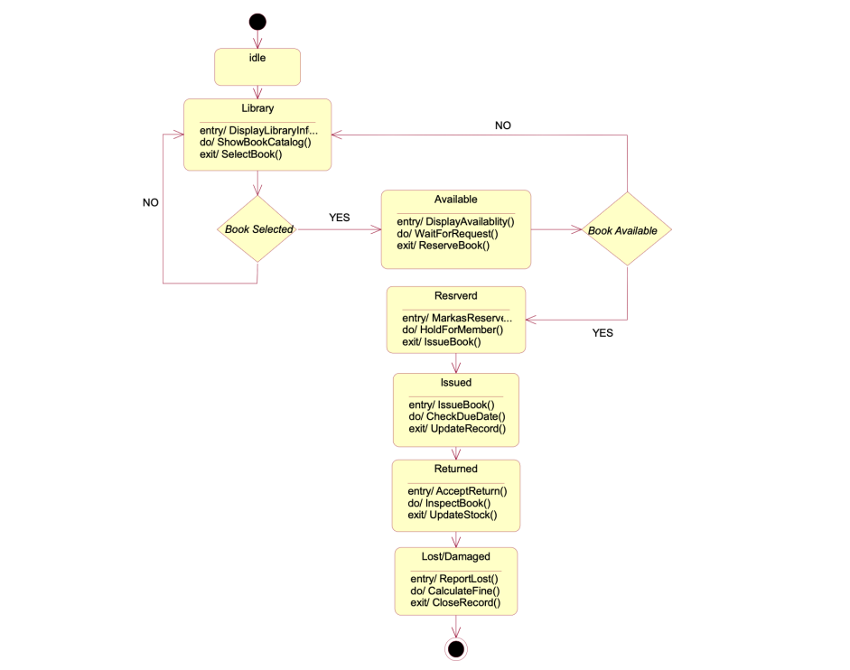

Result:
The State Chart Diagram for the Library Management System was successfully designed, showing all states such as login, search, borrow, return, fine payment, and database update.
Conclusion:
The experiment demonstrates how a state chart diagram can effectively represent the dynamic behaviour of a library management system and the transitions between different states.

