Assignment 15.2

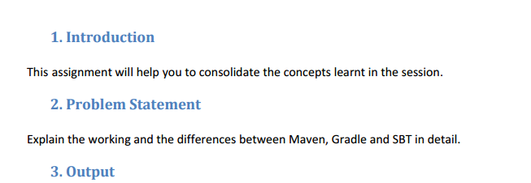

**Maven**

Maven is a "build management tool", it is for defining how your .java files get compiled to .class, packaged into .jar (or .war or .ear) files, (pre/post)processed with tools, managing your CLASSPATH, and all others sorts of tasks that are required to build your project. It is similar to Apache Ant or Gradle or Makefiles in C/C++, but it attempts to be completely self-contained in it that you shouldn't need any additional tools or scripts by incorporating other common tasks like downloading & installing necessary libraries etc.

It is also designed around the "build portability" theme, so that you don't get issues as having the same code with the same buildscript working on one computer but not on another one.

**Gradle**

Gradle is another build system that takes the best features from other build systems and combines them into one. It is improved based off of their shortcomings. It is a JVM based build system, what that means is that you can write your own script in Java, which Android Studio makes use of.

One cool thing about gradle is that it is a plugin based system. This means if you have your own programming language and you want to automate the task of building some package (output like a JAR for Java) from sources then you can write a complete plugin in Java or Groovy, and distribute it to rest of world.

**SBT**

sbt is an open source build tool for Scala and Java projects, similar to Java's Maven or Ant.

Its main features are:

* native support for compiling Scala code and integrating with many Scala test frameworks
* build descriptions written in Scala using a DSL
* dependency management using Ivy (which supports Maven-format repositories)
* continuous compilation, testing, and deployment
* integration with the Scala interpreter for rapid iteration and debugging
* support for mixed Java/Scala projects

sbt is the de facto build tool in the Scala community.

**DIFFERENCES -**

Comparison of Maven and Gradle on the basis of features :

* How easy is the initial learning curve

1. Maven is XML based tool, XML is very commonly used/known.
2. If existing project are using maven then developers are comfortable with the system.
3. Gradle is DSL based system and need to learn explicitly.

* How fast are different builds with each tool. Taken a report from zeroturnaround, they have done detail analysis of the speed of builds with both built tools and found maven and gradle are close enough on build timings.
* How complex is it to create and maintain the build script? Maven build scripts are xml based, which has predefined structure and only one way to write. So it makes it more standard and less flexible. Gradle has its own DSL which is introduced by Gradle itself and tightly connected to Gradle internals But its flexible and simple and short.
* How many plugins exist and how simple is it to customize your own plugins? Maven is called “plugin execution framework” Hundreds of plugins exist for Maven and you can create your own plugin is simple. Gradle’s architecture is also plugin-based, It’s easy to write plugins But availability of plugin in community may not be ease.
* How good is the community and documentation for each tool? Maven is in the market for very long time, Documentation is good, Lots of resources and help available in open community and forum. Gradle is very recent. It is open source but still under control of gradleware. They have option for commercial support.
* How well does each tool integrate with developer tools? (IDE, App Server, CI server). With many years of background Maven has full support to almost each tool and every category (IDE, App Server, CI). Lacking in the App Server and CI ServerCategories, mainly due to newness.

**One can decide the tool on the basis of their user case and requirement.**

Gradle - We may not be using other features which is used by google for android development as those features may or may not match with your needs however gradle is essentially emerging as popular tool and you may definitely want to have a look at it.

Maven - Maven is widely used in most of the companies and have robust defined workflow around it. Developers are very much familiar with the system. However this may not be viable option as android development need to use gradle.

Maven and Gradle (Both) - This would be the one more option for a company with wide range of development area which may give developers flexibility to adopt tool as per their choice with in given workflow.

SBT : Simple Build Tool is a general purpose build tool written in Scala for JVM developers. It borrows good ideas from other successful build tools like Ant, Maven, and Gradle. Features are :

1.Default project layouts

2.Built-in tasks

3.Plugin architecture

4.Declarative Dependency management

5.Code over Configuration: A DSL for build tool

Apart from the feature set mentioned above **sbt** also provides the following additional features:

6.Interactive nature: It isn't just a build tool, it also provides an interactive environment to work in.

7.Scala REPL integration. The maven workflow is hardcoded. SBT has a more flexible way of configuring how your builds should progress. But if you really need this, you may be overcomplicating things.