**Assignment 24.4**

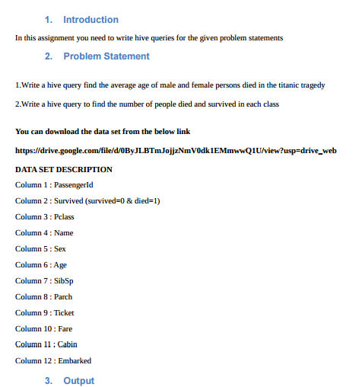

**Q 1) Write a hive query find the average age of male and female persons died in the titanic tragedy.**

First creating the table ‘titanic’ and then loading the given dataset into it.

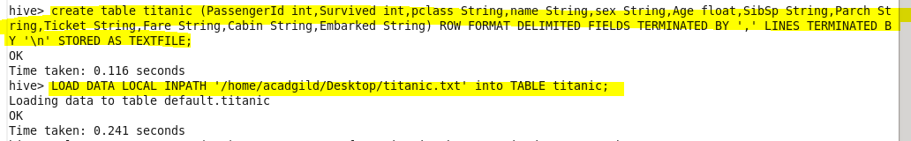

Here, finding the average age of male and female who died in the titanic tragedy using avg function.

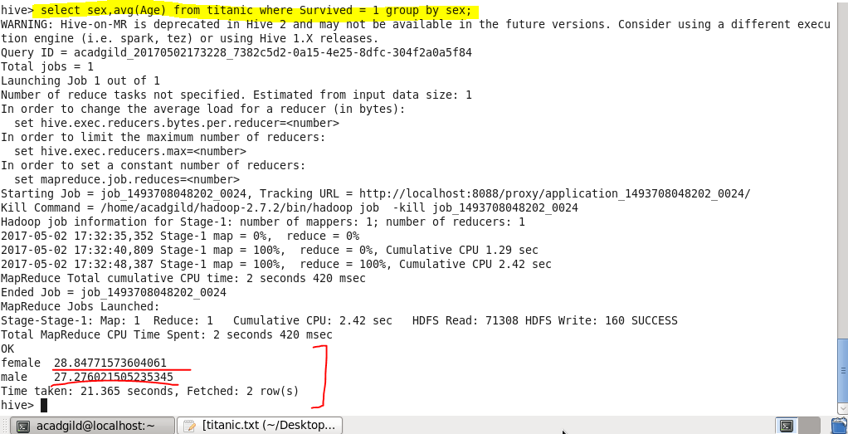

**Q 2)Write a hive query to find the number of people died and survived in each class.**

Here, finding the no. of people died and survived using count function.

Using select command we will select the pclass, survived status and then we will count all corresponding to the other two class and survived status and then will group by class and survived.

