**Problem Statement-10.5**

**Dataset Description Column**

1: City pair (Combination of from and to): String

Column 2: From location: String

Column 3: To Location: String

Column 4: Product type: Integer (1=Air, 2=Car, 3 =Air+Car, 4 =Hotel, 5=Air+Hotel, 6=Hotel +Car, 7 =Air+Hotel+Car)

Column 5: Adults traveling: Integer

Column 6: Seniors traveling: Integer

Column 7: Children traveling: Integer

Column 8: Youth traveling: Integer

Column 9: Infant traveling: Integer

Column 10: Date of travel: String

Column 11: Time of travel: String

Column 12: Date of Return: String

Column 13: Time of Return: String

Column 14: Price of booking: Float

Column 15: Hotel name: String

**Input File-**

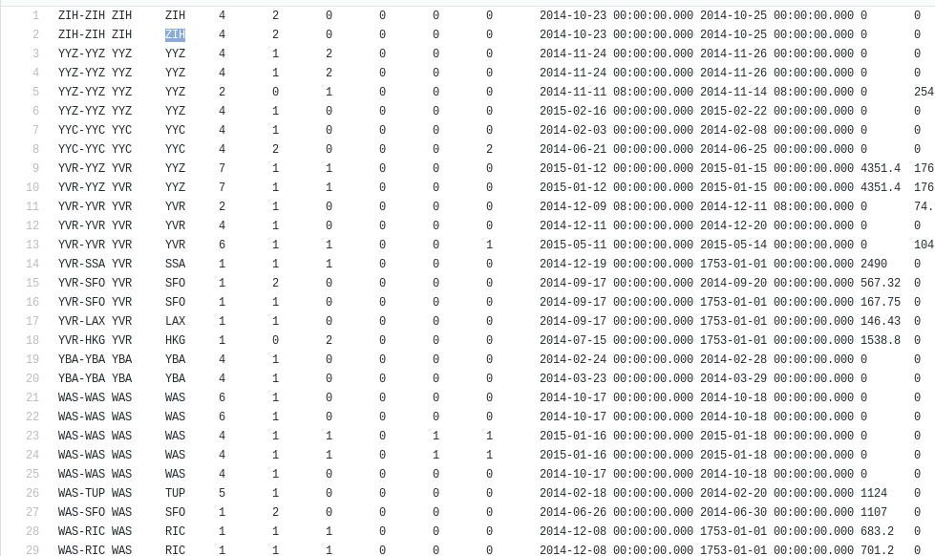

**1.Write a pig script to find the top 20 destination people travel the most: Based on the given data**

**Solution-**

1. Load data from input file.
2. Grouped data on the basis of destination.
3. Count number of times people travelled to the destination.
4. Order the count based on descending order to find most travelled destination.
5. Limit them by 20 to display top 20 destinations.

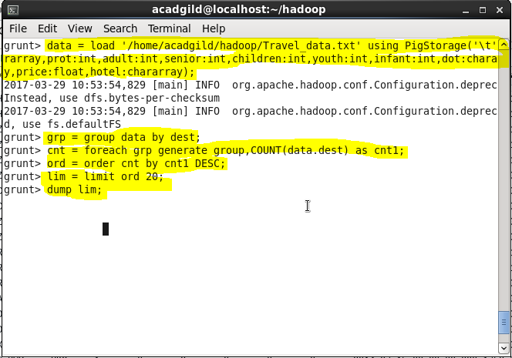

**Output-**

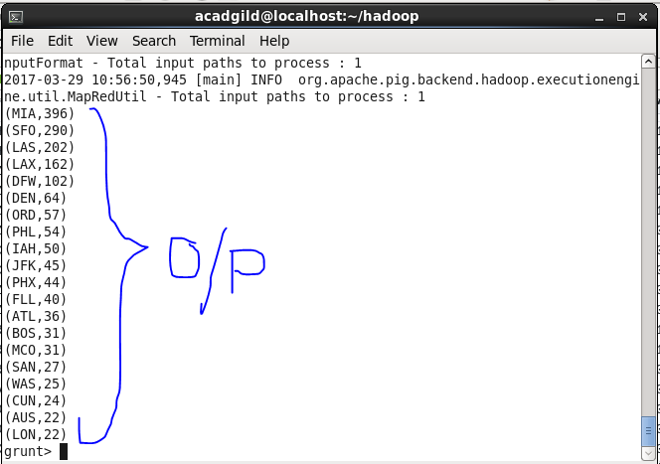

**2. Write a pig script to find the top 20 locations from where people travel the most**

**Solution-**

1. Load data from input file.
2. Grouped data on the basis of destination.
3. Count number of times people travelled to the destination.
4. Order the count based on descending order to find most travelled destination.
5. Limit them by 20 to display top 20 destination

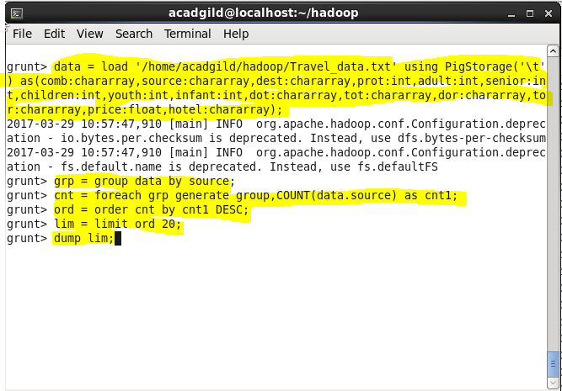

**Output-**

