**Problem Statement-10.5**

**Data Definition:**

Column 1: Weather Station

Column 2: Date(year/Month/Day)

Column 3: Observation Type

Column 4: Temperature

**Input File-**

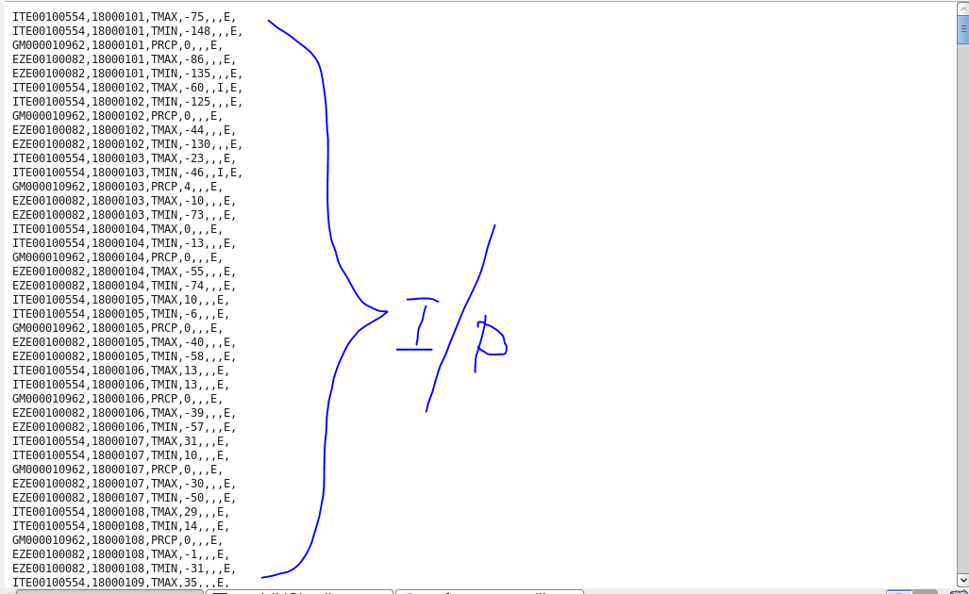

**1. Write a pig script to find the minimum temperature observed in a given weather station in a particular year.**

**Solution-**

1. Load data from input file.
2. Extract year from date.
3. Group data based on station and year.
4. Find minimum temperature from the group.
5. Display minimum temperature from the group.

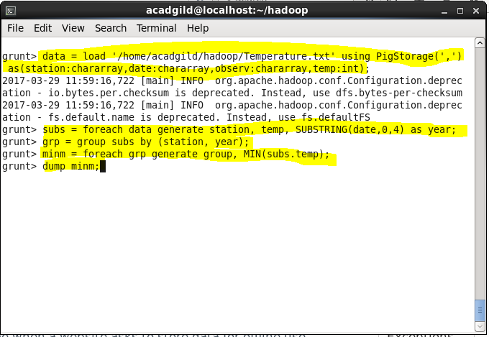

**Output-**

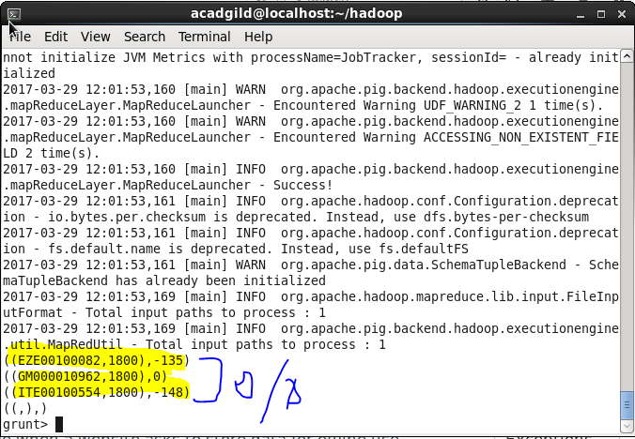

**2. Write a pig script to find the maximum temperature observed in a given weather station in a particular year.**

**Solution-**

1. Load data from input file.
2. Extract year from date.
3. Group data based on station and year.
4. Find maximum temperature from the group.
5. Display maximum temperature from the group.

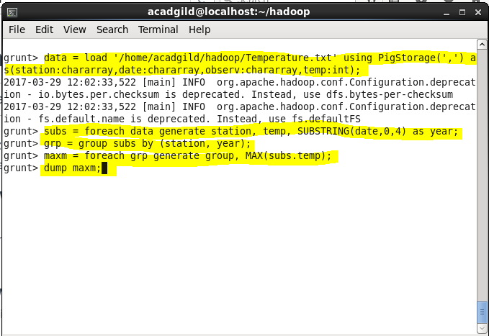

**Output-**

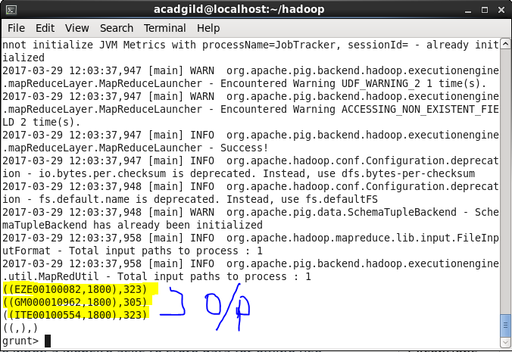

**3. Write a pig script to find the number of readings given by each weather station according to the dataset.**

**Solution-**

1. Load data from input file.
2. Group data on station.
3. Count temperature from each group.
4. Display maximum temperature from the group.

