**Assignment 11.2**

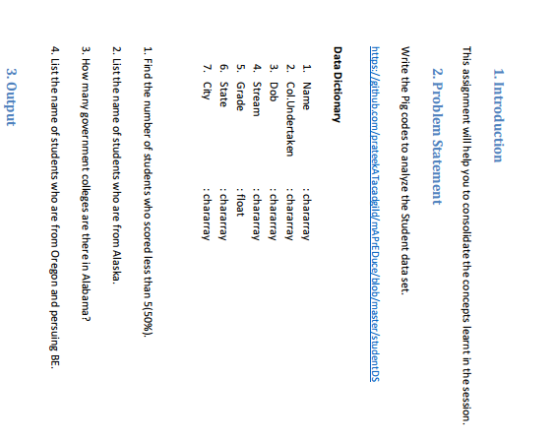

**1 > number of students scored less than (50%) –**

**Pig command :**

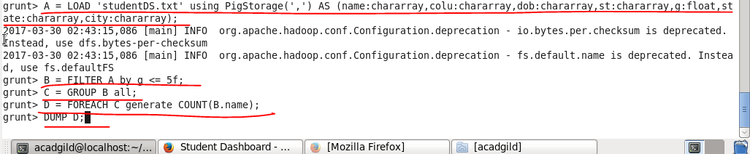

**Output :**

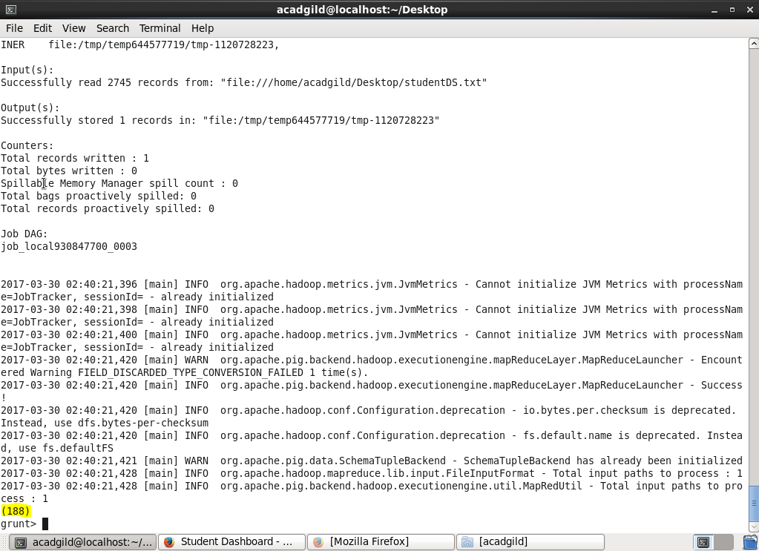

**2 > List the names of students who are from ALASKA :**

**Pig command :**

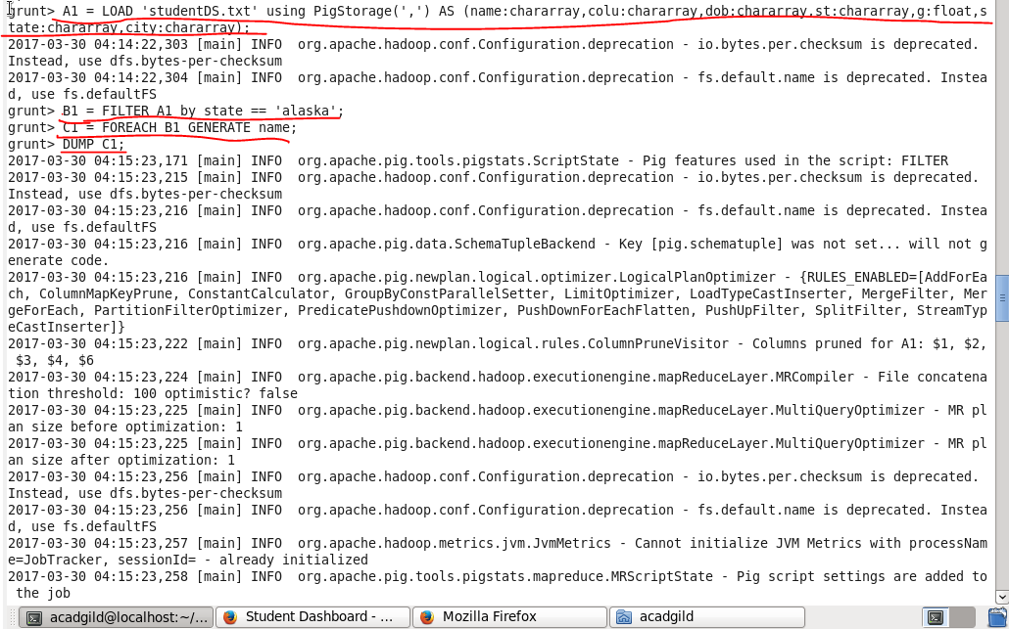

**Output :** 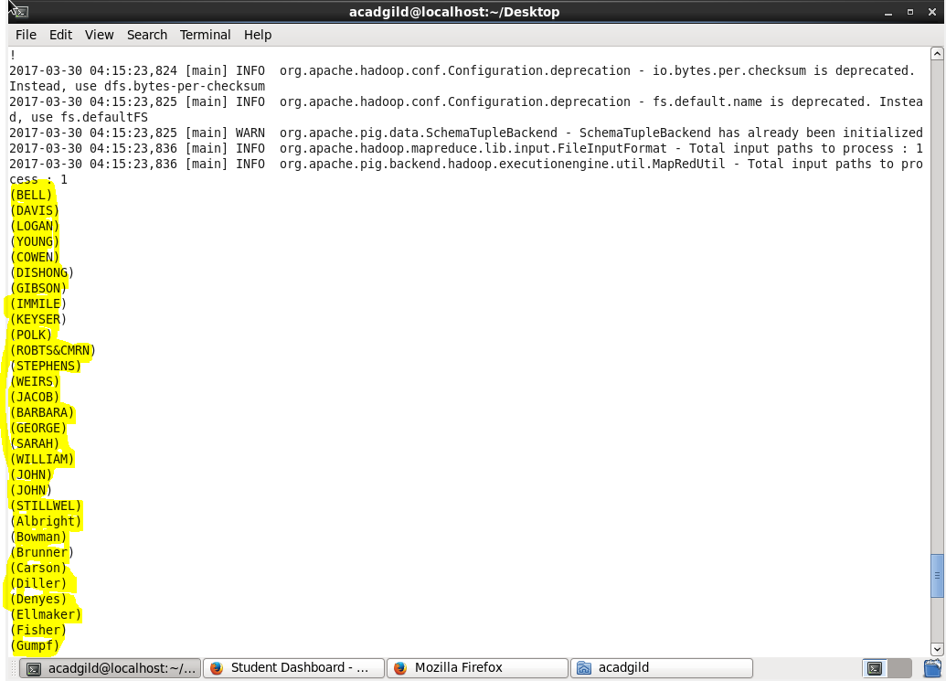

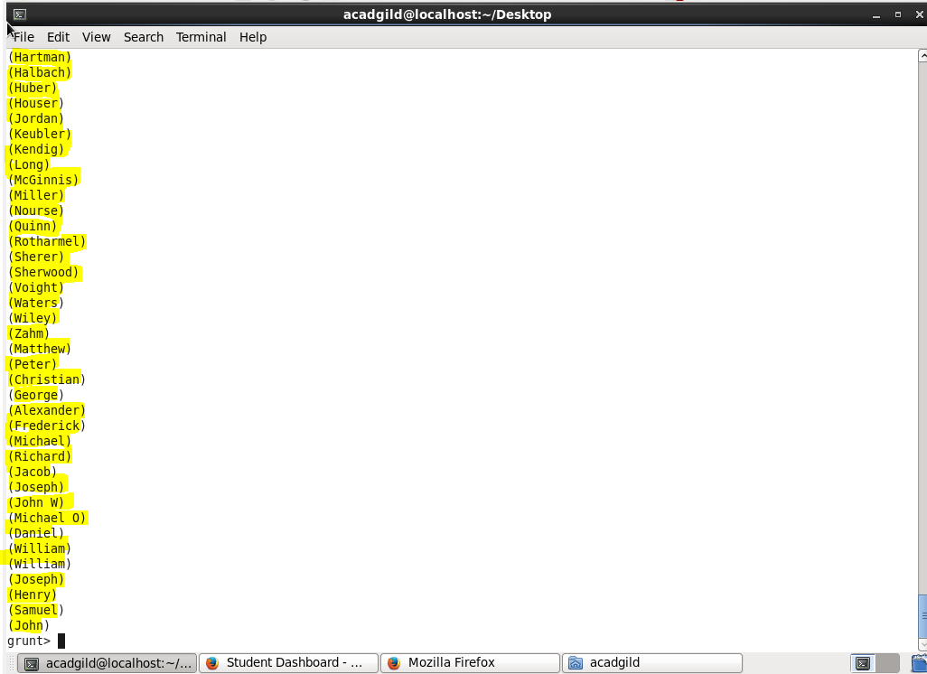

**3 > number of government colleges in Alabama :**

**Pig command :**

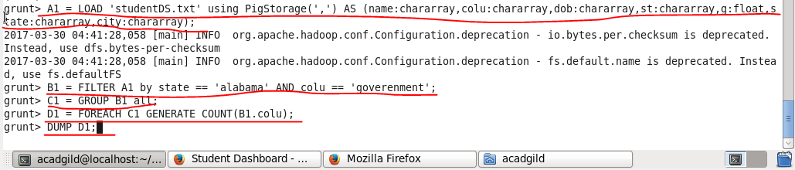

**Output :**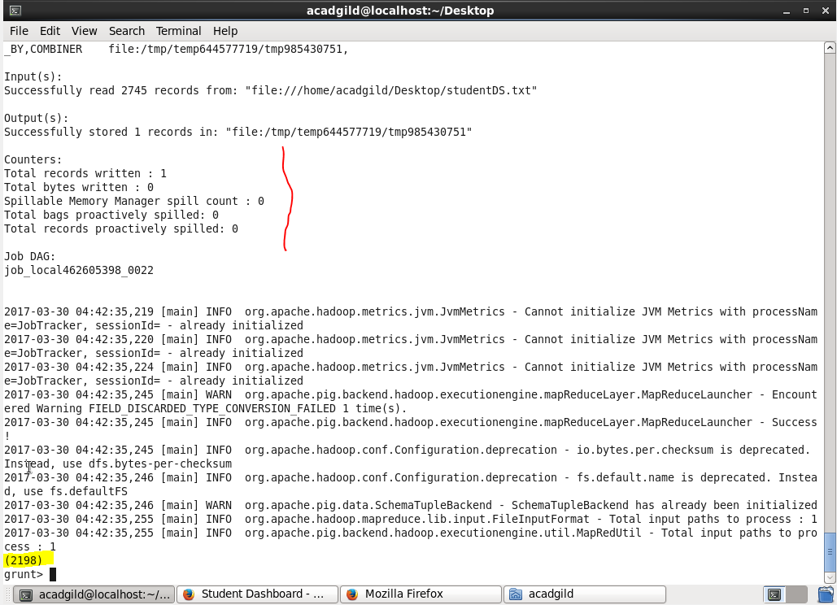

**4 > Students who are from Oregon and persuing be. :**

**Pig command :**

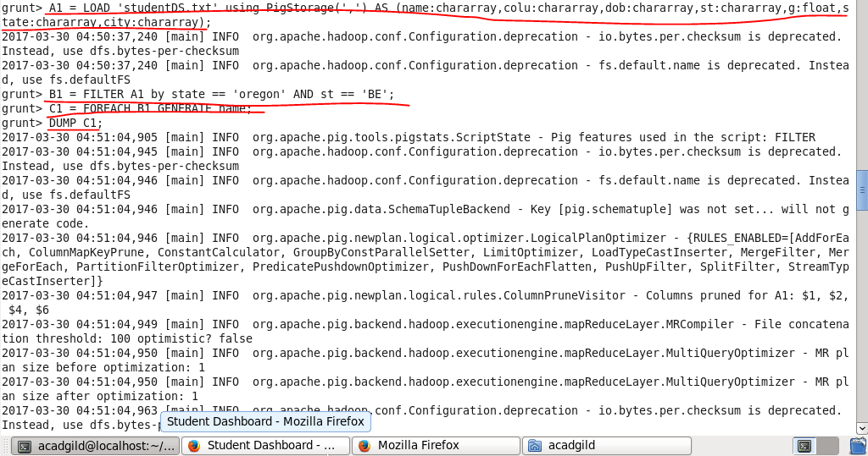

**Output :**

