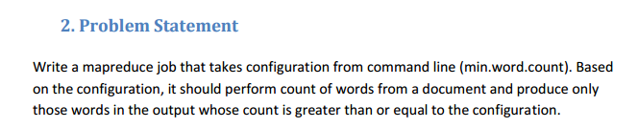

**Input file**

Hadoop is good subject

Hadoop is good subject

Hadoop is good subject

Hadoop is good subject for me

**Solution**

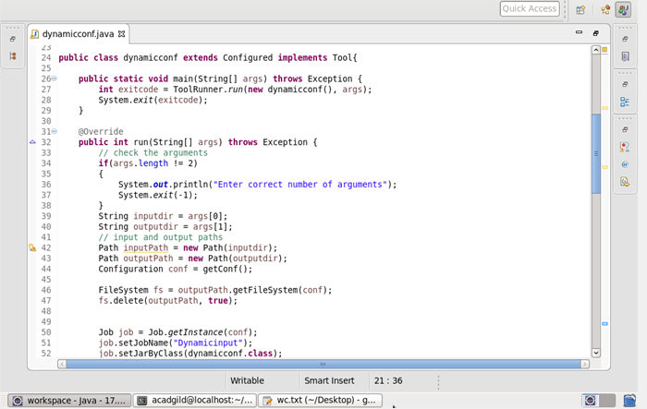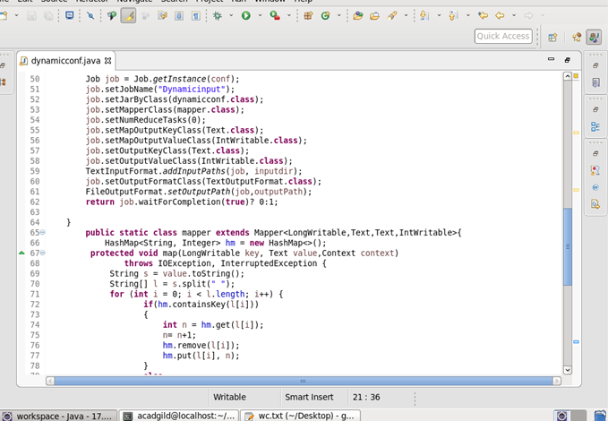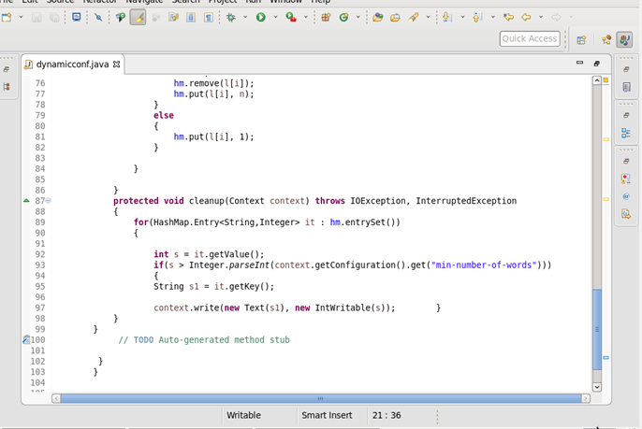

**Output**

