**Assignment 18.1**

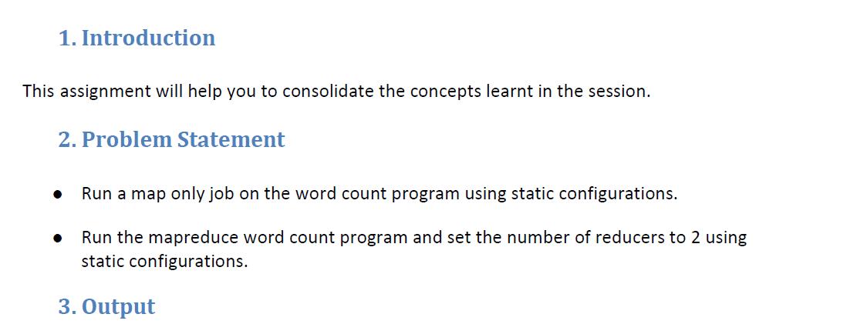

* **Run a map only job on the word count program using static configurations.**

**Driver Class:**

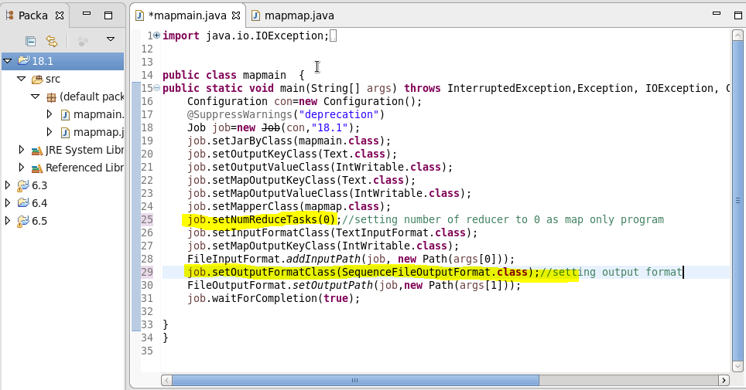

Here, we are setting number of reducer task (NumReduceTask) to ‘0’ statically. This is the static configuration.And then set output file format as Sequence Output File format.

So, no reducer will work and the output will be the map only word count.

Mapper class:

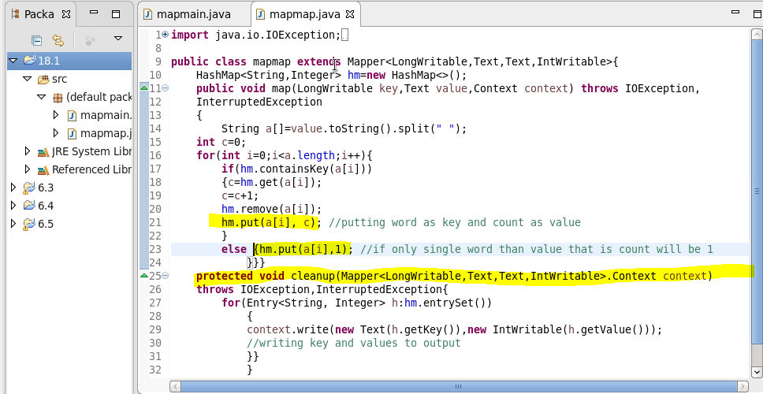

In mapper class we are adding unique keys and their respective values to a hashmap in map method. After processing all the data by map method, cleanup method is getting executed.

Cleanup Method :I will override the clean method and write the final key and value instead of writing in mapper as mapper will be invoked for each line

Running jars and Output:

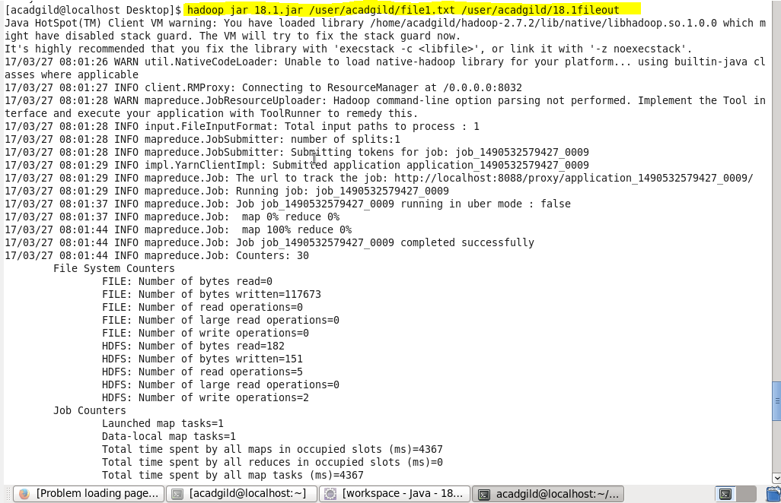

* Our output will be saved in a directory 18.1fileout as we gave above

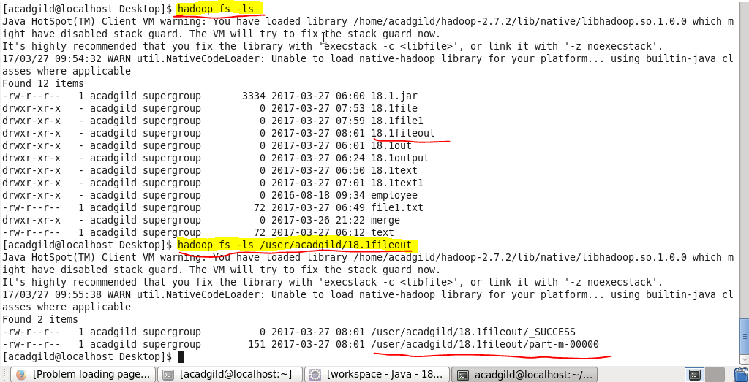

Above file will be created and our output will be saved in that file.

**Output**

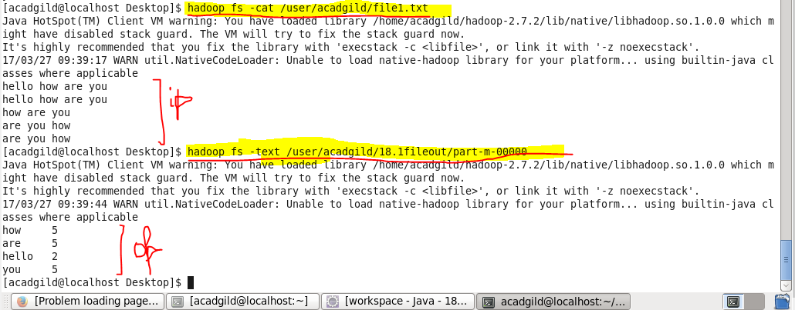

**2. Run the map reduce word count program and set the number of reducers to 2 using static configurations.**

**Driver class:**

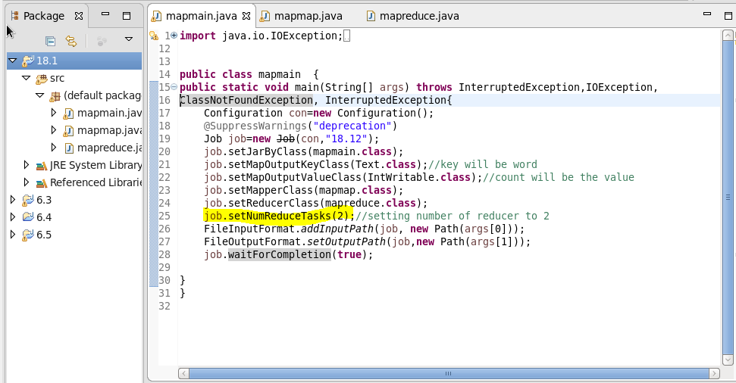

Here we are setting NumReduceTasks to ‘2’. So 2 reducers will be running and the now in this case mapper will send count as 1 value and each word individually as key to reducer.

This is the static configuration.

**Mapper class:**

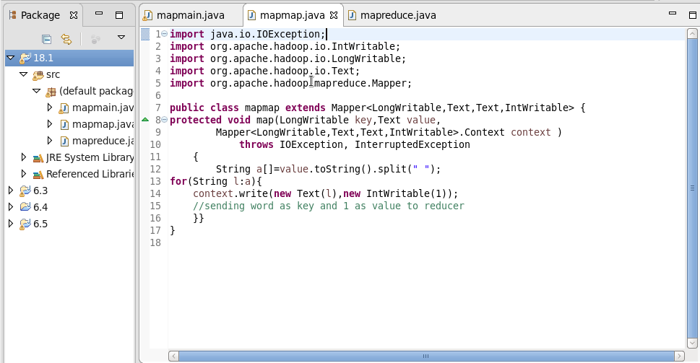

**Reducer class:**

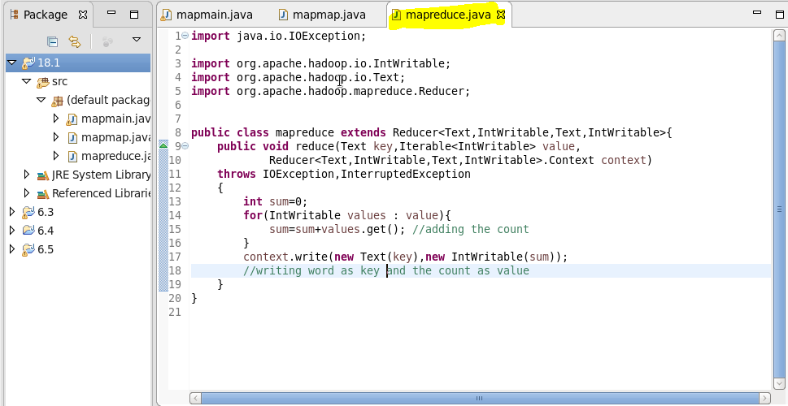

Reducer will increase the count by 1 when the word repeats.

**Running jars and output:**

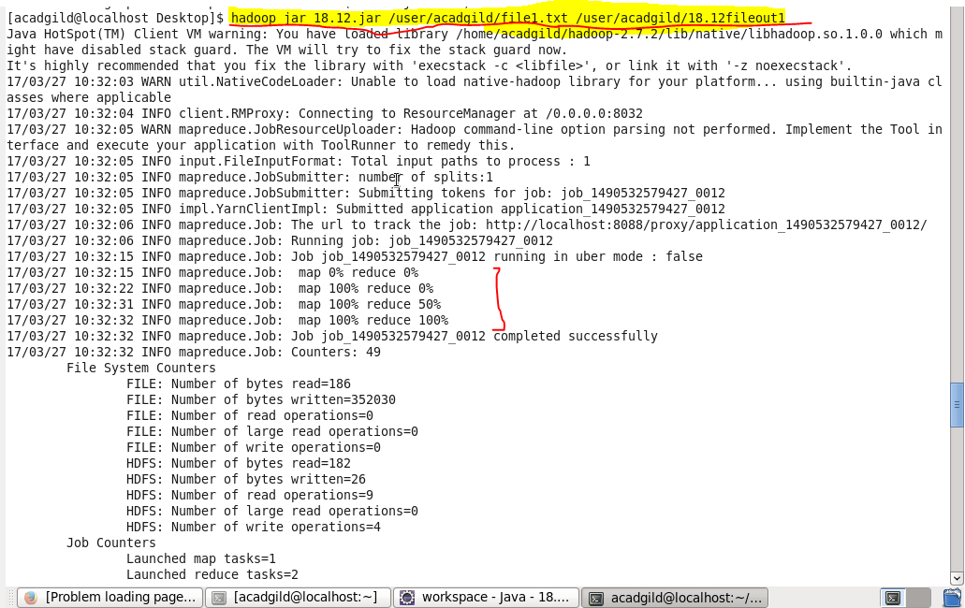

After running our jar file output directory will be created in HDFS named 18.12fileout1

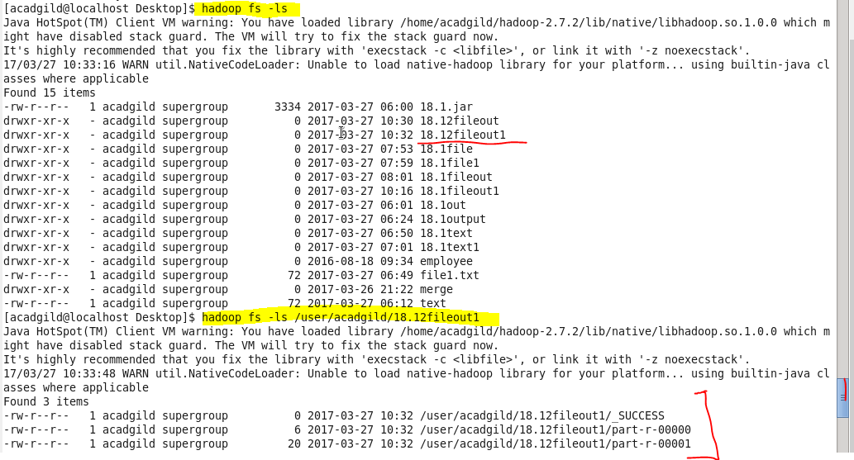

2 files will be created in out output directory and then we can check our output in both the files using

–text command as :

**OUTPUT :**

