**Assignment 18.2**

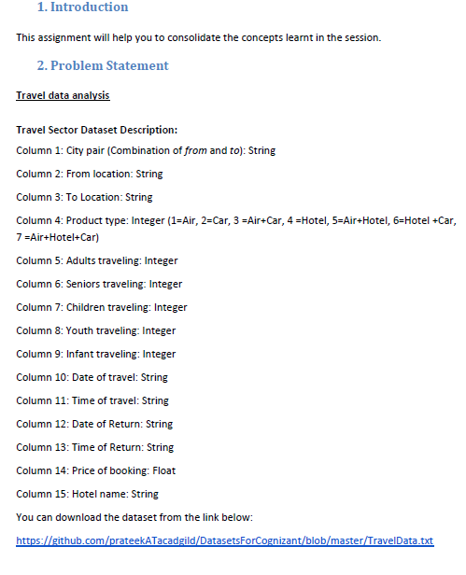

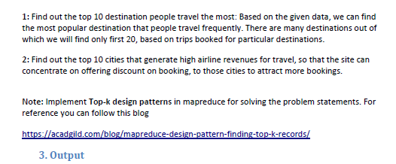

**Driver class:**

**In driver we will set 2 jobs for top 10 destinations and for next problem that is top 10 cities so that we will use single driver for both the problems**

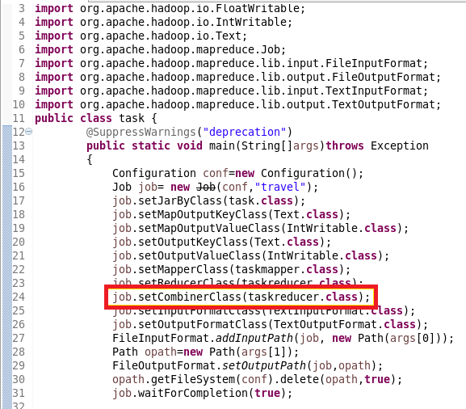

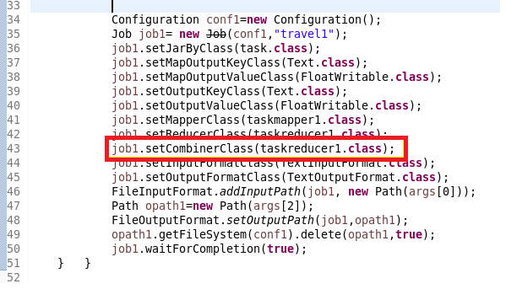

**Mapper class 1:**

**In mapper since top 10 Destination depend on no of people travelling a count of people were made from adult to infants and destination is send as key and count as value**

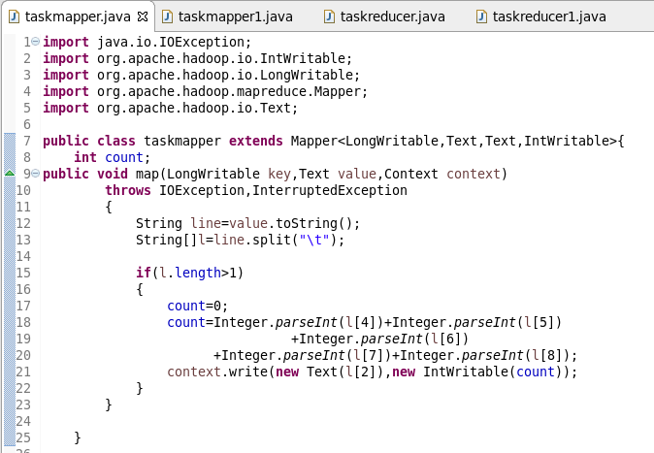

**Mapper class 2:**

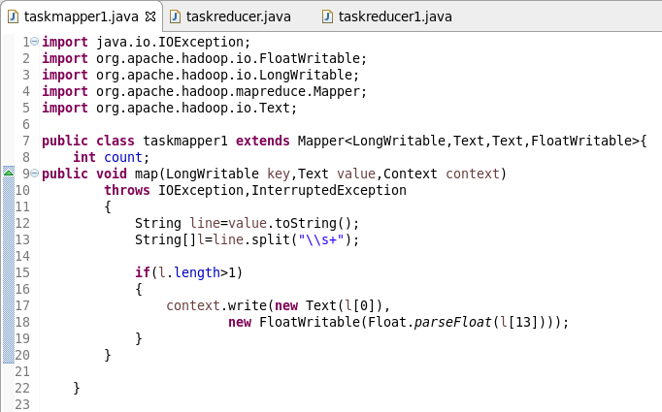

**Reducer class:**

**Step1:** overriding reduce method

In reducer total count is found and in order to order by descreasing count is send as key to Tree map which will be sorted in descending order by collection.reverse order

**Step2: overriding cleanup method**

In clean up method since we want top 10 we we will copy top 10 values into a new Tree map and the value will be written

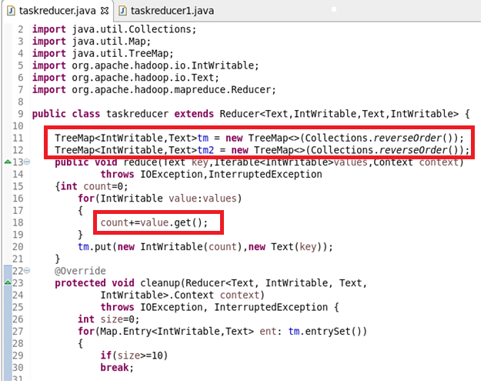

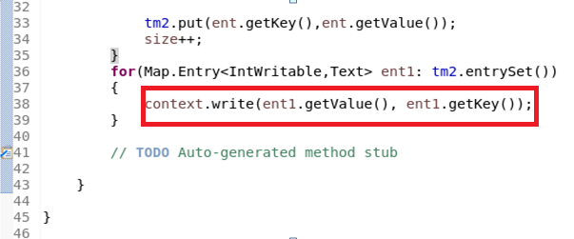

**Running jar:**

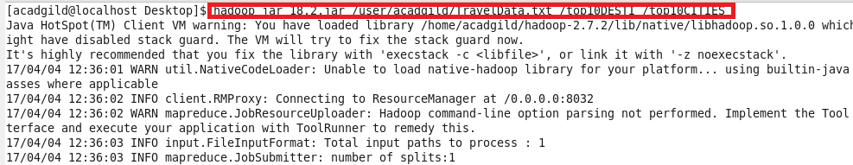

**Output 1**

So the top 10 destination people travel the most

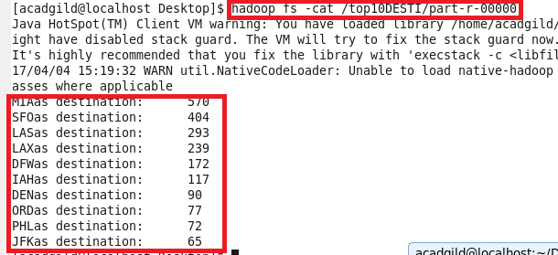

**Output 2:**

So, top 10 cities that generate high airline revenues for travel –

