**Assignment-26.3**

**Problem Statement-**

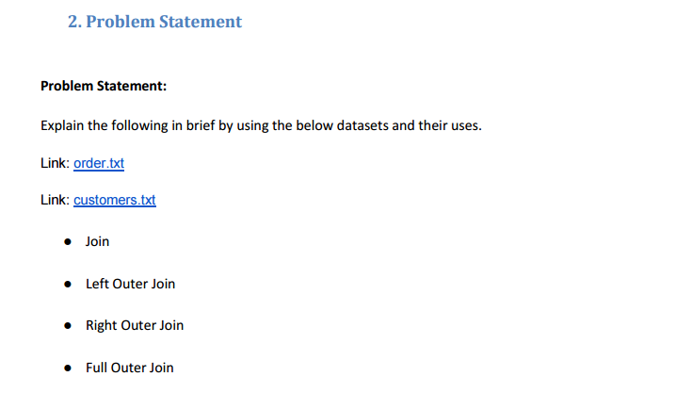

**Input File-**

**Orders-**

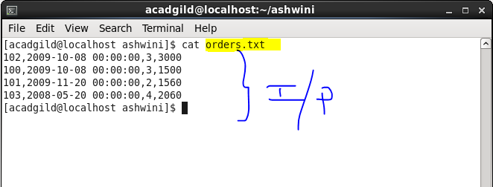

**Customers-**

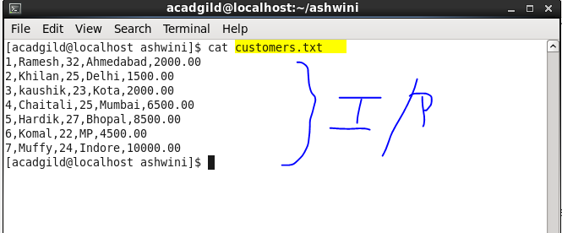

**Solution-**

1. **Join-**

Join clause is used to combine two tables in order to share data between both tables on the basis of some common column. It is similar to SQL joins. A join condition is to be raised using the primary keys and foreign keys of the tables. It is same as outer join of SQL.

**Example-**

* Created two tables named customers and orders and loaded data into them.
* Select statement to display data and join them on the basis of ID.

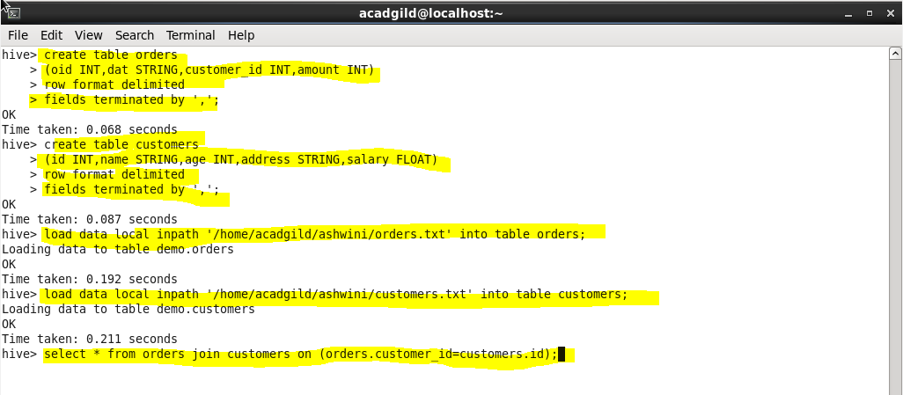

**Output-**

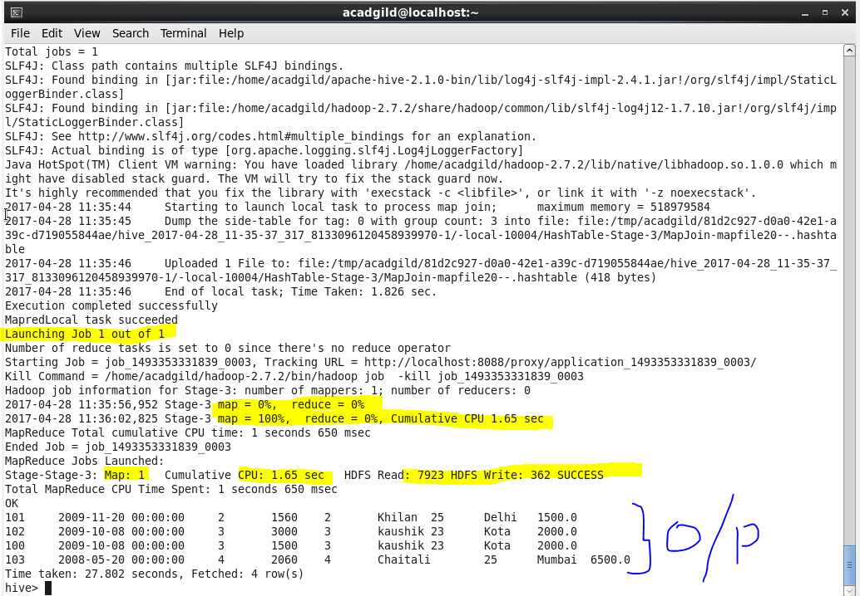

**B.Left Outer Join-**

Left Outer Join returns all the rows from the left table, even if there are no matches in the right table. A left join returns all the values from left table and the matched values from right table.

**Example-**

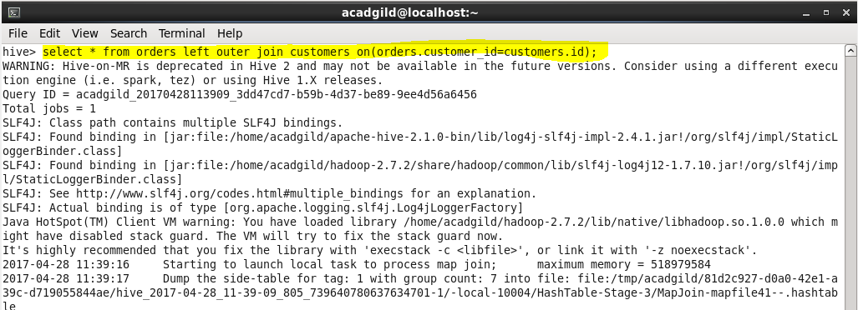

**Output-**

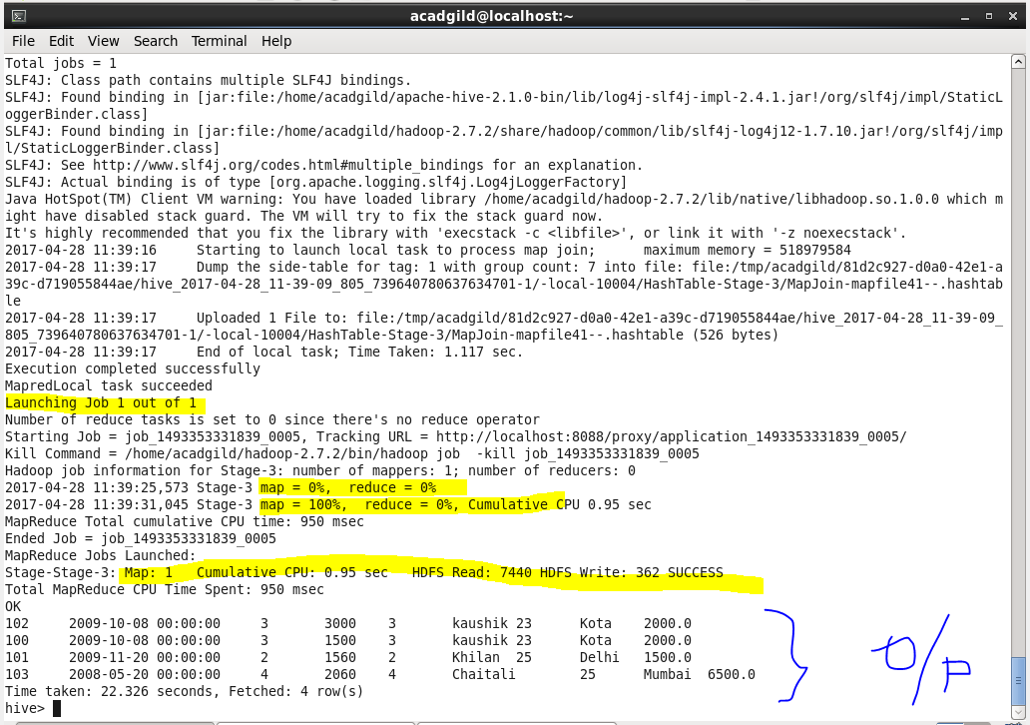

1. **Right Outer Join-**

A Right Join returns all the values from right table and the matched values from left table.

**Example-**

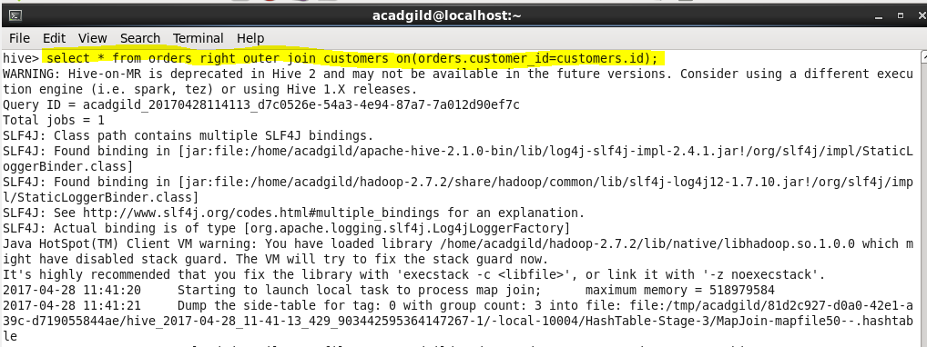

**Output-**

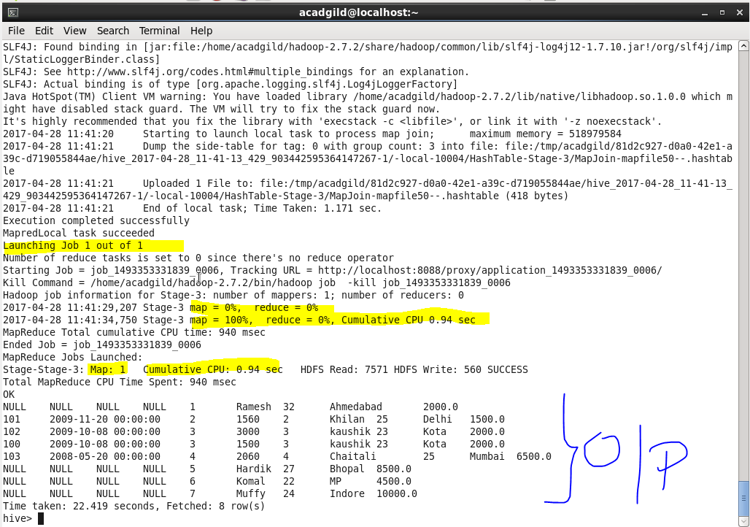

**D.**

**Full Outer Join-**

Full Outer Join combines the records of both the tables, left as well as right.

**Example-**

