**Assignment 33.2**

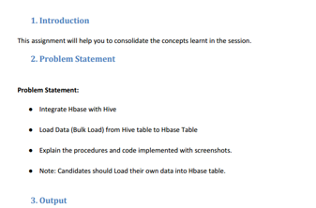

**FROM HBASE TO HIVE:**

**creating table in hbase and inserting records**

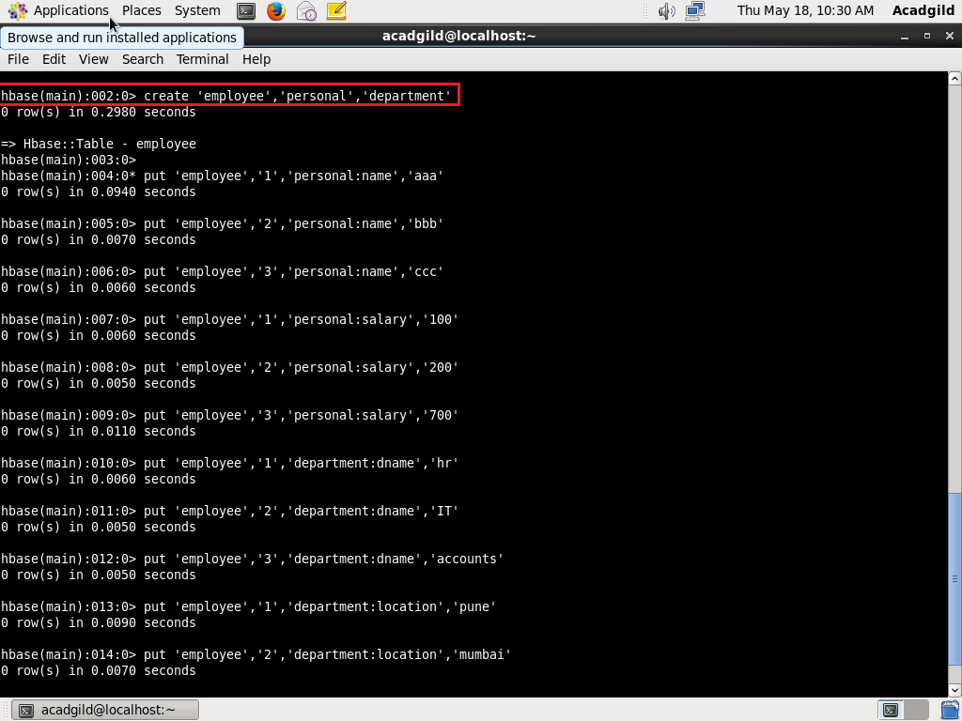

**displaying records in hbase table**

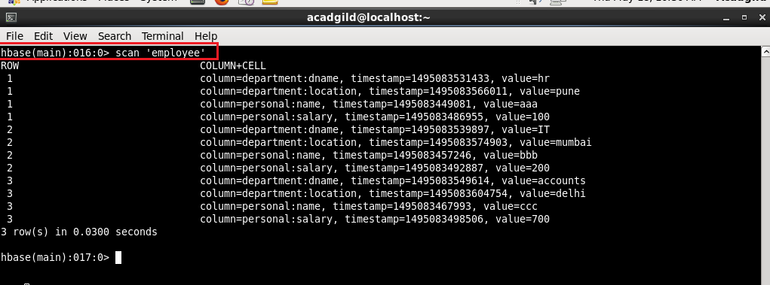

**integrating hbase and hive. Creating an external table in hive which will import data from hbase table**

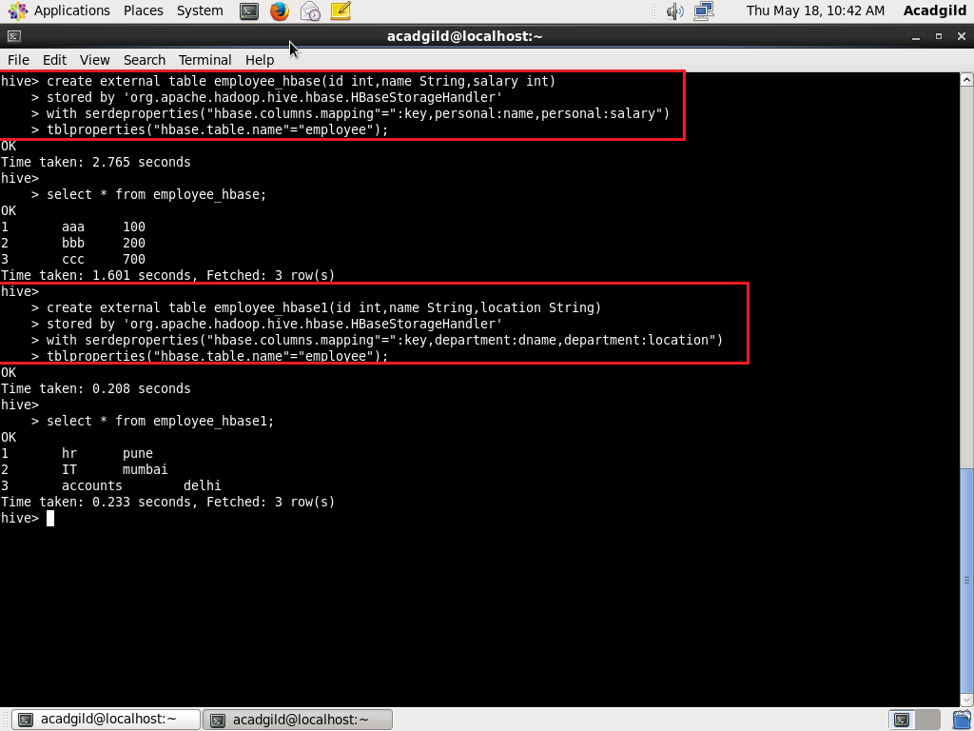

**FROM HIVE TO HBASE:**

**creating table in hbase**

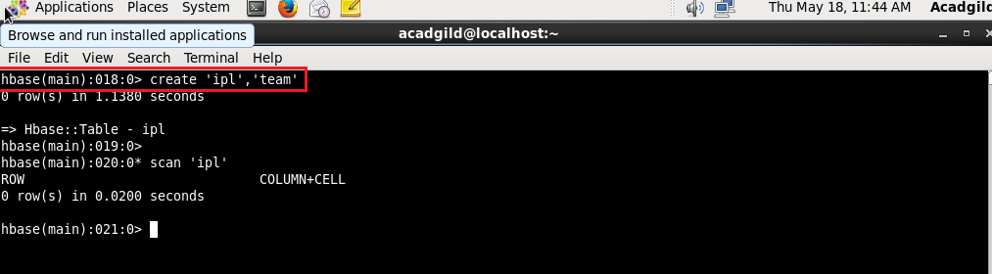

**creating table in hive so that it is integrated with hbase**

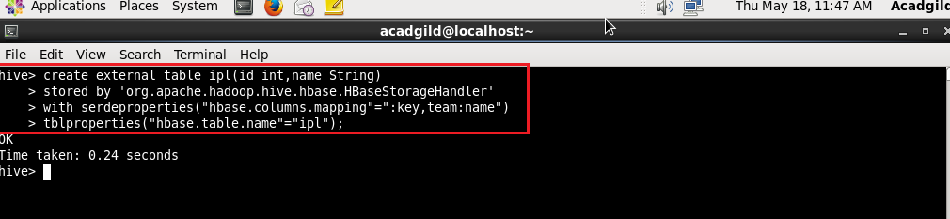

**displaying the contents of table in hive**

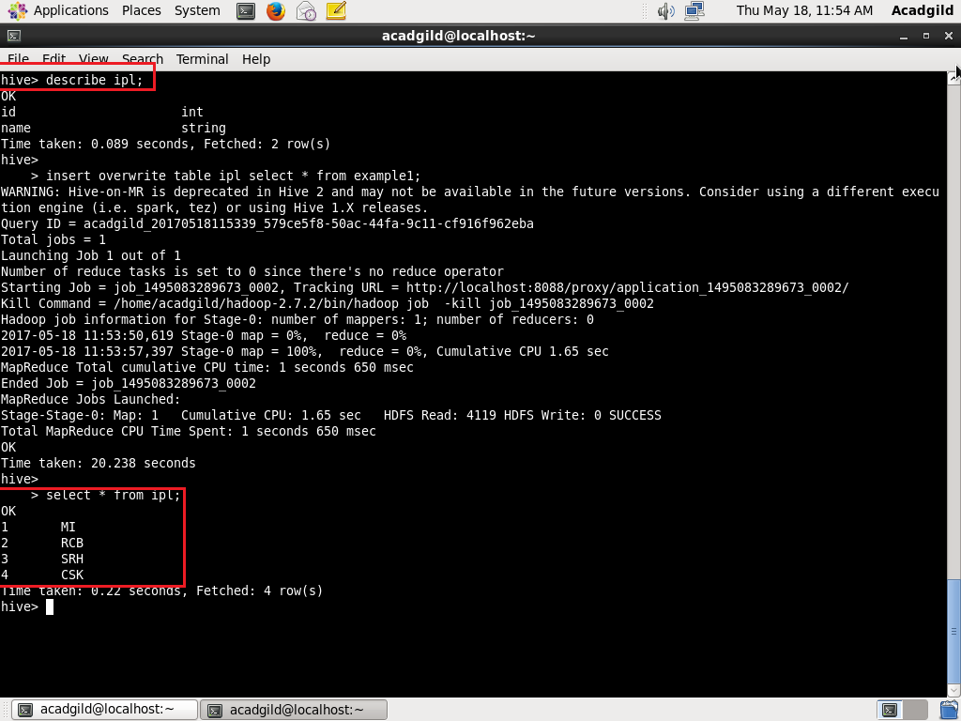

It can be seen, the contents of the table in hive are loaded into the table in hbase

