**Assignment 7.5**

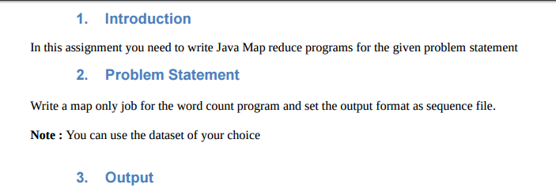

**DRIVER**

As it is a map only job so we will set number of reduce tasks to zero

And we set output file format as Sequence Output File format.

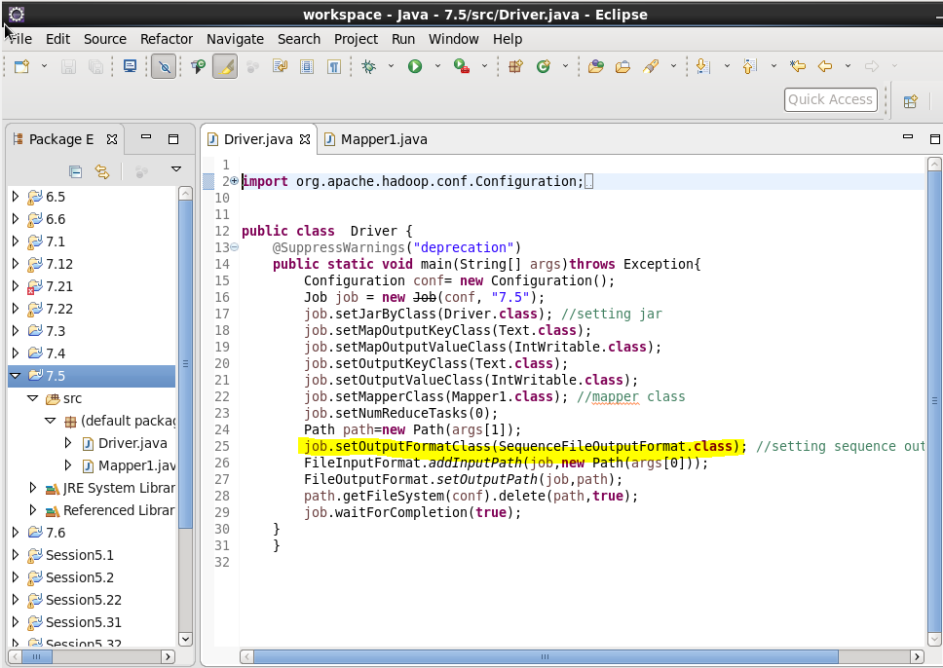

**MAPPER CLASS**

In mapper class we used a hashmap and updated it in such a way that if the word repeats we will increase the count by 1 and put it in hash map or else give a value of 1

Here we will override the cleanup method and write the final key and value instead of writing in mapper as mapper will be invoked for each line.

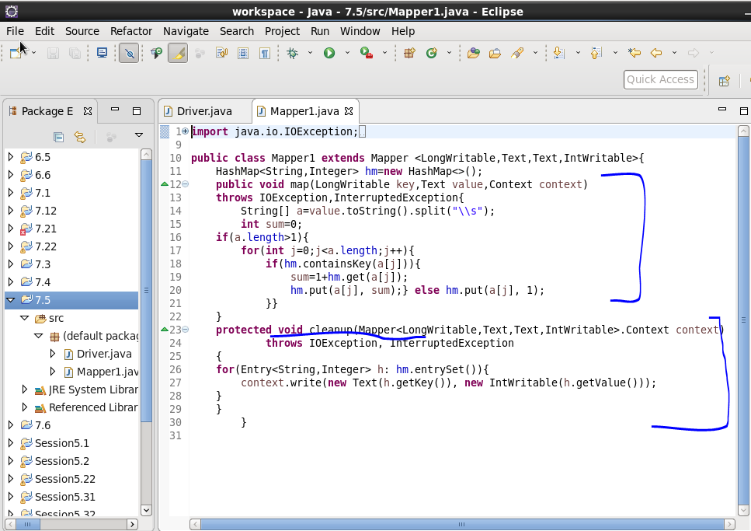

**Input File :**

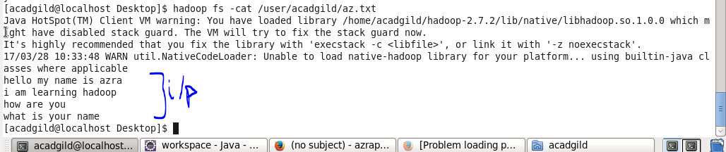

**RUNNING JAR**

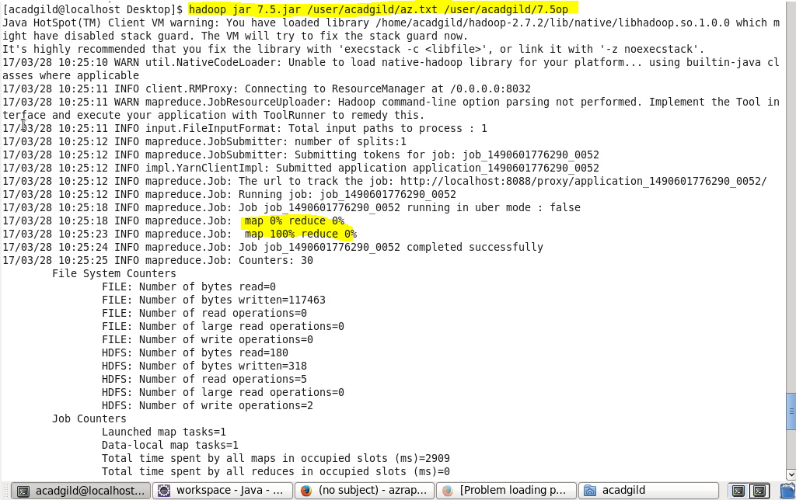

**OUTPUT**

**Will use –text command for running a sequence output file.**

