**1. Write a mapreduce program to find the total amount of petrol in volume sold by every distributor.**

**Driver**

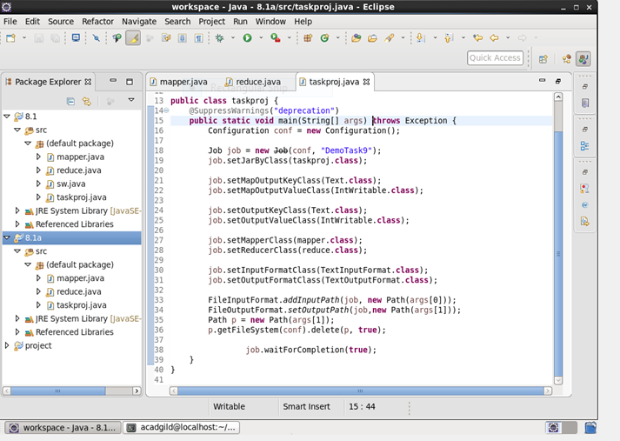

**Mapper**

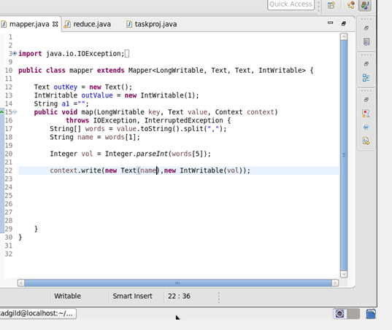

**Reducer**

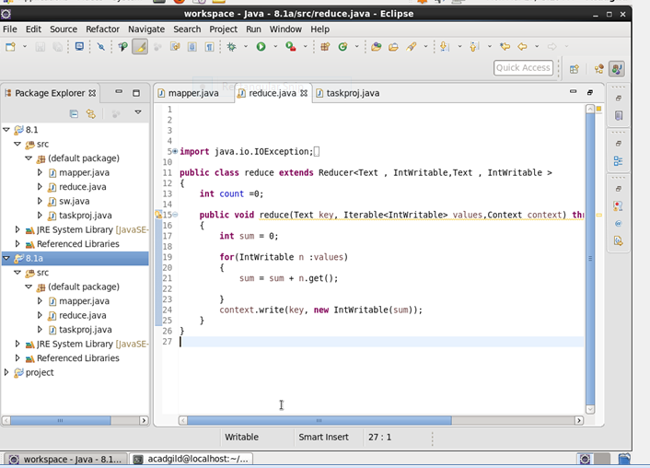

**Output**

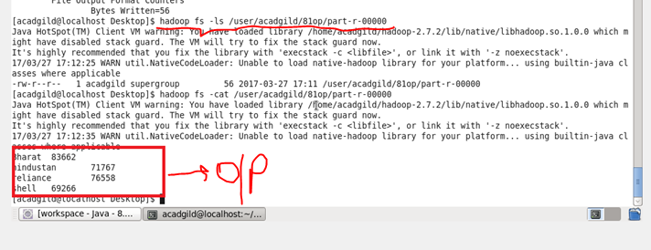

**2. Write a mapreduce program to find which are the top 10 distributors ID's for selling petrol and also display the amount of petrol sold in volume.**

**Driver**

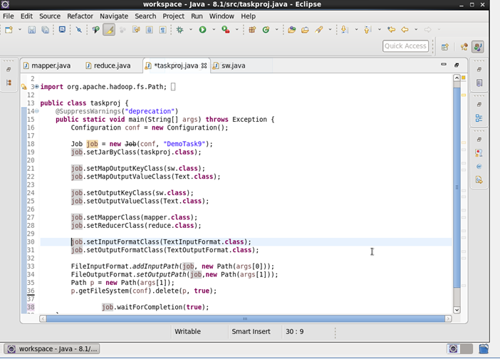

**Mapper**

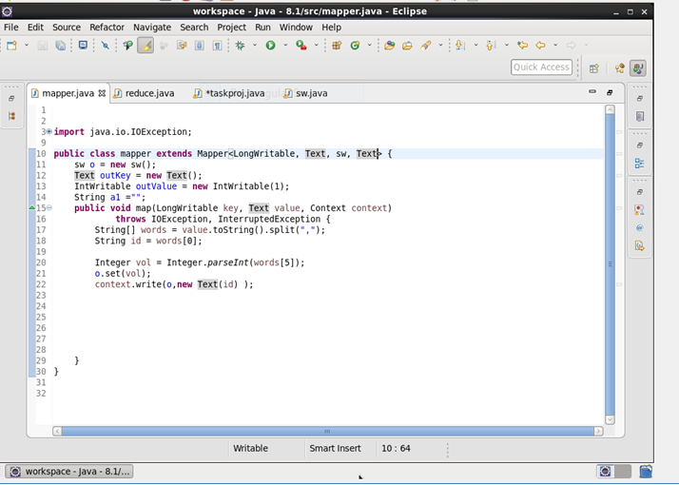

**Reducer**

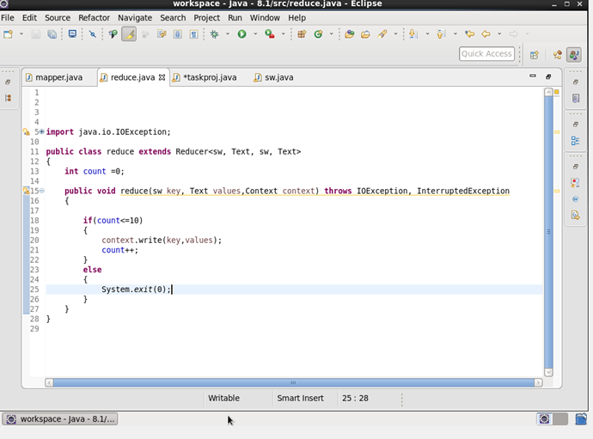

**Custom writable**

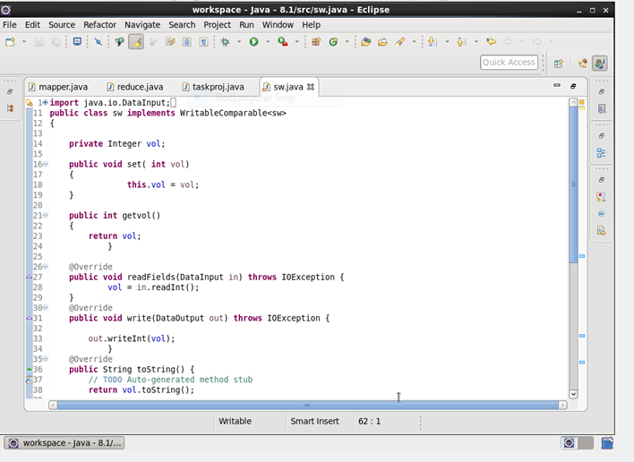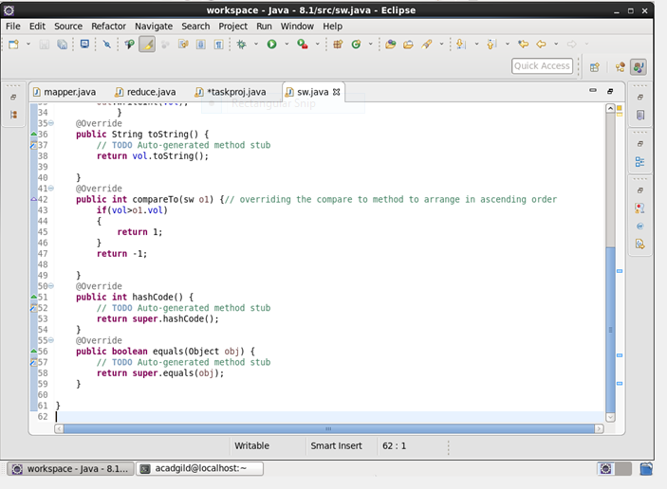

**Output**

