**Assignment 8.6**

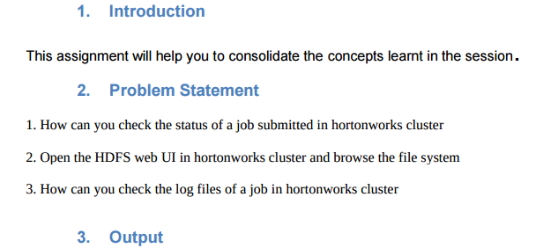

**1. How can you check the status of a job submitted in hortonworks cluster**

1. In MapReduce-v2 on YARN in HDP 2.0, the JobTracker no longer exists. The job life cycle management functionality is now the responsibility of the short-lived Application Masters.

2. Each MapReduce-v2 job will spin up an Application Master, and after the MapReduce2 job is complete, the Application Master will be terminated.

3. For this reason, a new MapReduce JobHistory server was added for MapReduce-v2, which maintains information about MapReduce jobs after their Application Master terminates.

4. The Resource Manager Web UI manages the forwarding of requests to the JobHistory server when the Application Master completes.

5. With HDP 2.0, Ambari provides a screen to manage and monitor the JobHistory Server.

6. The JobHistory UI is accessible as a link from this screen. The JobHistory UI lists all executed MapReduce2 jobs.

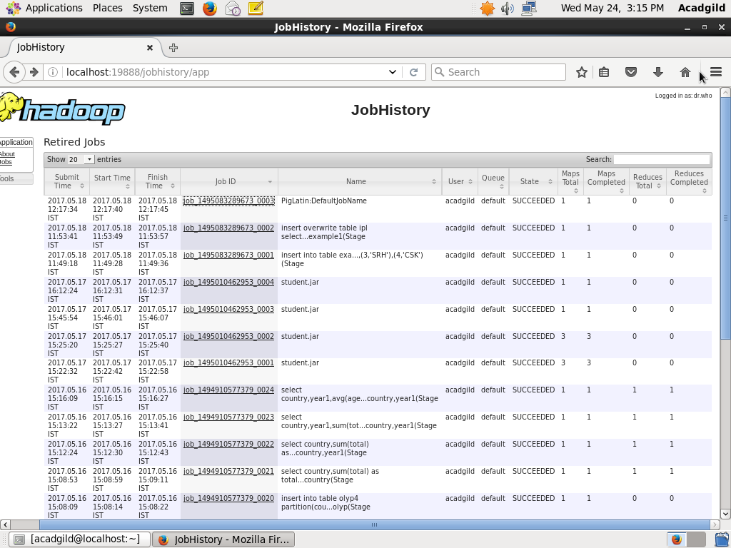

7. You can drill down into each job to get the detailed metrics about the job runtime.

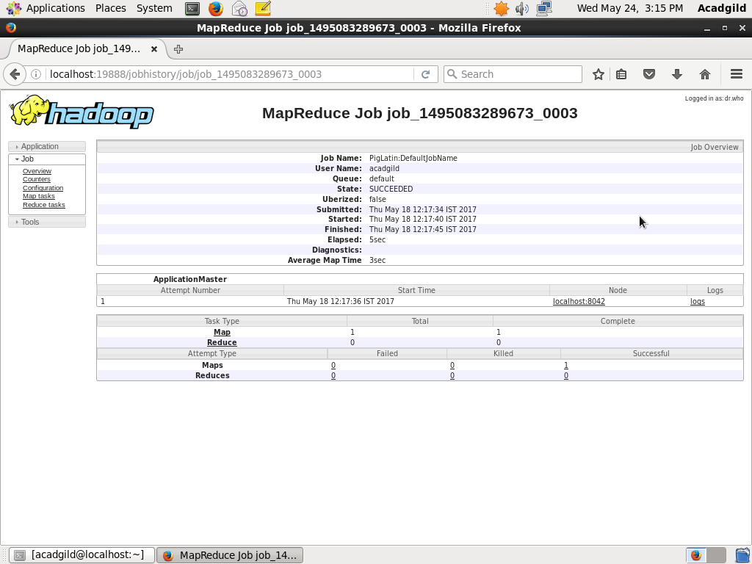

8. All the underlying data per job is persisted to HDFS. This means that historical operational metrics for each job is maintained and is accessible for the lifetime of the HDP cluster.

9. In HDP 2.0, the MapReduce job history files are stored in the “/mr-history/done” directory on HDFS. The directories are organized by date the job executed on:

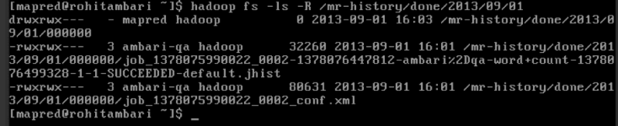

**Q2-Open the HDFS web UI in hortonworks cluster and browse the file system.**

**Solution:**

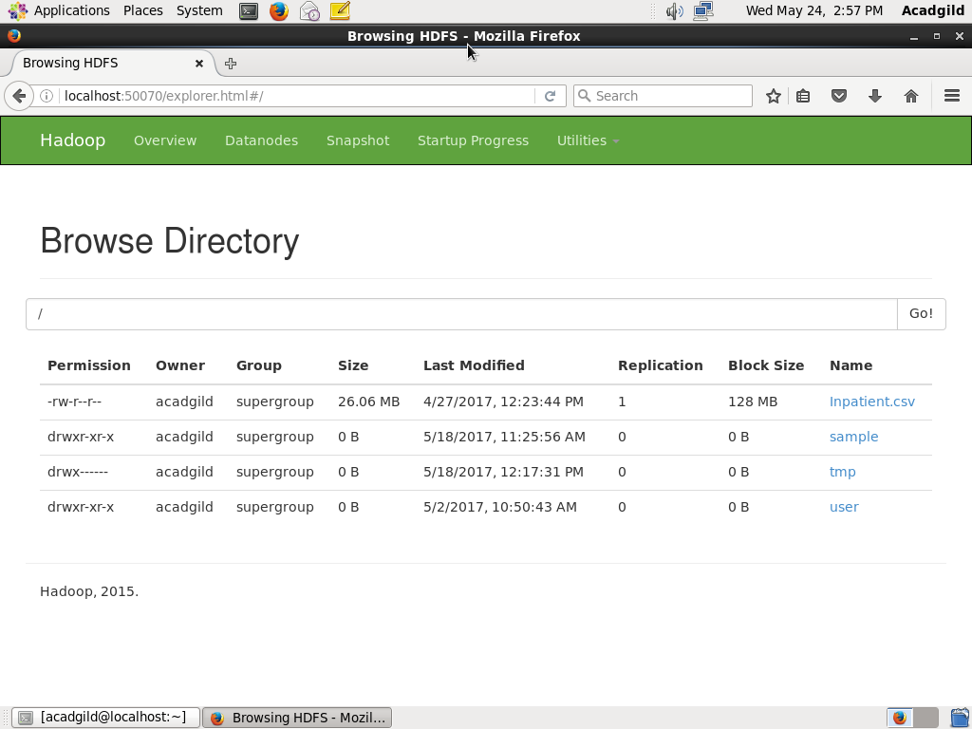

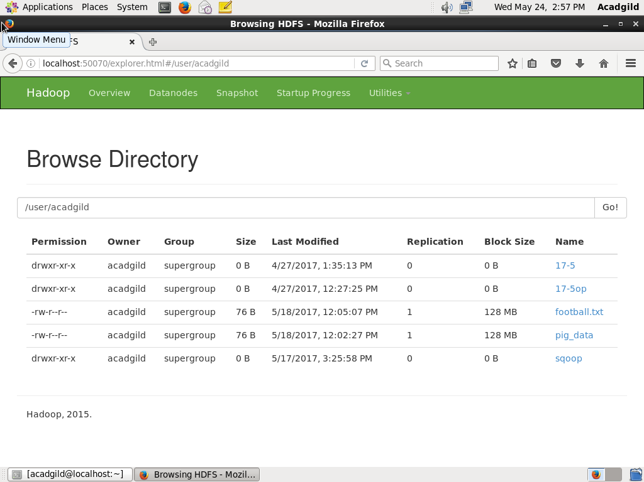

**Q3-How can you check the log files of a job in hortonworks cluster.**

**Solution:**

