Create database:-

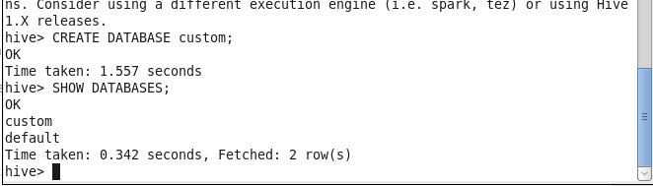

Using database;-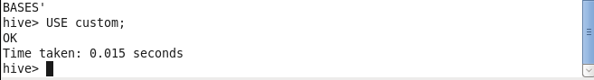

Creating table:

describe tables:-

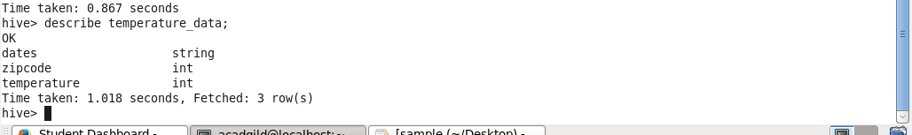

Loading data into tables;

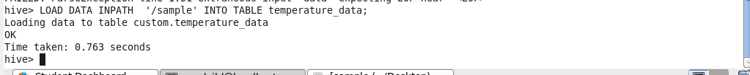

Output:-

