**Assignment 26.3**

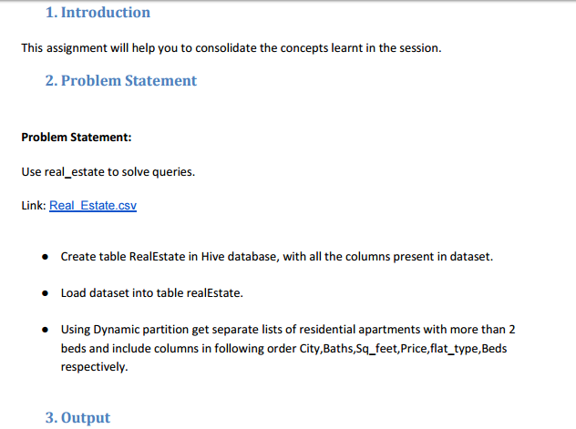

* **Create table RealEstate in Hive database, with all the columns present in dataset.**

**Using create command we will create table realestate -**

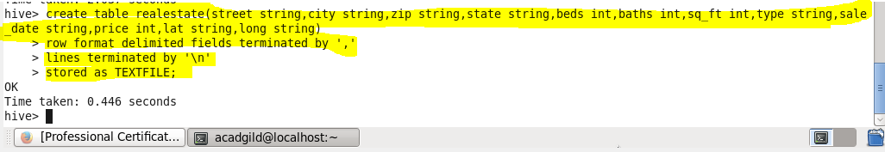

**Using Describe table command we can check the columns and their datatypes-**

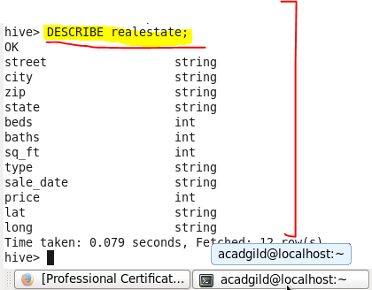

* Load dataset into table realEstate.

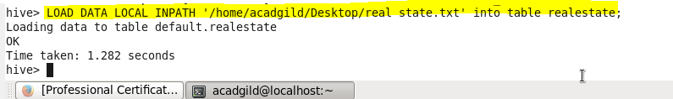

* Using Dynamic partition get separate lists of residential apartments with more than 2 beds and include columns in following order City,Baths,Sq_feet,Price,flat_type,Beds respectively.
* **Creating Partitioned Table**

**Here a partitioned table Separate is created where partition is made based on type,Beds as Shown**



**Using Dynamic partition get separate lists of residential apartments with more than 2 beds and include columns in following order City,Baths,Sq_feet,Price,flat_type,Beds respectively**

**In dynamic Partitioning we want to enter the bedrooms greater than 2,so we load data into the partitioned table by using select statement from realEstate Table where Beds>2 and type as residential**

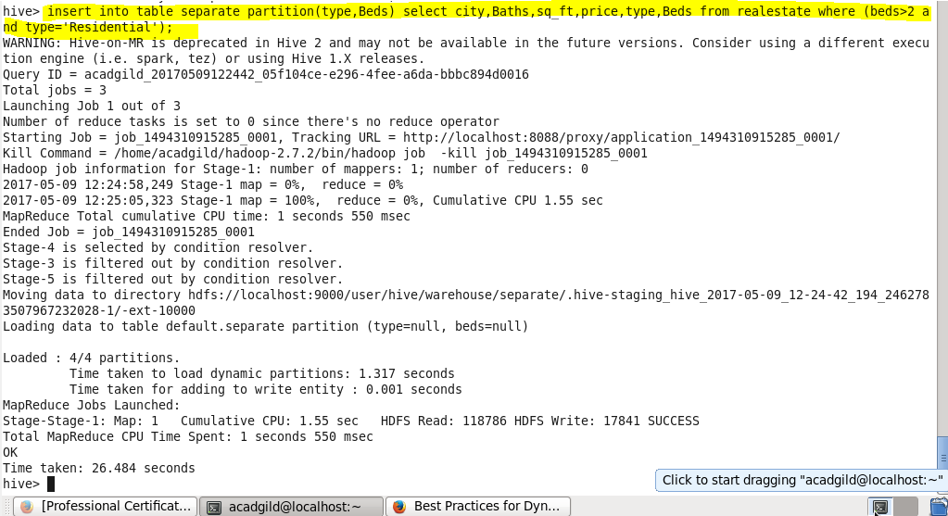

**Output:**

**In hive warehouse separate directories will be created for each beds count greater than 2 dynamically by hive**

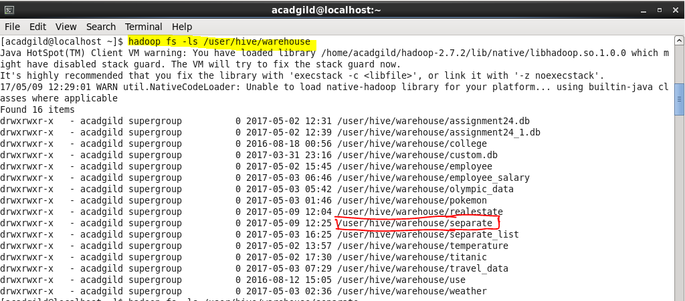

**Going inside we can check for our partition directory for type =Residential as we have partitioned by type**

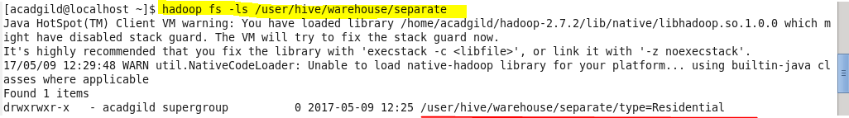

**Going inside we can check all separate list for beds >2 and type =Residential as we have partitioned by type and beds >2**

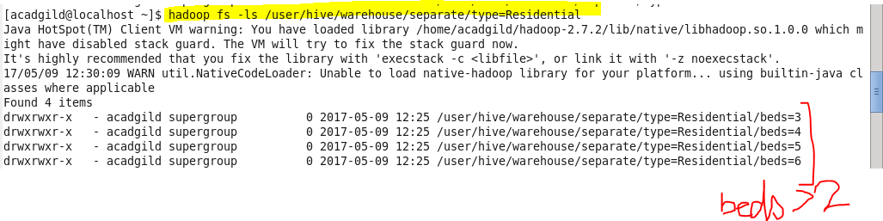

**So our separate list for bed =3 will be under this directory as showing**

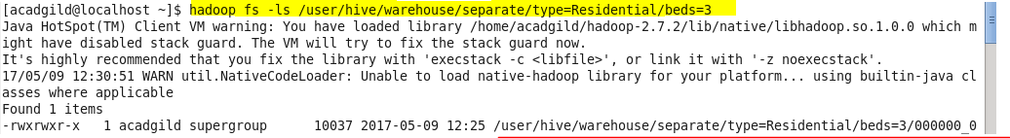

**Now we can check for the result using cat command in HDFS.**

1. **Sample Output for bed =3**

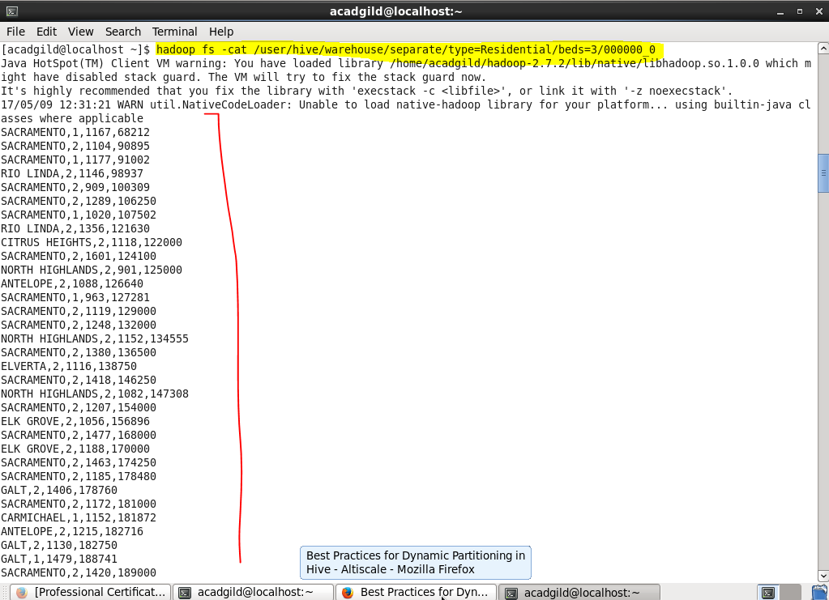

**Complete output data is attached in separate list - bed=3 file**

1. **Sample Output for bed =4**

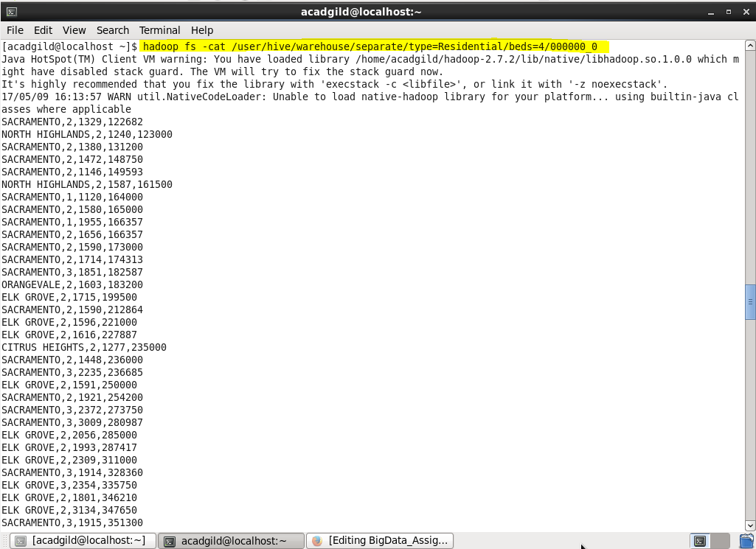

**Complete output data is attached in separate list - bed=4 file**

1. **Sample Output for bed = 5**



**Complete output data is attached in separate list - bed=5 file**

1. **Sample Output for bed = 6**

