**Assignment 26.4**

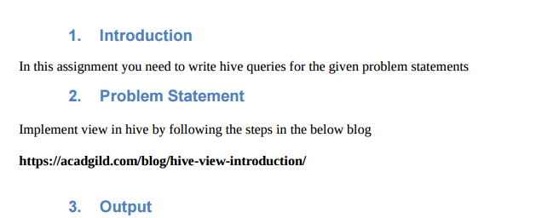

* **View in Hive**

1. **A view may be used to hide the complexity by dividing the query into smaller, more manageable pieces**
2. Hive view is similar to view in other RDBMS. Suppose we have a very long query that consists of multiple join , It will be large and time consuming to read and it will also result in a complex execution and will be difficult to understand the query flow and execution
3. View can also be used if we want hide some information to common user
4. Since it is a virtual table whenever a view is created only the query gets saved and whenever the view is used again in any other query it just reruns the query and no memory is allocated
5. **First for Hive View, we will create a table inside Hive and load the respective data.**
6. **Commands for doing so are:**

**Creating and loading data in table cart :**

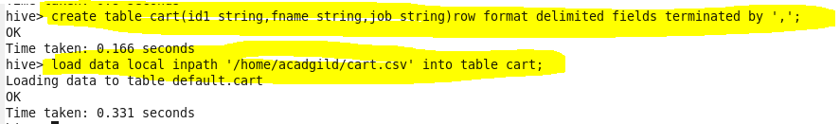

**Creating and loading data in table people:**

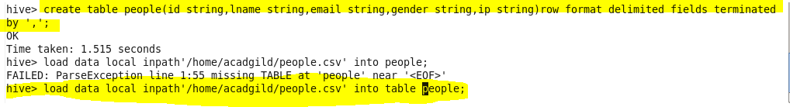

**Let us consider the below join statement**

**FROM (SELECT * FROM people JOIN cart**

**ON (cart.id1=people.id) WHERE last_name=’Henderson’) a**

**SELECT a.first_name WHERE a.id=’40-8340379′;**

1. The above query is a nested query where we are joining people and cart and giving a alias name as “a”.Then we are selecting firstname where id is 40-8340379

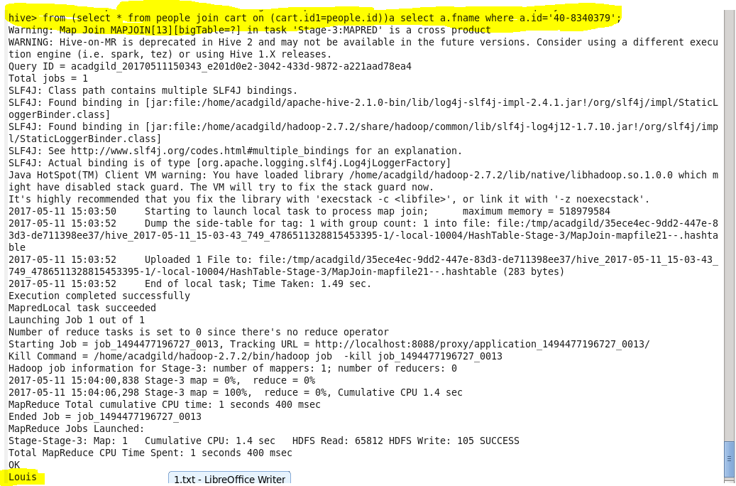

**Instead of using this complicated query we are creating view where we are joining this table as shown**

**Creating view**

C:\Users\612971\AppData\Local\Microsoft\Windows\Temporary Internet Files\Content.Word\26 4 join.png

**Now we are accessing data from this view and selecting the first_name where id=40-8340379**

**Output**

