ASSIGNMENT 4.3

Q).1. Write a Java program to display the content of a file in HDFS on screen.

Output : 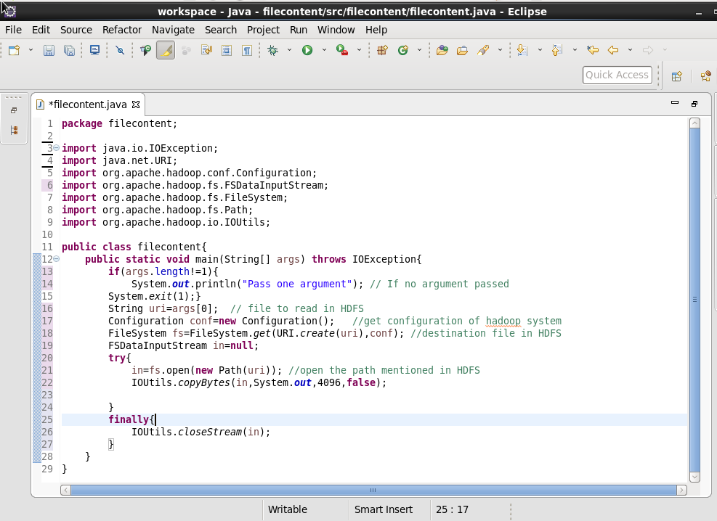

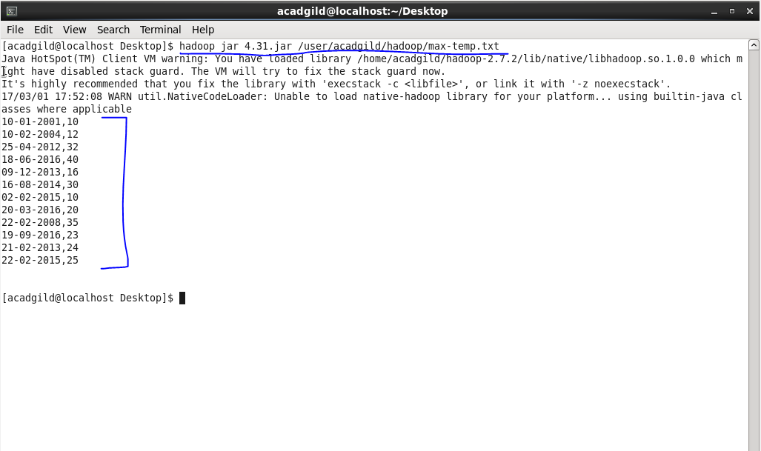

Q) 4.3.2. Write a Java program to copy a file from local file system to HDFS.

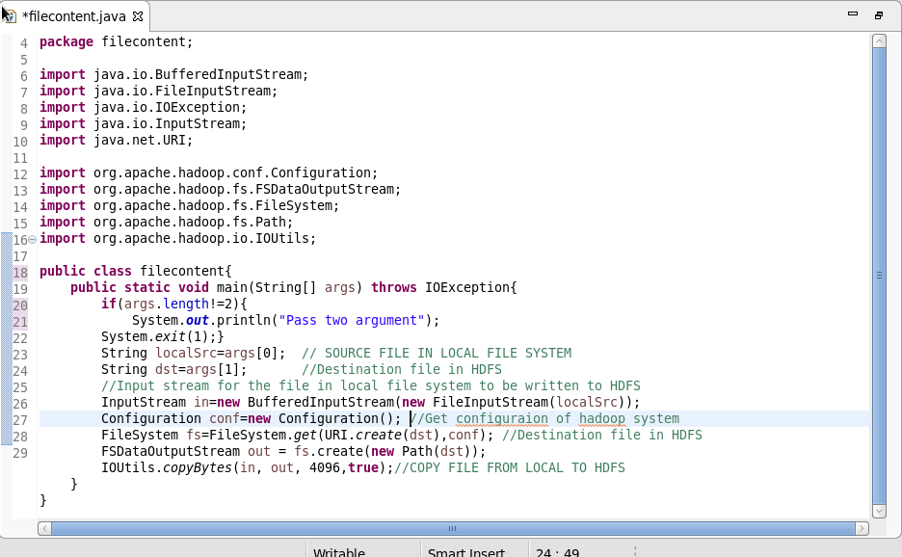

Output:

