Q 1) Write a Java program to copy a file from HDFS to LFS.

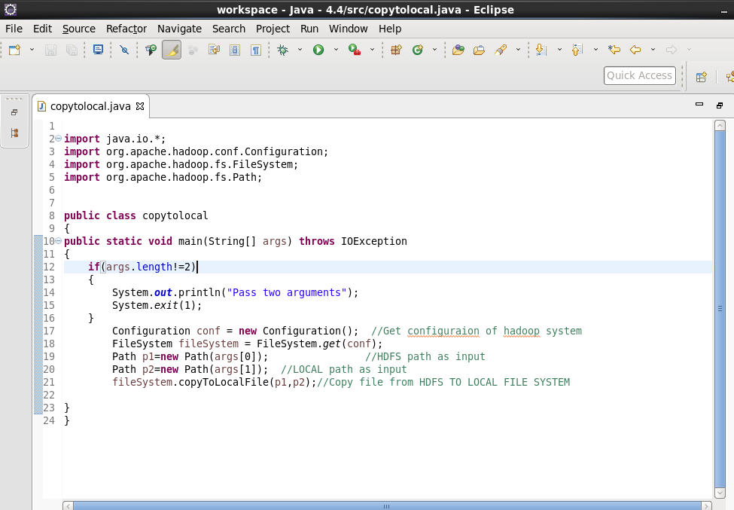

Output:

