DRIVER

In Driver class,set Partitioner class and set number of reducers as shown and customize partitioner class

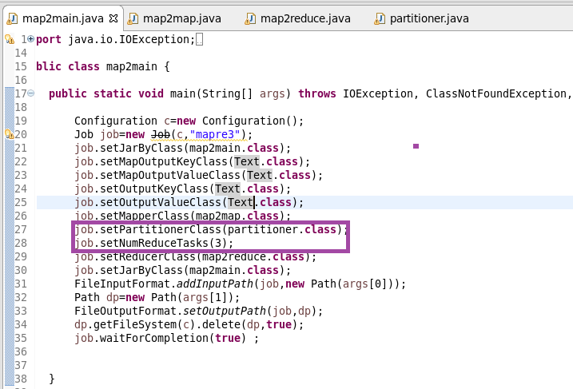

MAPPER

I AM SENDING THE NAME FROM TITANIC DATASET AND SENDING IT AS KEY

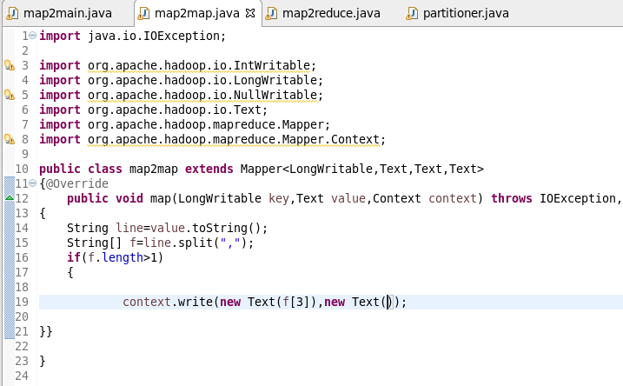

REDUCER

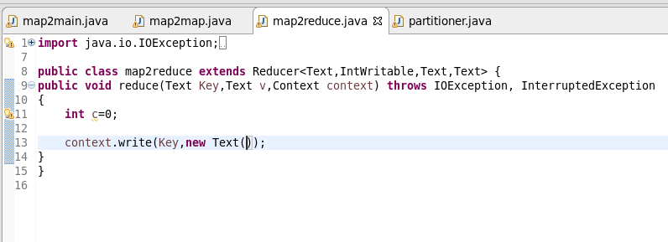

PARTITIONER

CUSTOMIZE PARTITIONER BASED ON KEY’S LENGTH AS PER THE QN

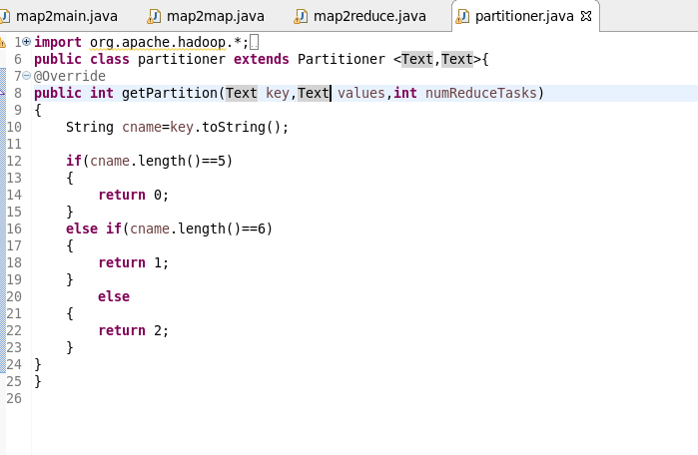

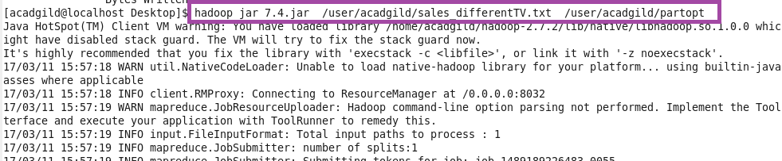

OTPT

OTPT STORED IN 3 REDUCERS

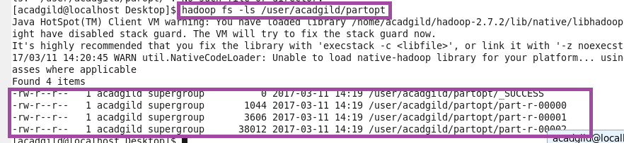

REDUCER OTPT

You can see that since

I