**QN1 .Sales of different TV Task 6 : Modify Sales of different TV Task 3 (refer session 5, assignment 2) to take advantage of Combiner.(** **Sales of different TV Task 3: Write a MapReduce program to calculate the total units sold in each state for Onida company**.**)**

DRIVER

USED COMBINER CLASS AND PROVIDE REDUCER CLASS FOR COMBINER AS LOGIC FOR REDUCER AND COMBINER IS SAME

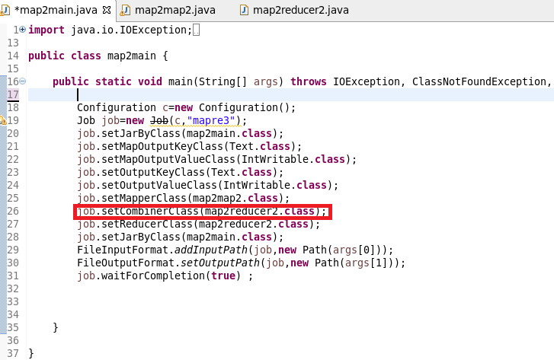

**MAPPER**

MAPPER : I will remove NA containing records and filter only those having “ONIDA”then send the company name as key and for each key I will sent 1 as value.So that a count could be made in reducer

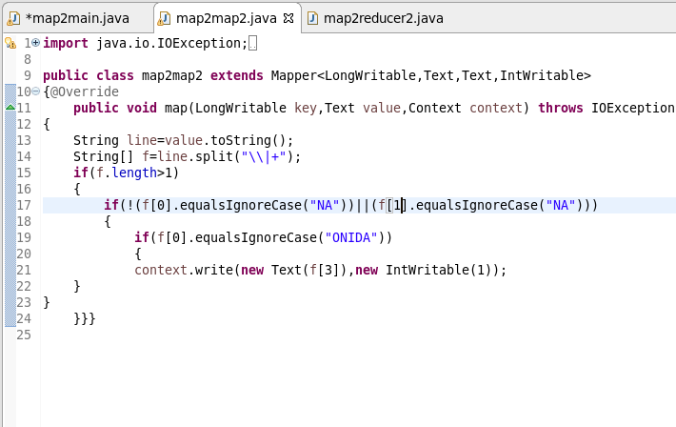

**REDUCER**

REDUCER:COUNT the no of units for ONIDA company by iterating

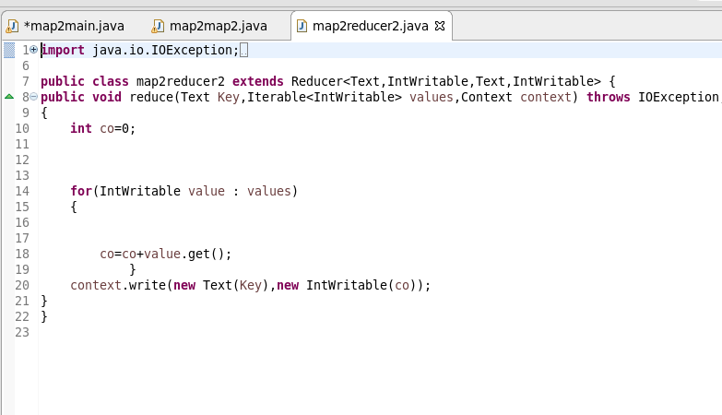

**RUNNING JAR**



**Otpt**

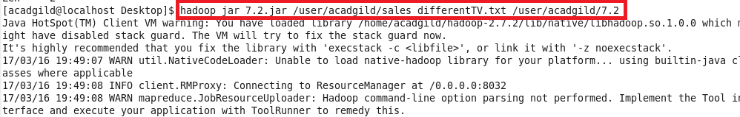

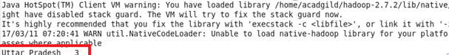

**QN2.** **Write a Mapreduce program to view the total sales for each product for every Company corresponding to each size. Make sure that all records for a single company goes to a single reducer and inside every reducer, keys must be sorted in descending order of the size. You may write a custom WritableComparable for this purpose.**

**Driver**

**IN DRIVER I SET PARTITOIONER CLASS AS IN QN THEY HAVE GIVEN “that all records for a single company goes to a single reducer” AND THEN CUSTOMISED PARTITIONER(SEE PARTITIONER CLASS)**

**THEN USED COMPOSITEKEY AS A MAPPER OUTPUT AND THEN USED A WRITABLE COMPARABLE**

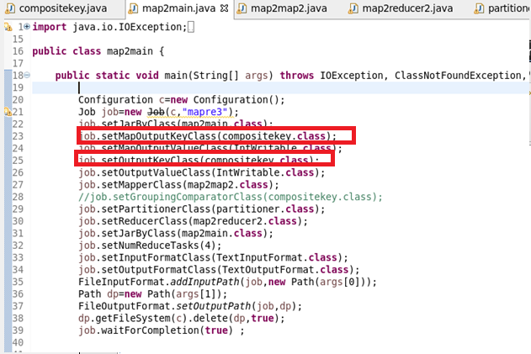

**MAPPER**

**IN MAPPER SPLIT THE DATA BY “|” AND THEN SENDING SIZE AND COMPANY NAME AS COMPOSITE KEY AND a count of 1**

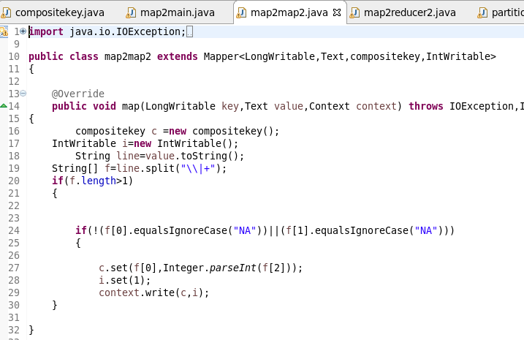

**REDUCER**

**Make a count by iterating the values for each composite key**

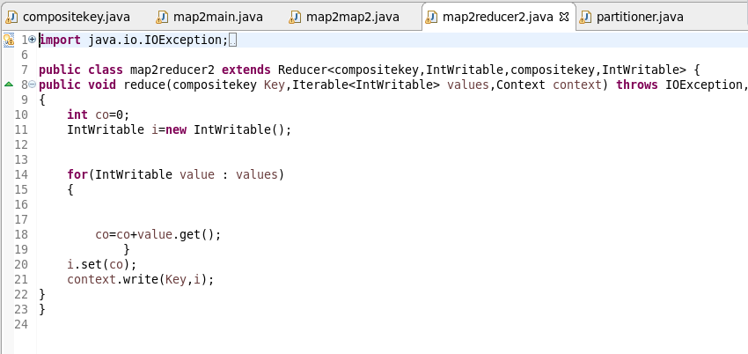

**PATITIONER**

**In parttitioner depending on company name ‘ hashcode divide company hachcode %numreduce task so that samy company records go to the same reducer**

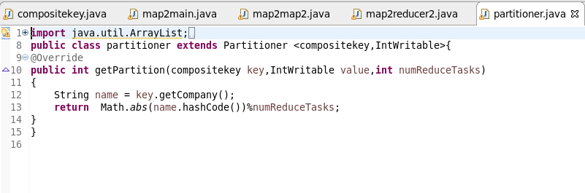

COMPOSITE KEY

STEP 1: OVERRIDING HASHCODE RETURNING HASHCODE OF COMPANY

STEP2 : OVERRIDING EQUALS METHOD:CHECKS THE COMPANY AND SIZE ARE EQUAL FOR EVERY OBJECT IF EQUAL IT WILL SEND TO THE CORRESPONDING HASHCODE LOCATION ELSE COMPARE TO WILL BE DONE

STEP 3 : OVERRIDING COMPARETO METHOD: IF BOTH THE COMPANY ARE EQUAL IF ITS SAME IT WILL RETURN (-1)(SIZE-OBJECT’S SIZE)(**-1 WILL REVERSE THE SORT DESCENDING BASED ON SIZE**) AND IT WILL BE SEND AND FRAMEWORK SORTING WILL BE MADE ON IT OR ELSE IF DIFFERENT IT WILL SEND THE COMPANY AND FRAMEWORK SORTING WILL BE MADE ON IT

STEP 4 : OVERRIDING TOSTRING METHOD TO PRINT THE COMPANY AND SIZE

READFIELDS AND WRITEFIELDS ARE USED FOR SEREALISATION AND DESEREALISATION

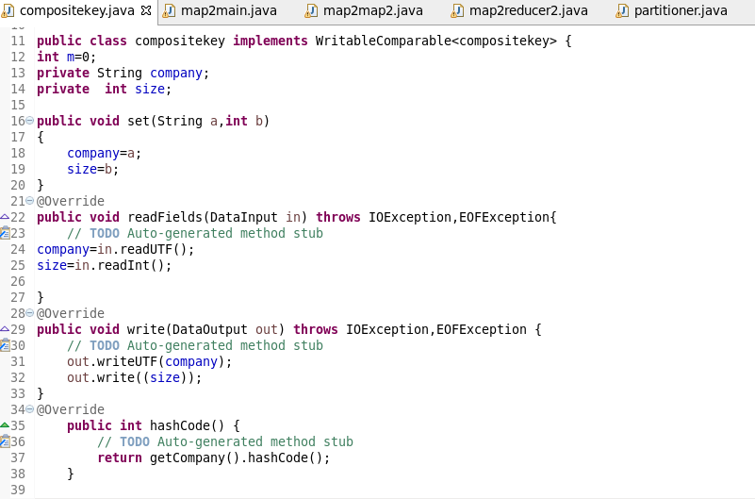

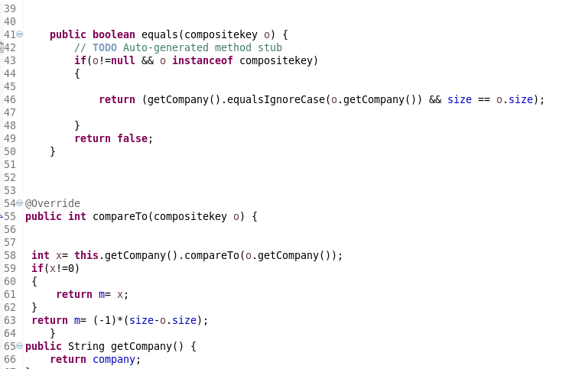

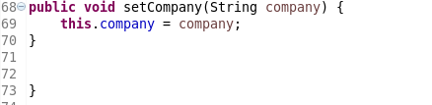

**RUNNING JAR**

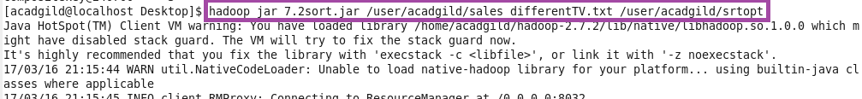

**OPT**

