LOGIC

For sending survived and dead along with gender I am creating a composite key and extending writable comparable

DRIVER

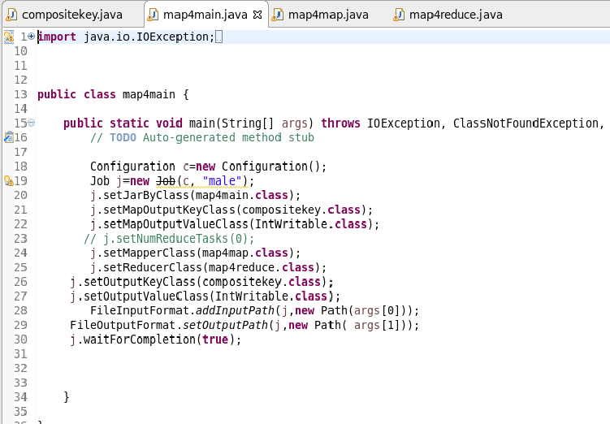

MAPPER CLASS

LOGIC : CHECKING WHETHER DEAD OR ALIVE AND THEN SENDING GENDER AND STATUS AS COMPOSITE KEY AND A COUNT OF 1 AS VALUE

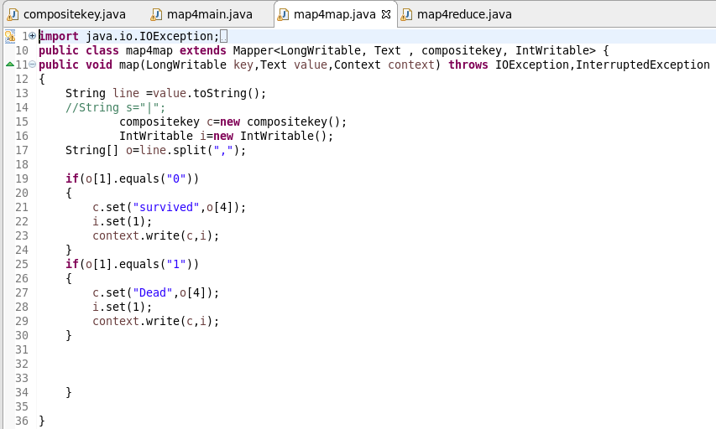

REDUCER CLASS:

COUNTING THE NUMBER OF SURVIVEDMALE AND SURVIVEDFEMALE AND DEADMALE AND DEADFEMALE

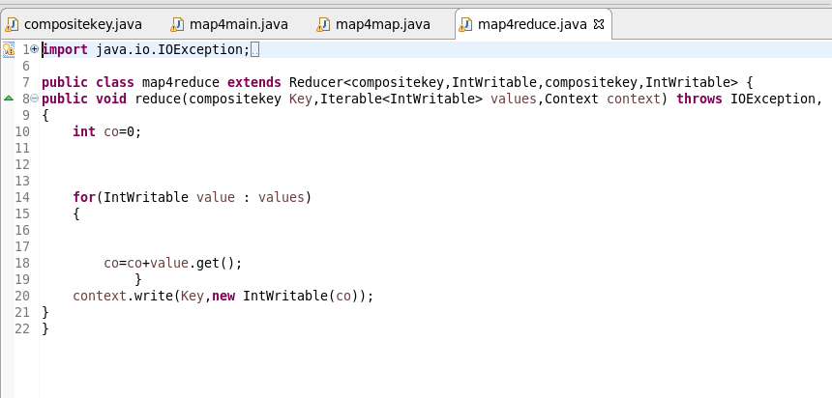

COMPOSITEKEY CLASS

STEP 1: OVERRIDING HASHCODE RETURNING HASHCODE OF STATUS (DEAD OR SURVIVED)

STEP2 : OVERRIDING EQUALS METHOD:CHECKS THE STATUS AND GENDER ARE EQUAL FOR EVERY OBJECT IF EQUAL IT WILL SEND TO THE CORRESPONDING HASHCODE LOCATION ELSE COMPARE TO WILL BE DONE

STEP 3 : OVERRIDING COMPARETO METHOD: IF BOTH THE STATUS ARE EQUAL IF ITS SAME IT WILL COMPARE THE GENDER AND IT WILL BE SEND AND FRAMEWORK SORTING WILL BE MADE ON IT OR ELSE IF DIFFERENT IT WILL SEND THE STATUS AND FRAMEWORK SORTING WILL BE MADE ON IT

READFIELDS AND WRITEFIELDS ARE USED FOR SEREALISATION AND DESEREALISATION

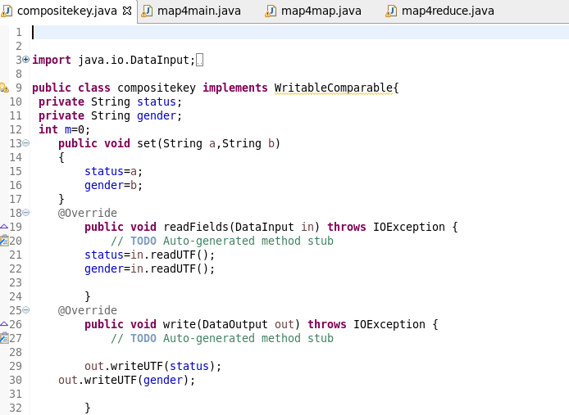

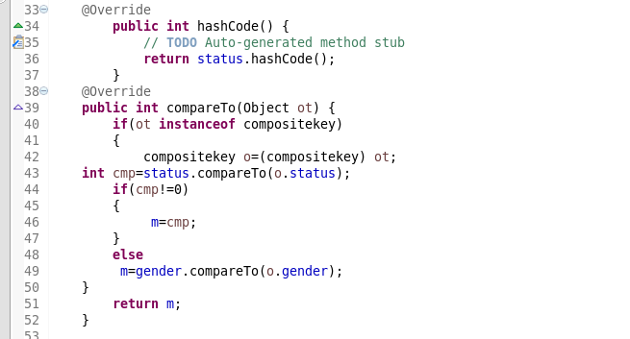

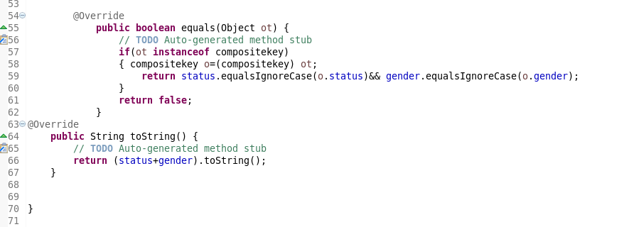

RUNNING JAR



OTPT

