**Assignment 24.5**

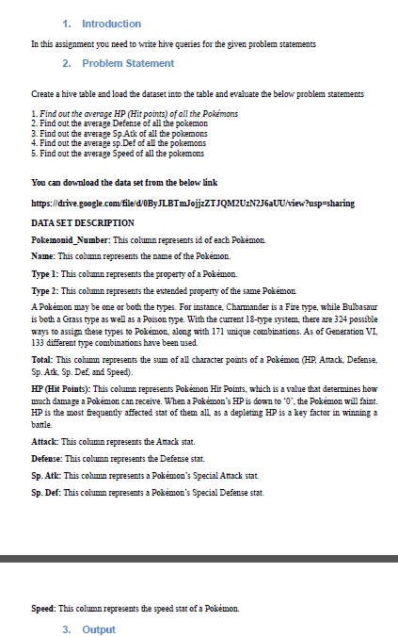

* **First we will create table pokemon using create command .**

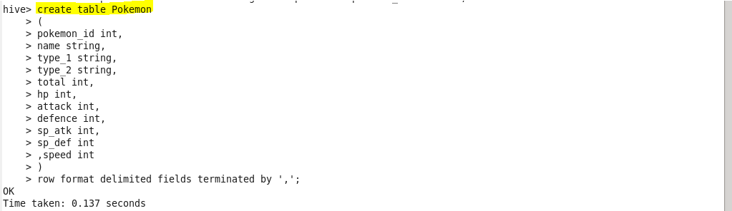

* **Load pokemon.txt dataset to pokemon table**

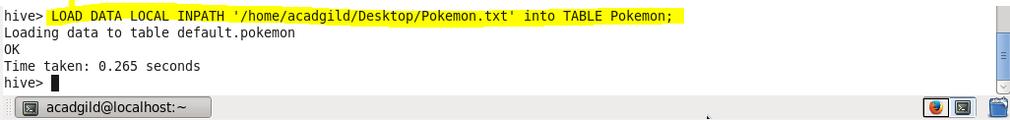

**Q 1) Find out the average HP (Hit points) of all the Pokémons –**

* Using select statement we will display the result
* For finding out the average we will use avg function.

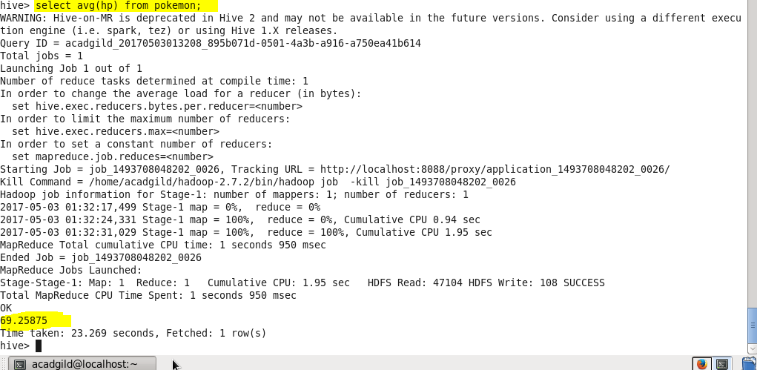

1. **Find out the average Defense of all the pokemon –**

* Using select statement we will display the result
* For finding out the average we will use avg function.

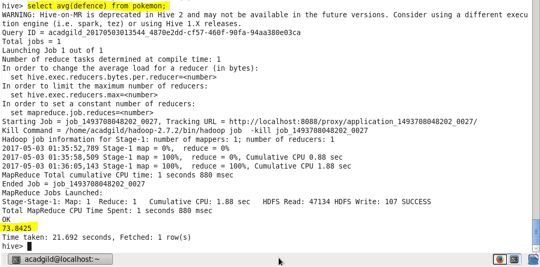

1. **Find out the average Sp.Atk of all the pokemons**

* Using select statement we will display the result
* For finding out the average we will use avg function.

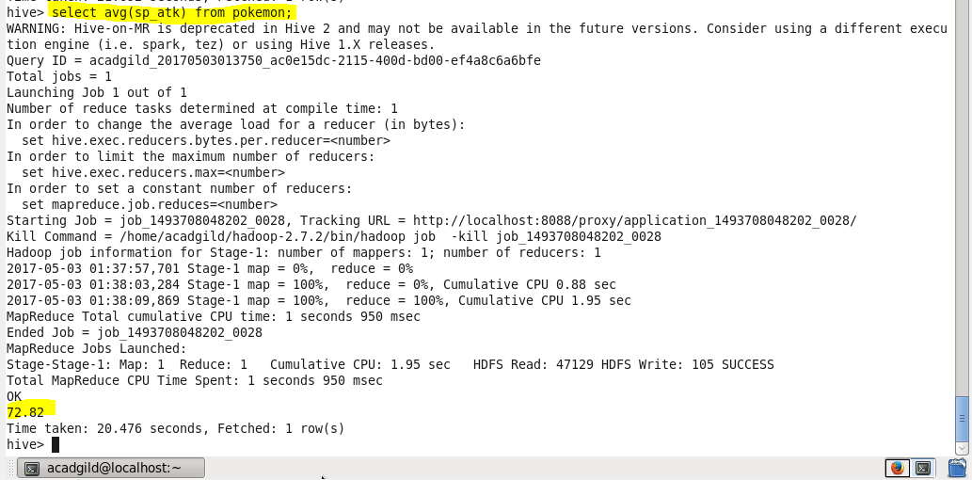

1. **Find out the average sp.Def of all the pokemons**

* Using select statement we will display the result
* For finding out the average we will use avg function.

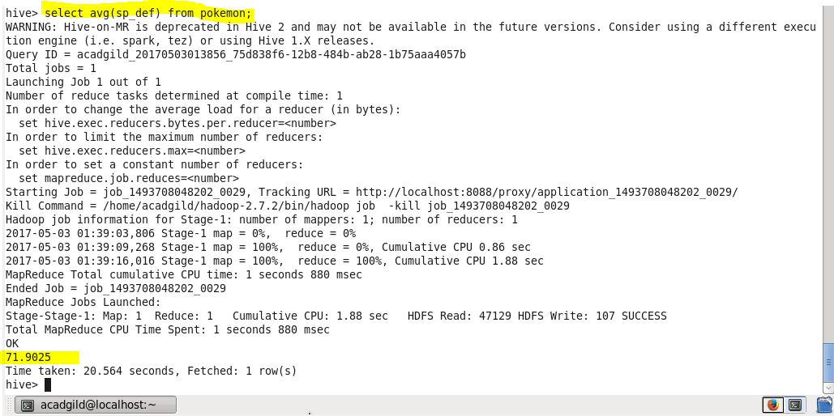

1. **Find out the average Speed of all the pokemons**

* Using select statement we will display the result
* For finding out the average we will use avg function.

