Lab Assignment-3

Indian Institute of Technology Roorkee Department of Computer Science and Engineering

CSN-361: Computer Networks Laboratory (Autumn 2019-2020)

Aman jaiswal
Enrollment No:-17114008
B.tech CSE 3rd Year.

Problem Statement 1:

Write a socket program in C to determine class, Network and Host ID of an IPv4 address.

Data Structure and Functions used:-
- char str[] : to store ipv4 address as string.
- char ipClass :to store class type of ip i.e A,B,C,D,E.
- findClass(char str[]) written method to determine the class type.
- separate(char str[], char ipClass) method to seperate network and host id from given ip.
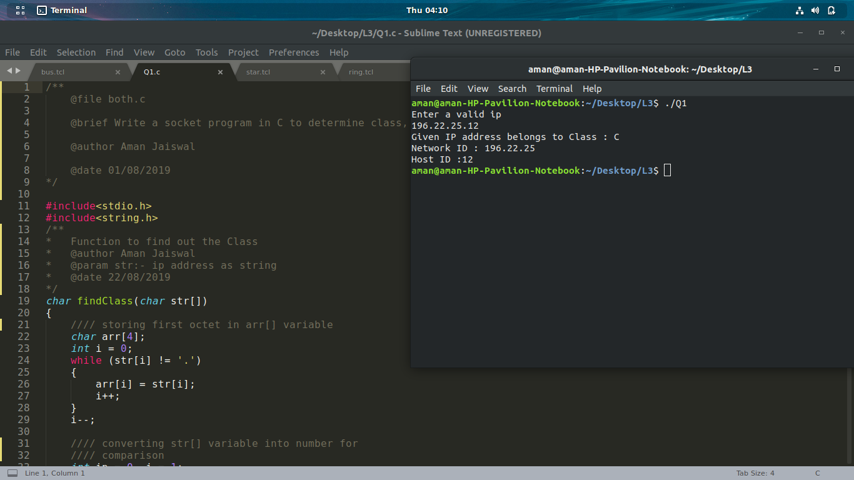

Problem Statement 2:

Write a C program to demonstrate File Transfer using UDP.

- Data Structure and Functions used:-

For Server -

- Socket creation:

int sockfd = socket(domain, type, protocol)

- sockfd: socket descriptor, an integer (like a file-handle)
- domain: integer, communication domain e.g., AF_INET (IPv4 protocol) , AF_INET6 (IPv6 protocol)
- type: communication type
- SOCK_STREAM: TCP(reliable, connection oriented)
- SOCK_DGRAM: UDP(unreliable, connectionless)
- protocol: Protocol value for Internet Protocol(IP), which is 0. This is the same number which appears on protocol field in the IP header of a packet.(man protocols for more details)

- Setsockopt:

int setsockopt(int sockfd, int level, int optname, const void *optval, socklen_t optlen);

This helps in manipulating options for the socket referred by the file descriptor sockfd. This is completely optional, but it helps in reuse of address and port. Prevents error such as: “address already in use”.
- Bind:

int bind(int sockfd, const struct sockaddr *addr, socklen_t addrlen);

After creation of the socket, bind function binds the socket to the address and port number specified in addr(custom data structure). In the example code, we bind the server to the localhost, hence we use INADDR_ANY to specify the IP address.
- FILE*fp = fopen(net_buf, "r");
fp is a pointer to file descriptor. R tells mode (read).

- recvfrom(): can be used to receive data on a socket and capture the address from which the data was sent, returns no of bytes recieved
- sendfile() copies data between one file descriptor and another.
- Sendto() function sends data to a specific destination.

For Client:-

- Socket connection: Exactly same as that of server’s socket creation
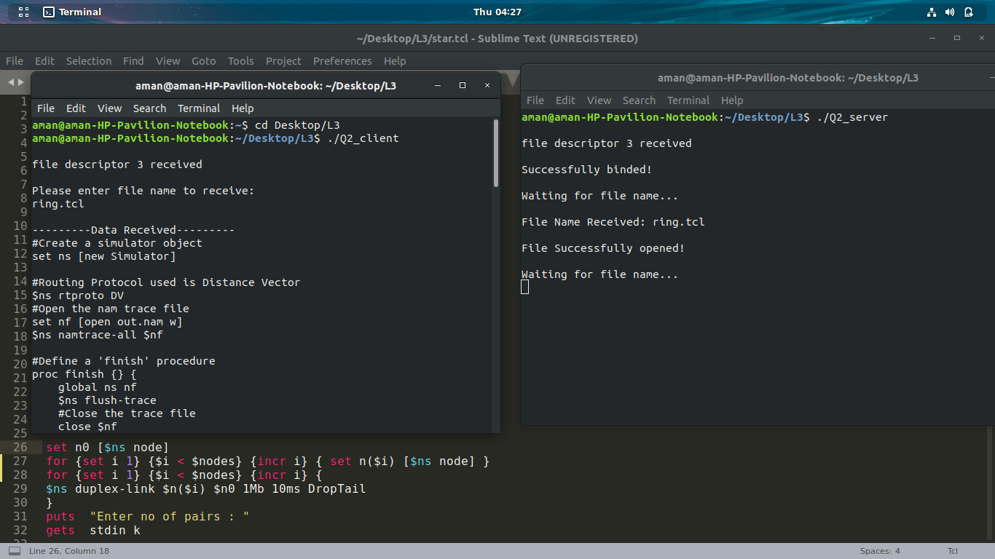

Problem Statement 3:

Write a TCL code for network simulator NS2 to demonstrate the star topology among a set of computer nodes. Given N nodes, one node will be assigned as the central node and the other nodes will be connected to it to form the star. You have to set up a TCP connection between k pairs of nodes and demonstrate the packet transfer between them using Network Animator (NAM). Use File Transfer protocol (FTP) for the same. Each link should have different color of packets to differentiate the packets transferred between each pair of nodes. The program should take the number of nodes (N) as input followed by k pairs of nodes.

- Data Structure and Functions used:-

- by stdin taking input from user no nodes and no pairs k. Also storing each pair in two array a and b.
- In ns2 nodes can be connected in two ways, simplex and duplex. Simplex connection allows one-way communication and duplex connection allow two-way communication. Each type require bandwidth, delay and type of queue for configuration.
Bandwidth is specified in Mbps(Mb) and delay is specified in milli seconds (ms).
- Agent Class :-For every node transport mechanism need to be defined to send data. These transport mechanism in ns2 defined using agent. For example FTP application requires TCP transport protocol, that's why TCP agent need to be associated with sending node. All agents are subclass of Agent class.
- In ns2 there are two type of applications are available one is traggic generator, second is simulated application. These applications are attached to agent which is attached to node. New application can be added in ns2.

- Traffic Generator generate traffic and there are four types of traffic generator.
- Exponential Traffic Generator
- Pareto Traffic Generator
- CBR
- Trace

Application/Traffic/CBR
CBR objects generate packets at a constant bit rate.
- $cbr start Causes the source to start generating packets.
- $cbr stop Causes the source to stop generating packets.

Configuration parameters are:

- PacketSize_ constant size of packets generated.
- Rate_ sending rate.
- Interval_ (optional) interval between packets.
- Random_ whether or not to introduce random noise in the scheduled departure times. defualt is off.
- Maxpkts_ maximum number of packets to send.

5. In ns2 two type of simulated applications are available
1. FTP:-
FTP objects produce bulk data for a TCP object to send.
- $ftp start Causes the source to produce maxpkts_ packets.

- $ftp produce n Causes the FTP object to produce n packets instantaneously.

- $ftp stop Causes the attached TCP object to stop sending data.

- $ftp attach agent Attaches a Application/FTP object to agent.

- $ftp producemore count Causes the Application/FTP object to produce count more packets.

Configuration Parameters are:

- maxpkts The maximum number of packets generated by the source.
2. Telnet:-
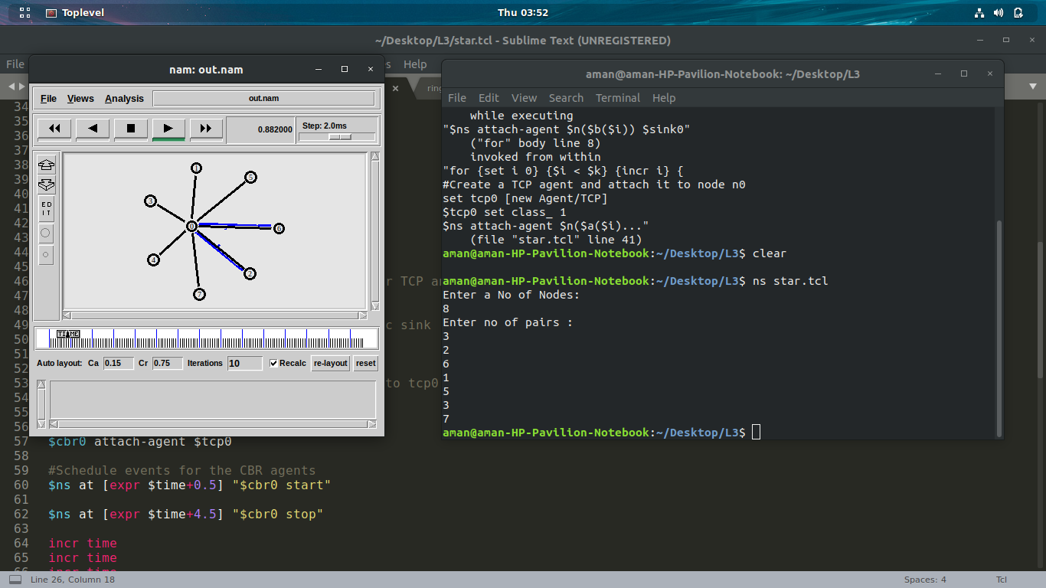

Problem Statement 4:

Write a TCL code for network simulator NS2 to demonstrate the ring topology among a set of computer nodes. Given N nodes, each node will be connected to two other nodes in the form of a ring. You have to set up a TCP connection between k pairs of nodes and demonstrate packet transfer between them using Network Animator (NAM). Use File Transfer protocol (FTP) for the same. Each link should have different color of packets to differentiate the packets transferred between each pair of nodes. The program should take the number of nodes (N) as input followed by k pairs of nodes.

- Data Structure and Functions used:-

- by stdin taking input from user no nodes and no pairs k. Also storing each pair in two array a and b.
- ns2 nodes can be connected in two ways, simplex and duplex. Simplex connection allows one-way communication and duplex connection allow two-way communication. Each type require bandwidth, delay and type of queue for configuration.
Bandwidth is specified in Mbps(Mb) and delay is specified in milli seconds (ms).
- Agent Class :-For every node transport mechanism need to be defined to send data. These transport mechanism in ns2 defined using agent. For example FTP application requires TCP transport protocol, that's why TCP agent need to be associated with sending node. All agents are subclass of Agent class.
- In ns2 there are two type of applications are available one is traggic generator, second is simulated application. These applications are attached to agent which is attached to node. New application can be added in ns2.

- Traffic Generator generate traffic and there are four types of traffic generator.
- Exponential Traffic Generator
- Pareto Traffic Generator
- CBR
- Trace

Application/Traffic/CBR
CBR objects generate packets at a constant bit rate.
- $cbr start Causes the source to start generating packets.
- $cbr stop Causes the source to stop generating packets.

Configuration parameters are:

- PacketSize_ constant size of packets generated.
- Rate_ sending rate.
- Interval_ (optional) interval between packets.
- Random_ whether or not to introduce random noise in the scheduled departure times. defualt is off.
- Maxpkts_ maximum number of packets to send.

5. In ns2 two type of simulated applications are available
1. FTP:-
FTP objects produce bulk data for a TCP object to send.
- $ftp start Causes the source to produce maxpkts_ packets.

- $ftp produce n Causes the FTP object to produce n packets instantaneously.

- $ftp stop Causes the attached TCP object to stop sending data.

- $ftp attach agent Attaches a Application/FTP object to agent.

- $ftp producemore count Causes the Application/FTP object to produce count more packets.

Configuration Parameters are:

- maxpkts The maximum number of packets generated by the source.
2. Telnet:-

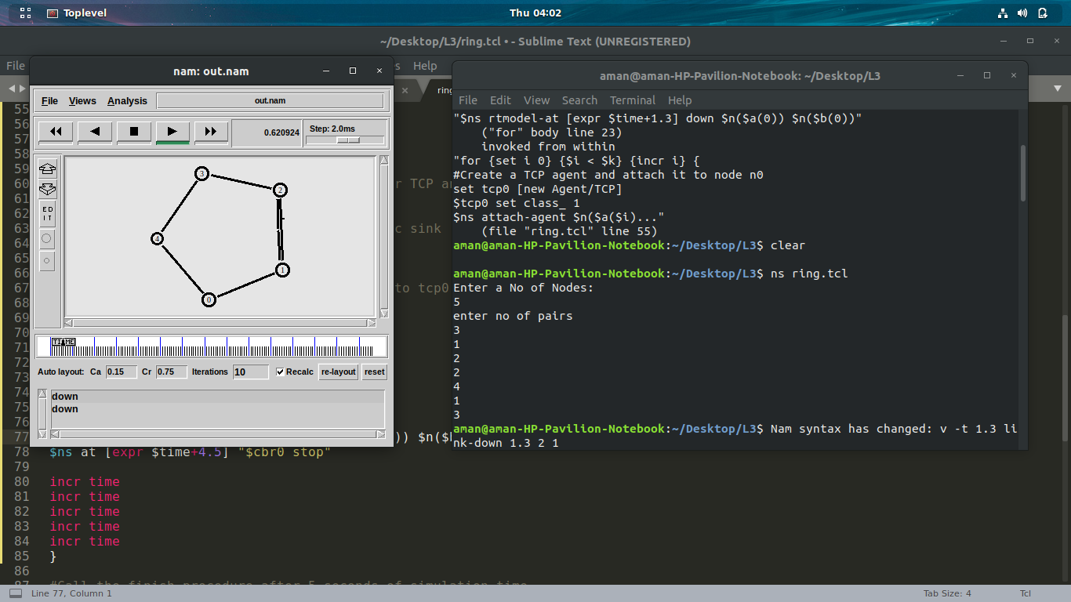

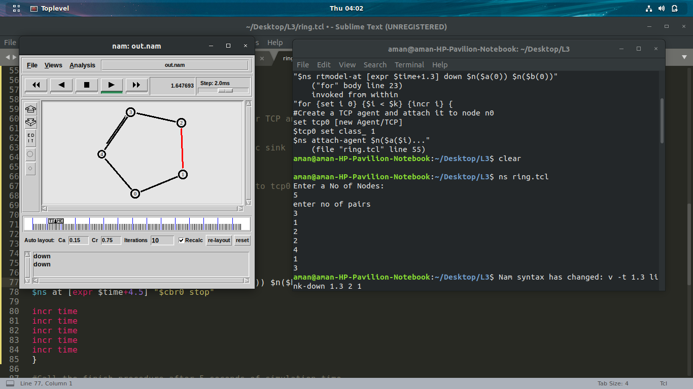

Problem Statement 5:

Write a TCL code for network simulator NS2 to demonstrate the bus topology among a set of computer nodes. Given N nodes, each node will be connected to a common link. You have to set up a TCP connection between k pairs of nodes and demonstrate packet transfer between them using Network Animator (NAM). Use File Transfer protocol (FTP) for the same. Each link should have different color of packets to differentiate the packets transferred between each pair of nodes. The program should take the number of nodes (N) as input followed by k pairs of nodes.

- Data Structure and Functions used:-

- In ns2 nodes can be connected in two ways, simplex and duplex. Simplex connection allows one-way communication and duplex connection allow two-way communication. Each type require bandwidth, delay and type of queue for configuration.
Bandwidth is specified in Mbps(Mb) and delay is specified in milli seconds (ms).
- Agent Class :-For every node transport mechanism need to be defined to send data. These transport mechanism in ns2 defined using agent. For example FTP application requires TCP transport protocol, that's why TCP agent need to be associated with sending node. All agents are subclass of Agent class.
- In ns2 there are two type of applications are available one is traggic generator, second is simulated application. These applications are attached to agent which is attached to node. New application can be added in ns2.

- Traffic Generator generate traffic and there are four types of traffic generator.
- Exponential Traffic Generator
- Pareto Traffic Generator
- CBR
- Trace

Application/Traffic/CBR
CBR objects generate packets at a constant bit rate.
- $cbr start Causes the source to start generating packets.
- $cbr stop Causes the source to stop generating packets.

Configuration parameters are:

- PacketSize_ constant size of packets generated.
- Rate_ sending rate.
- Interval_ (optional) interval between packets.
- Random_ whether or not to introduce random noise in the scheduled departure times. defualt is off.
- Maxpkts_ maximum number of packets to send.

5. In ns2 two type of simulated applications are available
1. FTP:-
FTP objects produce bulk data for a TCP object to send.
- $ftp start Causes the source to produce maxpkts_ packets.

- $ftp produce n Causes the FTP object to produce n packets instantaneously.

- $ftp stop Causes the attached TCP object to stop sending data.

- $ftp attach agent Attaches a Application/FTP object to agent.

- $ftp producemore count Causes the Application/FTP object to produce count more packets.

Configuration Parameters are:

- maxpkts The maximum number of packets generated by the source.
2. Telnet:-
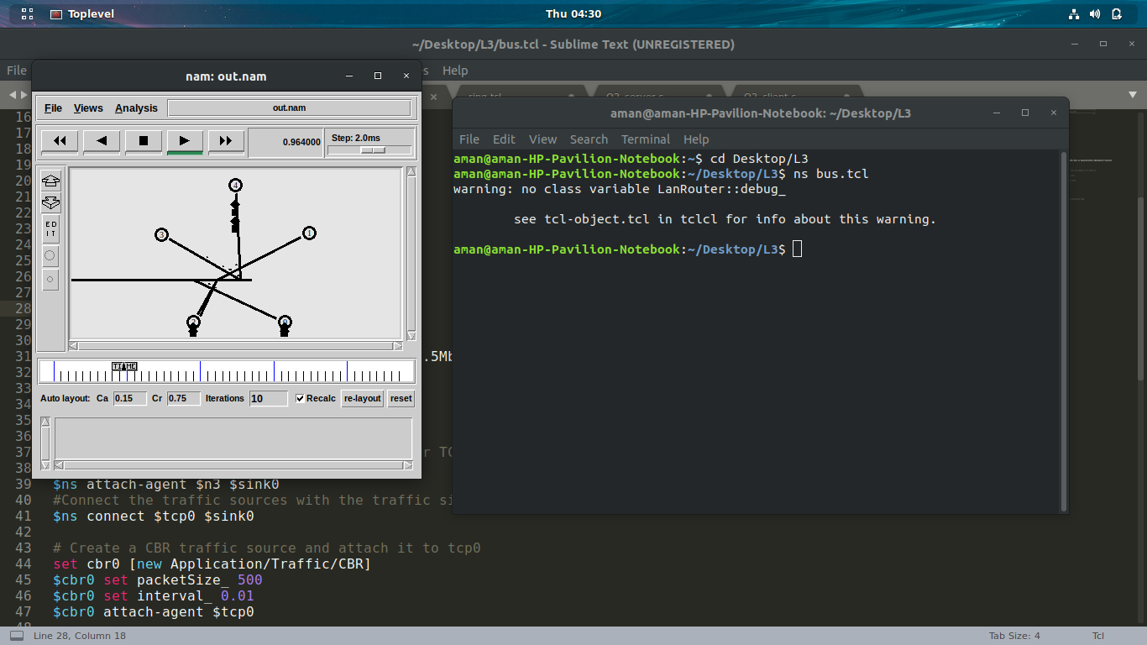

- Doxygen File :-

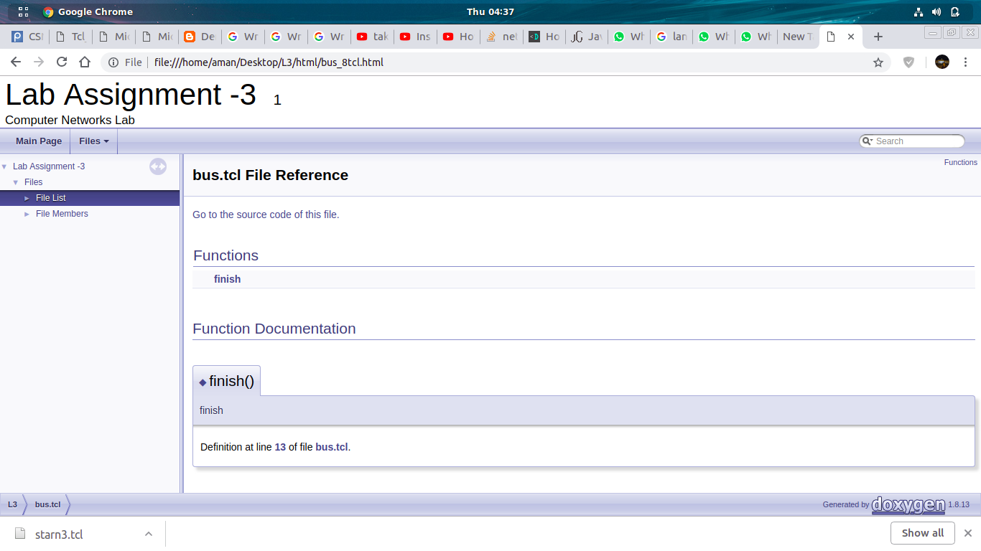

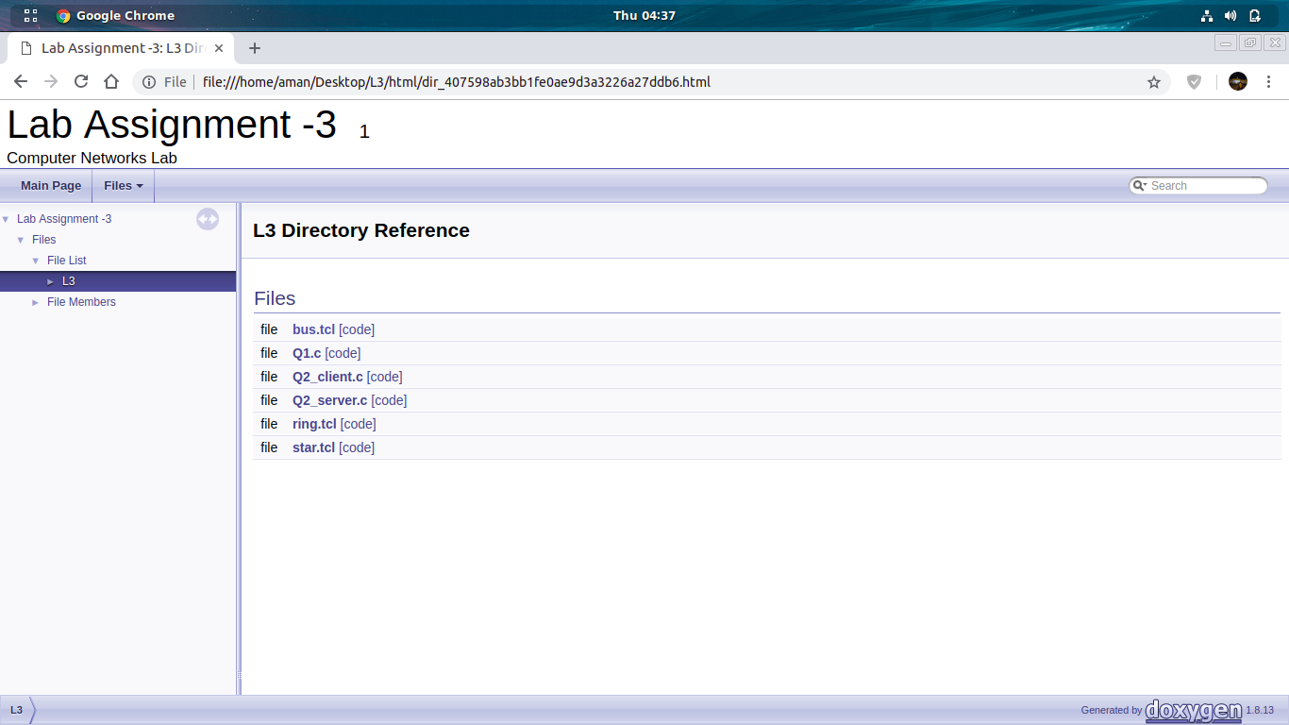

github link:-https://github.com/jaiswalaman/Assignment-03-CSN-361

