Lab Assignment-4

Indian Institute of Technology Roorkee Department of Computer Science and Engineering

CSN-361: Computer Networks Laboratory (Autumn 2019-2020)

Aman jaiswal
Enrollment No:-17114008
B.tech CSE 3rd Year.

Problem Statement 1:

Write a Network Simulator (NS2) code to simulate a three node network with duplex links among them as shown in figure. Show the topology using NAM. Study the variation in number of packets dropped with the variation of the queue size in the nodes and with the variation of the bandwidth of the links.

Data Structure and Functions used:-

- In ns2 nodes can be connected in two ways, simplex and duplex. Simplex connection allows one-way communication and duplex connection allow two-way communication. Each type require bandwidth, delay and type of queue for configuration.
- queue_limit to limit the number of packets for a link.
Bandwidth is specified in Mbps(Mb) and delay is specified in milli seconds (ms).
- Agent Class :-For every node transport mechanism need to be defined to send data. These transport mechanism in ns2 defined using agent. For example FTP application requires TCP transport protocol, that's why TCP agent need to be associated with sending node. All agents are subclass of Agent class.
- In ns2 there are two type of applications are available one is traggic generator, second is simulated application. These applications are attached to agent which is attached to node. New application can be added in ns2.

- Traffic Generator generate traffic and there are four types of traffic generator.
- Exponential Traffic Generator
- Pareto Traffic Generator
- CBR
- Trace

Application/Traffic/CBR
CBR objects generate packets at a constant bit rate.
- $cbr start Causes the source to start generating packets.
- $cbr stop Causes the source to stop generating packets.

Configuration parameters are:

- PacketSize_ constant size of packets generated.
- Rate_ sending rate.
- Interval_ (optional) interval between packets.
- Random_ whether or not to introduce random noise in the scheduled departure times. defualt is off.
- Maxpkts_ maximum number of packets to send.

- 5. In ns2 two type of simulated applications are available
1. FTP:-
FTP objects produce bulk data for a TCP object to send.
- $ftp start Causes the source to produce maxpkts_ packets.

- $ftp produce n Causes the FTP object to produce n packets instantaneously.

- $ftp stop Causes the attached TCP object to stop sending data.

- $ftp attach agent Attaches a Application/FTP object to agent.

- $ftp producemore count Causes the Application/FTP object to produce count more packets.

Configuration Parameters are:

- maxpkts The maximum number of packets generated by the source.
- 2. Telnet:-.

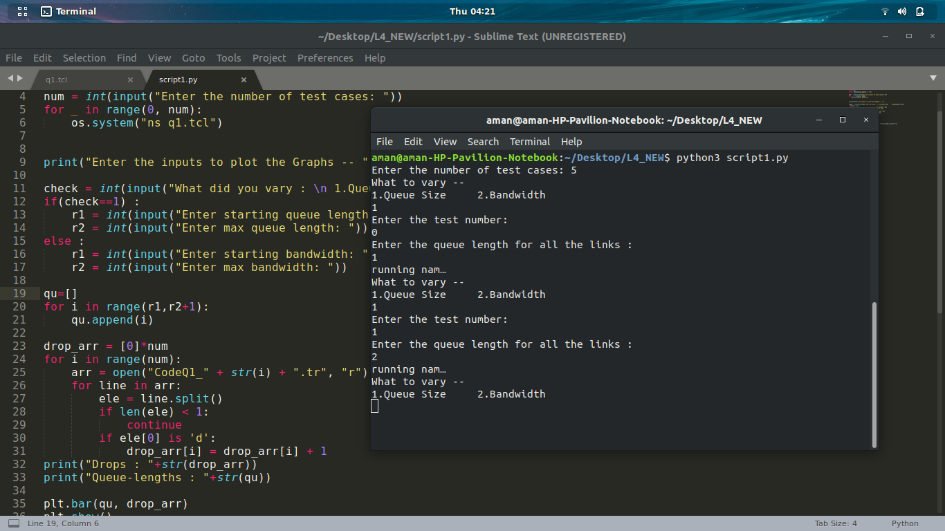
Varying queue size:-
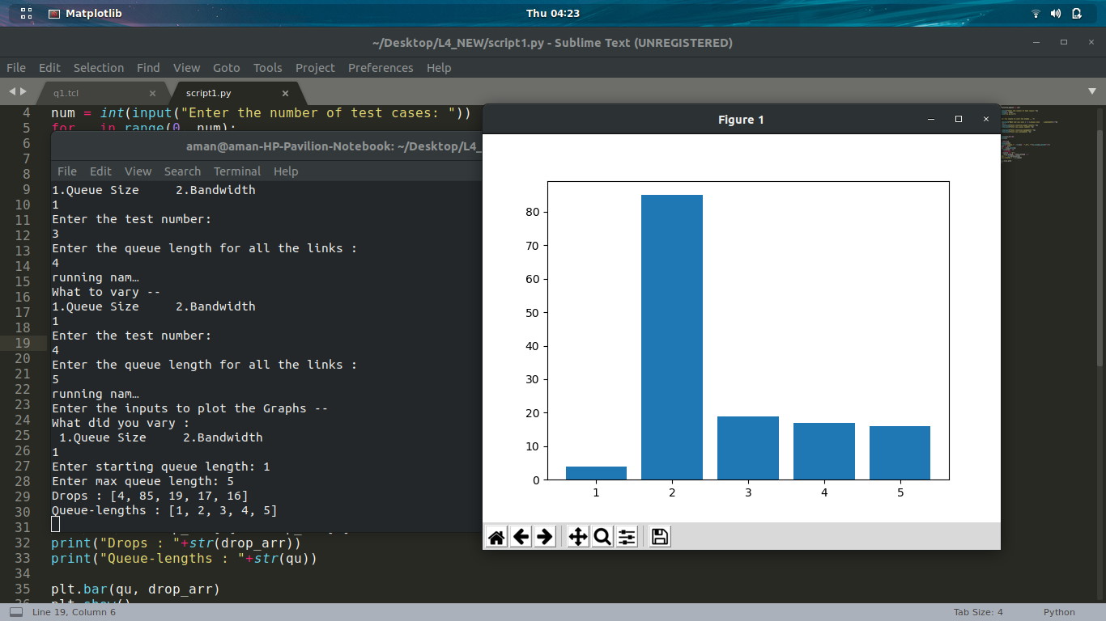
varying bandwidth:-
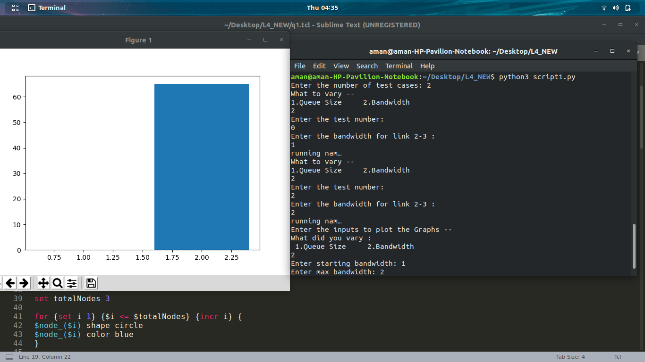

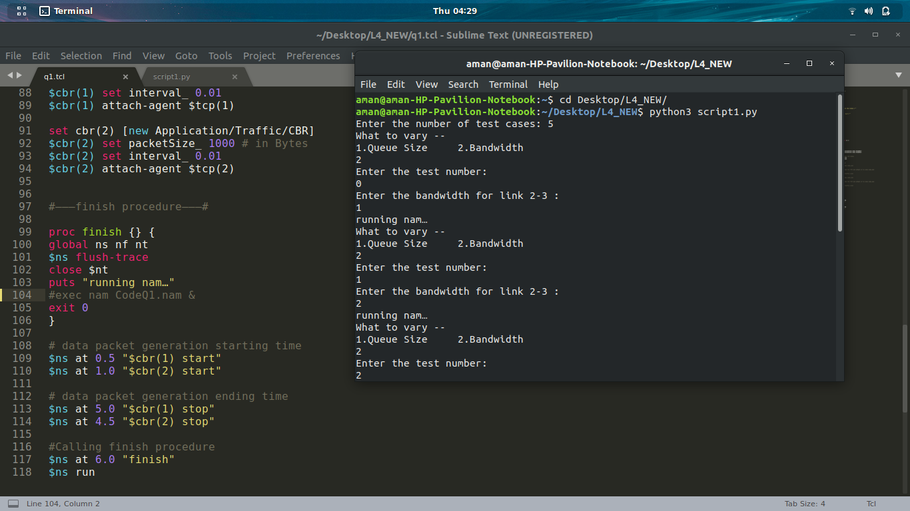

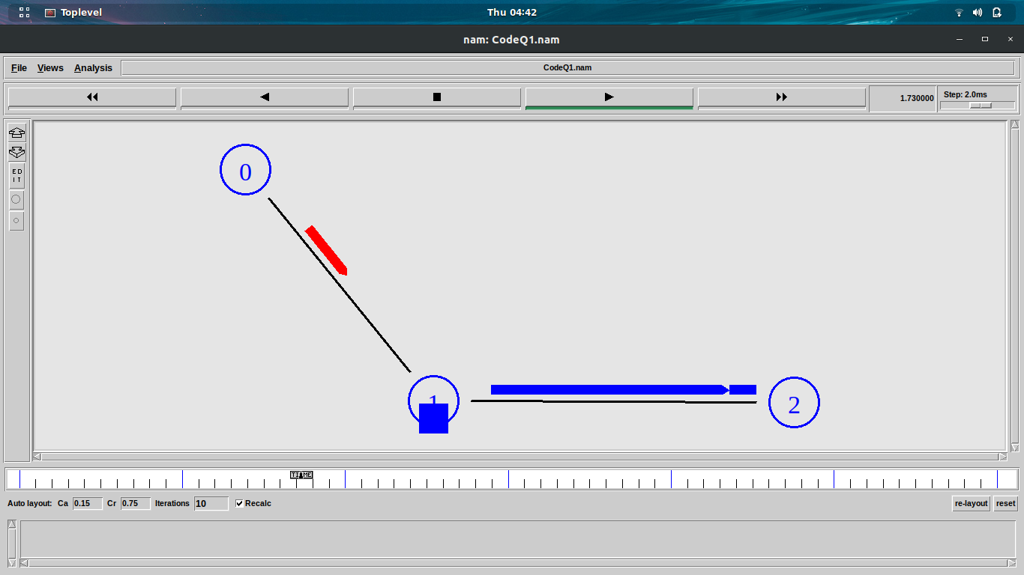

Problem Statement 2:
Write a Network Simulator (NS2) code to simulate the transmission of ping messages over a network topology consisting of 6 nodes and find the number of packets dropped due to congestion. Study the variation in number of packets dropped with the variation of the queue size in the nodes and with the variation of the bandwidth of the links.

- Data Structure and Functions used:-

- by stdin taking input from user no nodes and no pairs k. Also storing each pair in two array a and b.
- In ns2 nodes can be connected in two ways, simplex and duplex. Simplex connection allows one-way communication and duplex connection allow two-way communication. Each type require bandwidth, delay and type of queue for configuration.
Bandwidth is specified in Mbps(Mb) and delay is specified in milli seconds (ms).
- Agent Class :-For every node transport mechanism need to be defined to send data. These transport mechanism in ns2 defined using agent. For example FTP application requires TCP transport protocol, that's why TCP agent need to be associated with sending node. All agents are subclass of Agent class.
- In ns2 there are two type of applications are available one is traggic generator, second is simulated application. These applications are attached to agent which is attached to node. New application can be added in ns2.

- queue_limit to limit the number of packets for a link.
- Agent/Ping to send ping requests and receive ping answer by creating ping_agents.
where 12 fields of the trace string are as follows.
- 1. Type Identifier:
- “+”: a packet enqueue event
- “-”: a packet dequeue event
- “r”: a packet reception event
- “d”: a packet drop (e.g., sent to drop Head_) event
- “c”: a packet collision at the MAC level
- 2. Time: at which the packet tracing string is created.
- 3-4. Source Node and Destination Node: denote the IDs of the source and the destination nodes of the tracing object.
- 5. Packet Name: Name of the packet type
- 6. Packet Size: Size of the packet in bytes.
- 7. Flags: A 7-digit flag string
- “-”: disable
- 1st = “E”: ECN (Explicit Congestion Notification) echo is enabled.
- 2nd = “P”: the priority in the IP header is enabled.
- 3rd : Not in use
- 4th = “A”: Congestion action
- 5th = “E”: Congestion has occurred.
- 6th = “F”: The TCP fast start is used.
- 7th = “N”: Explicit Congestion Notification (ECN) is on.
- 8. Flow ID
- 9-10. Source Address and Destination Address: the format of these two fields is “a.b”, where “a” is the address and “b” is the port.
- 11. Sequence Number
- 12. Packet Unique ID-

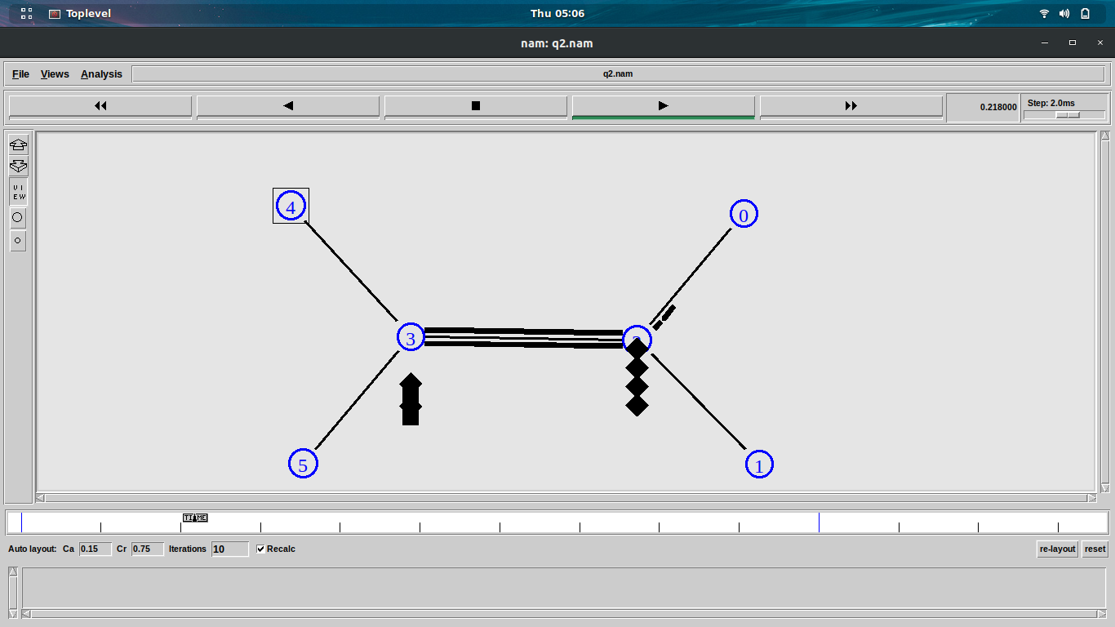

varitation with differen parameters shown using plotly:-

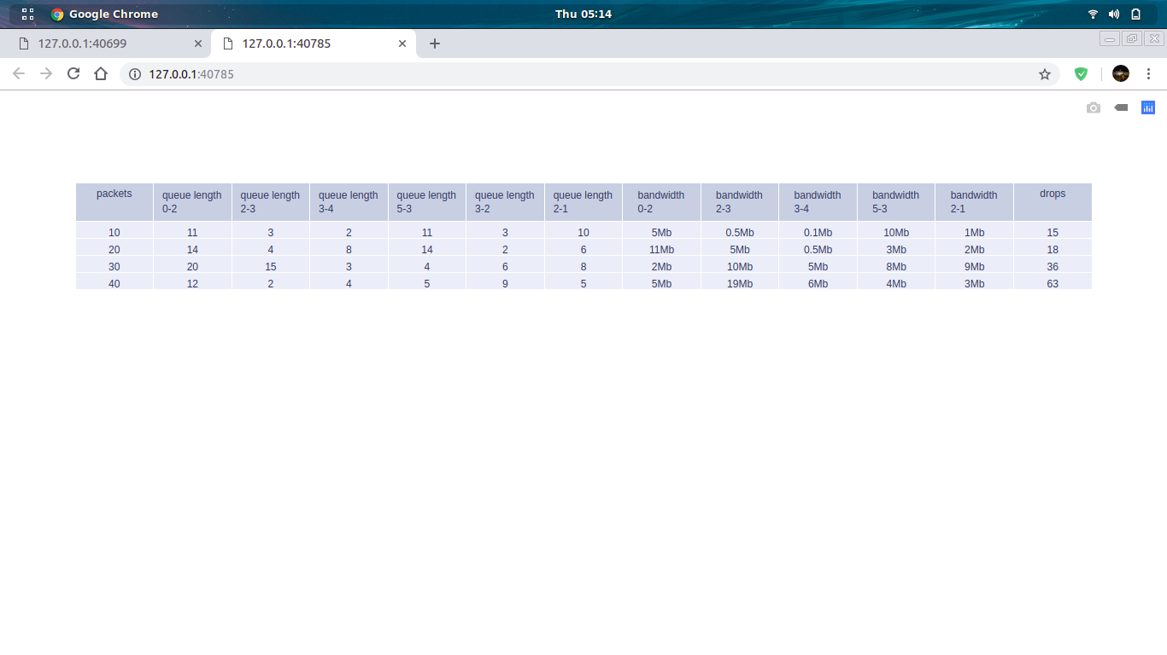

github link:-https://github.com/jaiswalaman/Assignment-4-CSN-361

