Employee Engagement, Satisfaction, and Burnout Diagnostic Analysis at Palo Alto Networks
Research Paper: Exploratory Data Analysis, Insights and Recommendations
Project submitted to Unified Mentor
Dataset: 1,470 employees, 31 indicators

Abstract
This study builds an early-warning view of employee experience for 1,470 employees. It constructs a composite Engagement Index (0–100), a burnout risk classification, and supporting well-being KPIs, then examines how workload, career stage and role relate to engagement. The organization-wide Engagement Index averages 57.4 / 100, and 33.9% of employees fall below the midpoint of 50. The strongest signal in the data is not engagement alone but overtime: employees working overtime leave at 30.5% versus 10.4% for those who do not. Employees who combine overtime with low work-life balance (the "High" burnout group, 8.6% of staff) leave at 33.3%, against 9.1% for the Low-risk group. Engagement is lower among leavers (50.4 vs 58.8), but it does not vary meaningfully with tenure, job level or time since promotion. Recommendations focus on overtime governance, targeted support for entry-level and newly hired staff, and using the dashboard for monthly monitoring.

1. Background and Objective
Burnout tends to precede attrition, and attrition is hard to reverse once an employee has decided to leave. HR currently lacks a unified engagement index and clear visibility of burnout-prone groups, so interventions are late and reactive. The objective is to shift to preventive diagnostics: detect disengagement and burnout exposure early, and show where to act first.

2. Data and Validation
The dataset has 1,470 employees and 31 fields (demographics, role, pay, tenure, satisfaction ratings, overtime, travel, attrition).
- Completeness: no missing values and no duplicate rows.
- Ordinal scales: JobInvolvement, JobSatisfaction, EnvironmentSatisfaction, RelationshipSatisfaction and WorkLifeBalance all take only the values 1–4. The pipeline still enforces this check and imputes any out-of-range or missing rating with the column median, so it is safe to re-run on future extracts.
- Normalization: each 1–4 rating is rescaled to 0–100 as (x − 1) / 3 × 100 so that all indices share one scale.
- Population: 237 employees (16.1%) have left; 1,233 remain. 416 (28.3%) work overtime.

3. Methodology
Measure | Definition
Engagement Index | Mean of the four normalized items: JobInvolvement, JobSatisfaction, EnvironmentSatisfaction, RelationshipSatisfaction (0–100). A z-score version is also stored.
Low engagement | Engagement Index below a threshold (default 50; adjustable in the dashboard).
Burnout Risk Score | OverTime = Yes (1 point) + WorkLifeBalance ≤ 2 (1 point). 0 = Low, 1 = Medium, 2 = High.
Work-Life Balance Index | WorkLifeBalance rescaled to 0–100.
Satisfaction Stability | 100 × (1 − standard deviation of the four satisfaction items / 1.5). 100 means ratings are identical across dimensions.
Workload Stress Indicator | (travel points + overtime) / 3 × 100, with travel points Non-Travel 0, Rarely 1, Frequently 2.
Commute bands | Short ≤ 5, Medium 6–15, Long > 15 (distance units as given in the data).
Stagnation | Three or more years since last promotion.

Group differences were tested with Mann–Whitney U (two groups), Kruskal–Wallis (several groups), Spearman correlation (continuous), and chi-square tests for attrition rates. Attrition is analyzed as context only; no predictive model is claimed.

4. Findings

4.1 Organization-wide engagement
KPI | Value
Engagement Index | 57.4
Employees below 50 | 33.9%
Work-Life Balance Index | 58.7
Satisfaction Stability | 45.3
Workload Stress Indicator | 45.7
Average Burnout Risk Score (0–2) | 0.57
High burnout risk | 126 employees (8.6%)

The share rating each dimension 1 or 2 (dissatisfied) is 31.2% for job involvement, 38.7% for job satisfaction, 38.8% for environment satisfaction, 39.4% for relationship satisfaction, and 28.8% for work-life balance. Roughly four in ten employees are dissatisfied with their job, environment or relationships.
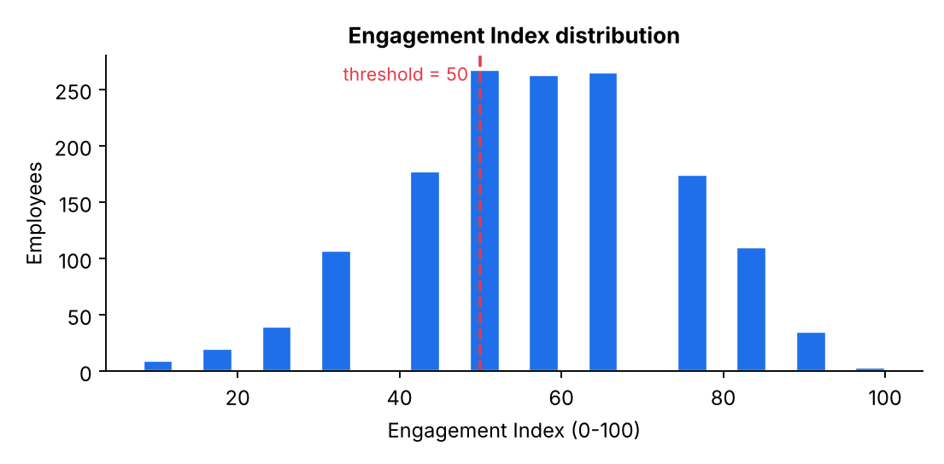
Figure 1. Distribution of the Engagement Index.
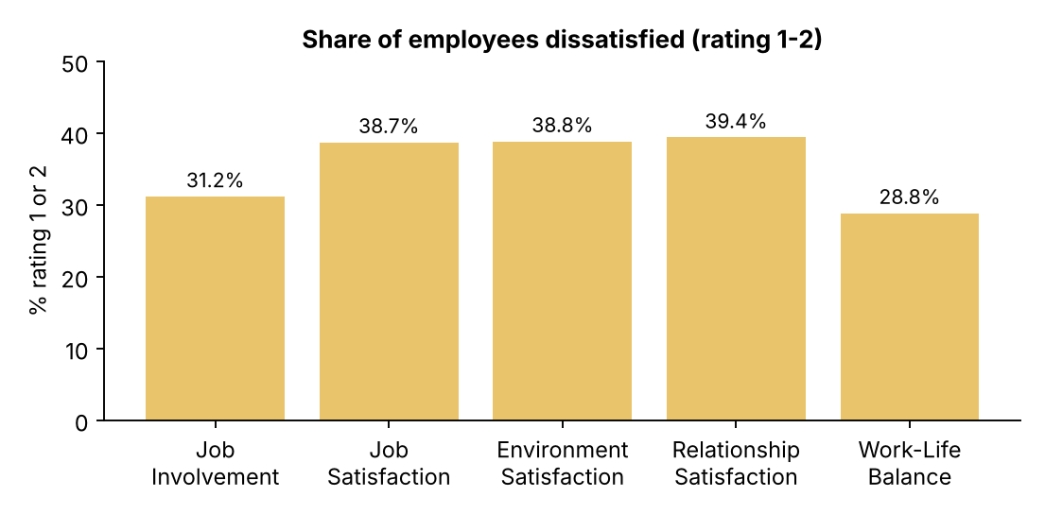
Figure 2. Share of employees rating each dimension 1 or 2.

4.2 Burnout risk
Burnout level | Employees | Attrition
Low | 756 | 9.1%
Medium | 588 | 21.4%
High | 126 | 33.3%

Attrition rises steadily with burnout level (chi-square p < 0.001). Overtime does most of the work: among employees with poor work-life balance, attrition is 13.8% without overtime but 33.3% with it. Employees working overtime with good work-life balance still leave at 29.3%. In other words, overtime is a stronger signal than self-reported work-life balance, although both matter.
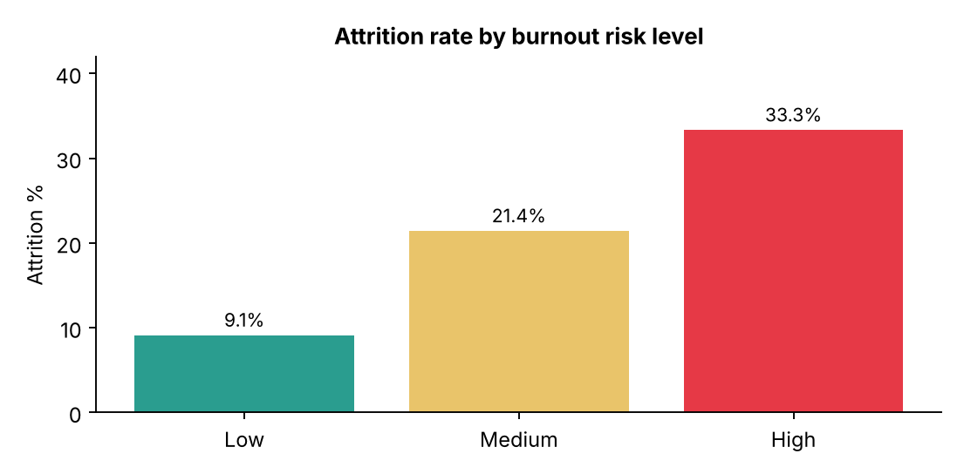
Figure 3. Attrition rises with burnout risk level.

4.3 Workload and stress
Group | Engagement | Attrition
No overtime (1,054) | 56.6 | 10.4%
Overtime (416) | 59.5 | 30.5%
Non-Travel (150) | 57.8 | 8.0%
Travel Rarely (1,043) | 57.2 | 15.0%
Travel Frequently (277) | 58.3 | 24.9%
Short commute (632) | 57.4 | 13.8%
Medium commute (509) | 57.3 | 16.1%
Long commute (329) | 57.8 | 20.7%

A counter-intuitive result: employees working overtime report slightly higher engagement (59.5 vs 56.6, p = 0.001), and frequent travelers show no engagement penalty. Heavy workload therefore does not show up as lower engagement scores, yet it is strongly linked to leaving. This suggests that engagement surveys alone would miss overtime-driven attrition risk, which is the main argument for tracking workload and well-being signals alongside engagement. Combined exposure is severe: employees with overtime and frequent travel (86) leave at 41.9%.
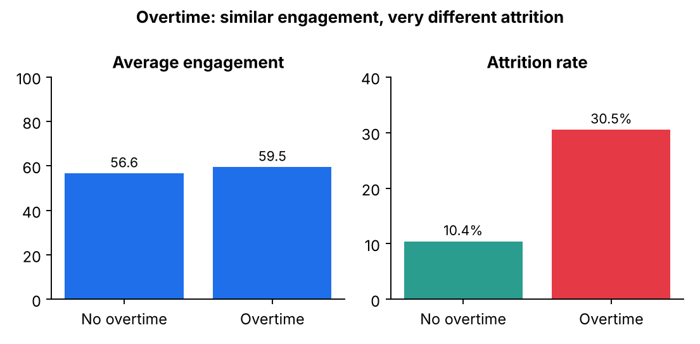
Figure 4. Overtime employees are not less engaged but leave far more often.
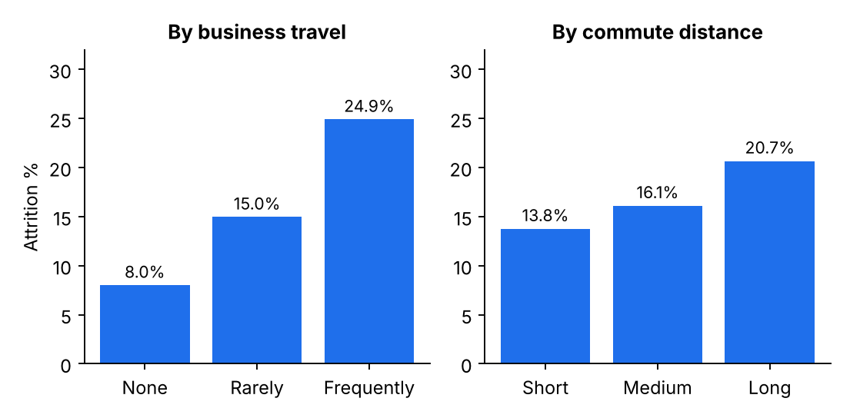
Figure 5. Attrition by business travel and commute distance.

4.4 Career stage
Segment | Engagement | Attrition
Job level 1 / 2 / 3 / 4 / 5 | 57.5 / 57.5 / 55.8 / 59.4 / 58.2 | 26.3% / 9.7% / 14.7% / 4.7% / 7.2%
Tenure 0–2 / 3–5 / 6–10 / 11+ years | 57.4 / 56.8 / 58.1 / 57.3 | 29.8% / 13.8% / 12.3% / 8.1%
Promoted within 3 years / stagnant | 57.3 / 57.7 | 17.0% / 13.7%

Engagement does not differ significantly by job level (Kruskal–Wallis p = 0.42), and it is essentially uncorrelated with years at the company (Spearman ρ = 0.008) or years since last promotion (ρ = 0.027). No stagnation-linked disengagement is visible in this data. The career-stage signal appears in attrition instead: entry-level staff (26.3%) and new joiners with 0–2 years' tenure (29.8%) leave most. Entry-level employees working overtime leave at 52.6% (156 employees), and new joiners working overtime at 51.0% (104 employees).
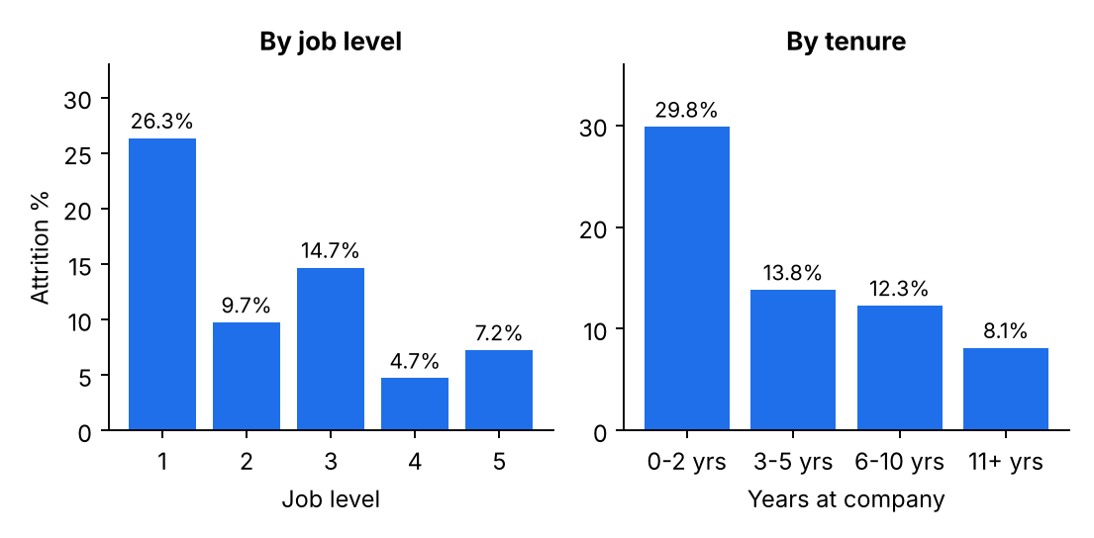
Figure 6. Attrition is concentrated in entry-level and new-joiner groups.

4.5 Engagement versus attrition (contextual)
 | Stayed (1,233) | Left (237)
Engagement Index | 58.8 | 50.4
Share below 50 | 31.0% | 48.9%
Job involvement | 2.77 | 2.52
Job satisfaction | 2.78 | 2.47
Environment satisfaction | 2.77 | 2.46
Work-life balance | 2.78 | 2.66

Leavers score 8.4 points lower on the Engagement Index (Mann–Whitney p < 0.001; Cohen's d = 0.51, a medium effect). Employees below 50 on the index left at 23.3% versus 12.4% for those at or above 50. Engagement is therefore a meaningful but partial early-warning signal.
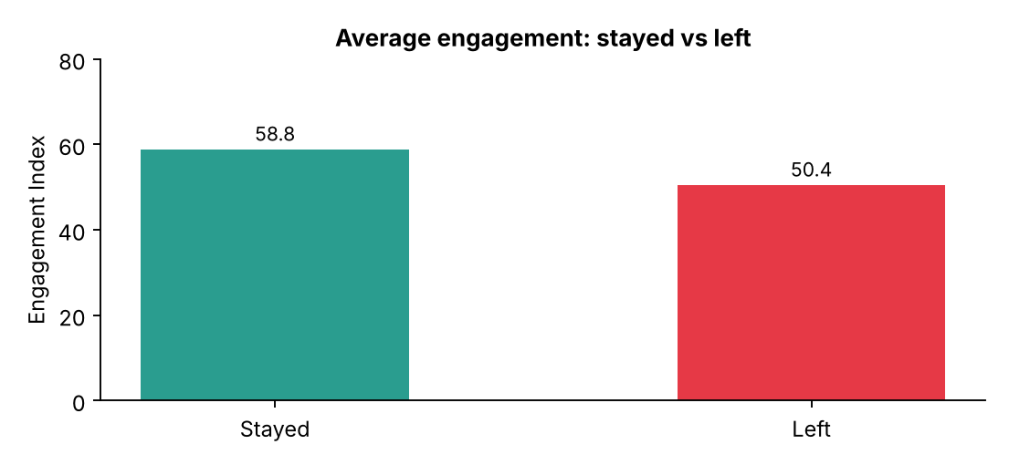
Figure 7. Leavers had lower average engagement.

4.6 Priority segments
Ranking Department × Job Role segments by a priority score (40% engagement gap, 40% high-burnout share, 20% low-engagement share), the top five are Research Director, Laboratory Technician, Sales Executive, Sales Representative and Research Scientist. Laboratory Technician (259 employees, 23.9% low engagement, 28.2% attrition), Sales Executive (326; 17.5%; 28.1%) and Sales Representative (83; 39.8% low engagement) combine large headcount with elevated risk. Sales Representatives have the highest share of low-engagement employees. Differences in average engagement between roles are small (55.5–58.8), so segment ranking is best used to focus conversations, not to label teams.
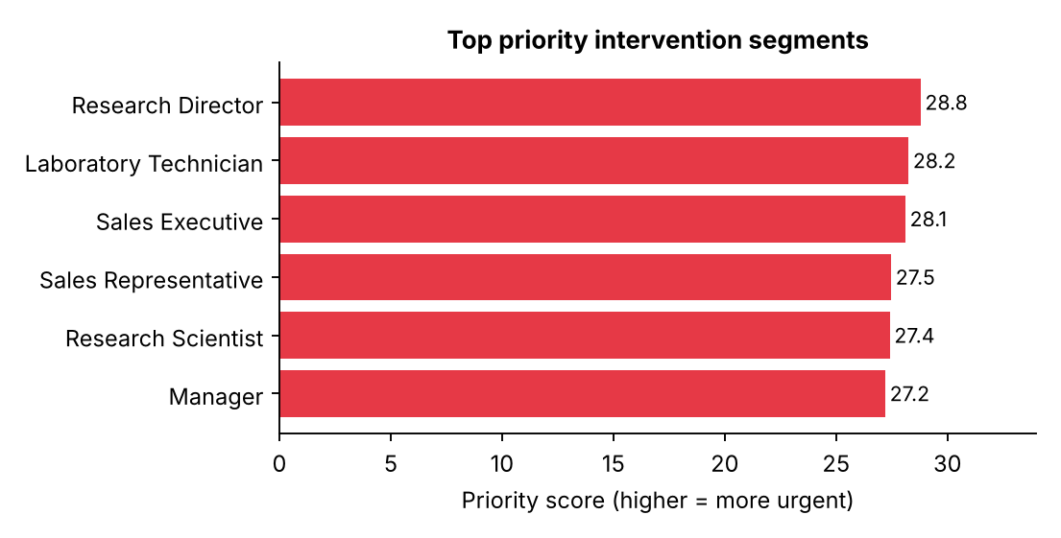
Figure 8. Top five segments by the intervention priority score.

5. Limitations
1. The four engagement dimensions are almost uncorrelated (pairwise correlations between −0.02 and 0.03). Real survey items usually move together. Combined with the flat relationship between engagement and tenure, level and promotion, this suggests the dataset may be synthetic or sample data. Findings about overtime and attrition are statistically strong, but the engagement-related findings should be re-validated on live survey data before action is taken.
2. For the same reason, the Satisfaction Stability score mostly reflects rating noise here, and it should be interpreted cautiously.
3. The data is a single snapshot; attrition is already observed, so the analysis shows association, not cause or timing. A true early-warning model needs repeated measurements.
4. Burnout risk is inferred from two proxies (overtime and work-life balance), not a validated burnout instrument.
5. Index weights are equal by design; thresholds (50, 3 years, commute bands) are adjustable assumptions.

6. Recommendations
1. Govern overtime first. Set review triggers for employees working sustained overtime, starting with the 126 High-risk employees (overtime plus poor work-life balance). Overtime is the largest attrition signal found (30.5% vs 10.4%).
2. Protect entry-level and new joiners. Cap or review overtime for Job Level 1 and employees under 2 years' tenure, where overtime coincides with ~50% attrition. Pair with onboarding check-ins and manager 1:1s.
3. Reduce stacked workload. Avoid combining frequent travel with overtime (41.9% attrition); rotate travel assignments.
4. Target engagement support by segment. Use the Manager Action Panel to prioritize Sales Representatives, Laboratory Technicians and Sales Executives, and to run pulse checks on the 33.9% below the threshold.
5. Track workload alongside engagement. Engagement scores alone did not reveal the overtime risk; add overtime hours, travel days and work-life balance to a monthly dashboard review.
6. Fix the measurement. Repeat the survey at least quarterly, link responses over time and validate the index against live data and a recognized burnout scale before using it to evaluate managers.

7. Conclusion
The diagnostic shows that the clearest early-warning signal at Palo Alto Networks is workload exposure, particularly overtime, rather than low engagement scores. Engagement is lower among leavers, but average scores look healthy among overtime-heavy groups that are leaving at the highest rates. A preventive program should therefore combine engagement, overtime and work-life balance indicators, as the accompanying Streamlit dashboard does.

Appendix: Reproducibility
All figures come from engagement.py applied to data/Palo Alto Networks.csv. The dashboard (app.py) uses the same module, so filters recompute every KPI consistently.

