Components used in project:

1. ATMEGA32 (Micro controller)–

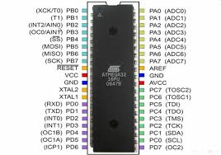

ATmega32 is high-performance, low-power Atmel 8-bit AVR RISC-based microcontroller that combines 32KB of programmable flash memory, 2KB SRAM, 1KB EEPROM. It is our main processing unit in the project. It has 4 ports, each containing 8 pins. All these 32 pins can programmed either to receive input or to send output. Signals are sent digitally 0V or 5V.

Some key features of ATMEGA32 are:

* 32 x 8 general working purpose registers.
* 32K bytes of in system self-programmable flash program memory
* 2K bytes of internal SRAM
* 1024 bytes EEPROM
* Available in 40 pin DIP, 44 lead QTFP, 44-pad QFN/MLF
* 32 programmable I/O lines
* 8 Channel, 10-bit ADC
* Two 8-bit timers/counters with separate prescalers and compare modes
* One 16-bit timer/counter with separate prescaler, compare mode and capture mode.
* 4 PWM channels
* In system programming by on-chip boot program
* Programmable watch dog timer with separate on-chip oscillator.
* Programmable serial USART
* Master/slave SPI serial interface

1. TCS3200(Colour Sensing Module) :

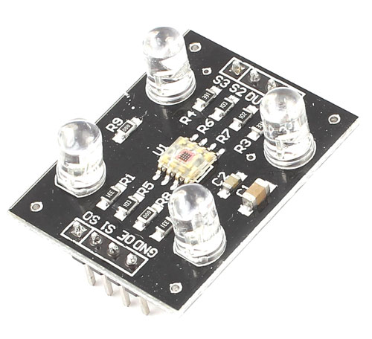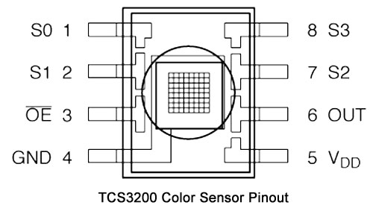

The **TCS3200 chip** consist of an 8 x 8 array of photodiodes. Each photodiode have either a red, green, or blue filter, or no filter. The filters of each color are distributed evenly throughout the array to eliminate location bias among the colors. Internal circuits includes an oscillator which produces a square-wave output whose frequency is proportional to the intensity of the chosen color.

### **Pin Configuration**

|  |  |  |
| --- | --- | --- |
| **PIN**  **NAME** | **PIN**  **NUMBER** | **DESCRIPTION** |
| GND | 4 | Power supply ground. All voltages are reference to the ground. |
| VCC | 5 | Supply voltage |
| OE | 3 | Enable for FO (Active low) |
| OUT | 6 | Output frequency (fo) |
| S0, S1 | 1, 2 | Select lines for output frequency scaling |
| S2, S3 | 7,8 | Select lines for photodiode type. |

|  |  |  |
| --- | --- | --- |
| S2 | S3 | PHOTODIODE TYPE |
| L | L | RED |
| L | H | BLUE |
| H | L | CLEAR (NO FILTER) |
| H | H | GREEN |

|  |  |  |
| --- | --- | --- |
| S0 | S1 | OUTPUT FREQUENCY SCALING(f0) |
| L | L | Power down |
| L | H | 2% |
| H | L | 20% |
| H | H | 100% |

1. RK-1211(Servo Motors) X2:

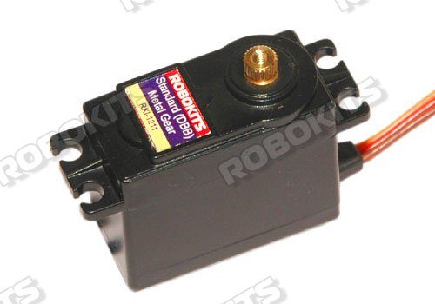

A Servo motor is a motor that can rotate an object with great precision. It can rotate in specific angle when given input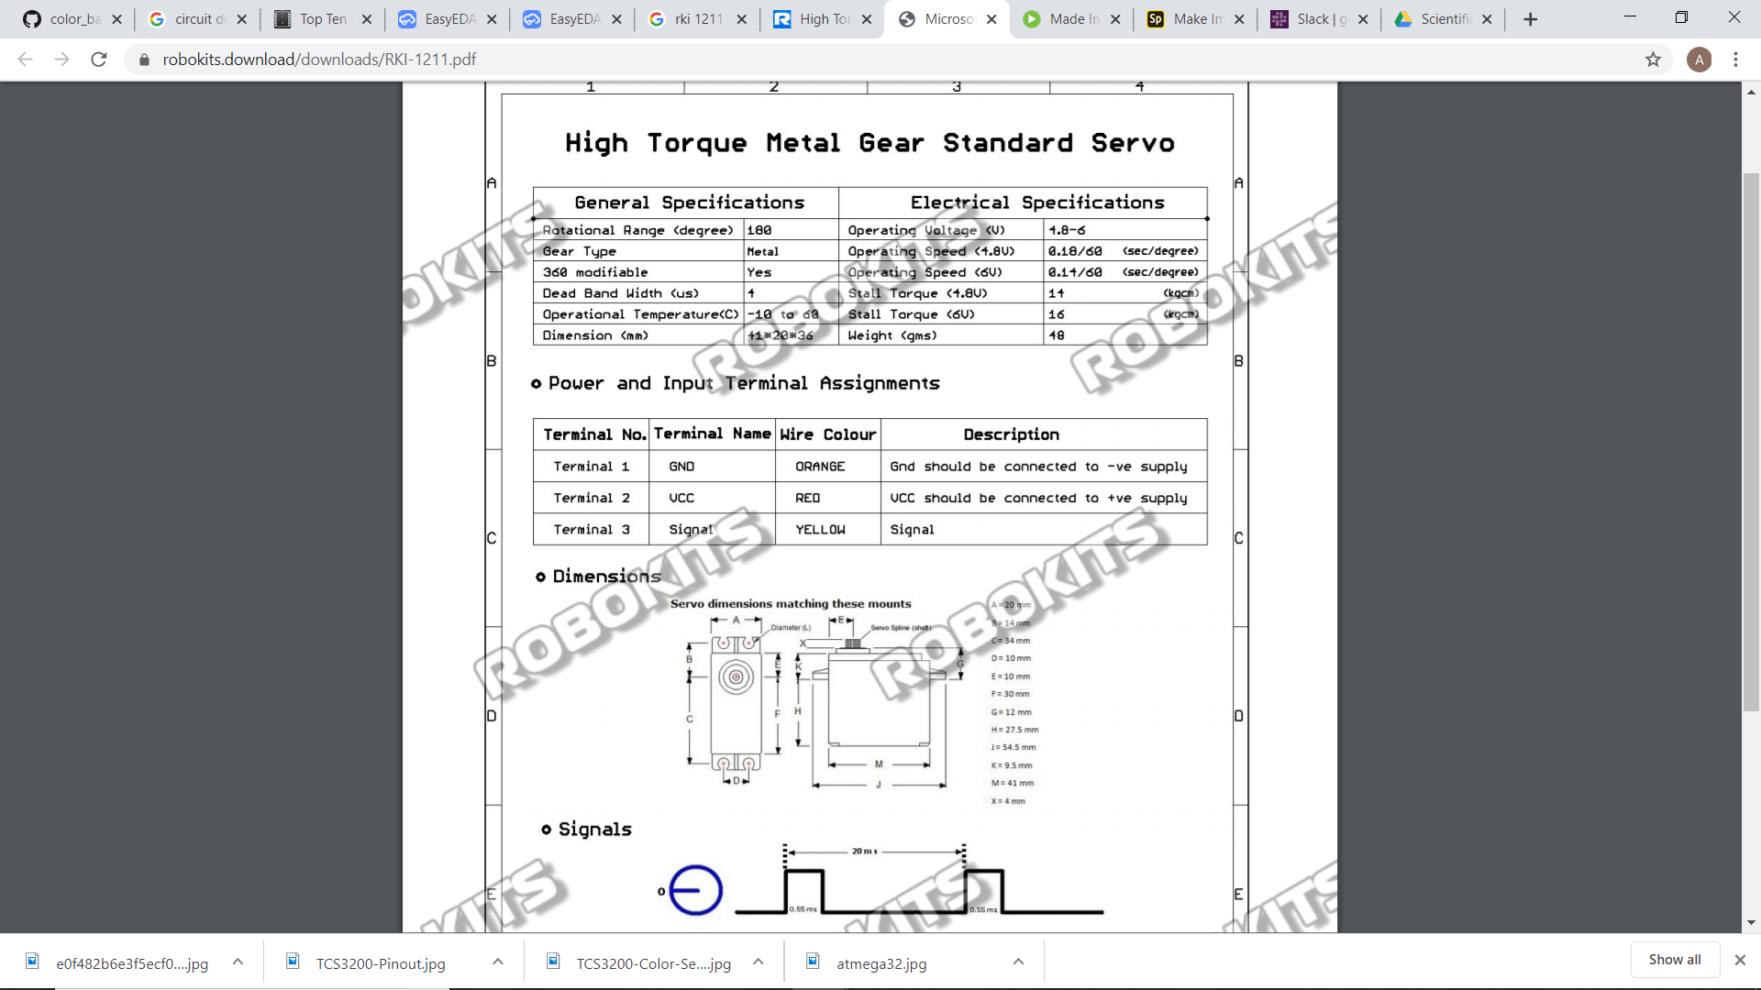

1. LM7805(voltage regulator):

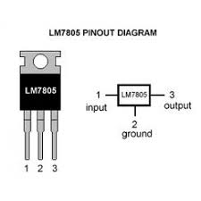

It converts a voltage supply above 5volts and below 40volts to 5volts.It provides a current of 1.5A

1. USB ASP PROGRAMMER:

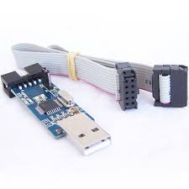

It is a USB in-circuit programmer for Atmel AVR micro-controllers.It is to burn the program into our avr(i.e ATMEGA32), which will execute when the atmega is powered.

1. PL2303 (USB to TTL):

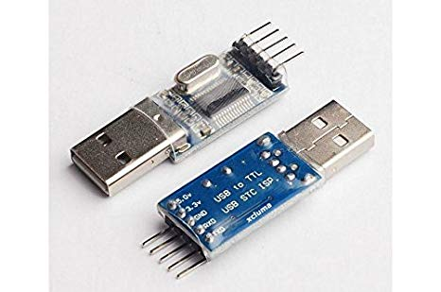

It is used to see the serial data that is being transmitted by the micro-controller (ATmega128 in our case). The software X-CTU is used to see the data being transmitted.