COMP.6210

Web Services & Design Methodologies

Web Application Design Assignment

Assignment 1 – Semester 1 2020

Submitted To: Submitted By:

Bruce Tuhakaraina Sonal

30022143

CONTENTS

1. SCP Subject…………...…………………………………………………2

2. SCP-002 4

3. SCP-003 5

4. SCP-004 7

5. SCP-005 8

6. SCP-006 9

**7. Database Screenshots…………………………………………..................................10**

**8. Cpanel………………………………………………………………………………...12**

**SCP SUBJECT DATABASE**

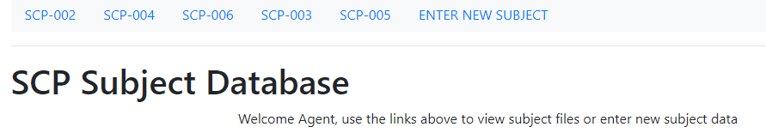

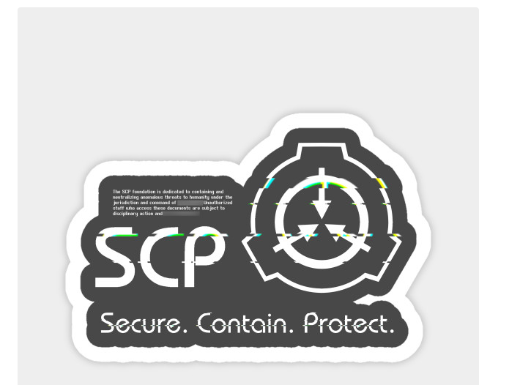

**SCP-002**

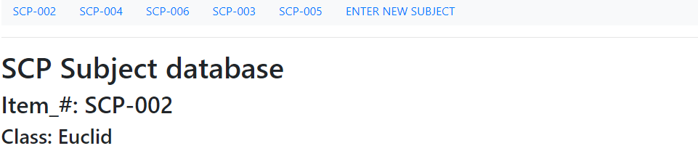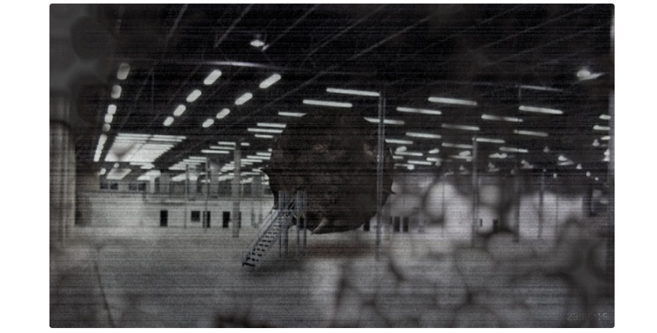

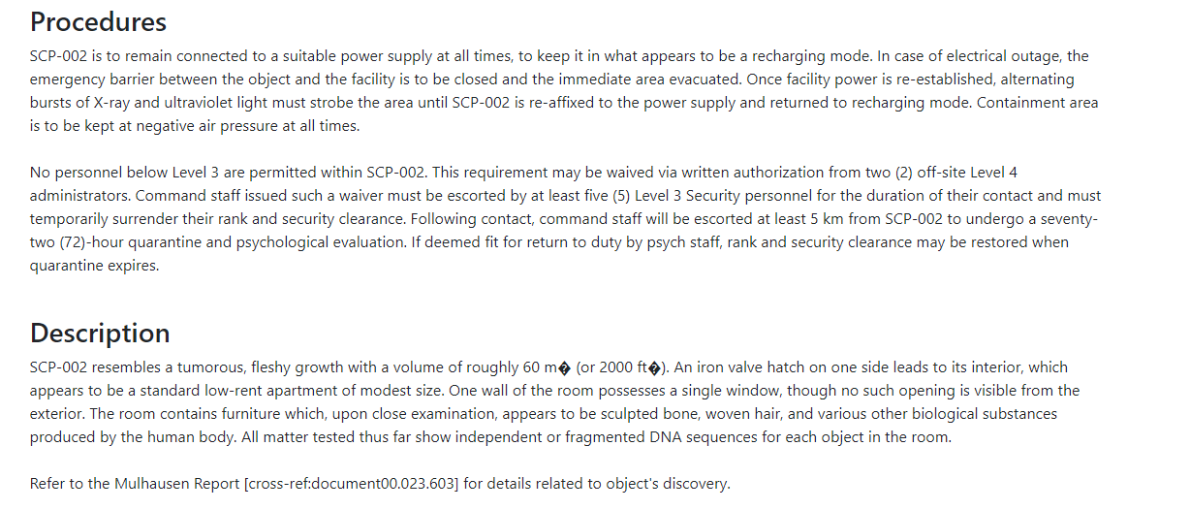

**SCP-003**

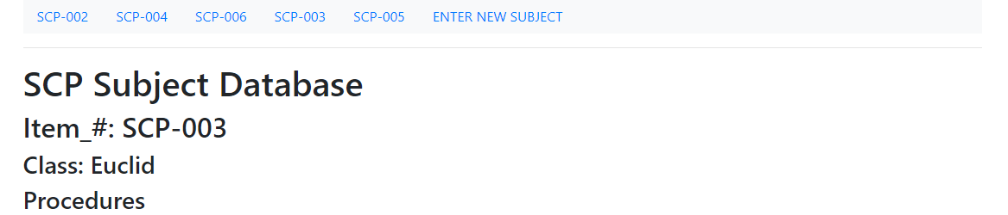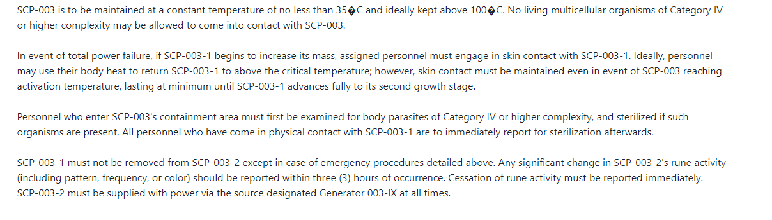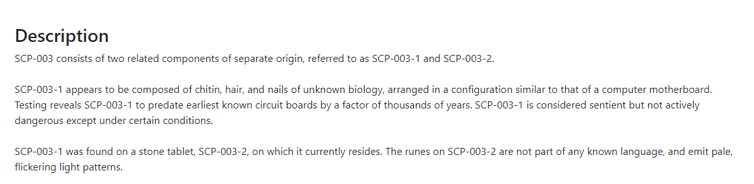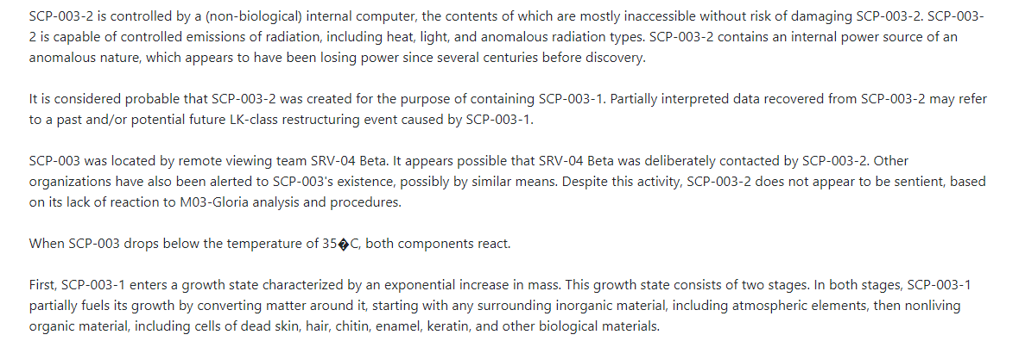

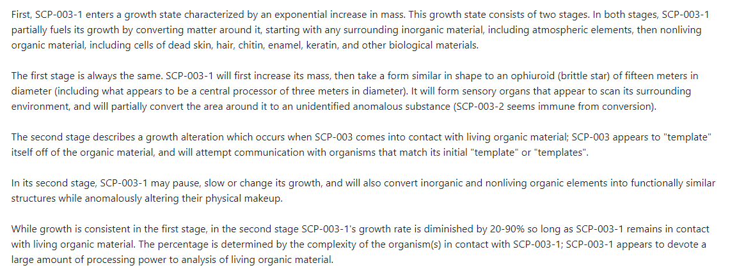

**SCP-004**

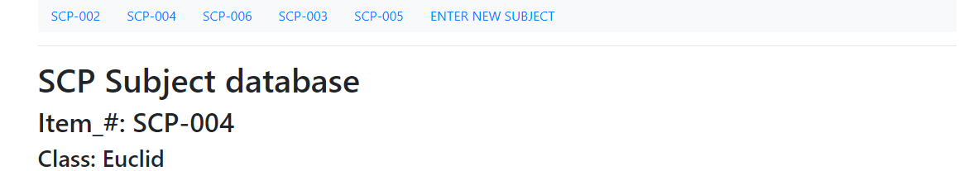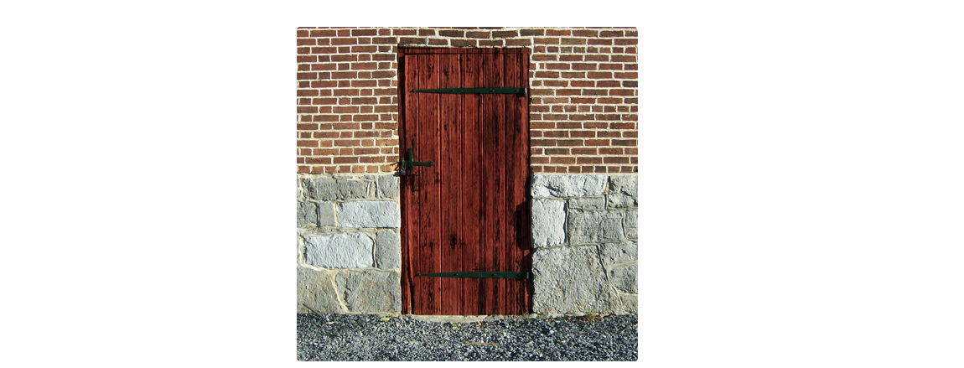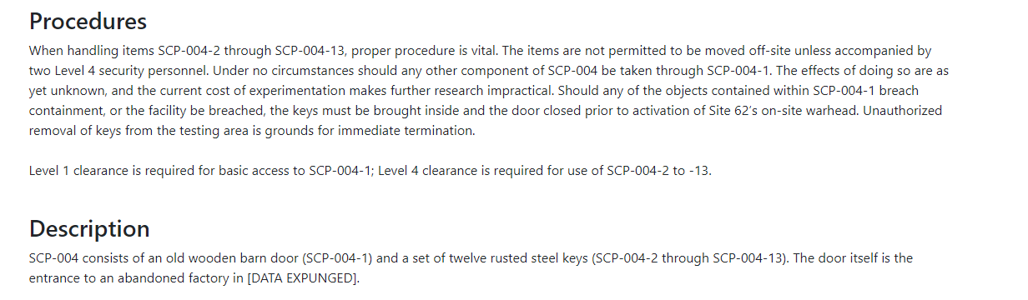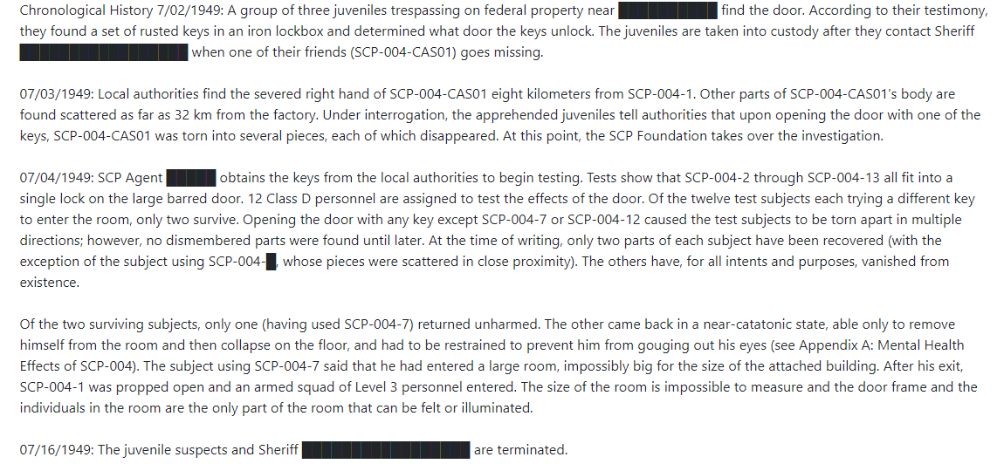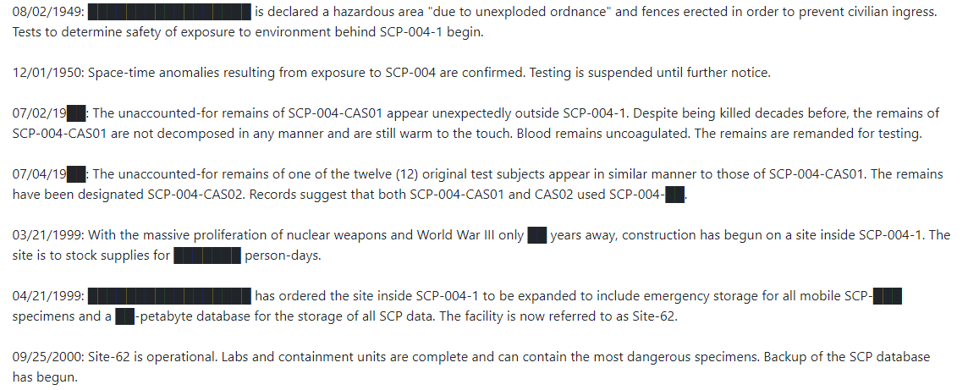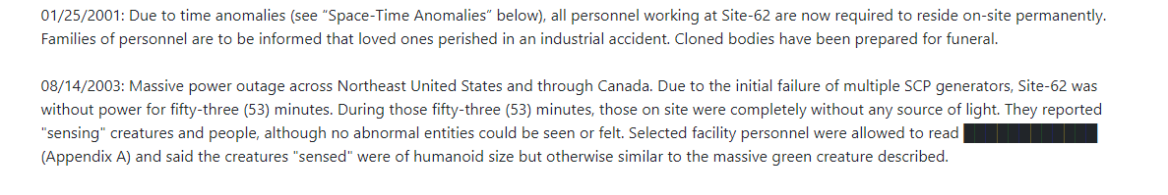

**SCP-005**

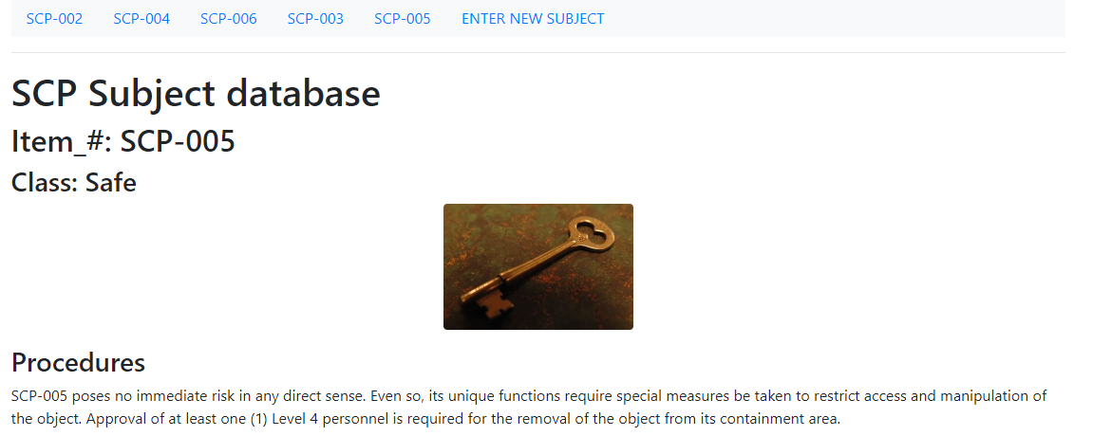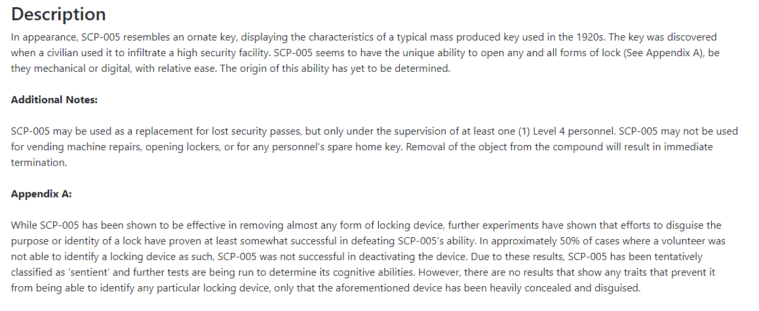

**SCP-006**

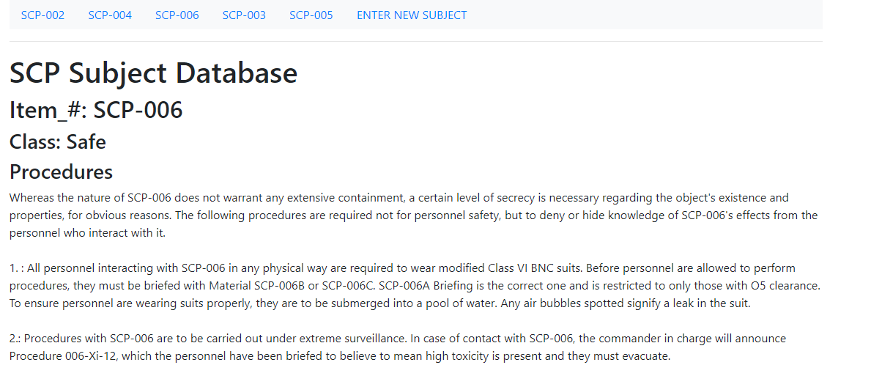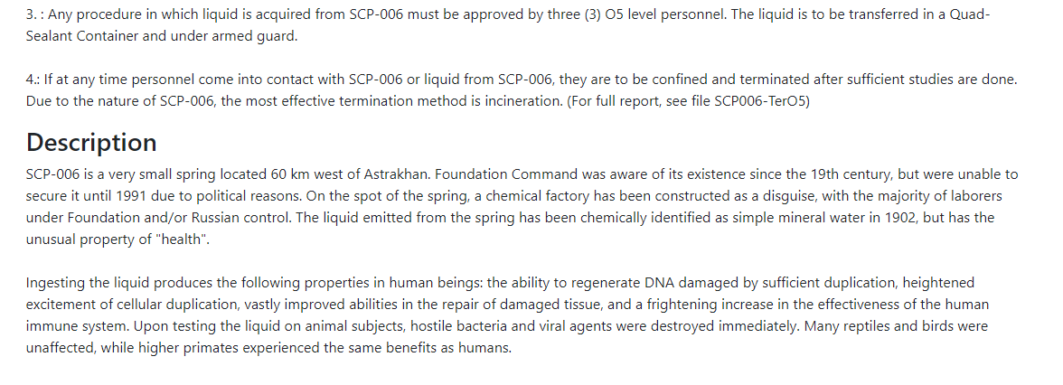

**DATABASE SCREESHOTS**

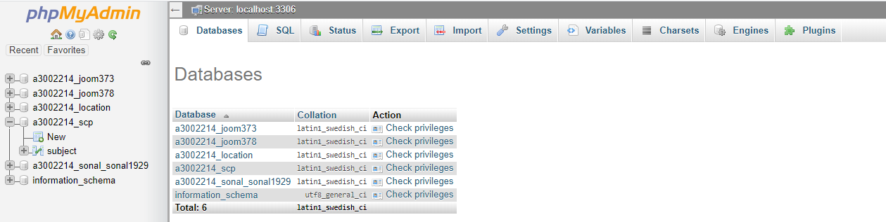

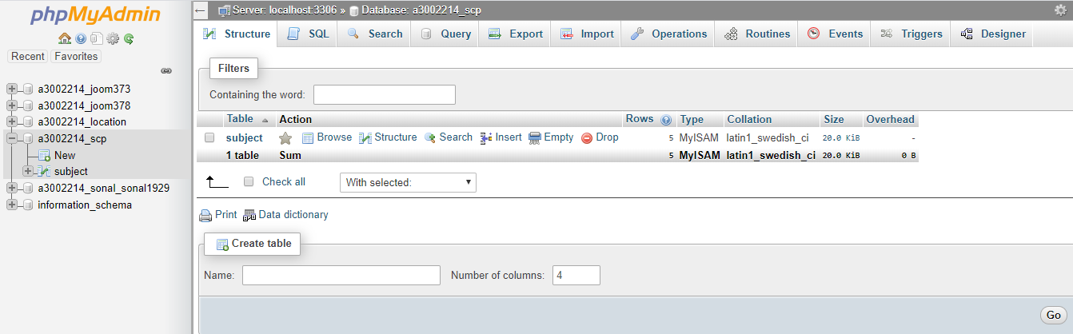

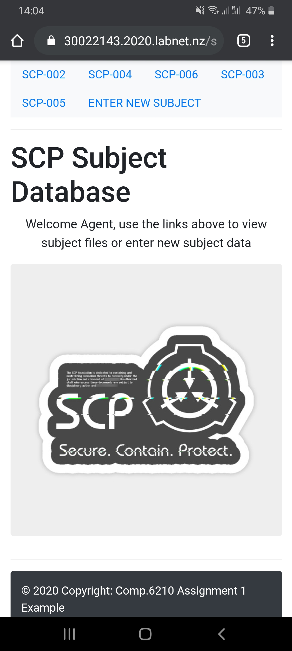

**CPANEL**

**Username:** a30022143

**Password:** mehaksonal1929

<https://github.com/jaiswalsonal446/scpp.git>

<https://30022143.2020.labnet.nz/scpp/>