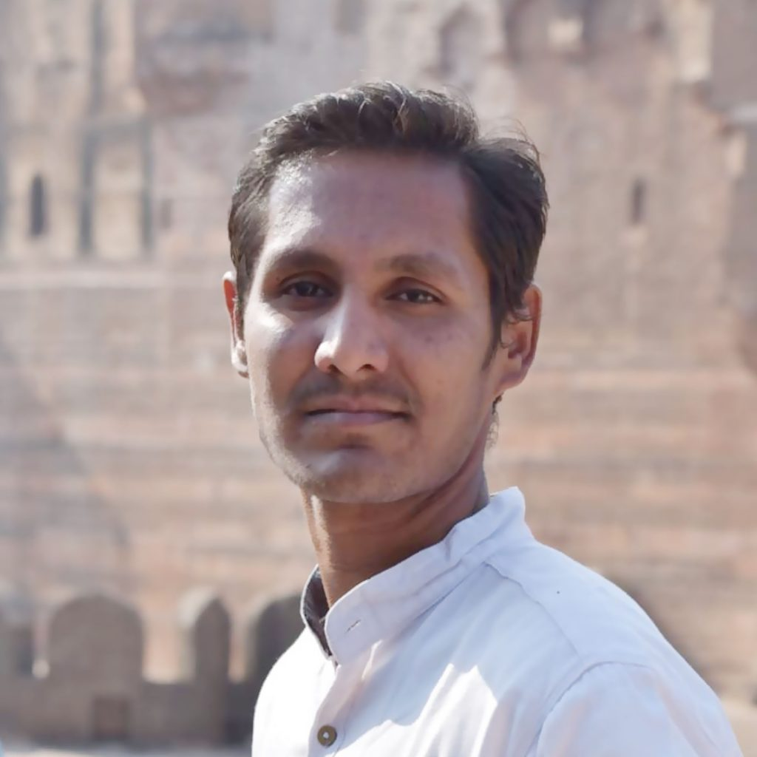

PAVANKUMAR
Mobile:- 08050481848
pavankamble01@gmail.com

WORK DESCRIPTION

- I have 3 years of Experience in WordPress Website and Ecommerce Website.
- User Interface (UI) applications using HTML, CSS & Bootstrap .
- Experience in WordPress frontend developer in Marketing Couch
- Developed User Interface (UI) applications and professional web applications using HTML, CSS, and Bootstrap.
- Good knowledge of working with browsers compatibility issues with browsers like IE, Firefox, Opera, and Chrome.
- Expertise in Responsive Web Design techniques with Bootstrap, and Grid supporting many browsers and devices.
- Hands-on experience with tools such as Edit Plus, Dreamweaver, Notepad++ and Visual Studio Code.
- Creating a WordPress Website with the Help of Elementor Plugins Using a Free Theme.
- Creating a Website in WordPress with the help of free themes and Paid themes.

technical knowLedge

Frameworks | Bootstrap 3/Bootstrap 4, Wordpress
UI Technologies | C, Java, Web Designing, HTML, HTML5, CSS 3, CSS, Javascript, Bootstrap
Debugging Tools | Chrome Developer Tools
Development Tools | Visual Studio Code
Graphic Designing | Adobe Photoshop CS6
Operating System | Windows 10/8.1/8/7
Computer Knowledge | Basic MS Office, Kannada & English Typing

PROFESSIONAL HISTREY

Employer : Marketing Couch
Designation : Web Developer/Wordpress Developer.
Date of Employment : April 2019 To April 2023
Current Location : Mumbai

EDUCATION QUALIFICATION

- Master of Computer Application – From BKIT College Bhalki Passed Out 2015 with 63.63%
- Bachelor of Computer Application – From Karnataka College Bidar Passed Out 2011 with 62.42%
- 12th - from Chhatrapti Shivaji College, Sawarmal passed out in 2008 with 71%
- 10th – from Sri Sai Aadarsh school bidar passed out 2005 with 55.84%

PROJECT EXPERIANCE

PROJECT: 1#

Project Name : TEXPLE
Duration : July-2022 to Jan-2023
Technology Stack : Wordpress.
Website Link : https://texple.com

Description: At Texple, we’re passionate about developing and employing digital solutions. The coherent energy behind our strategy and DevOps divisions keeps the brand’s applications and services at high velocity to consistently guide every piece of communication across platforms. Everything we do stems from an organization’s agenda. In our 5 years of existence, we have worked with brands from over 15 sectors, crafting creative solutions that give your brand the solution it requires to engage, compete, and thrive.

Roles& Responsibilities:
- Requirement Analysis, Design and Development.
- Create responsive website by using Wordpress.
- Installing Required Plugins.
- User Interface Development using HTML5, CSS3, Bootstrap, JavaScript.
- Cross Browser compatibility testing was performed.
- Regular checking of pages.
- Adding and removing the product of weekly deals pages.

PERSONAL PROFILE

- Name : PAVANKUMAR
- Father Name : Mallinath
- Date of Birth : 14th Jan 1990
- Gender : Male
- Marital Status : Single
- Languages Known : Hindi, Kannada, English,
- Permanent Address : Madhav Nagar , Mukthi Dham Behind
RRK School Plot No:-11, Naubad Road Bidar
Bidar (dist), Karnataka:- 585402.

DECLARATION

I hereby declare that the information furnished above is true to the best of my knowledge.

Date:

Place: (PAVANKAUMAR)

