DOCTORS EXAMINATION

|  |  |  |  |
| --- | --- | --- | --- |
| HEIGHT[cm]: | 158 | AGE: | 34 |
| BLOOD GROUP: | ''A' POSITIVE | WEIGHT [kg]: | 58 |
| TEMPERATURE: | 96.8 | SPO2: | 96 |

|  |  |  |  |  |
| --- | --- | --- | --- | --- |
| BLOOD PRESSURE: | | | | HEART RATE: |
| SYSTOLIC: | 120 | DIASTOLIC: | 70 | 89 |

# REMARKS: All Parameters are within Normal limits PRESENT COMPLAINTS:

**NIL**

# ADVICE: NIL

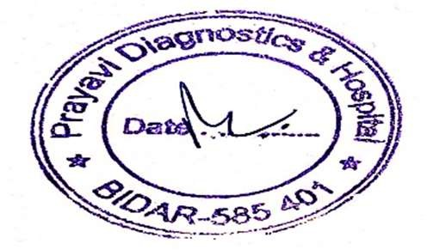**Note : Referred to Paryavi Hospital**

**DMO : SIGNATURE:**



### Hepatitis B Virus (HBsAg)

Hepatitis B Virus (HBsAg) Negative

#### Note:

**This is the screening test, Kindly confirm by ELISA/CLIA method.**

**END OF REPORT**



### Hepatitis C Virus (Hcv)

Hepatitis C Virus (Hcv) Non Reactive Index

**END OF REPORT**



### Liver Function Test

Bilirubin Total

Method : Jendrassik and Grof

Bilirubin Direct

Method : Diazonium

Bilirubin Indirect

Method : Calculation (T Bil - D Bil)

Alkaline Phosphatase

Method : PNPP-AMP Buffer/Kinetic

SGOT / AST

Method : IFCC without P5P

SGPT / ALT

Method : IFCC without P5P

Protein Total

Method : Biuret

Albumin

Method : BCG

Globulin

Method : Calculation (T.P - Albumin)

Albumin / Globulin Ratio

Method : Calculation (Albumin/Globulin)

0.6 0.3 - 1.0 mg/dL

0.1 0.0 - 0.2 mg/dL

0.4 0.2 - 0.8 mg/dL

98 30 - 120 U/L

22 Up to 31 U/L

18 Up to 34 U/L

6.8 6.6 - 8.7 gm/dL

5.0 3.5 - 5.2 gm/dL

2.6 2.5 - 3.5 gm/dL

2.1 1.0 - 2.1

**END OF REPORT**



|  |  |  |  |
| --- | --- | --- | --- |
| **Complete Blood Count (Cbc)** |  | | |
| HAEMOGLOBIN | 13.63 | 12-15 | gm/dL |
| Method : Automated/Cynmeth Method  TOTAL RBC COUNT | 4.36 | 3.80-4.80 | millions/cumm |
| Method : Electrical Impedance |  |  |  |
| P C V /H C T | 45 | 36-46 | % |
| Method : Calculated |  |  |  |
| M C V | 98.6 | 83 - 101 | fL |
| M C H | 28.36 | 27 - 32 | pg |
| M C H C | 31.56 | 31.50 - 34.50 | g/dL |
| Method : MCV/MCH/MCHC - Calculated  TOTAL WBC COUNT | 8945 | 4000 - 11000 | cells/cumm |
| Method : Electrical Impedance  PLATELET COUNT | 2.1 | 1.5 - 4.0 | lakhs/cumm |
| Method : Electrical Impedance |  |  |  |
| **DIFFERENTIAL COUNT** |  |  |  |
| POLYMORPHS | 57 | 40 - 80 | % |
| LYMPHOCYTES | 29 | 20 - 40 | % |
| EOSINOPHILS | 02 | 1 - 6 | % |
| MONOCYTES | 02 | 2 - 10 | % |
| BASOPHILS | 00 | 0 - 2 | % |
| **Method:** Automated Cellcounter & Microscopy |  |  |  |

**END OF REPORT**



### Hiv (1 & 2) Rapid test

Hiv (1 & 2) Rapid test Non Reactive

#### Note:

**This is the screening test, kindly confirm by ELISA/CLIA method.**

**END OF REPORT**



### Erythrocyte Sedimentation Rate (Esr)

Erythrocyte Sedimentation Rate (ESR)*

Method : Westergren's method

Interpretation :

18 0 - 20 mm

Erythrocyte sedimentation rate (ESR) is a usefull but non specific marker of underlying inflammation

ESR is decreased in: Polycythemia, hyper viscosity, sickle cell anemia, leukemia, low plasma protein (liver, kidney disease) and congestive heart failure.

Reference: Henry's Clinical Diagnosis and Management by Laboratory Methods, 22nd edition, Page-521

**END OF REPORT**



### Random Blood Sugar

RANDOM BLOOD GLUCOSE

Method : HEXOKINASE

98 70 - 140 mg/dL

**END OF REPORT**



|  |  |  |  |
| --- | --- | --- | --- |
| **Lipid Profile** |  | | |
| CHOLESTEROL | 141 | Desirable: <200 | mg/dL |
| Method : CHOD /POD |  | Borderline-high : 200 - 239  High : >/=240 |  |
| TRIGLYCERIDES | 90 | Normal : <150 | mg/dL |
| Method : CHOD /POD |  | Border line : 151 – 199  High : 200-499 |  |
|  |  | Very High > 500 |  |
| HDL | 45 | Desirable Level : > 60 | mg/dL |
| Method : CHOD /POD |  | Optimal : 40 - 59 |  |
|  |  | Undesirable < 40 |  |
| LDL Cholesterol | 123.6 | Optimal <100 | mg/dL |
| Method : Calculation |  | Near Optimal : 100 - 129 |  |
| VLDL Cholesterol | 29.6 | < 30 | mg/dL |
| Method : Calculation |  |  |  |
| CHOL / HDL Ratio | 3.5 | Low Risk: 3.3 - 4.4 |  |
| Method : Calculation |  | Average Risk : 4.5 - 7.1 |  |
|  |  | Moderate Risk : 7.2 - 11.0 |  |
| LDL Cholesterol / HDL Cholesterol Ratio | 1.5 | Desirable Level: 0.5 - 3.0 |  |
|  |  | Borderline Risk: 3.0 - 6.0 |  |
|  |  | High Risk: > 6.0 |  |
| NON HDL | 120 | < 130 |  |

Method : Calculation

**END OF REPORT**



### Malarial Parasite

Malarial Parasite

Method : Immunochromatography

Negative

**END OF REPORT**



|  |  |  |  |
| --- | --- | --- | --- |
| **Renal Function Test ( RFT)** |  | | |
| Blood Urea Nitrogen-BUN | 15 | 7 - 18 | mg/dL |
| Urea | 28 | 17 - 43 | mg/dL |
| Creatinine | 0.8 | 0.7 - 1.4 | mg/dL |
| Uric Acid | 4.6 | 3.5 - 7.2 | mg/dL |

**END OF REPORT**



### URINE ROUTINE

**PHYSICAL EXAMINATION**

COLOUR PALE YELLOW PALE YELLOW

APPEARENCE CLEAR CLEAR

REACTION /PH Acidic 6.5 4.6 - 8.0

SPECIFIC GRAVITY

Method : Ph Indicator

**CHEMICAL EXAMINATION**

PROTEINS

Method : Protein error of Indicator

GLUCOSE

Method : Benedicts Semi Quantitative

KETONE BODIES

Method : Nitroprusside Reaction/Rotheras Method

UROBILINOGEN

Method : Colour Reaction

1.020 1.003 - 1.035

NIL NIL

Absent NIL

NEGATIVE NEGATIVE

- 0.2 - 1.0 mg/dL

|  |  |  |
| --- | --- | --- |
| BILIRUBIN | NEGATIVE | NEGATIVE |
| **MICROSCOPIC EXAMINATION**  PUS CELLS | 2 - 4 /HPF | 0 - 5 /HPF |
| RBC. | NIL | NIL |
| EPITHELIAL CELLS | 1 - 2 /HPF | 0 - 8 /HPF |
| CASTS | NIL | NIL |
| CRYSTALS | NIL | NIL |
| OTHERS | NIL | NIL |
| **Method:** Reagent Strips and Microscopy. |  |  |

**END OF REPORT**

|  |  |  |  |
| --- | --- | --- | --- |
| **T3 T4 & TSH** |  | | |
| Total T3  Method : Chemiluminescence Immuno Assay (CLIA | **1.82** | 0.60 - 1.81 Adults Pregnancy : | ng/mL |
|  |  | First Trimester : 0.81-1.90 |  |
|  |  | Second Trimester : 1.00-2.60 |  |
|  |  | Third Trimester : 1.00-2.60 |  |
| Total T4 | 5.21 | 4.5 - 10.9 Adult | ?g/dL |
| Method : Chemiluminescence Immuno Assay (CLIA |  | Pregnancy : 6.4 - 10.7 |  |
| TSH | 2.39 | 0.46 - 8.10 < 1Year | ?IU/mL |
| Method : Chemiluminescence Immuno Assay (CLIA |  | 1 - 6 Yr: 0.65 - 5.9 |  |
|  |  | 7 - 11 Yr : 0.6 - 4.8 |  |
|  |  | 12 - 20 Yr: 0.5 - 4.3 |  |
|  |  | 0.3 - 4.5 Adult |  |
|  |  | Pregnancy : |  |
|  |  | First Trimester : 0.3-4.5 |  |
|  |  | Second Trimester: 0.5-4.6 |  |
|  |  | Third Trimester : 0.8-5.2 |  |

Note:

**Interpretation :**

Thyroid gland may result in excessive (Hyper) or below normal (Hypo) release of T3 or T4.

In Primary Hypothyroidism TSH levels are significantly elevated, while in secondary and tertiary hypothyroidism TSH levels are low.

1. TSH levels are subject to circadian variation, reaching peak levels between 2 - 4.a.m. and at a minimum between 6-10 pm .
2. Physiological rise in Total T3 / T4 levels is seen in pregnancy and in patients on steroid therapy.

**END OF REPORT**



**Iron**

Iron

Method : TPTZ

45 Adults :

Female : 60-180 Children : Newborn: 100-250

Infant : 40-100

Children : 50-120

?g/dL

* Measurements of serum iron, TIBC and the percentage of iron saturation of transferrin are useful screening tests for iron deficiency anaemia.
* May transiently rise after dietary or iron supplements & post blood transfusion.
* In the presence of acute & chronic inflammatory processes the concentrations of iron and transferrin in the serum are significantly affected.
* Concurrent measurement of the markers like Ferritin, Soluble Transferrin receptor and Hepcidin. provides a reliable work up for microcytic hypochromic anaemia.

**END OF REPORT**



### Magnesium

MAGNESIUM SERUM

Method : Calmagite

2.1 1.3 - 2.5 mEq/L

**END OF REPORT**



### Gamma Glutamyl Transferase Pronunciation ( Ggtp )

Sr. GAMMA G.T.

Method : ENZYMATIC

24 9 - 36 U/L

**END OF REPORT**



### C-Reactive Protein (Crp)

CRP

Method : Nephlometry

3.8 mg/L

CRP

Method : Turbidimetry

< 6.0 mg/L : Negative

< 6.0 mg/L : Negative

>/= 6.0 mg/L : Positive

mg/L

#### Interpretation:

Elevated CRP levels are seen in inflammatory disorders, neonatal septicema and following tissue injury. CRP levels can be used for risk assessment of cardiovascular and peripheral vascular disease. .

**END OF REPORT**



### Ferritin

#### Serum Ferritin

**Method : Chemiluminescence Immuno Assay (CLIA)**

Interpretation:

118 11.0 - 307 ng/mL

Serum ferritin has been found to be more and sensitive than serum iron for differentiating iron-deficiency anemia from anemia of chronic disease. For diagnostic purposes, the Ferritin findings should always be assessed in conjuction with the patients medical history, clinical examination and other findings.

**END OF REPORT**



### VDRL

Rapid Plasma Reagen (RPR)VDRL

Method : Slide Floculation

#### Interpretation :

Non Reactive

The Rapid Plasma Reagen (RPR) antigen is a microscopic nontreponemal flocculation test for detection and quantitation of anti lipoidal antibodies. Biological false positive results may be seen in presence of diseases such as, leprosy, malaria, toxoplasmosis, infectious mononucleosis or lupus erythmatosis.

**END OF REPORT**



### Blood Grouping

Blood Group (ABO group)

Method : Tube

" A "

Rh Type ( D) POSITIVE

#### Interpretation :

Records of previous blood grouping/Rh typing not available. Please verify before transfusion.

**END OF REPORT**



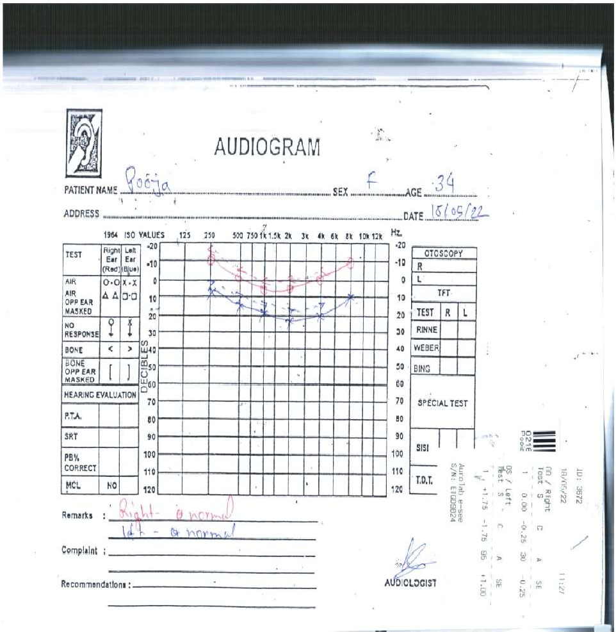

|  |  |
| --- | --- |
| RIGHT EAR: | NORMAL |
| LEFT EAR: | NORMAL |

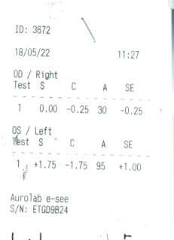

|  |  |
| --- | --- |
| RIGHT EYE: | -0.25 |
| LEFT EYE: | +1.00 |

LUNG FUNCTION

# PRAYAVI HOSPITAL BIDAR

|  |  |  |  |  |  |
| --- | --- | --- | --- | --- | --- |
| **PatientInfo**  **Name** | **rmation**  POOJA | Test Type | | | FVL (ex/in) |
| ID | 01 | Test Date | | | 5/18/2022 10:02:01AM |
| Age | 34 | Interpretation | | | GOLD(2008)/HardieHank |
| Height Weight Gender | 158 cm  58 kg Female | Predicted  Value Selection | | | inson (NHANES III), 1999*0.95  Best Trial |
| Ethnicity | Asian |  | | |  |
| Asthma | -- |  | | |  |
| Smoker | -- |  | | |  |
|  |  |  |  | Pre Best | |
| Parameter |  | Pred | LLN | ~~Trial 2~~Z-Score | |
| FVC [L] |  | 3.03 | 2.47 | 4.49 4.25 | |
| FEV1 [L] |  | 2.60 | 2.13 | 2.78 0.61 | |
| FEV1/FVC |  | 0.844 | 0.746 | 0.619* -3.77 | |
| FEF25-75 [L/s] |  | 3.19 | 2.13 | 0.36* -4.41 | |

PEF [L/s] FET [s] FIVC

[L] PIF [L/s]

6.27

- 3.03

-

4.81

- 2.47

-

2.38*

5.1

0.19*

0.04

-4.37

-

-8.35

-

System Interpretation Pre No interpretation, not enough acceptable maneuvers

Caution: Poor session quality. Interpret with care.

* Indicates value outside normal range or significant post change.

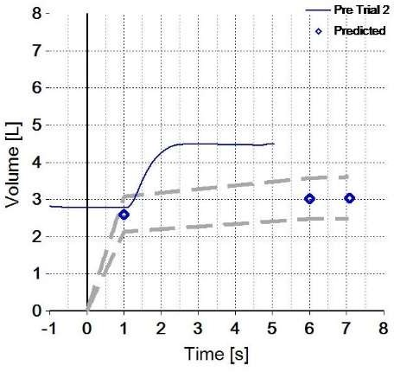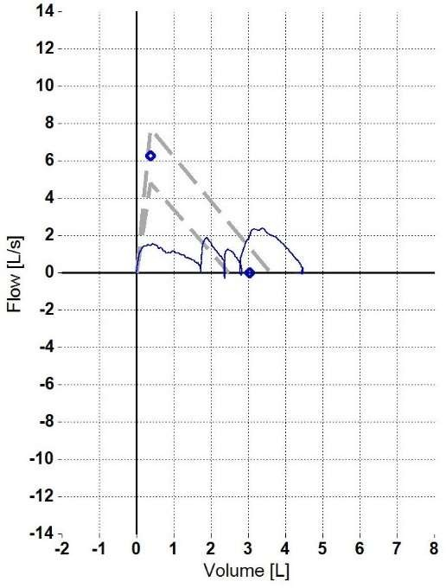

## LABOUR CARD

