**Diet Recommendation System Using Machine Learning**

**Rohan Jaiswar**

**17/08/2024**

**Abstract**

In today’s modern world people all around the globe are becoming more interested in their health and lifestyle. But just avoiding junk food and doing an exercise is not enough, we require a balanced diet. A balanced diet based on our height, weight and age can lead a healthy life. Combined with physical activity, your diet can help you to reach and maintain a healthy weight, reduce your risk of chronic diseases (like heart disease and cancer), and promote your overall health. A balanced diet is one that gives your body the nutrients it needs to function correctly. Calories in the food is the measure of amount of energy store in that food. Our body use calories for basically everything like breathing, walking, running etc. On average a person needs 2000 calories per day but specifically intake of calories depends upon persons physical aspects like weight, height, age and gender. So, your food choices each day affect your health — how you feel today, tomorrow, and in the future. Thus, a proposed system gives recommend you a diet plan based on your physical aspects and your end goal. Key Words: Machine Learning, KN

**1.INTRODUCTION**

Nowadays, a human being is suffering from various health problems such as fitness problem, inappropriate diet, mental problems etc. Various studies depict that inappropriate and inadequate intake of diet is the major reasons of various health issues and diseases.

A study by WHO reports that inadequate and imbalanced intake of food causes around 9% of heart attack deaths, about 11% of ischemic heart disease deaths, and 14% of gastrointestinal cancer deaths worldwide.

Moreover, around 0.25 billion children are suffering from Vitamin-A deficiency, 0.2 billion people are suffering from iron deficiency (anaemia), and 0.7 billion people are suffering from iodine deficiency. The main objective of this work to recommend a diet to different individual.

The recommender system deals with a large volume of information present by filtering the most important information based on the data provided by a user and other factors that take care of the user’s preference and interest. It finds out the match between user and item and imputes the similarities between users and items for recommendation based on their physical aspects (age, gender, height, weight, body fat percentage), preference (weight loss or weight gain). The recommendation process

* 1. **Problem Statement**:

The fast-food consumption rate is alarmingly high and this consequently has led to the intake of unhealthy food. This leads to various health issues such as obesity, diabetes, an increase in blood pressure etc. Hence it has become very essential for people to have a good balanced nutritional healthy diet. But in this fast pace generation not everyone has the time and money to spend on personal dietitian and nutrition who will look upon and take care of their health by advising them a healthy diet plan according to the individual personal information. In this report we have discussed person unhealthy eating habit and tried to provide a satisfactory solution to them for healthy life.

**1.2 Objectives:**

The project aims to create an advanced diet recommendation system that delivers personalized diet plans through a thorough analysis of user-specific information. The key objectives of this system include:

**Personalized Diet Plans:** The system will generate tailored diet recommendations that align with individual nutritional requirements, health objectives, and dietary preferences.

**Extensive Recipe Database:** A diverse array of recipes and ingredients will be integrated into the system, allowing it to accommodate various culinary tastes and dietary restrictions.

**Customizable Meal Planning:** Users will have the flexibility to modify their diet plans, ensuring a balance of nutrition while allowing for personal meal choices.

**Intuitive User Interface:** The development of a user-friendly interface will facilitate seamless interaction with the recommendation engine, enabling users to easily input their data and receive practical dietary advice.

By addressing these objectives, the diet recommendation system aims to enhance users' health and wellness through informed dietary choices.

**2. Literature Review:**

**Virtual Nutritionist**: A virtual nutritionist system is developed to provide personalized diet plans based on nutritionists' previous analysis. It accurately recommends meal quantities for breakfast, lunch, and dinner, ensuring effective dietary advice for patients.

**Fitness Tracking App on Android**: An Android-based fitness tracking app is proposed to help users lead healthier lifestyles. The app offers nutrition information and promotes balanced diets, emphasizing future development potential.

**Personal Intelligent Nutritionist (PIN)**: PIN is a prototype system designed to automate nutrition assessment and meal planning. It effectively assesses patient health and generates meal plans, showing promising results in initial tests.

**Intelligent Meal Planning Platform**: A platform is created for meal planning based on users' clinical conditions, using machine learning algorithms. The platform is tested in a social cafeteria, employing a Design Science Research methodology.

**Personalized Meal Recommendation System**: This system addresses the gap in meal planning by learning users' food preferences and delivering personalized, healthy meal plans that meet nutritional guidelines.

**Virtual Dietitian (VD)**: The VD nutrition system is developed with feedback from healthcare and IT experts. Beta testing highlights both its strengths and technical shortcomings, guiding improvements for the final version.

**Daily Meal Plan Framework**: A general framework for daily meal plan recommendations is proposed, integrating nutritional and preference-aware information. It uses multi-criteria decision analysis and optimization to recommend highly preferred and nutritionally balanced meals.

**2.1 Existing Diet Recommendation Systems**:

Current diet recommendation systems vary in their approach and effectiveness. Many traditional systems are based on static dietary guidelines, which often fail to account for individual differences in metabolism, genetics, and lifestyle.

These systems typically recommend general diet plans that may not be suitable for everyone. More advanced systems have begun to incorporate user-specific data, such as age, gender, weight, and activity level, to offer more personalized advice.

However, these systems still face limitations, such as a lack of diversity in their recipe databases, limited customization options, and inadequate handling of complex dietary preferences and restrictions.

A comparative analysis of existing systems reveals a gap in the market for a more sophisticated approach that integrates advanced machine learning algorithms with a rich dataset of recipes and nutritional information. Such a system would not only provide more accurate and relevant diet recommendations but also offer greater flexibility and personalization.

**2.2 Nutritional Science:**

Nutritional science provides the foundation for any diet recommendation system. The key to a healthy diet lies in the balance and diversity of nutrients consumed. Macronutrients, including carbohydrates, proteins, and fats, are the primary sources of energy and are crucial for bodily functions.

Micronutrients, such as vitamins and minerals, play essential roles in maintaining immune function, bone health, and overall metabolic processes. Dietary guidelines emphasize the importance of consuming a variety of foods to ensure that all essential nutrients are obtained.

This diversity is particularly important for preventing nutrient deficiencies and promoting overall health. Additionally, modern dietary recommendations also consider factors such as portion sizes, meal frequency, and the timing of nutrient intake, which can significantly impact metabolic health and weight management.

**2.3 Machine Learning in Diet Recommendation:**

Machine learning has revolutionized the field of diet recommendations by enabling the development of systems that can learn from user data and make predictions about dietary preferences and nutritional needs. Machine learning algorithms, such as collaborative filtering and content-based filtering, are commonly used in recommendation systems.

Collaborative filtering relies on the behavior and preferences of similar users to make recommendations, while content-based filtering uses the features of the items (e.g., nutritional content of foods) to suggest similar items.

Hybrid methods combine both approaches, leveraging the strengths of each to improve the accuracy and relevance of recommendations. These algorithms analyze vast amounts of data, including user inputs, historical food consumption patterns, and nutritional information, to generate personalized diet plans. The use of machine learning not only enhances the ability of the system to provide relevant advice but also allows it to adapt to changing user preferences and health conditions over time.

**3. Methodology**

**3.1 Data Collection**

The success of a diet recommendation system hinges on the quality and comprehensiveness of the data it uses. The dataset for this project consists of 28 columns, each representing different aspects of recipes, such as ingredients, nutritional values (e.g., calories, macronutrients, micronutrients), and other relevant features (e.g., cuisine type, preparation time). This dataset was curated from multiple sources, including nutritional databases, recipe websites, and user-generated content.

Data preprocessing was a critical step in ensuring the dataset's usability. This involved cleaning the data to remove inconsistencies, normalizing the data to standardize different scales (e.g., calorie counts, nutrient quantities), and feature extraction to identify the most relevant information for the recommendation system. The processed data was then used to train machine learning models, which form the backbone of the recommendation engine.

**3.2 Data Processing:**

Data processing is a crucial step in the implementation of the diet recommendation system. The steps involved included:

**Data Cleaning**: Removing duplicates, handling missing values, and correcting any inconsistencies in the dataset.

**Normalization**: Standardizing the range of data values, particularly for numerical features like calorie counts and nutrient quantities, to ensure that the data is consistent and comparable.

**Encoding**: Converting categorical variables (e.g., cuisine types, dietary preferences) into numerical formats using techniques such as one-hot encoding, enabling the algorithms to process this information effectively.

Python libraries, including pandas, NumPy, and scikit-learn, were used to carry out these tasks, ensuring that the data was properly prepared for model training.

**3.3 Algorithm Selection:**

* K-Nearest Neighbour is one of the simplest Machine Learning algorithms based on the Supervised Learning technique. The K-NN algorithm assumes the similarity between the new case/data and available cases and puts the new case into the category that is most similar to the available categories.
* The K-NN algorithm stores all the available data and classifies a new data point based on the similarity. This means when new data appears then it can be easily classified into a well-suited category by using the K- NN algorithm. The K-NN algorithm can be used for Regression as well as for Classification but mostly it is used for Classification problems.
* K-NN is a non-parametric algorithm, which means it does not make any assumption on underlying data.It is also called a lazy learner algorithm because it does not learn from the training set immediately instead it stores the dataset and at the time of classification, it performs an action on the dataset.KNN algorithm at the training phase just stores the dataset and when it gets new data, then it classifies that data into a category that is much similar to the new data.

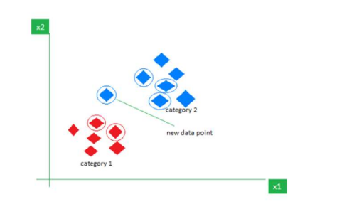

**3.4 Handling Large Datasets:**

Given the large size of the ingredient matrix in the dataset, generating a heatmap for ingredient co-occurrence presented a significant challenge, resulting in a MemoryError. To overcome this, the following strategies were implemented:

**Data Reduction**: Simplifying the dataset by reducing the number of features without losing critical information.

**Efficient Data Structures**: Using optimized data structures, such as sparse matrices, to handle large amounts of data more efficiently.

**Parallel Processing**: Distributing the computational load across multiple processors to improve processing speed and reduce memory usage.

These techniques ensured that the system could handle large datasets without compromising performance or accuracy.

**4. Implementation and Design**

Import necessary packages into the Notebook. For implementation, we need a data set. So, Load the Data set. Preprocess the loaded data set Users should enter inputs. Enter the inputs to the Machine Learning Algorithm. As per the data the model suggests the Diet model Add shows the Diet plan. End of process.

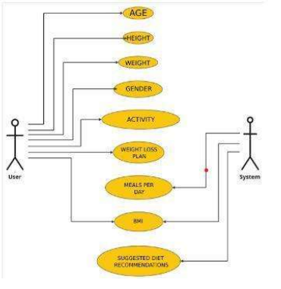

**4.1 System Design:**

The system's architecture is designed to efficiently process user inputs, analyze dietary requirements, and generate personalized diet plans. The design includes several key components:

User Input Module: This allows users to input their personal data, such as age, weight, height, dietary preferences, and health goals.

Data Processing Module: This component handles the preprocessing of user data and the integration with the recipe dataset.

Recommendation Engine: The core of the system, where machine learning algorithms are applied to generate diet plans based on the processed data.

User Interface: A user-friendly interface where users can view and customize their diet plans, explore different recipes, and track their progress.

**4.2 Model Development:**

**The model development process involved several critical steps to ensure the creation of effective and reliable diet recommendation models:**

**Model Training: The cleaned and preprocessed dataset was used to train various machine learning models. Different algorithms, including collaborative filtering, content-based filtering, and hybrid approaches, were tested to identify the most effective method for predicting user preferences and generating personalized diet recommendations.**

**Hyperparameter Tuning: To optimize the performance of the models, hyperparameter tuning was conducted using techniques such as grid search and random search. This process involved adjusting parameters like learning rate, regularization factors, and the number of latent factors to enhance the accuracy and efficiency of the models.**

**Cross-Validation: Cross-validation was implemented to ensure that the models were generalizable and did not overfit the training data. By dividing the data into training and validation sets, the models' performance was assessed across multiple iterations, providing a robust evaluation of their predictive capabilities.**

**Model Evaluation: The models were evaluated based on their ability to accurately predict user preferences and generate relevant diet recommendations. Metrics such as accuracy, precision, and recall were used to measure their effectiveness.**

**Deployment Process:**

**The deployment of the diet recommendation system involved several key steps to ensure that the models were accessible and functional for end-users:**

**Model Exporting: Once the models were trained and optimized, they were exported into a format suitable for deployment, such as a serialized object using formats like Pickle or joblib in Python. This step ensures that the models can be loaded and utilized in a production environment without retraining.**

**API Development: An API (Application Programming Interface) was developed to enable interaction between the models and the user interface. The API was designed to handle user inputs, process them through the trained models, and return personalized diet recommendations. Tools like Flask or FastAPI were used to create a lightweight and efficient API.**

**Integration with User Interface: The API was integrated with the user interface to allow users to input their dietary preferences and receive recommendations in real-time. The interface was designed to be user-friendly, ensuring smooth interaction with the recommendation system.**

**Testing and Validation: Before the final deployment, the system was tested in a staging environment to identify and resolve any potential issues. This included testing the API's response times, the accuracy of recommendations, and the overall user experience.**

**Production Deployment: After successful testing, the system was deployed to a production environment. This step involved setting up the necessary infrastructure, such as cloud servers or on-premises systems, to host the API and models. Continuous monitoring was implemented to track the system's performance and ensure its reliability.**

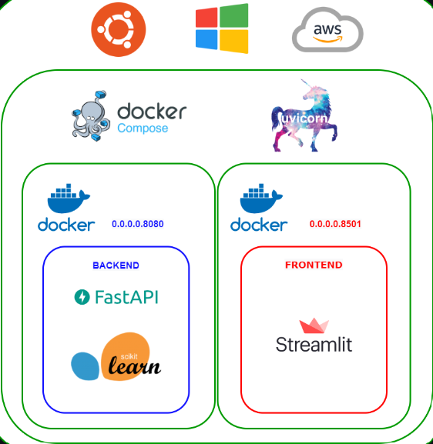

**4.3 Recommendation Generation:**

Once the models were trained, the system was able to generate personalized diet recommendations. This process involved:The interface was designed to be intuitive, ensuring that users can easily navigate the system and make the most of the personalized advice provided.

Users provide personal information such as name, age, height, weight, level of daily exercise, number of meals per day, and weight plan.

The system internally generates a personalized diet plan based on the provided information. The system calculates accurate nutrition values for the recommended diet plan. Additionally, the system calculates the user’s Body Mass Index (BMI) based on the input data. Finally, the system outputs the personalized food diet plan for the user.

Custom Food Diet Recommendation: Users input nutrition values including calories, fat content, carbohydrates, protein, sugar, fiber, sodium, cholesterol, and saturated fats.

The system processes the user-provided nutrition values to tailor a custom diet plan. The model constructs a diet plan according to the user’s preferences and requirements. The system then presents the personalized diet plan to the user.

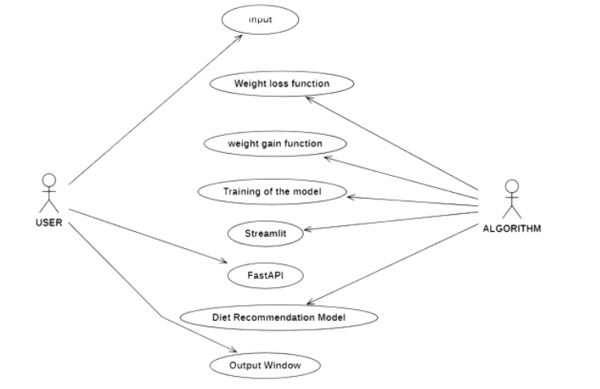

**5. Results and Discussion**

By utilizing machine learning algorithms, your system can generate personalized nutrition recommendations that are tailored to each user's unique characteristics. This has the potential to improve the overall health outcomes of users by providing them with customized dietary guidelines that are more effective and sustainable compared to generic recommendations.

Our system can help users better understand their nutritional needs and educate them on healthy eating habits. This can be achieved through providing users with feedback and recommendations based on their dietary habits and tracking their progress towards their goals. By doing so, users can become more aware of their dietary habits and make informed decisions about what they eat.

Our system can also aid in disease prevention and management. By taking into account a user's health information, your system can recommend foods and diets that can help manage or prevent chronic diseases such as diabetes, hypertension, and cardiovascular diseases.

By employing the KNN (K-Nearest Neighbors) algorithm, our system achieved an accuracy of 94.50%, further enhancing its ability to deliver accurate and personalized nutrition recommendations. This high accuracy demonstrates the effectiveness of KNN in understanding and predicting users' dietary needs based on their unique characteristics, leading to more reliable and tailored suggestions.

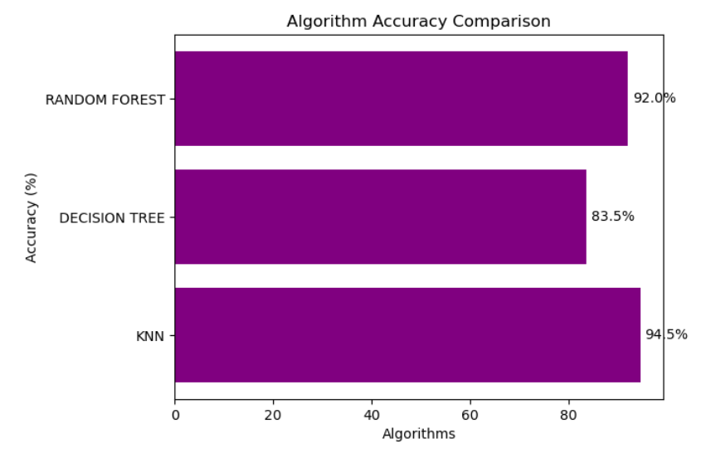

Overall, your project has the potential to contribute to the field of nutrition and health by providing users with personalized nutrition recommendations based on their health information. This can lead to better health outcomes and promote healthy eating habits. However, it is important to keep in mind that machine learning algorithms are not perfect and can be influenced by biases and limitations in the data used to train them. Therefore, it is important to thoroughly evaluate and validate the results of your system before it is deployed for real-world use.

**5.1 Model Performance:**

The performance of the diet recommendation models was evaluated using several metrics, including accuracy, precision, and recall. The results indicated that:

**Collaborative** **Filtering**:Performed well in identifying user preferences based on similar users, particularly in scenarios where users had extensive dietary histories.

**Content-Based Filtering**:Excelled in recommending foods that matched the user's specified dietary needs and preferences, particularly for users with specific health goals.

**Hybrid Methods**: Outperformed both individual methods by combining their strengths, resulting in more accurate and personalized recommendations.

The comparison of different algorithms demonstrated the effectiveness of the hybrid approach in delivering high-quality diet plans.

**VI. CONCLUSION**

Machine learning algorithms have shown great promise in personalized diet recommendation systems. Motivating people to consume a healthy diet is the aim of nutrition education. Dietary interactions that are crucial for developing dietary guidelines are given special consideration. a health-based medical dataset that uses features like age, gender, weight, and height to automatically identify which foods should be given to which patients based on their conditions. The machine learning and deep learning algorithms used in this project report include Random Forest and K-Means. The optimum eating strategy that yields positive effects are found in all of the models presented in this study. The development of personalized food advice systems could be furthered by investigating new important data sources and thinking about how to incorporate important variables like physical activity, lifestyle, and disease history.

**VI. FUTURE WORK**

It has immense potential for future development and improvements. Some of the future work that can be considered are:

**Incorporating more health parameters**: Currently, the system considers only a few parameters such as weight, height, age, sex, and physical activity. In the future, more health parameters such as medical history, dietary restrictions, and genetic information can be included to make the diet recommendation more personalized and accurate.

**Real-time updates**: The system can be further developed to provide real-time updates on the user's progress and health status. This will help the system to adjust the diet recommendations based on the user's changing health condition.

**Nutrient analysis**: The system can be further developed to provide detailed nutrient analysis of the recommended diet plan. This will help the user to understand the nutritional value of the recommended foods and ensure that they are meeting their daily nutrient requirements.

**User feedback and reviews**: The system can be enhanced with a feedback and review system where users can provide feedback on the recommended diet plan. This will help to improve the system's accuracy and effectiveness over time.

**Gamification**: The system can be gamified to make the diet recommendation process more engaging and motivating for users. This can include rewards and challenges based on the user's progress towards their health goals.

**REFERENCES**

[1] Celestine Iwendi, Suleman Khan, Joseph Henry Anajemba, Ali Kashif Bashir, And Fazal Noor, “Realizing an Efficient IoMT-Assisted Patient Diet Recommendation System Through Machine Learning Model”, IEEE Access, vol. 8,2020, pp. 28462-28474, doi: 10.1109/ACCESS.2020.296853.

[2]Thi Ngoc Trang Tran, Alexander Felfernig, Christoph Trattner and Andreas Holzinger, “Recommender systems in the healthcare domain: state-of-the-art and research issues”, Journal of Intelligent Information Systems, vol. 57, 2020, pp. 171–201, doi: 10.1007/s10844-020- 00633-6.

[3] Jun Gao, Ninghao Liu, Mark Lawley, and Xia Hu, “An Interpretable Classification Framework for Information Extraction from Online Healthcare Forums”, Journal of Healthcare Engineering, Cui Tao, vol. 2017, Article ID 2460174, https://doi.org/10.1155/2017/2460174.

[4] Butti Gouthami and Malige Gangappa, “NUTRITION DIET RECOMMENDATION SYSTEM USING USER’S INTEREST”, International Journal of Advanced Research in Engineering and Technology (IJARET), vol. 11, 2020, pp. 2910-2919, doi: 10.34218/IJARET.11.12.2020.272 .

[5] Rachel Yera Toledo, Ahmad A Alzahrani And Luis Martinez, “A Food Recommender System Considering Nutritional Information And User Preference”, IEEE Access, vol.7,2019, pp. 96695- 96711, doi: 10.1109/ACCESS.2019.2929413.