- Process > name
- Setting > app/web recorder > filter by > tick classic
- Open Notepad and keep it aside
- Activities > open application > drag and drop
- Indicate notepad
- Activities> type into > indicate notepad type area > text: ‘kkkkkkk’
- Activities > mouse> click > select cross sign
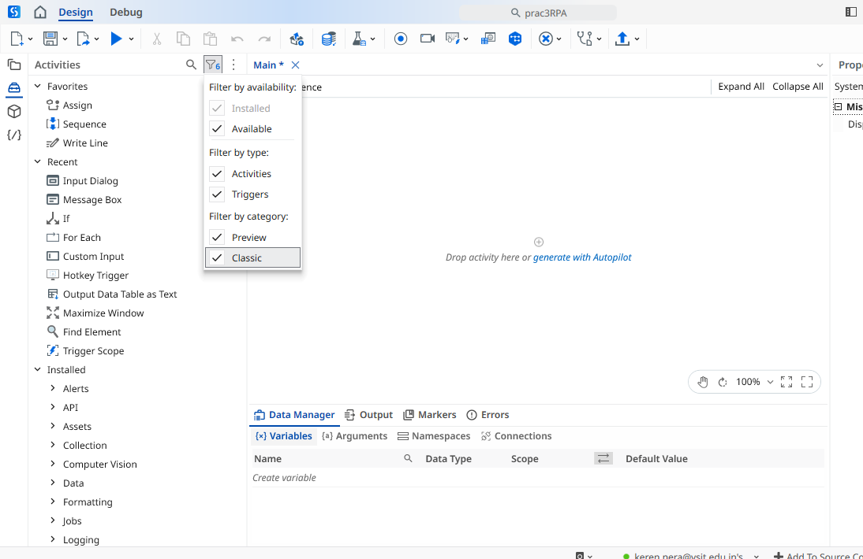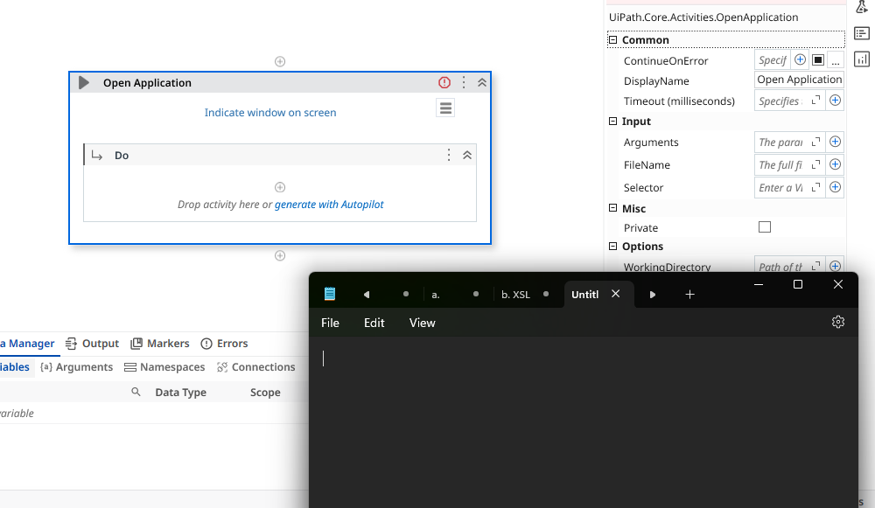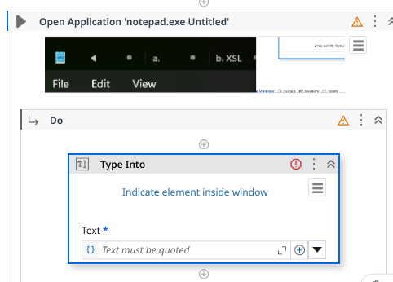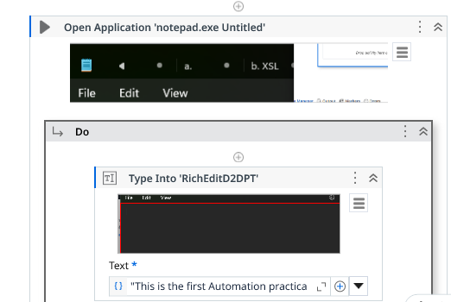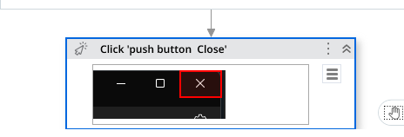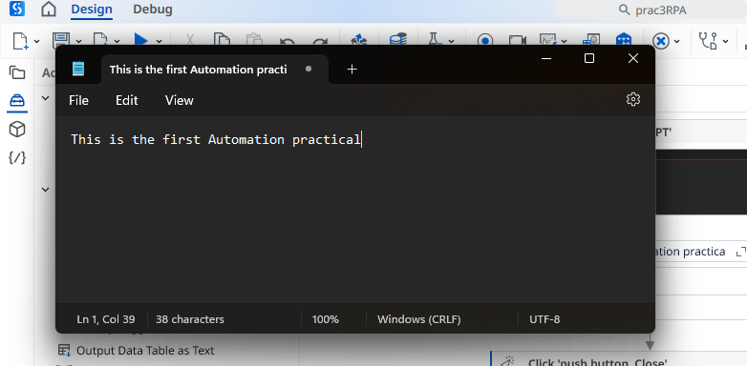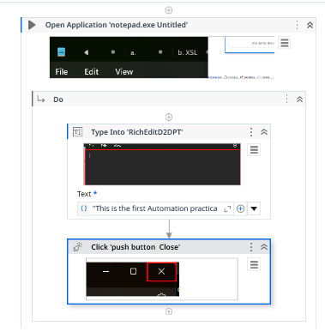
Web automation
- Home > tools > uipath extension > install chrome
- Open browser > setting: type> chrome > url:”imdb.com”
- Type into inside do > select search bar
- Click> movie name
- Get text> ratings > string > name: rating
- Message box> “Rating” +rating
