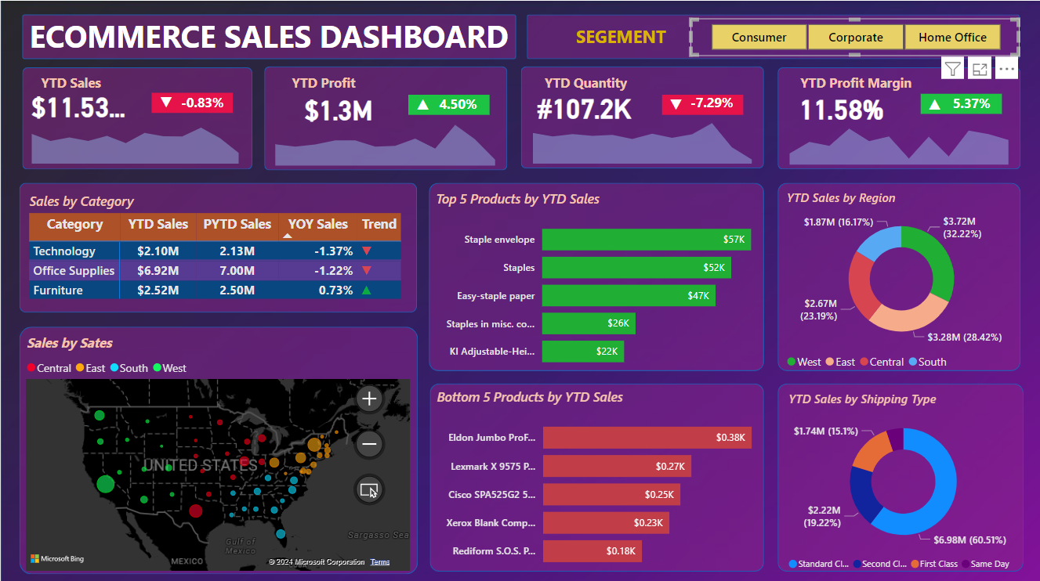

**INTRODUCTION**

E Commerce Sales Dashboard:

* It offers insights into various metrices and key performances indicators. KPI’s related to sales, profits and products performance.
* The dashboard utilizes data collected from a factitious online source, cleaned and processed using excel and power BI.

**Key – performance Indicators (KPI)**

* Year-to-Date (YTD) Metrices: A KPI banner displays YTD sales, YTD profit, YTD quantity sold, and YTD profit margin. These metrics serve as crucial indicators of performance over the current year.
* Year – on – Year (YOY) Growth: The dashboard calculates the year-on-year growth for each KPI, providing insights into the trend of performance compared to the previous year.

**Data Collection and Cleaning**

* The data was sourced from an online repository and uploaded to MySQL for processing.
* Cleaning involved removing duplication, adjusting columns and rows, and ensuring data integrity.
* Data types were carefully checked and adjusted as necessary to facilitate analysis in Power BI.

**Data Analysis**

* Power Bi’s Data Analysis Expressions (DAX) functions were employed to calculate KPIs such as YTD sales, profit, quantity, and profit margin.
* Icons and colour coding were utilized to visually represent changes in values, making it easier for stakeholders to interpret the data at a glance.

**Data Visualization**

* Various visualization tools such as card, pie charts, maps, and tables were used to present the data.
* Sales distribution by location, region, and shipping type was visualized to identity trends and patterns.
* Column charts were employed to highlight the top 5 and bottom 5 products sold on a YTD basis.
* An interactive dashboard allows stakeholders to dynamically explore data and gain insights using filters.

**Conclusion**

The E-commerce sales dashboard provides stakeholders with valuable insights into sales performance, profitability, and product trends. By leveraging data visualization and KPI tracking, stakeholders can make informed decisions to optimize operations and drive business growth. This analysis will be presented to project stakeholders to facilitate strategic decision – making and enhance overall performance in the E-commerce domain.