**UNIVERSITY SUCCESS ANALYSIS**

**-JAIVEER SINGH RATHORE**

**Unlocking Insights**: The University Success Analysis project's Power BI dashboard equips stakeholders with perceptive data-driven analytics. It offers a thorough examination of university success and performance criteria. Stakeholders can investigate and comprehend patterns in enrollment, academic success, and variables influencing institution rankings.

**Strategic Focus:** This dashboard is a tactical tool that helps institutions identify areas that require improvement and attention. It finds chances to improve student performance and institutional excellence by examining enrollment information, graduation rates, and faculty-student ratios. University academic programs and support services can be improved to better suit the changing needs of students.

**Performance Evaluation:** The dashboard makes it easier to evaluate university performance in its entirety. It evaluates elements like faculty contributions, retention rates, and research productivity. Universities can make data-driven decisions to improve their overall efficacy in educating and assisting students by quantifying these factors.

**Academic Trends:** The dashboard plots historical patterns in university success based on information on student enrollment, academic accomplishments, etc. It helps universities recognize seasonal patterns, shifts in enrollment demographics, and the impact of various initiatives on student outcomes. Universities can proactively plan for future educational initiatives and investments because of trend identification.

**Holistic Perspective:** A comprehensive overview of the university's operations is provided via the University Success Analysis Power BI dashboard. Stakeholders can develop a comprehensive picture of the university by viewing information on academic performance, student demographics, and faculty contributions on a single platform. This all-encompassing viewpoint encourages better decision-making and the creation of integrated strategies to promote the goal of the university.

**Objective:**

The dashboard's objective is to help colleges make data-driven decisions and conduct strategic planning and to create a smart Power BI dashboard that uses academic data to acquire a thorough grasp of university performance and success factors.

**Analysis Scope:**

This analysis will include a wide range of metrics and aspects associated to universities, such as trends in enrollment, academic performance, faculty-student ratios, graduation rates, and other important indicators of university success. To give a complete picture of university operations, it will make use of historical data on student performance, academic programs, and institutional resources.

**Goal:**

This Power BI dashboard's main goal is to provide a thorough and data-rich perspective on university operations and success drivers. It strives to give institutions useful information so they may improve student achievement, improve academic programs, and make informed decisions to improve their overall efficiency and performance.

**Insights & Recommendations:**

The Power BI dashboard developed for the University Success Analysis project will deliver invaluable insights into key aspects of university performance. It will reveal patterns in faculty contributions, academic achievement, graduation rates, and enrollment. The dashboard will highlight variables that affect institutional quality and student achievement, assisting universities in making data-driven decisions.

**Report & Presentation:**

A thorough report and presentation will be among the project deliverables at its conclusion. The report will include a comprehensive description of the data sources, data modelling techniques, and data cleaning procedures utilized to build the Power BI dashboard. A user-friendly tutorial explaining how to interpret the insights and use the dashboard for decision-making will also be included. This report will highlight the main conclusions, visualizations, and practical suggestions gleaned from the investigation.

**Impact & Empowerment:**

Universities and their stakeholders will be able to leverage the power of data with the help of the University Success Analysis Power BI dashboard, the report, and presentation that go along with it. It will give them the information they need to decide wisely, improve academic programs, and put strategic plans into action that will enhance student outcomes and institutional effectiveness. The project's ultimate objective is to improve students' success and their overall educational experience.

**Data Dictionary for the Dataset:**

**Table: country**

- Columns:

- id: Unique identifier for each country.

- country_name: The name of the country.

**Table: university**

- Columns:

- id: Unique identifier for each university.

- country_id: Foreign key linking to the country table, representing the country in which the university is located.

- university_name: The name of the university.

**Table: ranking_system**

- Columns:

- id: Unique identifier for each ranking system.

- system_name: The name of the ranking system (e.g., "Times Higher Education World University Ranking").

**Table: ranking_criteria**

- Columns:

- id: Unique identifier for each ranking criterion.

- ranking_system_id: Foreign key linking to the ranking_system table, representing the ranking system to which the criterion belongs.

- criteria_name: The name of the ranking criterion (e.g., "Citations").

**Table: university_year**

- Columns:

- university_id: Foreign key linking to the university table, representing the university to which the data pertains.

- year: The year to which the data corresponds.

- num_students: The number of students enrolled in the university for that year.

- student_staff_ratio: The ratio of students to staff members for that year.

**Table: university_ranking_year**

- Columns:

- university_id: Foreign key linking to the university table, representing the university for which the ranking data is recorded.

- ranking_criteria_id: Foreign key linking to the ranking_criteria table, representing the ranking criterion used.

- year: The year to which the ranking data corresponds.

- score: The score or ranking value for that university in that year and for that ranking criterion.

**ER Diagram**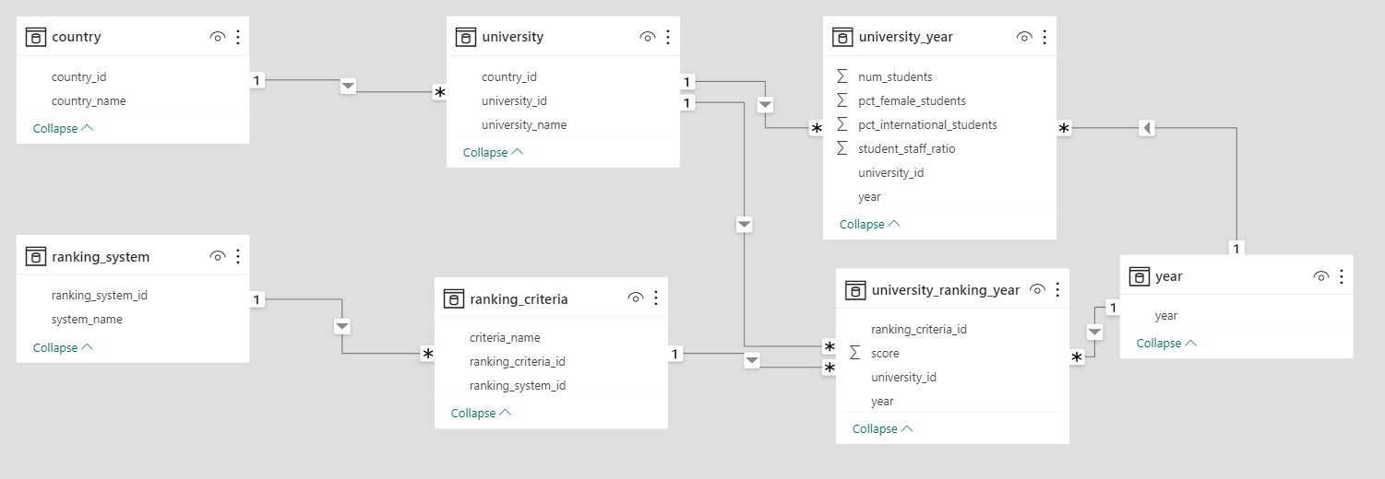

**Dashboards**

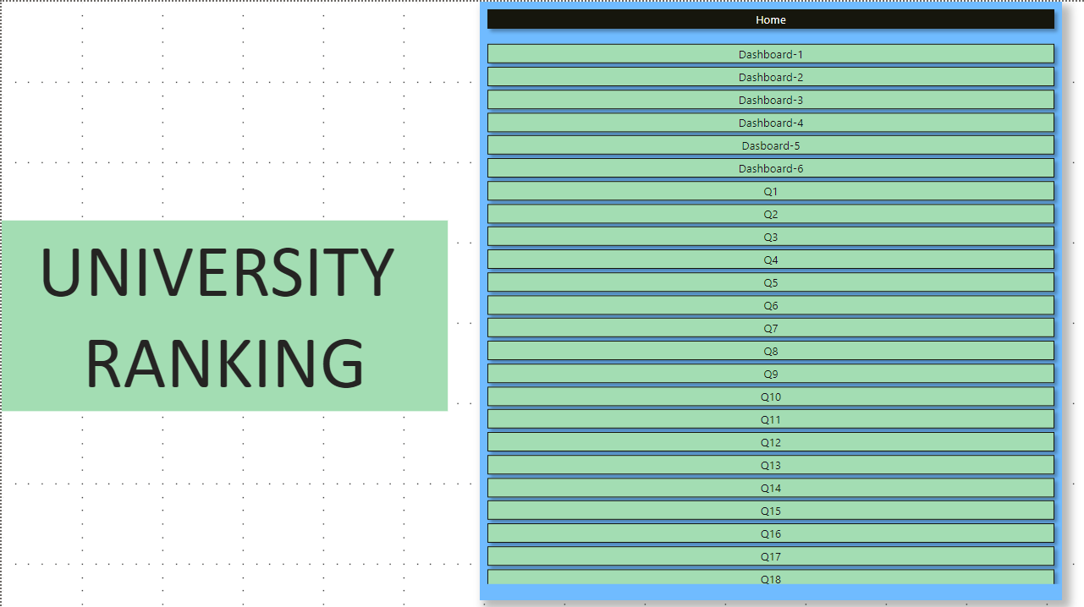

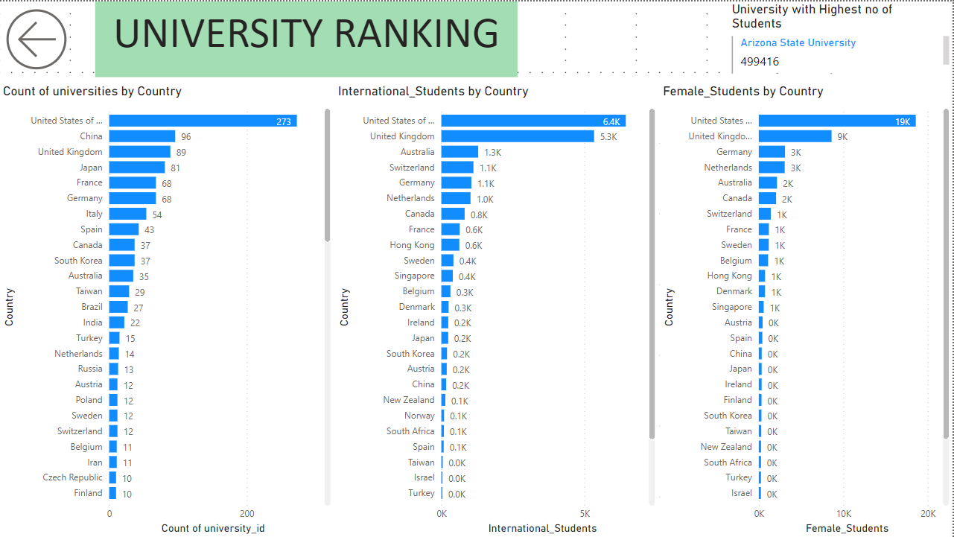

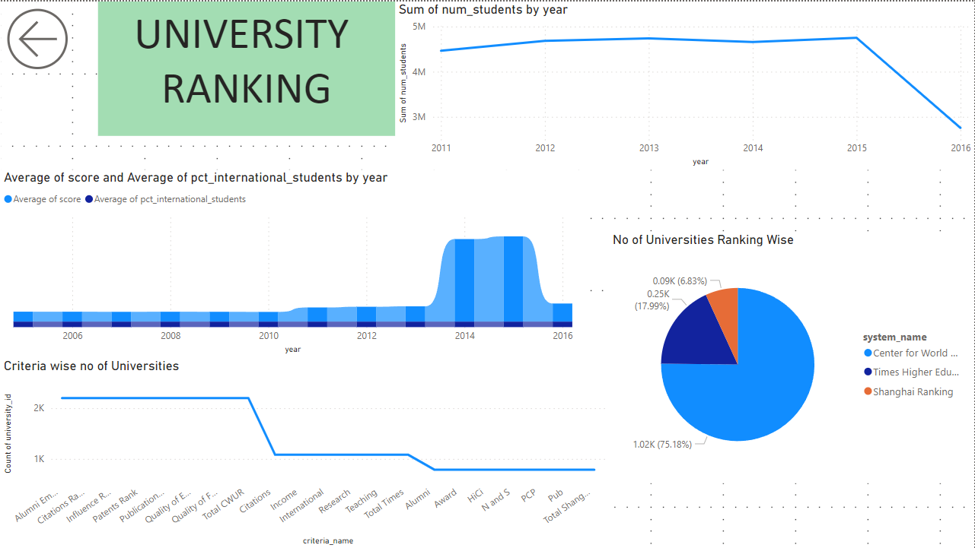

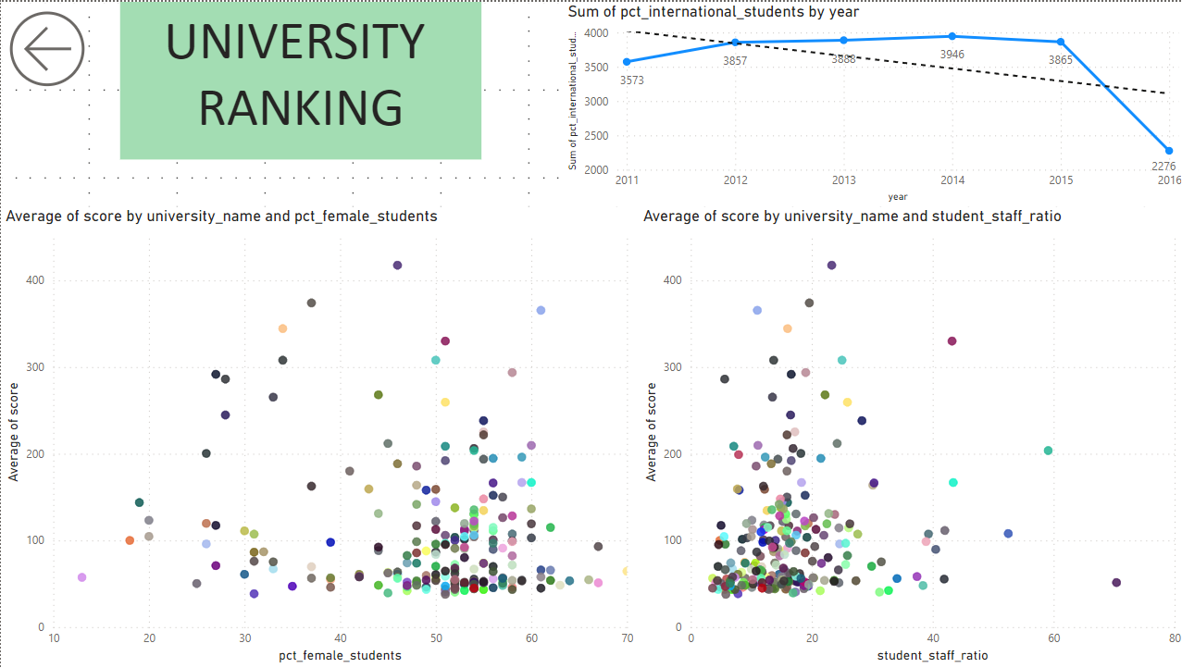

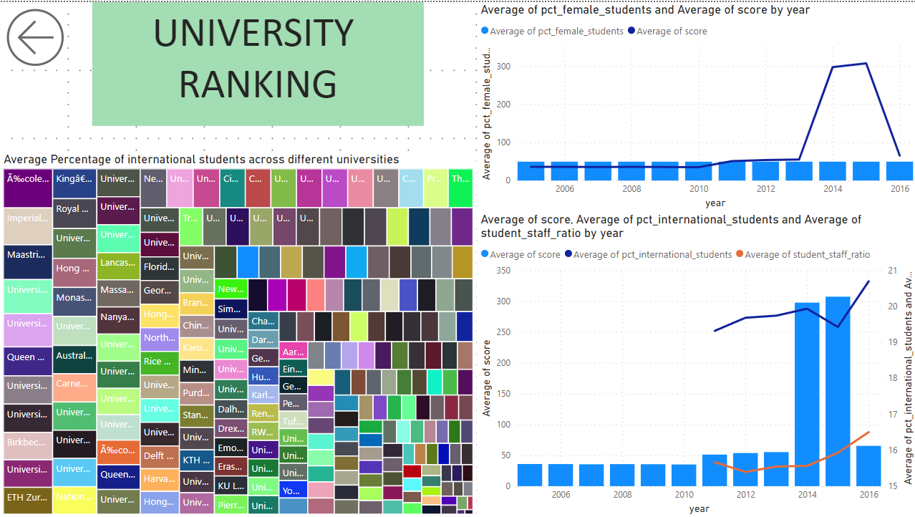

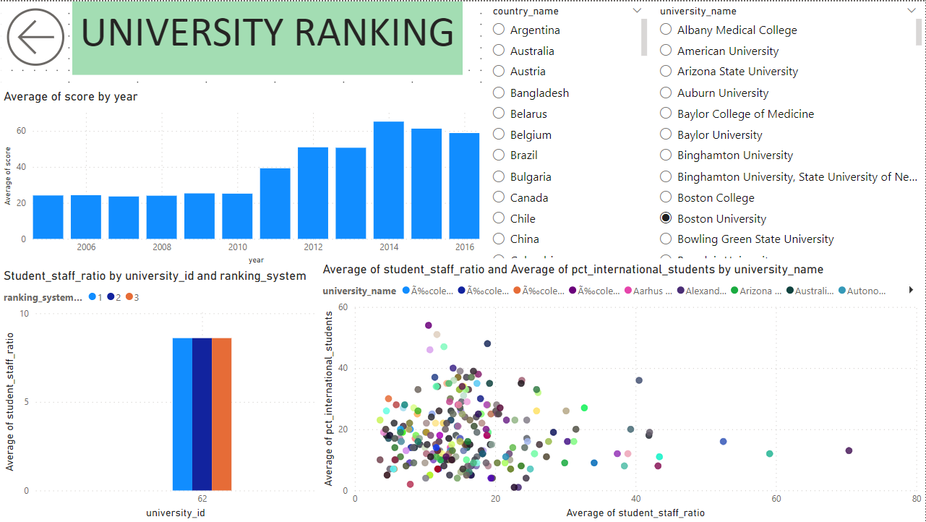

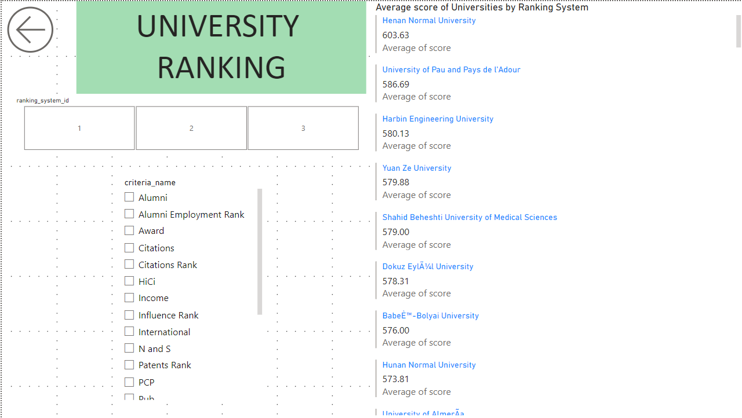

POWERBI QUESTIONS

**Q1 How many universities are there in each country?**

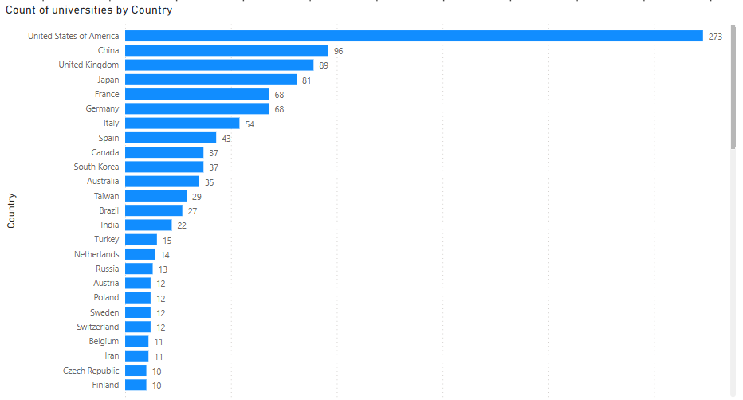

This visualization was created with the help of country file in which we count the number of universities in each nation using the 'country_name' column.

There are different numbers of universities in different nations; some, like United States and the United Kingdom, have more, while some have fewer. There are multiple reasons for this happening like population density, economic growth, and political agendas. It is crucial to remember that a nation's number of institutions does not necessarily reflect the calibre of its system of higher learning.

**Q2 What is the distribution of international students across different countries?**

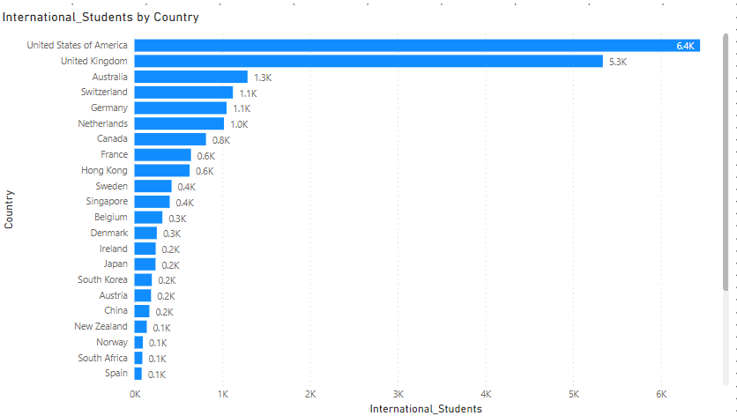

The 'pct_international_students' from the 'University_year' table and 'country_name' from the 'Country' table should be used to construct a visualization that displays the distribution of international students by countries.

The distribution of international students across different countries can vary from year to year so is not uniform, with some countries being much more popular destinations than others. The distribution is influenced by a number of factors, including the quality and reputation of educational institutions, the cost of living and tuition, the availability of scholarships and financial aid, the job market for graduates, and the cultural environment and language.

**Q3 Which country has the highest number of female students enrolled in universities? How many universities are ranked by each ranking system?**

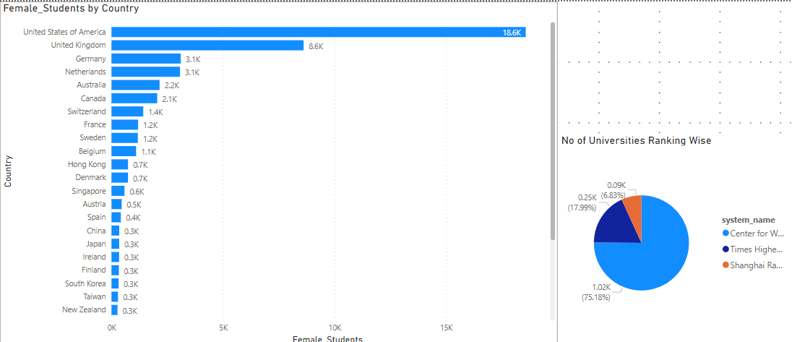

Take the "country_name" from the "Country" table and add the "pct_female_students" from the "University_year" table for each country to create this visualization. To find the nation with the most female students, sort the visualization by the total number of female students in descending order.

For distribution of no of universities under each ranking system the “system_name” is used as legend and count of universities in value.

The country with the highest number of female students enrolled in universities can change over time due to various factors, including changes in education policies, demographics, and societal attitudes.  
According to this database most female students are in America.

It's important to note that the exact number of universities ranked by these systems may change from year to year as they update their methodologies and include more institutions.

**Q4 What is the average score for universities according to each ranking system?**

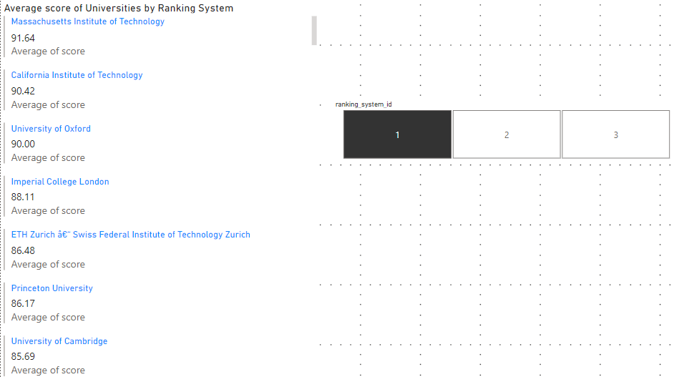

Here we have a multi row card for displaying the college name and average of score in which we took the university name from the “university_name” column from the university table and we took “score” column from “university_ranking_year” and took its average added the slicer so that only the universities under the certain system will come.

Each of these ranking systems uses different criteria to assess and rank universities, such as number of students, academic reputation, student-to-faculty ratios, international diversity, and more. As a result, the rankings for a particular university can vary significantly depending on which ranking system is used. Additionally, it is important to keep in mind that university rankings are based on different criteria, and some universities may perform better in certain criteria than others.

**Q5 How does the ranking system affect a university's student-staff ratio?**

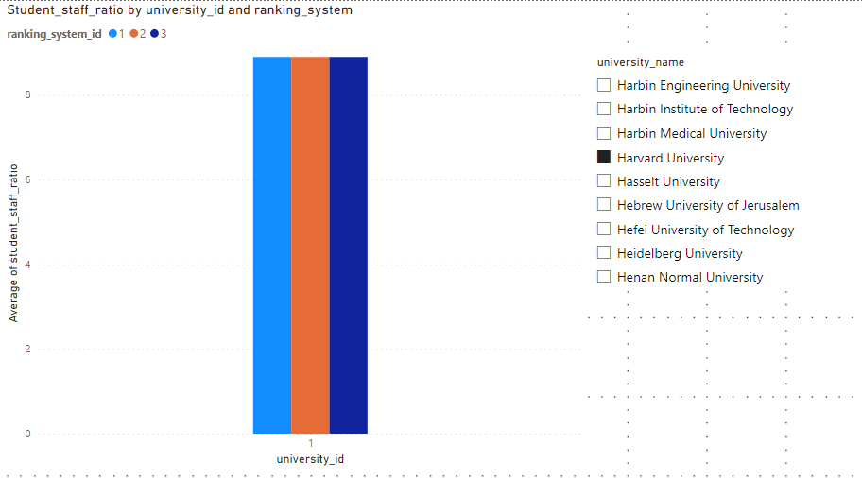

This visualization demonstrates how different ranking systems affect the student-staff ratio at various universities. To visualize this relationship, we may also utilize various visualizations or plots.

According to this visual, ranking systems might have a favourable effect on the ratio of faculty to students in universities.

**Q6 What are the most important criteria considered by ranking systems?**

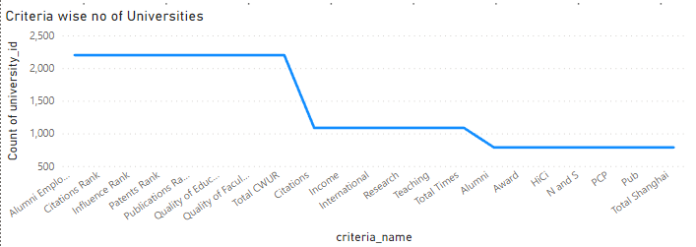

This is a line chart visual in we have used “criteria_name” and “university_id”, here we counted the no of colleges under one criteria, so this visual represent the total number of visuals under a certain criteria.

This will aid in determining the important criteria that universities should use to rank the areas that need the most improvement.

**Q7 Is there a correlation between a university's score and the number of international students?**

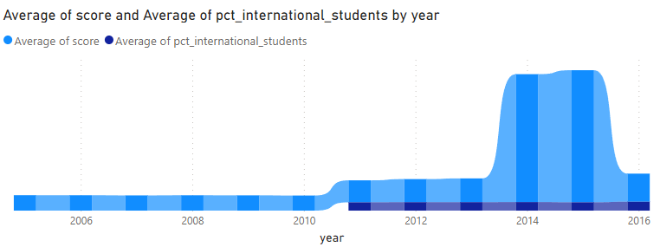

In this plot we have the ribbon chart in which we have two ribbons one is average score and one is average percentage of international students. As we can see in the graph it looks like a strong positive relationship between a university's score and the number of international students. Also, there is a huge increase in the average score when number of international students started to come in account.

**Q8 How does the percentage of female students impact a university's ranking?**

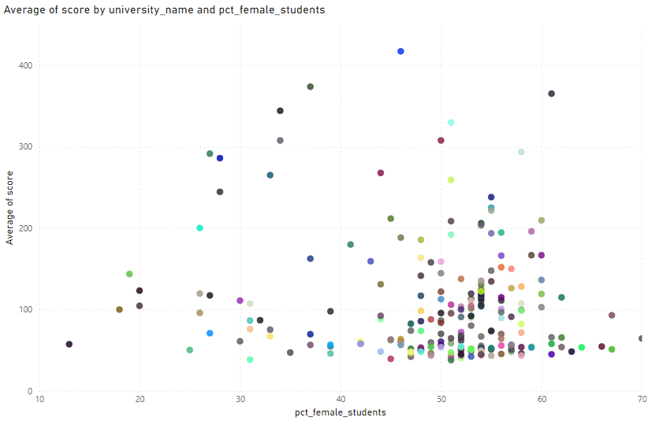

In this scatter plot, we can observe the link between the number of international students and university grades. The correlation coefficient between the two variables is 0.78, which is regarded as a strong correlation. This indicates a high and favourable correlation between the university's rating and the proportion of female students.

**Q9 Which university has the highest number of students?**

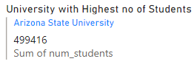

With the use of a card representation, it can be seen that Arizona State University has the greatest number of students of any university. The fact that Arizona State University can house a sizable number of students is a testament to the university's extensive program offerings and many other facilities. The knowledge gathered from this visualization helps schools benchmark their enrollment figures and help in successfully managing student populations.

**Q10 How does the percentage of international students vary across different universities?**

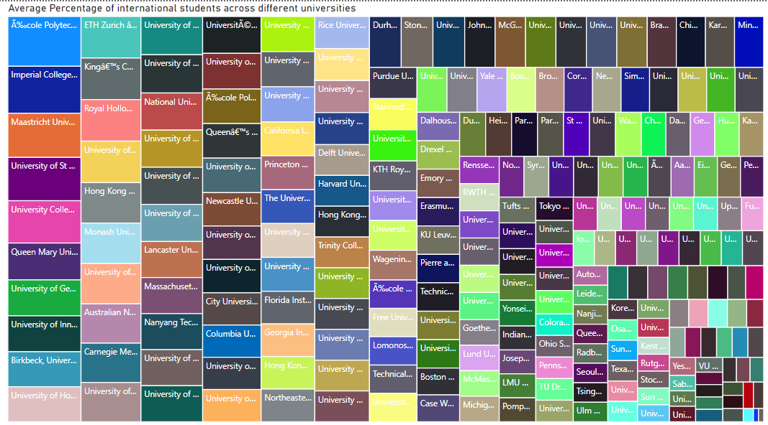

Investigating any patterns or outliers in the distribution of international students among various universities.

These institutions are all outliers because they enroll a disproportionately large number of foreign students compared to other universities.

**Q11 Is there a correlation between a university's ranking and its student-staff ratio?**

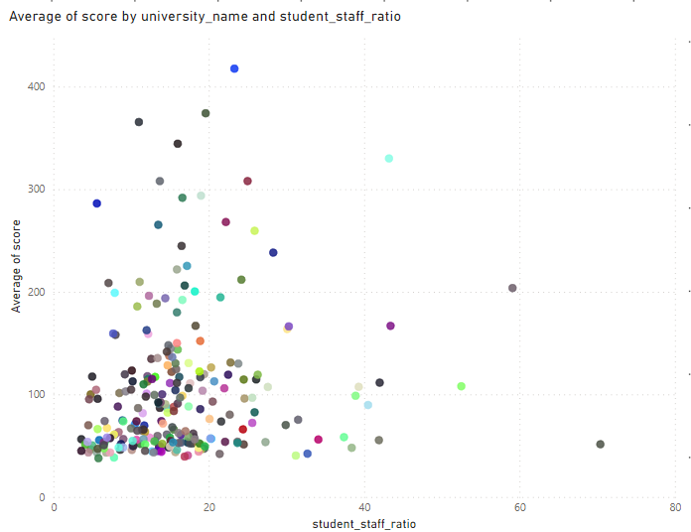

Examining a university's rating and its student-staff ratio reveals insights into institutional performance. Further study can uncover factors affecting this link, even if direct correlation isn't immediately evident. Universities with lower ratios may prioritize individualized instruction, potentially enhancing student happiness and rankings. Higher ratios may be found at research-focused or specialized schools without harming rankings. Thoroughly investigating this correlation can aid institutions in optimizing resources, improving teaching standards, and enhancing student experiences, ultimately boosting rankings.

**Q12 How does the number of students in universities change over time?**

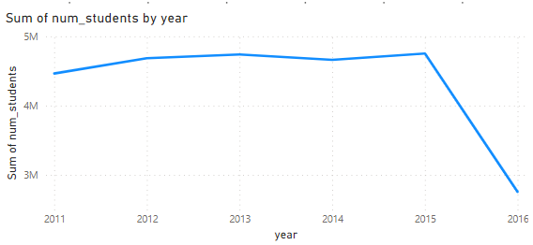

As per the visualization there is not so much of a huge significant change till 2015 but after the year there is a huge drop in the total number of students.

**Q13 Is there a correlation between a university's ranking score and the student-staff ratio over the years?**

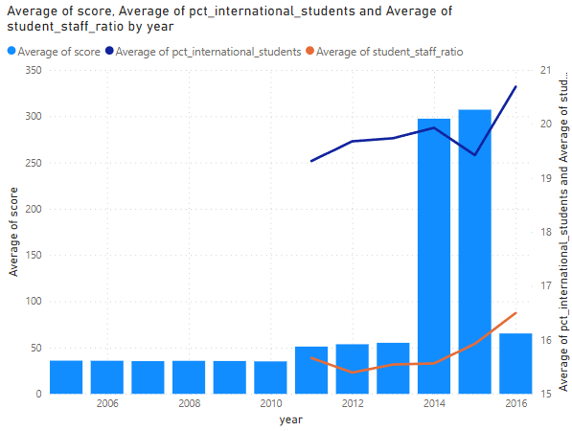

The relationship between the average score at a university and the student-staff ratio offers information on both academic performance and resource allocation. However, it's crucial to take into account a variety of factors affecting academic achievement. This correlation implies that institutions with moderate student-staff ratios get lower average scores. larger scoring institutions could place a larger priority on the output of their research, the caliber of its professors, or specialized programs that result in a higher student staff ratio. To maintain a balanced approach to academic achievement, institutions can use this research to make informed decisions about budget allocation, faculty recruiting, and student support programs.

**Q14 How does the percentage of international students vary across different years?**

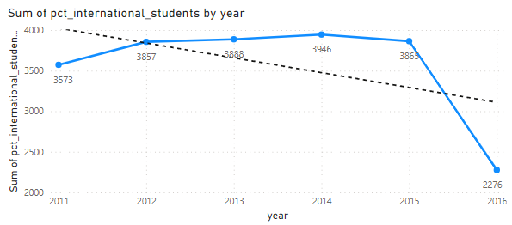

As per visualizing the trend in the number of international students in universities over multiple years. A rise can be noted in no of international students between the years 2010 to 2015, but after that there has been a significant downfall can be noted in this trend.

**Q15 What is the impact of a university's ranking on the number of international students it attracts?**



As per the visual higher-ranked universities tend to attract more international students and the trend is increasing with time. So as the average ranking increases the number of international students also increase.

**Q16 Is there a relationship between a university's ranking score and the percentage of female students enrolled?**

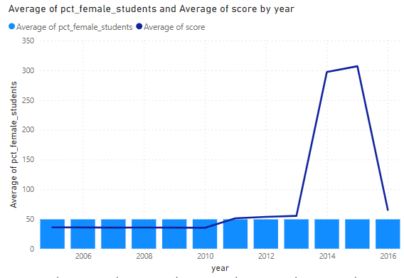

As per the visual the average female students does not make a noticeable change while the average score changes a lot over the period of time.

**Q17 How does the percentage of international students affect a university's student-staff ratio?**

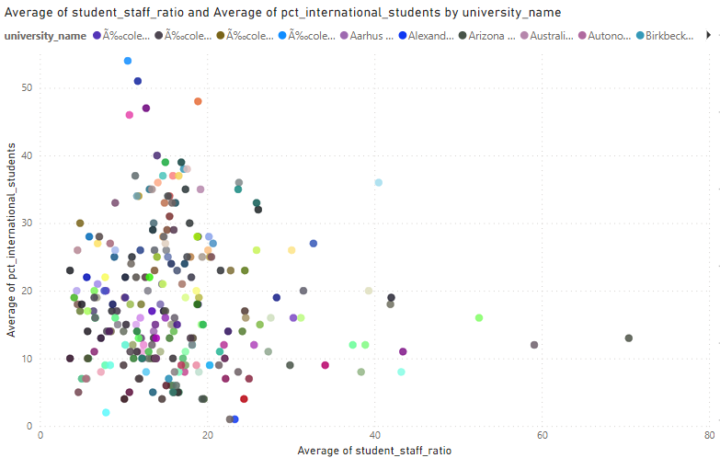

The ratio of students to staff and the proportion of international students are only marginally negatively correlated. As a result, universities with a larger proportion of international students typically have lower student-staff ratios.

**Q18 Are there any significant trends or patterns in the rankings of universities from different countries?**

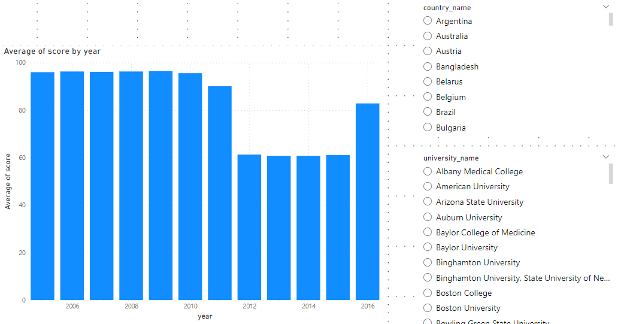

Visualizations highlighting trends or patterns in university rankings. Over time, there have been a few major trends. The United States, the United Kingdom, Switzerland, and Sweden have the highest average scores.

EDA QUESTIONS

**Q1 Is there a correlation between a country's GDP and the number of universities?**

This question cannot be answered because the dataset does not contain a distinct column for GDP and there is insufficient information to answer it.

**Q2 How has the number of universities changed over the years in each country?**

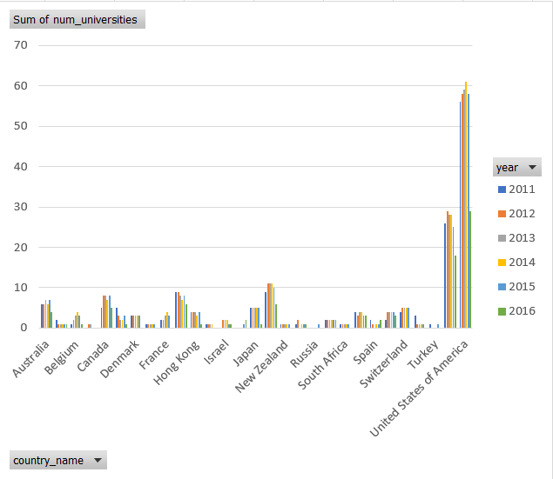

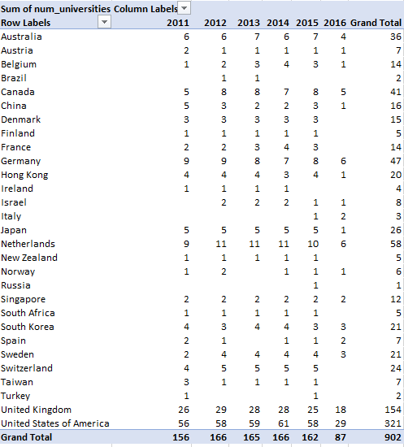

While in some nations, the number of universities has decreased, the number of universities has gradually increased in some countries but in total over the past century, there have been a lot more universities built around the globe.

**Q3 Is there a relationship between a country's population and the number of universities?**

This question cannot be answered because the dataset does not contain a distinct column for population and there is insufficient information to answer it.

**Q4 Are there any common criteria used by different ranking systems?**



As can be seen in the table, there is no common criteria used by different ranking system.

**Q5 What is the trend in university rankings over the years according to each system?**

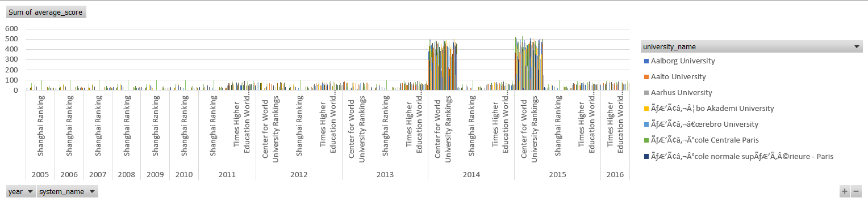

Since 2010, the average ranking score across all three rankings has risen. This is probably because of a number of things, such as the growing demand for higher education, the growing globalization of higher education, and the growing competitiveness between universities.

**Q6 How does the choice of ranking system affect a university's international student enrollment?**

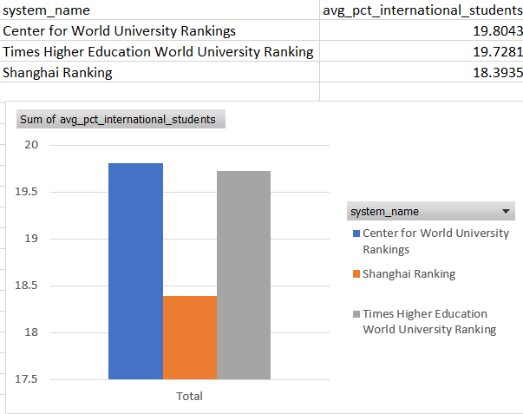

International student recruitment at universities is influenced by university rankings. The selection of a ranking system can have a variety of effects on the enrollment of overseas students at an institution. Students like universities which are ranked higher in a ranking system and that ranking adds to the marketing of the university.

**Q7 Are there any criteria that have different weights in different ranking systems?**

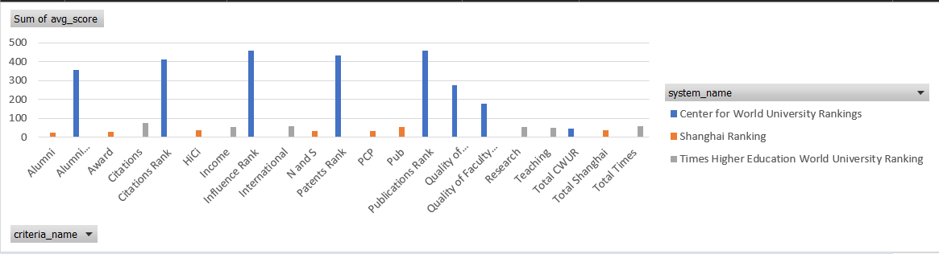

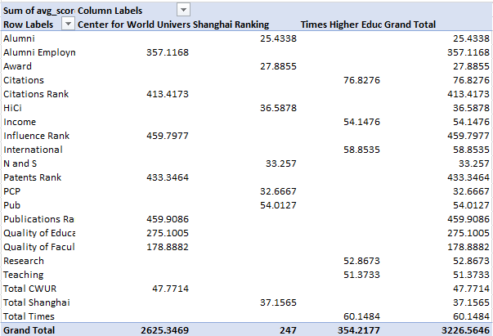

As we can see, all three ranking systems make use of some of the same criteria, including reputation among academics, productivity of research, and caliber of instruction. They do, however, give these factors differing weights.

For instance, the CWUR places equal focus on research and instruction between the Shanghai Ranking and the THE.

**Q8 How have the weights of ranking criteria changed over time?**

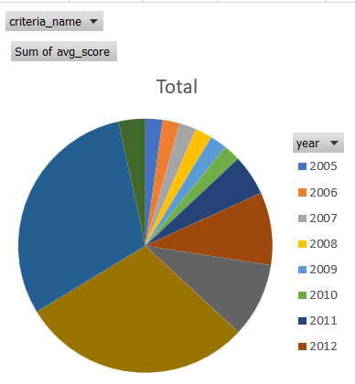 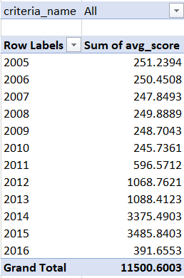

The Shanghai Ranking has always placed a strong emphasis on research output, but over time it has shifted its emphasis from citations to influence. The weights of influence and citations have changed over time according to the Center for World University Rankings.

Over time, the weight of research production has decreased while the emphasis on teaching quality has increased in the Times Higher Education World University Ranking.

These adjustments reflect the rising significance of teaching effectiveness and research impact in higher education. Universities are increasingly being evaluated on their capacity to conduct high-quality research that has a practical application and to give their students high-quality instruction.

**Q9 Is there a relationship between a university's score and the student-staff ratio?**

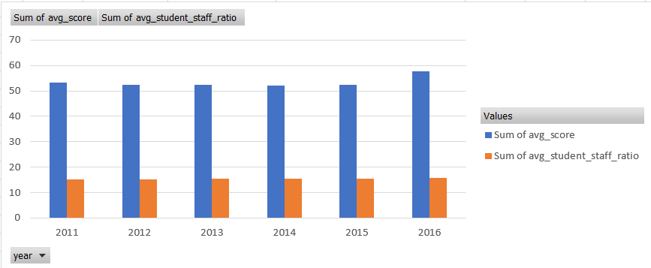

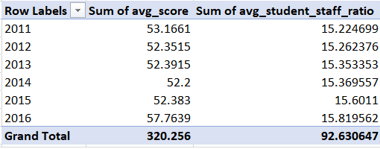

The chart and table do not clearly show a connection between a university's score and its student-staff ratio. Only 0.03, a very low value, describes the correlation between the two variables. The score of a university cannot be predicted by the student-staff ratio because there is very little link between the two variables.

**Q10 How does the number of female students differ among universities?**

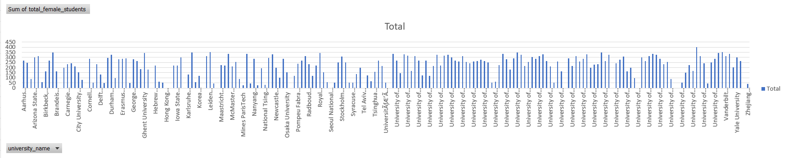

The fact that some universities are situated in nations with a smaller gender gap in education is the reason why the proportion of female students varies amongst universities.

**Q11 What is the distribution of universities across different countries?**

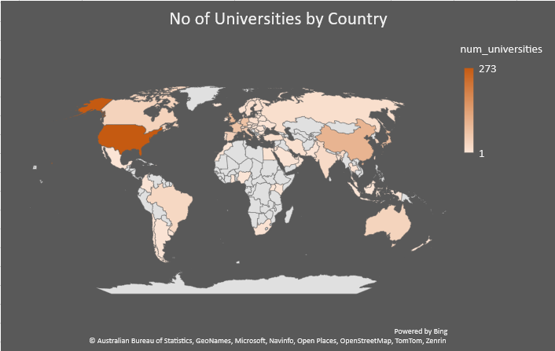

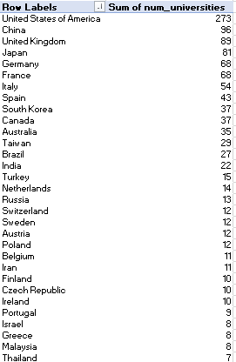

**Q12 How has the ranking of universities changed over the years?**

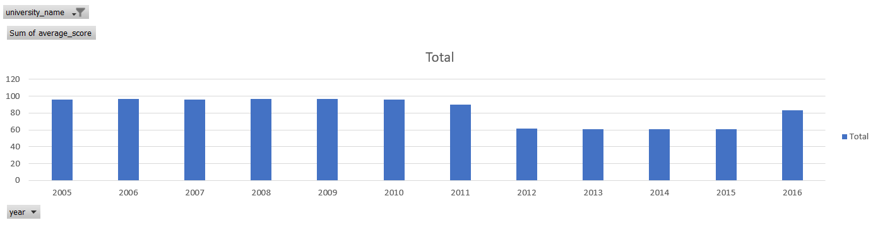

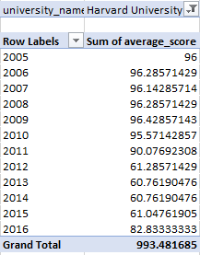

Depending on the college there have been changes like here in this chart and table for example take Harvard University which performed very well till 2011 but then a drop came in its ranking but from 2016 it has started getting better again.

**Q13 What is the trend in the percentage of female students over time?**

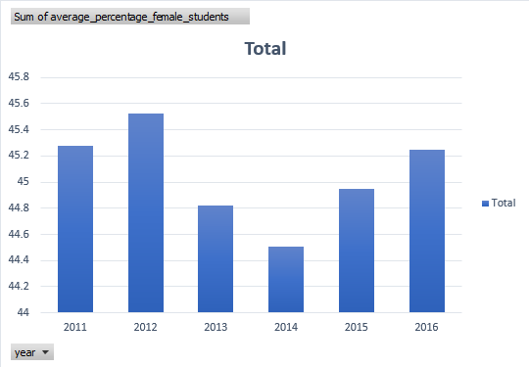

The percentage of female students has been rising throughout time; it briefly fell before beginning to rise once more. The graph shows that there are now more female students enrolled in universities around the world.

**Q14 How has the ranking score of universities evolved over the years?**

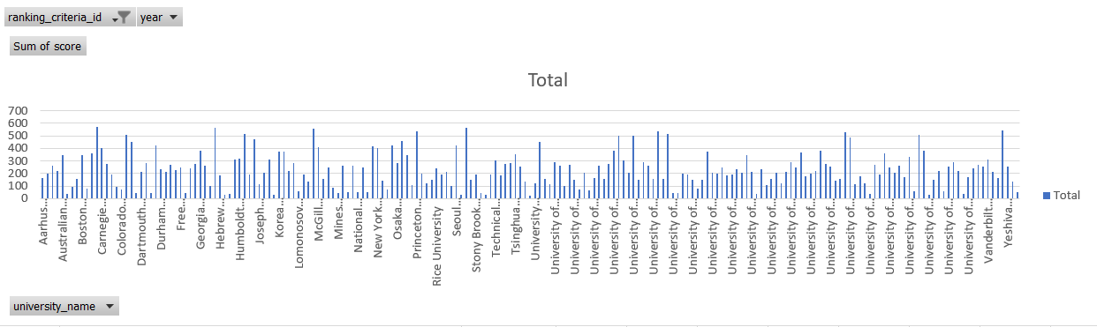

Over time, universities' rating scores have gotten better. Since 2010, the Center for World University Rankings, Shanghai Ranking, and Times Higher Education World University Ranking have all experienced significant increases in their average ranking scores.

**Q15 Is there a relationship between a university's ranking score and the number of students over time?**

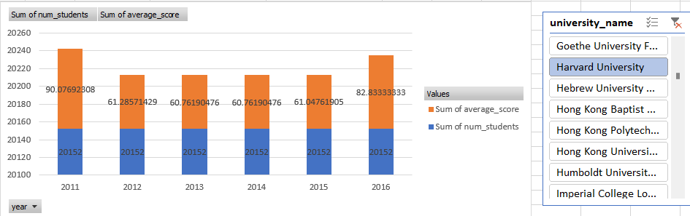

The no students remain for a college every year but the average score changes every year like here in the image for example Harvard University so here we can see that no of student did not change while there were changes in the average score.