PROJECT REORT
on
PG LOCATOR

Submitted to

LOVELY PROFESSIONAL UNIVERSITY

in partial fulfilment for requirement for
the award of the degree/diploma of

MCA

Submitted By

JAIVEER KUMAR PANWAR

Registration No. 22100015192

Programme: 1624-S

Batch: 2021-I

Under the Guidance of

Name of Project Guide: Sumit Jaiswal
Destination: Professor

LOVELY FACULTY OF DISTANCE EDUCATION
LOVELY PROFESSIONAL UNIVERSITY, PHAGWARA
2023

Lovely Professional University, Phagwara
Lovely Faculty of Distance Education

DECLARATION

This to certify that the project report titled PG LOCATOR submitted by JAIVEER KUMAR PANWAR, 22100015192. In partial fulfilment for the award of Master of Computer Application from Lovely Professional University, Phagwara is a record of original work done by me. This project has not been submitted to any other university or institution for the award of any degree/Diploma/Certificate.

Signature of Student.

Place:
Date:

Table of Contents

- Project Description
  - Introduction
  - Purpose

- Background
  - PHP
  - MySQL Database
  - HTML, CSS, JavaScript, and jQuery

- Requirement Analysis
  - Requirement Gathering
  - Requirement Specification
    - Software Requirements
    - Hardware Requirement

- Project Module
  - Registration
  - Search
  - PG Listing
  - Manage Account

- System Design
5.1 Use Cases Diagram of PG Locator
5.2 Data flow Diagram of PG Locator
5.3 E-R Diagram of PG Locator
5.4 Activity Diagram
5.4.1 Employer
5.4.2 JobSeeker

- Database Design
6.1 Table Structure of PG Locator

- Implementation
7.1 Frontend (HTML, CSS, JS)
7.2 Backend (PHP)
7.3 Security

- Graphical User Interface
8.1. Registration Page
8.2 Tenant Registration
8.3 Owner Registration
8.4 Login Options Page
8.4.1 Tenant Login
8.4.2 Owner Login
8.5. Owner Dashboard
8.6. Add PG
8.7. Booked PG
8.8. Property Detail

- Testing
9.1 Testing Level
9.2 Test Cases

- Snapshot of Code
10.1 Index Page
10.2 DB config
10.2 Registeration
10.3 Login
10.4 Navbar
10.5 Booking
10.6 Add Property
10.7 View Property
11. References

Project Description

  - Introduction

The "PG Locator" project is a groundbreaking web application designed to revolutionize the way individuals search for paying guest (PG) accommodations, hostels, and rental houses. The quest for suitable housing, particularly in urban areas, can often be an arduous and time consuming process, plagued by a lack of transparency and efficient search options. Recognizing this challenge, the "PG Locator" project emerges as a comprehensive solution to facilitate and streamline the housing search experience.

In a world where mobility is on the rise, whether it's students embarking on educational journeys or professionals seeking new job opportunities, the need for a reliable, user-centric platform for discovering ideal PG accommodations and rental houses has never been more critical. The "PG Locator" project is not just a product; it's a commitment to deliver a seamless and secure housing search platform that empowers users to make well-informed decisions.

This project is characterized by its advanced features and innovative functionalities, designed to provide a comprehensive, trustworthy, and user-friendly platform. The primary goal of the "PG Locator" is to simplify and enhance the housing search experience, offering users a one-stop solution that encompasses efficient search tools, detailed property information, user reviews, and secure communication channels. By providing an intuitive interface, real-time features, and robust security measures, the "PG Locator" project promises to transform the way people discover their next home.

1.2 Purpose

The PG Locator project serves the purpose of establishing a centralized online platform designed to facilitate the connection between individuals actively seeking Paying Guest accommodations and property owners who offer such spaces. The primary objective is to simplify and enhance the overall experience for users by providing an intuitive interface for efficient search and booking processes. For property owners, the project aims to offer effective tools for managing listings, including the ability to activate or deactivate postings based on their availability.

Administrators play a crucial role in maintaining the integrity of the platform by overseeing user accounts, PG listings, and user reviews. Additionally, they have access to analytical insights through an admin dashboard, aiding in data-driven decision-making. In essence, the PG Locator project endeavors to create a user-friendly and comprehensive solution that benefits both accommodation seekers and providers in the dynamic landscape of Paying Guest accommodations.

BACKGROUND

In the development of the PG Locator project, the choice of frameworks and technologies has been carefully considered to meet the specific requirements of the application. The project primarily consists of a web application designed to connect individuals seeking Paying Guest accommodations with property owners offering such spaces.
The web application leverages the power of the PHP programming language for server-side scripting and interacts with a MySQL database for efficient data storage and retrieval. The frontend is developed using a combination of HTML, CSS, and JavaScript to ensure a responsive and user-friendly interface. The use of jQuery enhances the interactivity and dynamic features of the application.

2.1 PHP
The PHP scripting language serves as the backbone of the web application, handling server-side logic and facilitating seamless communication between the frontend and the MySQL database. PHP's versatility and efficiency make it well-suited for the dynamic requirements of the PG Locator project.

2.2 MySQL Database
The project relies on the MySQL relational database management system to store and manage data related to user profiles, PG listings, bookings, inquiries, reviews, and other crucial information. The use of a relational database model allows for efficient organization and retrieval of data, contributing to the overall robustness of the application.

2.3 HTML, CSS, JavaScript, and jQuery
The frontend of the PG Locator project is crafted using a combination of HTML, CSS, and JavaScript to create a visually appealing and responsive user interface. JavaScript and jQuery play a crucial role in enhancing the user experience by providing dynamic content, interactive features, and seamless navigation.

In summary, the PG Locator project incorporates a well-thought-out technology stack, including PHP for server-side scripting, MySQL for database management, and a combination of HTML, CSS, JavaScript, and jQuery for frontend development. This strategic choice of frameworks ensures the efficient functioning of the application, contributing to a positive and effective user experience.

Requirement Analysis

3.1 Requirement Gathering

The PG Locator project will involve user registration and login functionalities, allowing users to create profiles with personal details and profile pictures. Property owners can list their PG accommodations, providing details like address, facilities, rent, and contact information. The system should support user searches with filters, integrated with Google Maps for location visualization. Users can inquire about and book PGs, with a notification system for relevant events. Reviews and ratings, along with an admin dashboard for user and property management, are essential. The technical stack includes a responsive frontend (HTML, CSS, JS), secure backend (PHP) with server-side validation, and a MySQL database. Security measures, scalability considerations, thorough testing, and comprehensive documentation will be implemented throughout the development process.

3.2 Requirement Specification

Below are the technical requirements to develop PG Locator application

3.2.1 Software Requirements
- Operation System : Window 7,8,10,11
- IDE : Visual Studio Code
- Frameworks : Bootstrap and PHP
- Database : MYSQL, PHPMYADMIN
- Front End : HTML5, CSS3, JavaScript, jQuery
- Browser : Edge or Chrome or Firefox or Internet Explorer

3.2.2 Hardware Requirement
- Processor : Dual Core
- Processor Speed : 1GHz
- RAM : 512 MB
- Minimum disk space (32-bit) : 4.5 GB
- Minimum disk space (64-bit) : 4.5 GB

Project Module

4.1 Registration
Users, both Property Owners and Tenants, can register with valid details. Registration is facilitated with method:
- Manual Entry: Users can manually enter essential details such as name, email, and contact number for registration.

4.2 Search
- Tenants: Users can search for PG accommodations based on their preferences, including location, budget, and amenities. Additionally, they can apply for the desired PGs directly through the platform.
- Property Owners (Employers): Employers can search for potential tenants based on specific criteria. Communication between employers and seekers is facilitated through messaging, allowing for queries and additional information exchange.

4.3 PG Listing
Property Owners (Employers): Employers can post listings for their PG accommodations. Details such as address, facilities, rent, and contact information are included. This feature provides a comprehensive overview of the available accommodations, making it easy for seekers to find suitable options.

4.4 Manage Account
Admin: The administrator has the authority to manage employee and employer details. They can observe user actions, including job postings and candidate details, to ensure accuracy and platform integrity. Admin has the capability to oversee and moderate the overall functioning of the PG Locator application.

System Design

5.1 Use Cases Diagram of PG LOCATOR

A diagram is a visualization of set of elements and the relationships between them. Use case is a set of scenarios, which defines functionalities of the system from a user’s perspective. The main components of a use case diagram include actors, use cases and their relationships. They depict the interaction between actors and system to achieve certain goal. This, a use case diagram is important in modeling the behavior of a system.

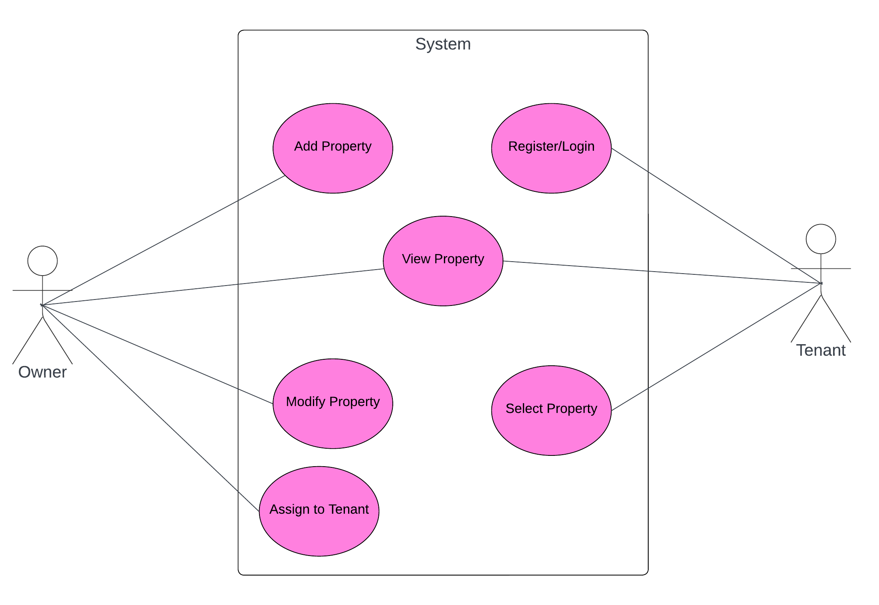

Use Cases for Property Owners (PG Owners):

Listing a Property:

- Log in and access "List Your PG."
- Fill in property details.

Managing PG Listings:

- Log in and navigate to "Manage Listings."
- Activate, deactivate, or edit listings.

Reviewing Applicants:

- Log in and access "Applicant Management."
- Review and accept/reject applications.

Use Cases for Users (Accommodation Seekers):

Searching for PGs:

- Log in and use "Search PGs" feature.
- Set filters for location, budget, amenities.
- View relevant PG accommodations.

Applying for Accommodation:

- Log in and browse PG listings.
- Choose desired PG and click "Apply."
- Fill in application details and submit.

5.2 Data flow Diagram of PG Locator

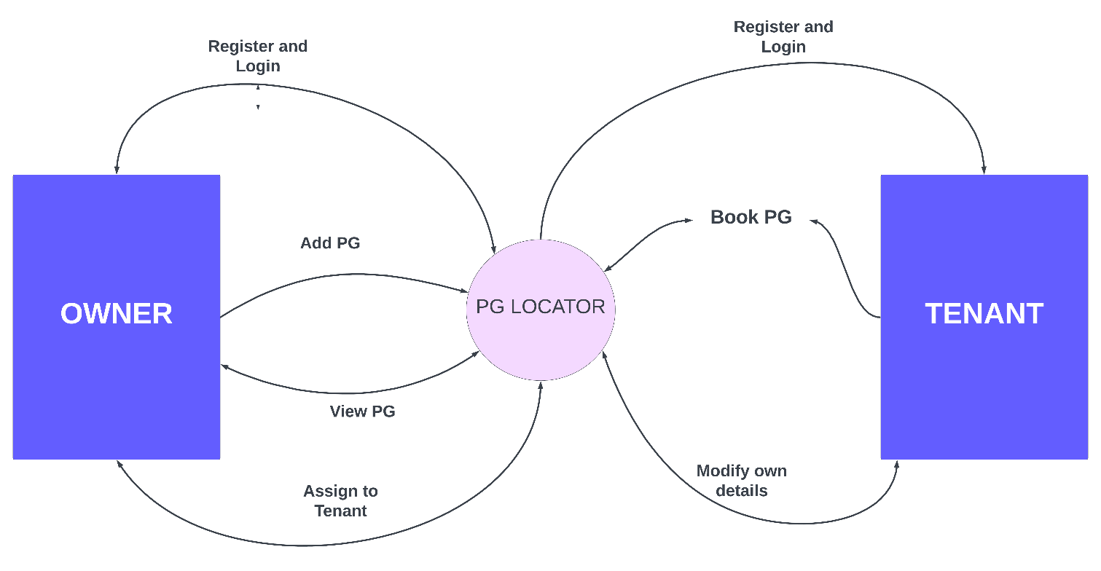

Figure: Data flow Diagram

5.3 E-R Diagram of PG Locator

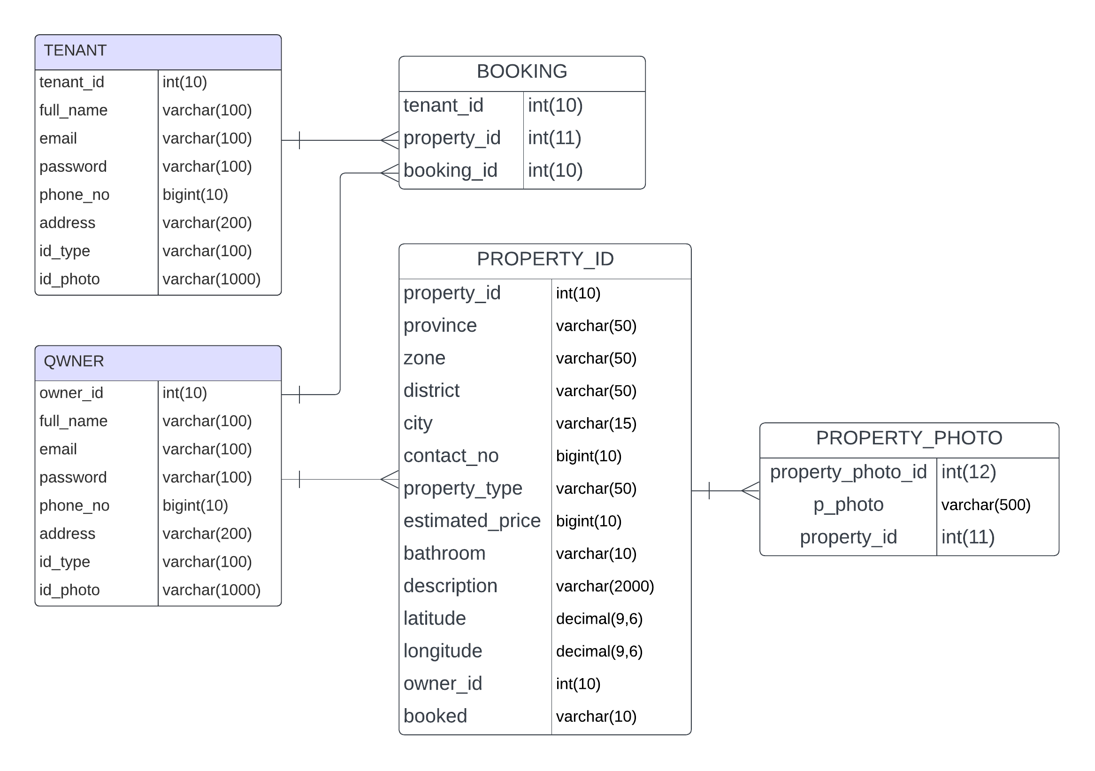

5.4 Activity Diagram

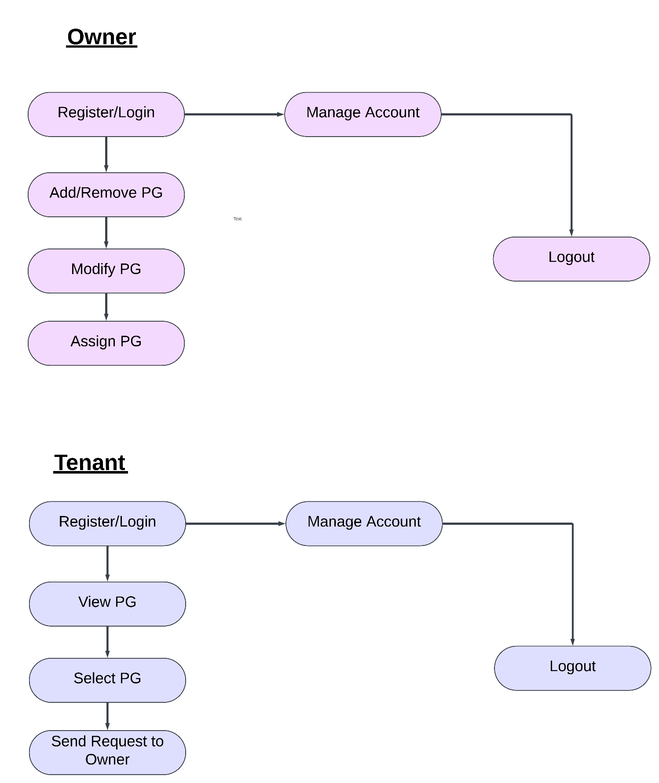

Database Design

The PG Locator website employs a robust database system to effectively manage information about PG accommodations, users, and their interactions. MySQL has been selected as the database management system due to its versatility, scalability, and compatibility with web applications. phpMyadmin serves as the primary tool for designing, creating, and managing tables, as well as executing queries to retrieve and manipulate data.

Several key tables have been meticulously crafted to achieve the core functionalities of the website:

- PG Table: Stores comprehensive details about each PG accommodation, including location, amenities, rules, pricing, availability, photos, and descriptions.

- PG Owner Table: Holds information about PG owners, such as name, contact details, and property ownership details.

- PG Seeker Table: Captures details about individuals seeking PG accommodations, including their preferences, search criteria, and personal information.

- Bookings Table: Records booking requests, confirmations, and payment details to ensure seamless reservation management.

- Property Photo Table: Holds all the picture of the properties listed in the database.

- User Accounts Table: Securely stores user login credentials and preferences, enabling personalized experiences.

6.1. Table Structure of PG Locator

Owner table structure :-

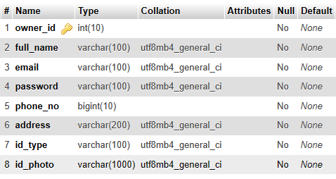

Tenant table structure :-

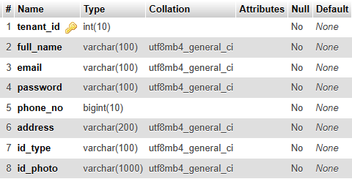

Booking table Structure :-

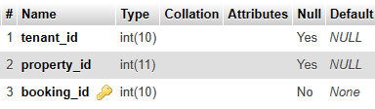

Add property table structure :-

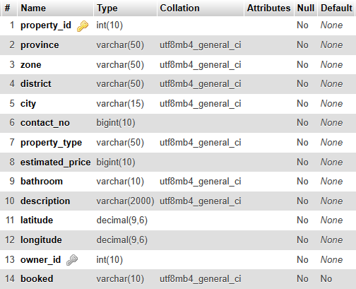

Property_photo table structure :-

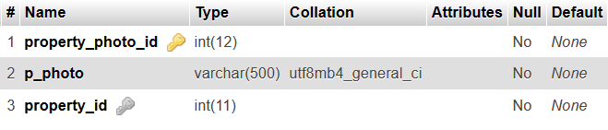

Implementation

Implementing a complete PG Locator project involves creating various components, including the frontend, backend, and database. Below, I'll provide a high-level overview of how you might structure and implement different parts of the project. Note that this is a simplified example, and a real-world implementation would require more thorough design, security measures, and testing.

7.1. Frontend (HTML, CSS, JS):

- User Registration and Login:

- Create HTML forms for registration and login.
- Use JavaScript for form validation.
- Implement SQL queries with PHP to send data to the backend.

- User Profile:

- Design a user profile page using HTML and CSS.
- Allow users to update their profile information.
- Include a file input for uploading profile pictures.

- PG Listing:

- Create a form for property owners to list their PGs.
- Display PG listings using HTML and CSS.

- Search and Filter:

- Design a search interface with filters using HTML and CSS.
- Use JavaScript to handle user interactions and filter results.
- Integrate Google Maps for location visualization.

- Booking and Inquiry:

- Implement booking and inquiry forms.
- Uses SQL queries with PHP to send booking and inquiry requests to the backend.
- Display notifications for users based on server responses.

7.2. Backend (PHP):

- User Management:

- Implement PHP scripts to handle user registration and login.
- Use sessions for user authentication.

- Property Management:

- Create PHP scripts to handle the addition and retrieval of PG listings.
- Implement CRUD operations for property listings.

- Booking and Inquiry:

- Develop PHP scripts to handle booking and inquiry requests.
- Update the database with relevant information.

7.3. Security:

- Password Hashing:

- Used MD5 password hashing for storing user passwords.

- Input Validation:

- Validate user inputs on both the frontend and backend to prevent SQL injection and other vulnerabilities.

- Secure Connections:

- Implement HTTPS to secure data transfer between the frontend and backend.

Graphical User Interface

The graphical user interface is developed using HTML5, CSS, JavaScript, jQuery, and Bootstrap to provide easy-to-understand interactive screens. Various screens and the navigation between them are discussed below.

Registration page :-

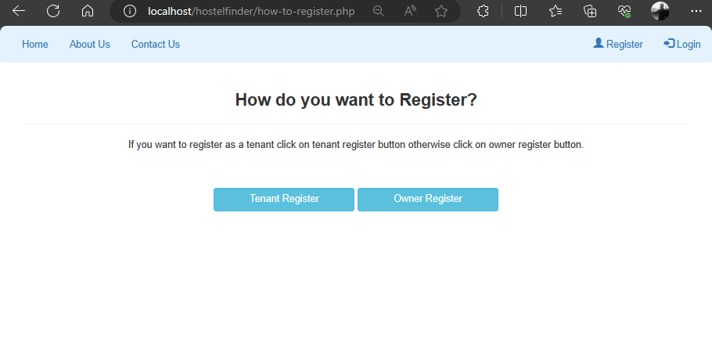

Tenant Registration :-

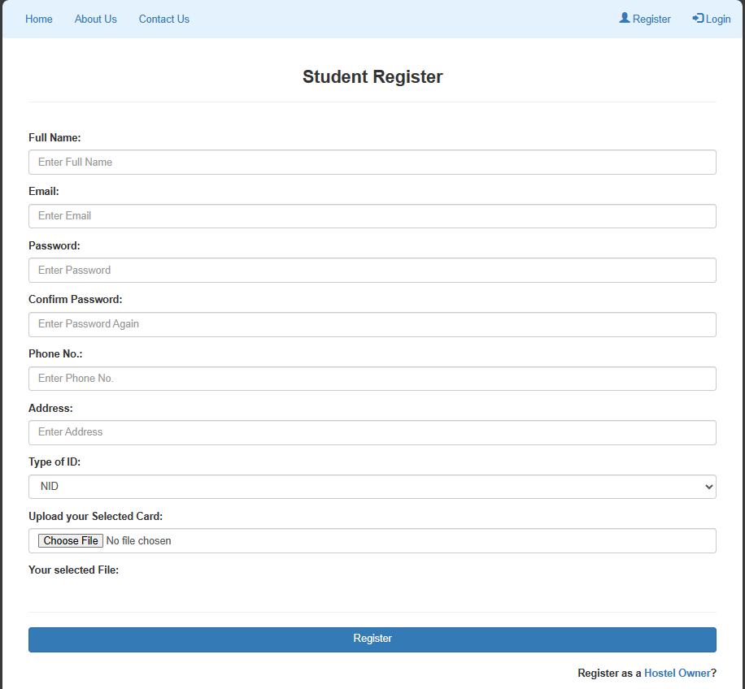

Owner Registration :-

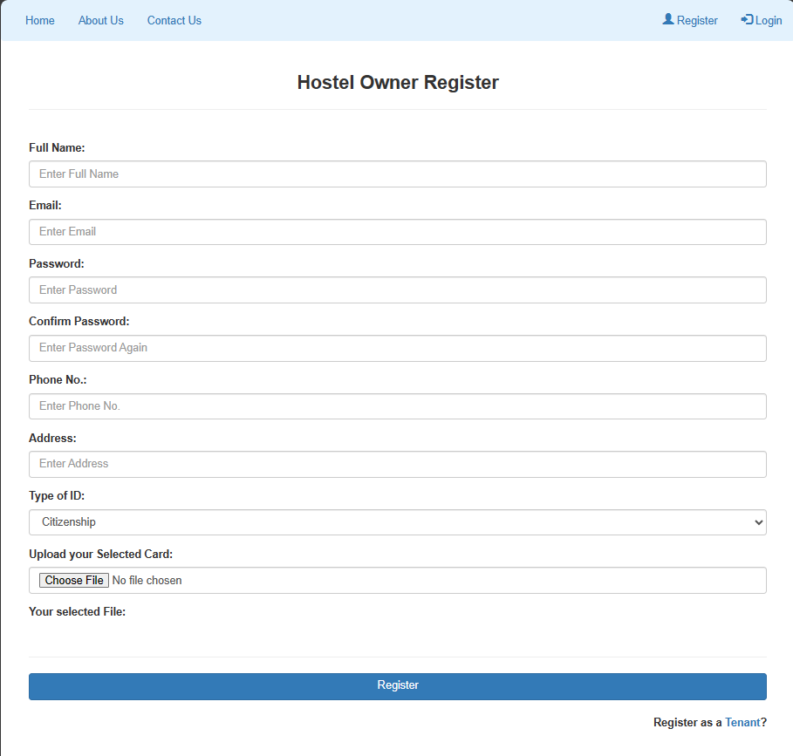

Login Options Page :-

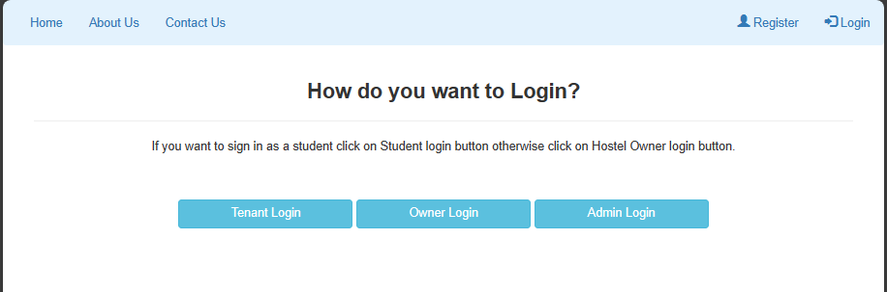

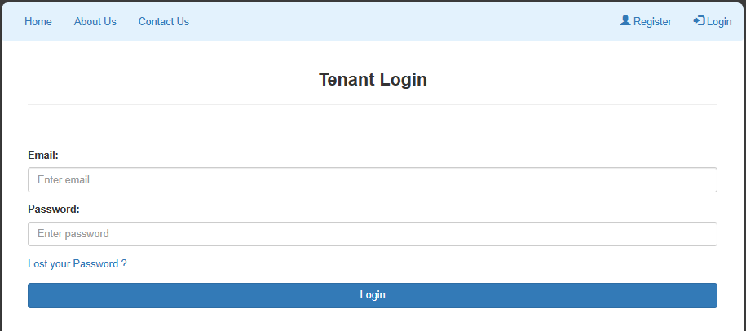

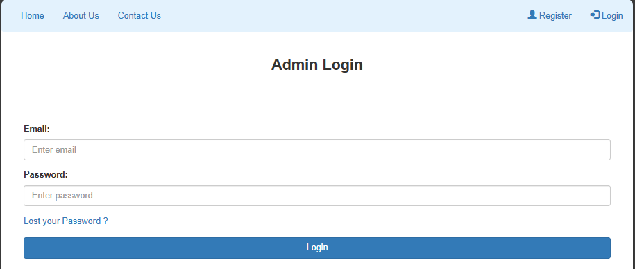

Owner Dashboard :-

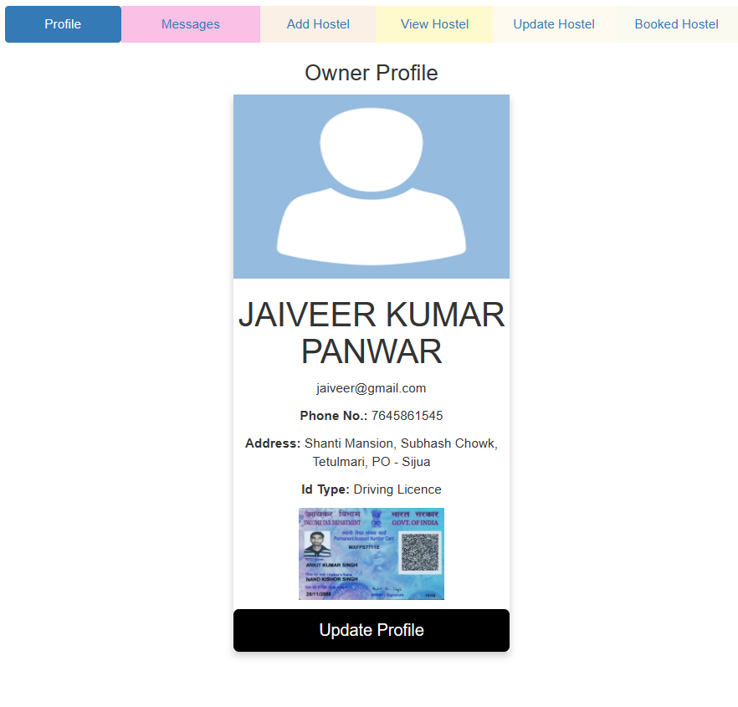

Add PG :-

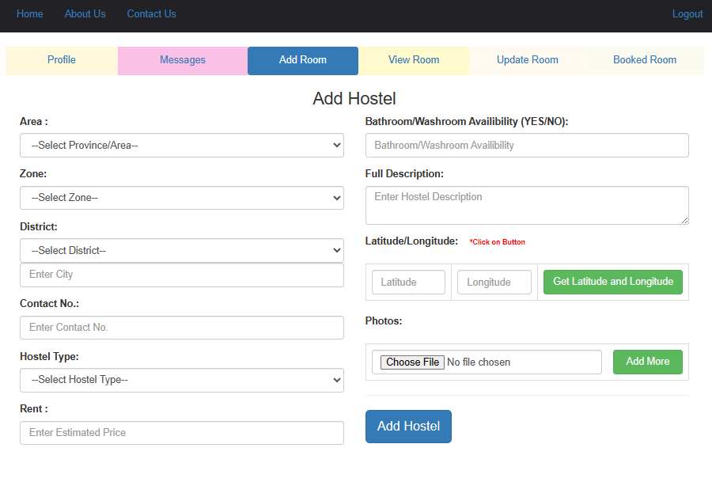

Booked PG :-

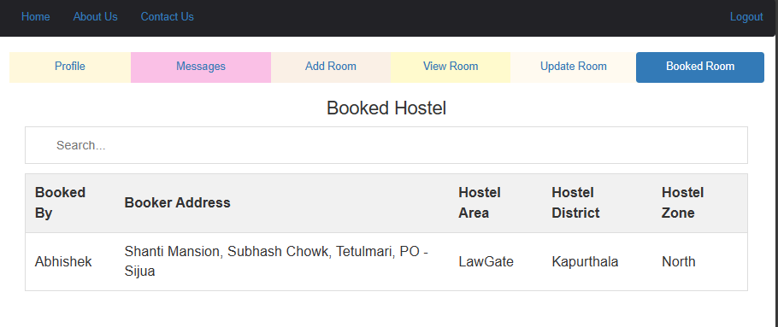
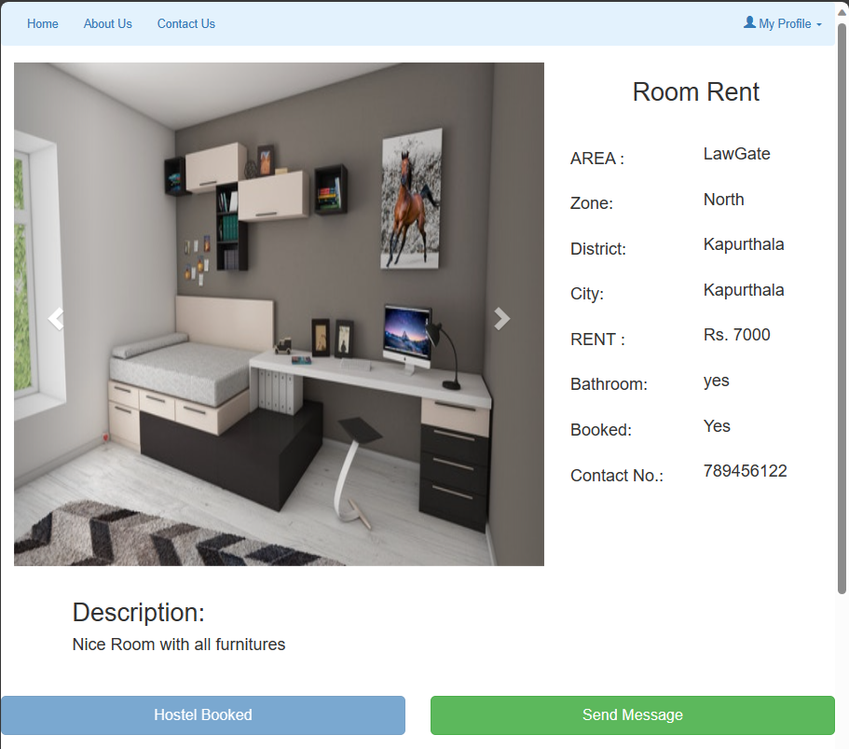
Property Detail :-

Testing

Testing is a process of executing a program with the intent of finding bugs that cause the application to fail to meet the expected behavior. Regardless of the development methodology, the ultimate goal of testing is to ensure that what is created does what it is supposed to do. Testing plays a critical role in assuring the quality and reliability of the software. I have included testing as a part of the development process. The test cases should be designed with the maximum possibility of finding errors or bugs. Various levels of testing are as follows.

9.1 Testing Level

Unit Testing:
Unit testing tests the functionality of individual units of source code. It is the smallest component of testable software that works in isolation with other parts of the code. I have done unit testing for various individual components of the source code to uncover errors within the boundary of the application.

Integration testing:
Integration testing focuses on the design and construction of the software. Here the individual components that are tested using unit tests are combined and tested as a group. Its primary purpose is to expose the defects associated with the interfacing of modules. It checks if the modules perform the desired functionality when integrated together

System testing:
System testing is performed on a completely integrated system to see if it meets the requirements.

Regression testing:
Regression testing aims at verifying the functionality of the software that is previously tested and to which changes are made. It is to ensure the old software still works with new changes.

Acceptance testing:
Acceptance testing is conducted to verify if the system compliance the business requirements.

Adhering to the levels of testing, Unit testing is performed on individual components of the system ensuring the expected behavior. Later, I have integrated various components together and performed Integration testing. Once the integration testing is done, I have performed System 30 testing and ensured the application works as per the requirements. Finally, acceptance testing is performed to check if the client accepts the system.

9.2 Test Cases

A test case is a set of rules or conditions to check if the system or one of its feature works in accordance to the requirement. It is a document with a set of details which includes, set of test data, expected results, actual results, environment information and soon. I have designed and executed a few test cases to check if the application meets the functional requirements.

Test Case | Test Objective | Input Specification | Output Specification | Pass/Fail
1 | User Registration | Provide valid registration details | User is registered successfully, redirects to login page | PASS
2 | User Login | Enter incorrect email/password | Displays error message | PASS
3 | Property Listing | Property owner adds a new PG listing | New listing added, displayed in property list | PASS
4 | Search PGs | User searches based on location and filters | Displays list of PGs matching search criteria | PASS
5 | Booking | User books a PG accommodation | Confirmation message displayed, booking reflected in profile | PASS
8 | Admin Moderation | Admin moderates owner and student details | Details and Users can be moderated by admin | PASS

Snapshot of Code

index.php :-

<?php
session_start();
include("navbar.php");
?>
<div class="bg"></div><br>
<div class="container active-cyan-4 mb-4 inline">
<form method="POST" action="search-property.php">
<input class="form-control" type="text" placeholder="Enter location to search hostel." name="search_property" aria-label="Search"> <br>
<button class="button" type="submit">SEARCH</button>
</form>
</div>
<br><br><br><br>
<?php
include("property-list.php");
?>
<br><br>

config.php :-

<?php

$db = new mysqli('localhost','root','','alikehome');

if($db->connect_error){
echo "Error connecting database";
}

?>

Registration.php :-

<?php
session_start();
if(isset($_SESSION["email"])){
header("location:index.php");
}
include("navbar.php");
?>
<section class="container-fluid sign-in-form-section">
<div class="container">
<div class="row">

<div class="col-md-12 sign-up" style="text-align: center;">
<h3 style="font-weight: bold;">How do you want to Register?</h3><hr>
<p>If you want to register as a tenant click on tenant register button otherwise click on owner register button.</p><br><br>
<button type="submit" class="btn btn-info" onclick="window.location.href='tenant-register.php'" style="width:200px;">Student Register</button>
<button type="submit" class="btn btn-info" onclick="window.location.href='owner-register.php'" style="width:200px;">Owner Register</button>
</div>

</div>
</div>
</section>

Login.php :-

<?php
session_start();
if(isset($_SESSION["email"])){
header("location:owner/owner-index.php");
}

include("navbar.php");
include("owner-engine.php");

?>

<div class="container">
<h3 style="font-weight: bold; text-align: center;">Owner Login</h3><hr><br><br>
<form method="POST">
<div class="form-group">
<label for="email">Email:</label>
<input type="email" class="form-control" id="email" placeholder="Enter email" name="email" required>
</div>
<div class="form-group">
<label for="pwd">Password:</label>
<input type="password" class="form-control" id="pwd" placeholder="Enter password" name="password" required>
</div>

<center><input type="submit" id="submit" name="owner_login" class="btn btn-primary btn-block" value="Login"></center>
</form>
</div>

Navbar.php :-

<!DOCTYPE html>
<html lang="en">
<head>
<title>ALIKEHOME</title>
<meta charset="utf-8">
<meta name="viewport" content="width=device-width, initial-scale=1">
<link rel="stylesheet" href="https://maxcdn.bootstrapcdn.com/bootstrap/3.4.1/css/bootstrap.min.css">
<script src="https://ajax.googleapis.com/ajax/libs/jquery/3.5.1/jquery.min.js"></script>
<script src="https://maxcdn.bootstrapcdn.com/bootstrap/3.4.1/js/bootstrap.min.js"></script>

<nav class="navbar navbar-expand-sm navbar-light justify-content-between" style="background-color: #e3f2fd;">
<div class="container-fluid">
<a class="navbar-header" href="index.php">
<img src="../images/logo1.png" alt="logo" style="height:50px;">
</a>
<ul class="nav navbar-nav">
<li class="nav-item">
<a class="nav-link" href="admin-index.php">Home</a>
</li>
<li class="nav-item">
<a class="nav-link" href="#">About Us</a>
</li>
<li class="nav-item">
<a class="nav-link" href="#">Contact Us</a>
</li>
</ul>
<ul class="nav navbar-nav navbar-right">
<?php
if(isset($_SESSION["email"]) && !empty($_SESSION['email'])){
echo '<li><a href="../logout.php">Logout</a></li>';
}

else {?>
<li><a href="../how-to-register.php"><span class="glyphicon glyphicon-user"></span> Register</a></li>
<li><a href="../how-to-login.php"><span class="glyphicon glyphicon-log-in"></span> Login</a></li>
<?php } ?>
</ul>
</div>
</nav>
</body>
</html>

Booking.php :-

<?php
include("config/config.php");
if(isset($_POST['book_property'])){
if(isset($_SESSION["email"])){
global $db,$property_id;
$u_email=$_SESSION["email"];
$property_id=$_GET['property_id'];

$sql="SELECT * FROM tenant where email='$u_email'";
$query=mysqli_query($db,$sql);
if(mysqli_num_rows($query)>0)
{
while ($rows=mysqli_fetch_assoc($query)) {
$tenant_id=$rows['tenant_id'];
$sql1="UPDATE add_property SET booked='Yes' WHERE property_id='$property_id'";
$query1=mysqli_query($db,$sql1);
$sql2="INSERT INTO booking(property_id,tenant_id) VALUES ('$property_id','$tenant_id')";
$query2=mysqli_query($db,$sql2);
if($query2)
{
$email=$rows['email'];
$msg="Thankyou Mr/Ms ".$rows['full_name']." for booking Property. Please visit the property location to view it personally.";
$recipient=$email;
$subject="Property Booked";
$mailheaders="From: alikehome\n";
?>

Addproperty.php :-

<?php
$property_id='';$province='';$zone='';$district='';$city='';$contact_no='';$property_type='';$estimated_price='';$description='';$latitude='';$longitude='';$booked='';
$owner_id='';
$db = new mysqli('localhost','root','','hostelfinderDB');

if($db->connect_error){
echo "Error connecting database";
}

if(isset($_POST['add_property'])){
add_property();
}

if(isset($_POST['owner_update'])){
owner_update();
}
function add_property(){

global $property_id,$country,$province,$zone,$district,$city,$contact_no,$property_type,$estimated_price,$bathroom,$description,$latitude,$path,$p_photo,$property_photo_id,$longitude,$owner_id,$booked,$db;

$province=validate($_POST['province']);
$zone=validate($_POST['zone']);
$district=validate($_POST['district']);
$city=validate($_POST['city']);

$contact_no=validate($_POST['contact_no']);
$property_type=validate($_POST['property_type']);
$estimated_price=validate($_POST['estimated_price']);

$bathroom=validate($_POST['bathroom']);
$description=validate($_POST['description']);
$latitude=validate($_POST['latitude']);
$longitude=validate($_POST['longitude']);
$booked='No';
$u_email=$_SESSION['email'];
$sql1="SELECT * from owner where email='$u_email'";
$result1=mysqli_query($db,$sql1);

if(mysqli_num_rows($result1)>0)
{
while($rowss=mysqli_fetch_assoc($result1)){
$owner_id=$rowss['owner_id'];

$sql = "INSERT INTO add_property(province,zone,district,city,contact_no,property_type,estimated_price,bathroom,description,latitude,longitude,booked,owner_id) VALUES('$province','$zone','$district','$city','$contact_no','$property_type','$estimated_price','$bathroom','$description','$latitude','$longitude','$booked','$owner_id')";
$query=mysqli_query($db,$sql);

$property_id = mysqli_insert_id($db);

$countfiles = count($_FILES['p_photo']['name']);

for($i=0;$i<$countfiles;$i++){
$paths = $_FILES['p_photo']['tmp_name'][$i];
if($paths!="")
{
$path="product-photo/" . $_FILES['p_photo']['name'][$i];
if(move_uploaded_file($paths, $path)) {
$sql2 = "INSERT INTO property_photo(p_photo,property_id) VALUES('$path','$property_id')";
$query=mysqli_query($db,$sql2);

}}

}
if(!empty($query)){

?>

bookedProperty.php :-
<?php
$u_email=$_SESSION['email'];
$sql3="SELECT * from tenant where email='$u_email'";
$result3=mysqli_query($db,$sql3);

echo '<center><h1>Booked Hostels</h1></center>';

if(mysqli_num_rows($result3)>0)
{
while($rowss=mysqli_fetch_assoc($result3)){
$tenant_id=$rowss['tenant_id'];

$sql1="SELECT * FROM booking where tenant_id='$tenant_id'";
$query1=mysqli_query($db,$sql1);
if(mysqli_num_rows($query1)>0)
{
while ($ro=mysqli_fetch_assoc($query1)) {
$prop_id=$ro['property_id'];

$sql="SELECT * FROM add_property where property_id='$prop_id'";
$query=mysqli_query($db,$sql);
if(mysqli_num_rows($query)>0)
{
while ($rows=mysqli_fetch_assoc($query)) {
$property_id=$rows['property_id'];

?>

- Bibliography or References :-

For this project, we have taken help and support from various resources such as :-

- Youtube

- W3Schools

- GeeksForGeeks

- Bootstrap Documentation Page

- CDN Libraries

